## Tutorials

## Exercise Rules:

1. When you are ready, delete the ***node_modules***folder, make sure all dependencies are listed in the ***package.json*** file and submit your archived project at: [SoftUni Judge](https://judge.softuni.bg/Contests/Practice/Index/3121#1)
2. You are provided with **HTML & CSS** resources, which you can **modify**
3. Use **Express.js** as a back-end framework
4. Use **MongoDB** as a database with **mongoose**
5. You can use whatever **view engine** you like (Handlebars, EJS, Pug etc.…)

## Application Overview

Get familiar with the provided **HTML & CSS** and create an application for **tutorials**, **courses** and **course lectures.**

## Functional Requirements

The Functionality Requirements describe the functionality that the **Application** must support.

**Guest (Not Logged In)**

The **application** should provide Guest (not logged in) users with the functionality to login, register and **view** the Home page.

**Users (Logged In)**

The **application** should provide **Users** (logged in) with the functionality to **view all the courses which are listed**, **course details page of all listed courses** and **they should be able to enroll in courses**.

**Database Models (10 Pts)**

The **Database** of the Tutorials application needs to support:

### User

* Username - string (required), unique
* Password - string (required)
* **Enrolled Courses - a collection of** Courses

### Course

* **Title - string (required), unique**
* **Description - string (required), max length of 50 symbols,**
* **Image Url - string (required),**
* **Duration – string (required),**
* **Created at – Date or String, (required),**
* **Users Enrolled - a collection of Users**

Implement the entities with the **correct datatypes**.

### Application Pages (70 Pts)

**Guest Pages (15 Pts)**

These are the pages and functionalities, accessible by **Guests (logged out users).**

**Home Page (Logged Out User)**

List the **top three (3) public courses ordered** by the **count** of enrolled in users in **descending** order.

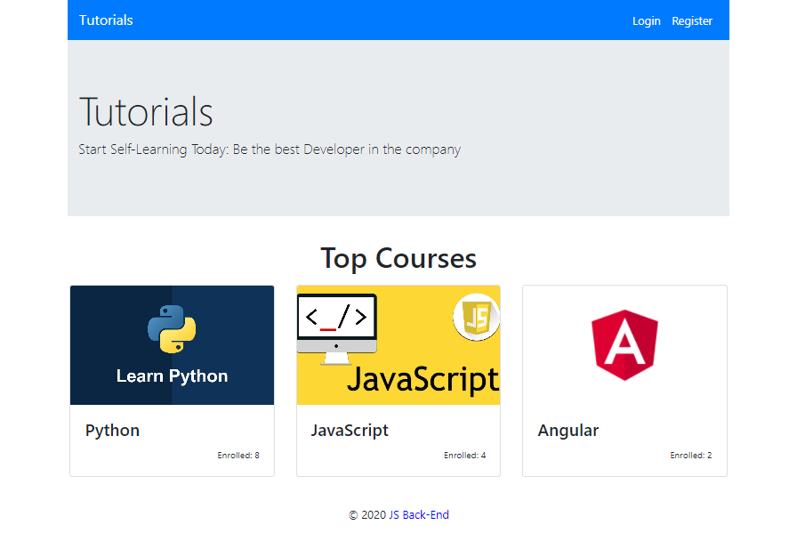

If there are no courses in the database yet, display **"No courses..."**

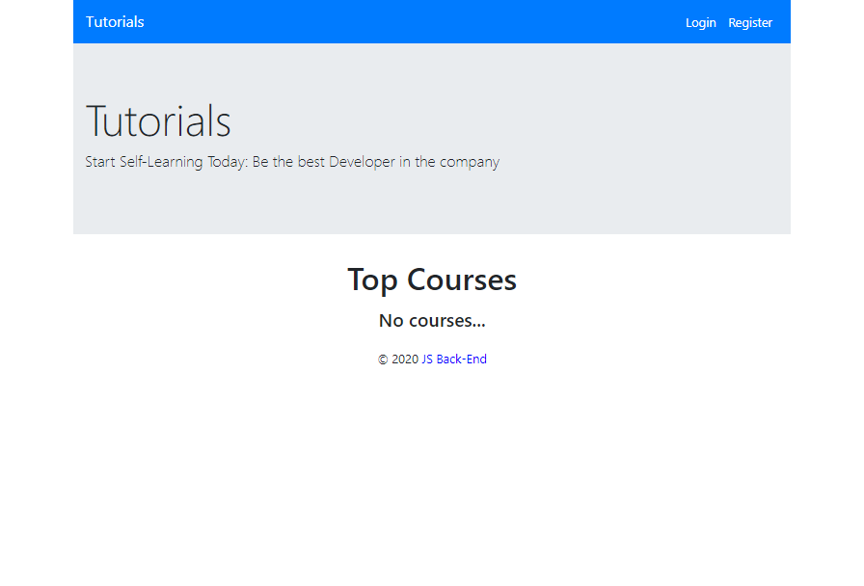

**Register Page (Logged Out User)**

Register a user inside the database with **username** and **password**. Both **passwords** must **match**! After successful registration, you should **redirect to Home page** and the user should be already **logged in**.

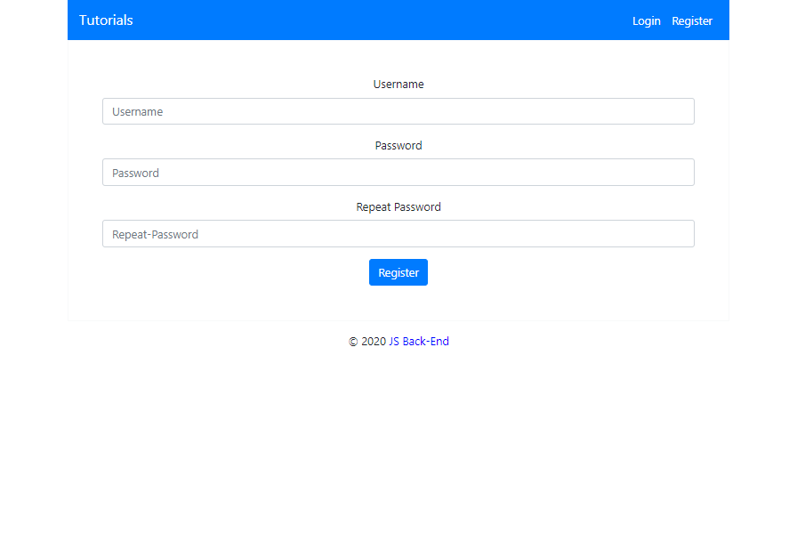

**Login Page (Logged Out User)**

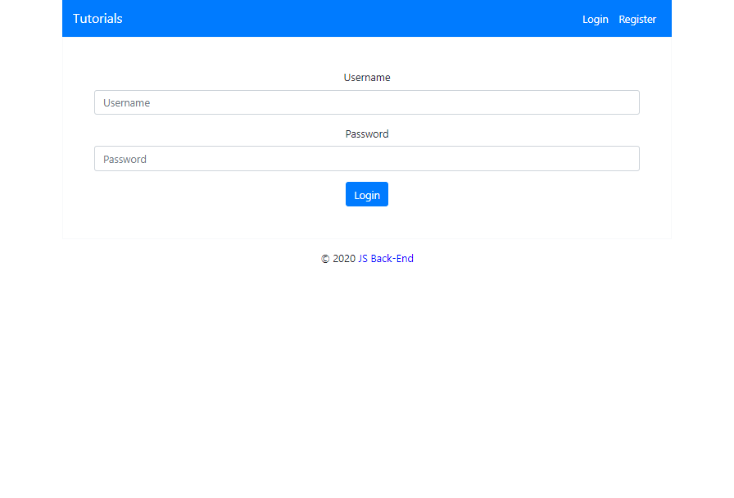

**User Pages (55 Pts)**

These are the **templates** and **functionalities**, accessible by Users (**logged in** users).

**Home Page (Logged in User)**

List **all public** courses sorted in **ascending** **order** by the **created** **time** with a button **Details** which leads to a **course details page**.

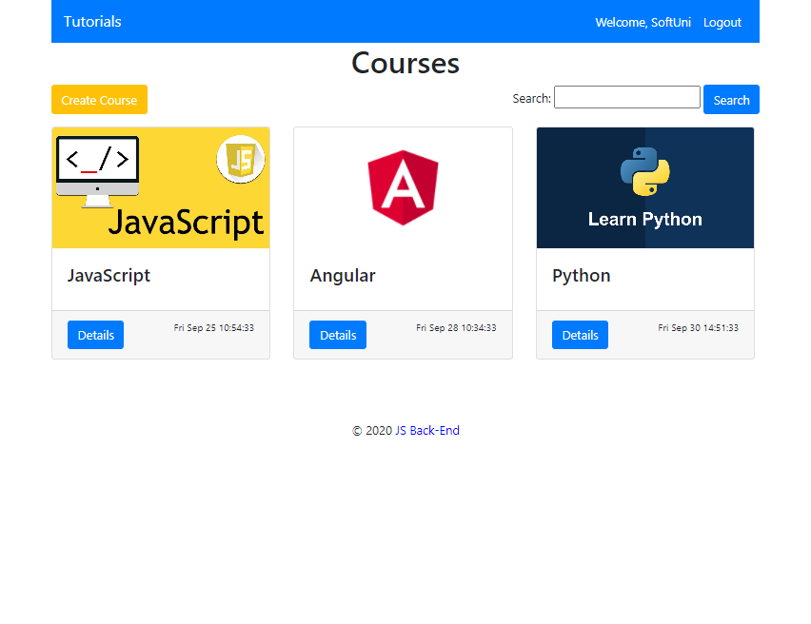

If there are no courses in the database yet, display **"No courses..."**

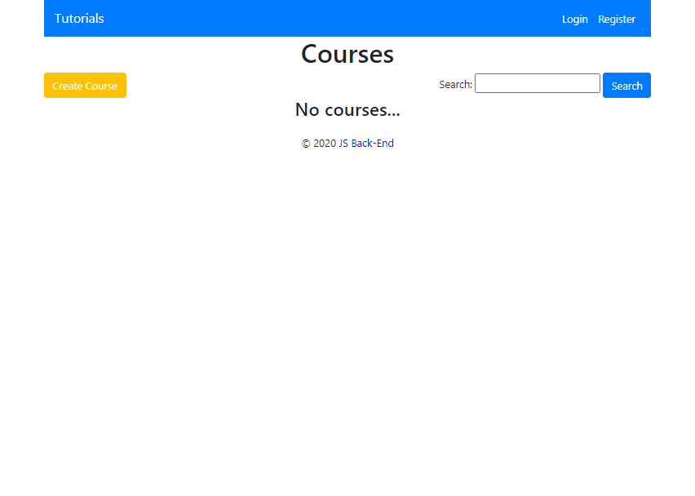

**Create Course Page (Logged in User)**

Enter course **title**, **description**, **image URL** and **duration**. After the course is created successfully, you should **redirect to Home page**.

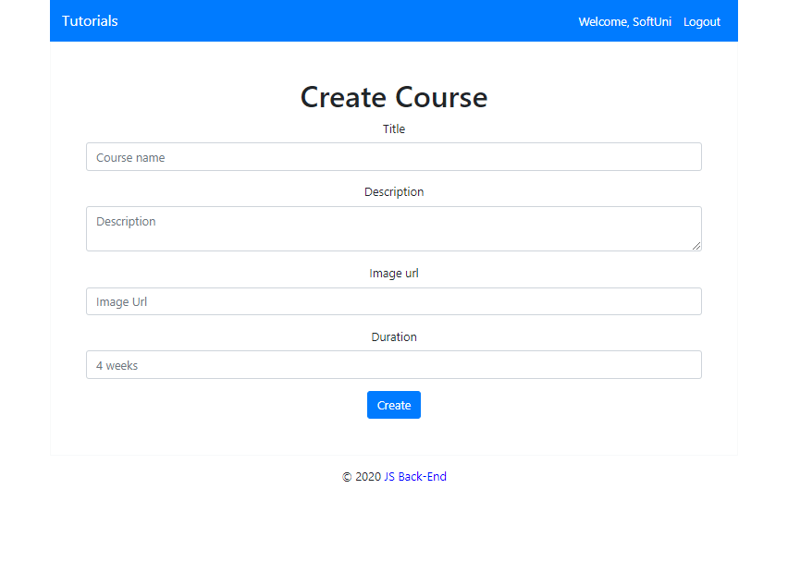

**Logged in Details Page (Logged in User)**

In the Details of a course section, you should load course **name** and **description**.

**Not Enrolled in Course (Logged in User)**

If the user is **not enrolled** in the course, you should display **Enroll button.**

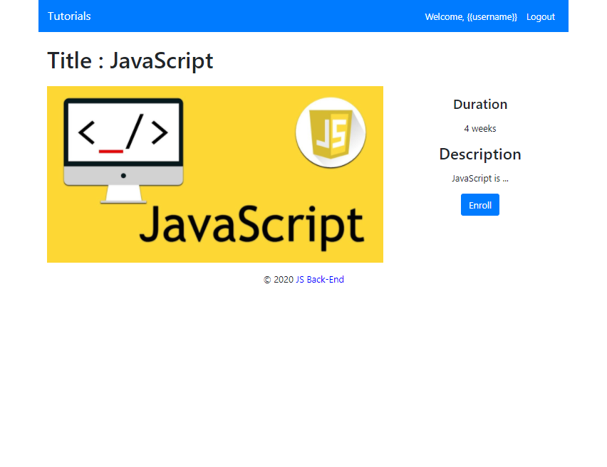

**Enrolled in Course (Logged in User)**

**After** the user has enrolled in the course, the **"You are already enrolled" span element** should be **shown instead of the [Enroll] button.**

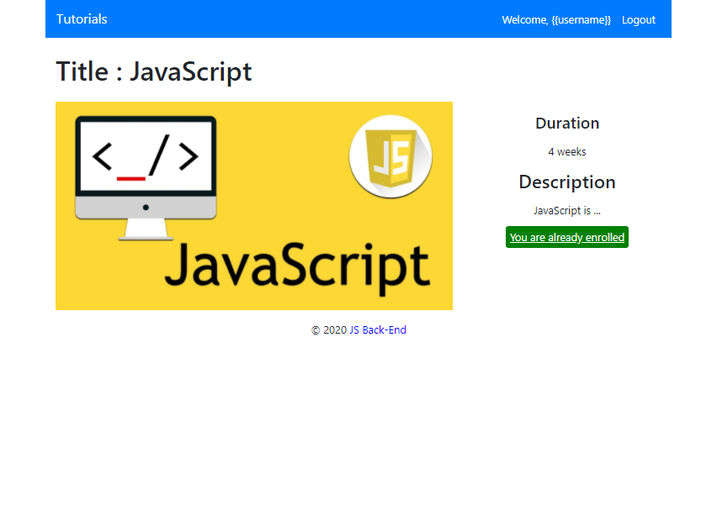

**Course Creator (Logged in User)**

The creator of the course should see **[Delete] [Edit]**

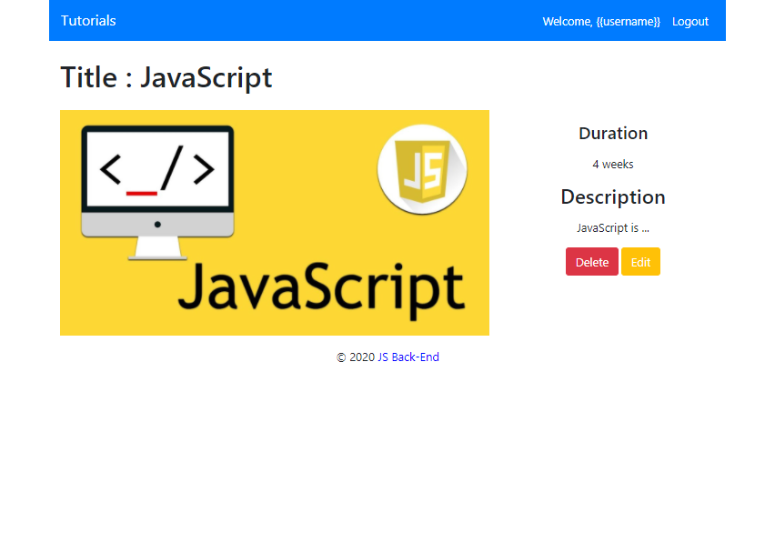

**Delete Course (Logged in User)**

Upon deleting a lecture (clicking over **[Delete] button**), you should be **redirected to the home page**.

**Edit Course (Logged in User)**

All form fields should be **filled** with the corresponding information of the selected course. When a put request is sent (clicking over **[Edit] button**), you should be **redirected to the Details page**.

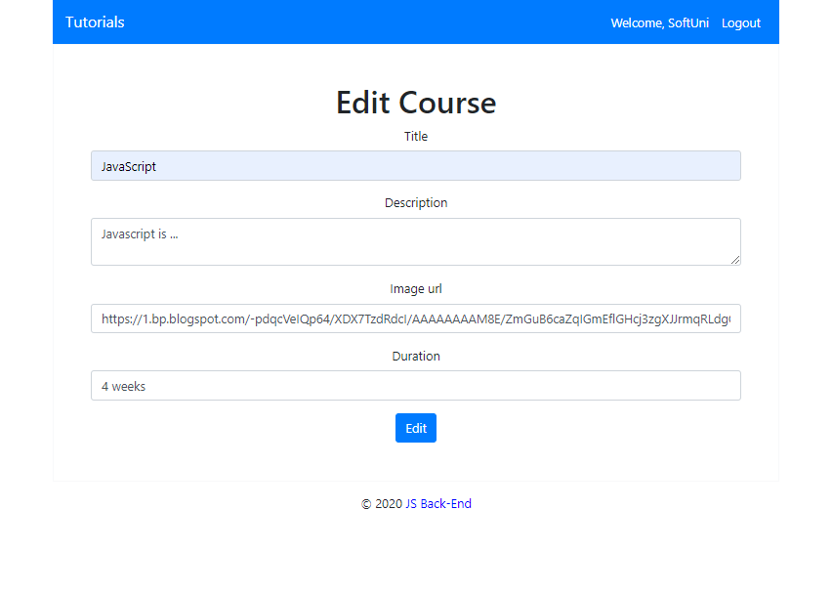

**Security Requirements (10 Pts)**

The Security Requirements are mainly **access** requirements. Configurations about which users can access specific functionalities and pages.

* Guest (not logged in) users can access Home page and functionality.
* Guest (not logged in) users can access Login page and functionality.
* Guest (not logged in) users can access Register page and functionality.
* Users (logged in) can access Home page (Listed all Courses)page and functionality.
* Users (logged in) can access **Course** Details page and functionality.
  + **Users** (not course creator) can **Enroll** **once** for the course
  + **Users** (course creator) can **Edit** and **Delete** the current course
* Users (logged in) can access **Create Course** page and functionality.
* Users (logged in) can access Logout functionality.

**Validation and Error Handling (10 Pts)**

The application should notify the users about result of their actions.

### Login / Register

You should make the following validations:

* The **username** should be **at least 5 characters** long and should consist only **english** **letters** and **digits**
* The **password** should be **at least 5 characters** long and should consist only **english** **letters** and **digits**
* The **repeat password** should be **equal to the password**

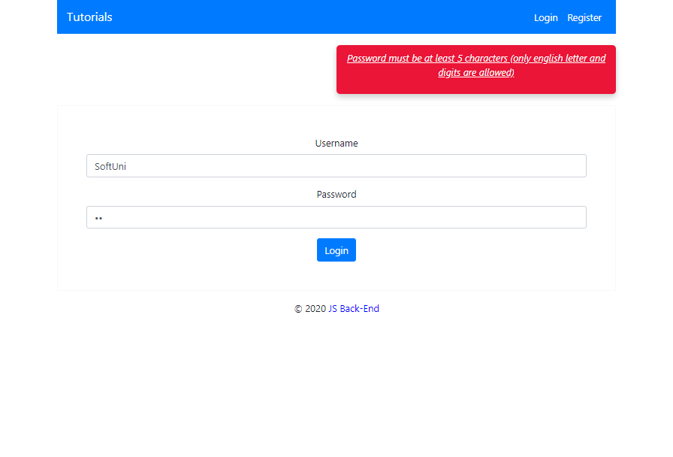

### Course

You should make the following validations while **creating** or **editing a** **course**:

* The **title** should be **at least 4 characters**
* The **description** should be **at least 20 characters** long
* The **imageUrl** should **starts with http or https**

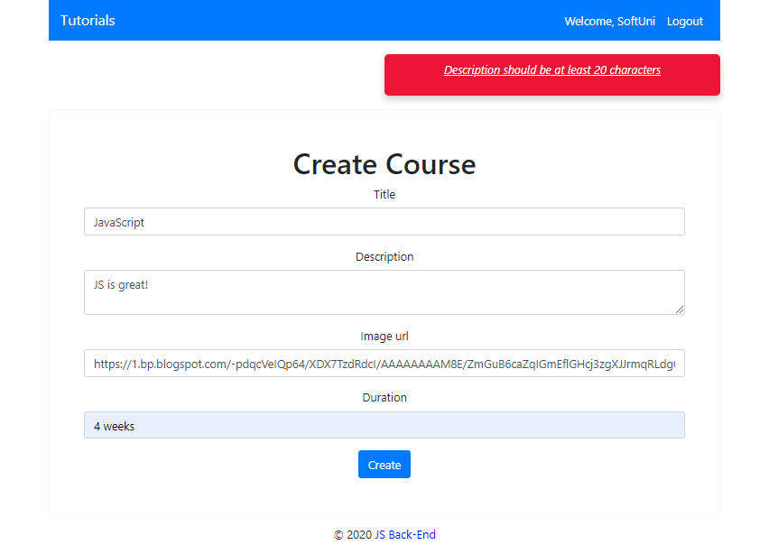

**\* Bonus (10 Pts)**

**Search in courses.** Filter only the **courses names** that **include the searched string** (**case-insensitive**).

