Statistical Theories for Brain and Parallel Computing

Assignment No.4

17M18819

ZHU LICHENG

## Description of Assignment

In assignment 4, I need to use a probabilistic and binary model to solve the simultaneous equation, which is the same as assignment 3. In addition, observe whether the number of occurrence of each states obeys Boltzman’s theory.

## Solution

***Probabilistic and Binary Model***

For this assignment, one way to solve it is to apply Gibb’s copies to generate large quantities of copies of neural network, which costs a lot of memory and time. Therefore, I apply the idea of Ergodicity to save the computational cost. In this method, we can just use one RNN and the states generated by it as a sequence while updating.

The procedure of this program:

1. Use one RNN and assign initial value (0,0,0,0,0) to it.
2. Update the neurons one by one using the probabilistic updating rule, where I choose one of the five neurons to update each time with an equal probability.
3. Among the sequence of states generated by updating ,I will count the number of each states that appeared and output it in the command window.

I used python to implement this task. I created one class called **ass4.py** where we can call the function **ass4().prob_rec(init)** where init is all the coefficients of the linear equation.

Some part of the program is similar to assignment 3. However, when updating, we need to generate a random number from 0 to MAX (2^31-1) and judge whether this number is bigger than MAX*P where P is the probability of updating this neuron. P = 1/(1+exp(-alpha*(E(updated)-E(original)))). Here I adjusted the negative sign in advance and the core part is as follows.

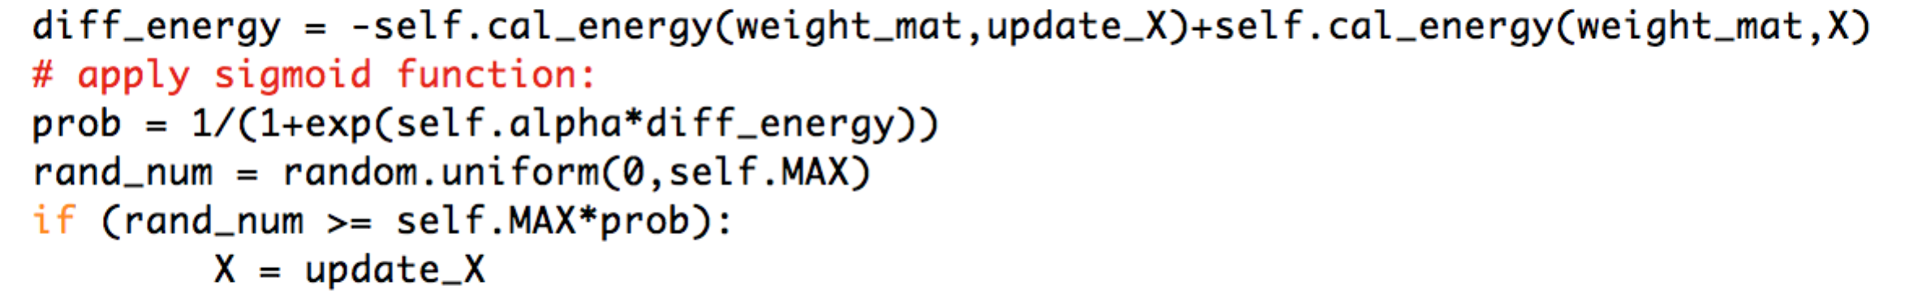

After updating 10000 times, I count the number of occurrence of the states which appeared during the process.

Then, I tried to observe whether the number of occurrence of states obey the Boltzman’s theory where

**N(x1,x2,x3,x4,x5) = A*exp(-alpha*E(x1,x2,x3,x4,x5))**

I tried several times and adjusted the coefficient A to a reasonable value.

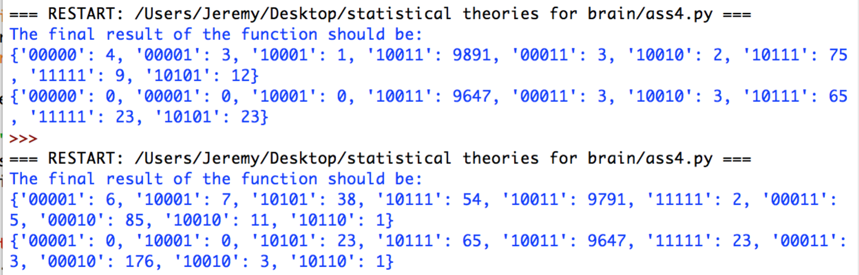

We can see here the result ‘1,0,0,1,1’ has a supremely large number of occurrence which confirms the correctness of my program. In these two trials, above one is the **actual count of occurrence**, the below one is the **ideal number of occurrence.** However, it is obvious that not every value has a very close value, which may result from not enough number of trials. Therefore, I increased the number of transitions to 1,000,000 and run the program again.

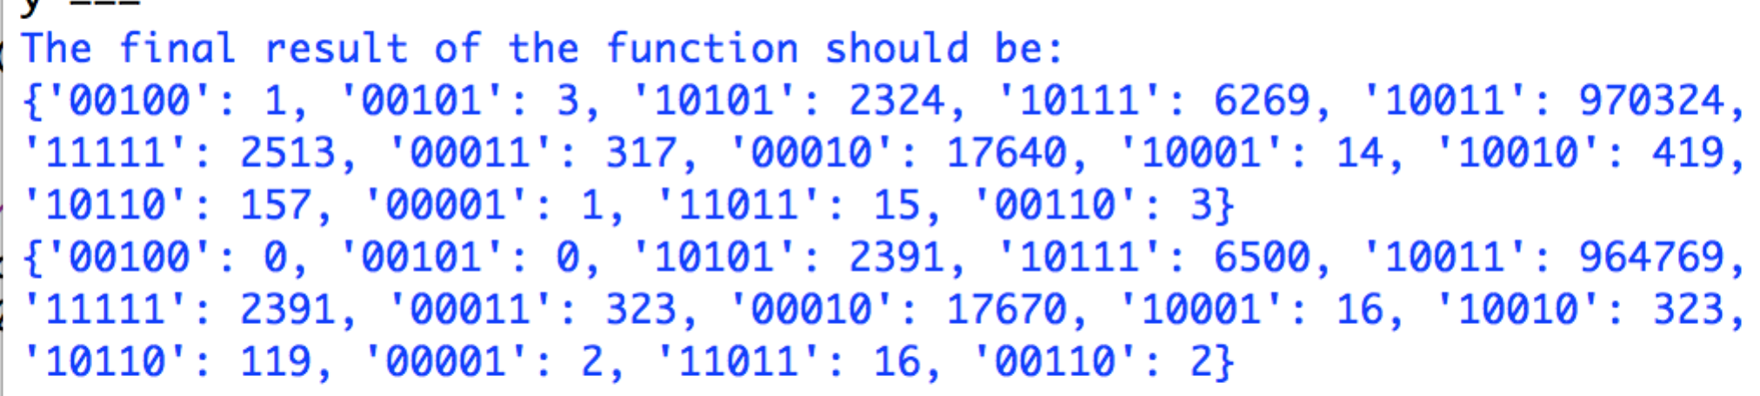

Now we can find that most of the values relate closely with each other which we can roughly say that the number of occurrence of our neural network obeys the boltzman’s theory. With the increasing of number of trials, the numbers will come cloaser

## Running command

(The following parameters can be changed by hand when calling function **prob_rec()**)

*prob_rec([[1,-2,1,2,-1,-2],[-1,1,1,-1,-1,3],[2,1,-1,-2,-2,2],[1,2,-1,-1,-1,1],[-1,-1,1,1,1,-1]])*