**Macao Society of Nuclear Medicine and Molecular Imaging**

**Constitution**

**Section One**

**General Provisions**

1. Name:

Chinese: "澳門核醫及分子影像學會";

Portuguese: "Sociedade de Medicina Nuclear e Imagem Molecular de Macau";

Portuguese abbreviation: "SMNIMM";

English: "Macao Society of Nuclear Medicine and Molecular Imaging";

English abbreviation: "MSNMMI".

2. Missions:

(a) To develop the profession of nuclear medicine and molecular imaging, with a view to improving the standard of clinical services, teaching and research;

(b) To promote the international standing of nuclear medicine and molecular imaging of Macao;

(c) To promote molecular imaging translational research and industrial application;

(d) To advise on and to provide a consultation platform for the handling and regulation of radiopharmaceuticals;

(e) To provide education on nuclear medicine and molecular imaging to the Macao public, and to encourage Macao students to join the profession;

(f) To protect the legitimate rights and interests of the members;

(g) MSNMMI is a non-profit and legal professional body.

3. Corresponding address: Flat J, 12/F, Regent Park Tower, One Oasis, Coloane, Macao SAR, China.

**Section Two**

**Membership**

1. Membership eligibility:

(a) Member: Professional engaged in nuclear medicine and molecular imaging related occupations can apply to the Council to become a Member subject to the Council’s approval. Membership of a Member cannot be retained if the Member leaves Macao or retires;

(b) Permanent Member: Members with more than five years of relevant work experience can apply to become a Permanent Member subject to the Council’s approval. Membership of a Permanent Member can be retained if the Permanent Member leaves Macao or retires.

2. Permanent membership assessment:

Applications to become a Permanent Member will be assessed by advisor or Permanent Member appointed by the Council.

3. Member rights:

(a) To attend the General Assembly and participate in all activities of MSNMMI;

(b) To nominate, vote and be elected in the General Assembly;

(c) To raise objections and to quit MSNMMI.

4. Member obligations:

(a) To attend the General Assembly; to participate, support and assist the arrangement of activities of MSNMMI;

(b) To comply with the Constitution and resolutions approved by the General Assembly;

(c) Members and Permanent Members are required to pay annual dues, otherwise membership will be automatically withdrawn after missing paying annual dues for two consecutive years, except for Permanent Members who have left Macao or retire;

(d) Not to commit any act detrimental to the reputation of MSNMMI;

(e) Not to represent MSNMMI without the consent of the Council.

5. Sanctions:

If Member is in breach of the Constitution of MSNMMI, the Council can give warning to the Member. If the breach is substantial, the General Assembly can assess and approve termination of the membership of the Member.

**Section Three**

**Governing Body (consisting of Permanent Members and Members who reside in Macao)**

1. The Governing Body includes: the General Assembly, the Council and the Supervisory Board.

2. General Assembly:

(a) General Assembly holds the highest authority in MSNMMI, possesses the right to formulate and amend the Constitution, elect and appoint members for the General Assembly, the Council and the Supervisory Board, to deliberate the Council’s progress report and Supervisory Board’s financial report;

(b) General Assembly consists of all Permanent Members and Members and meet at least once a year. The quorum is half the total number of all Permanent Members and Members. If there is no quorum, the meeting can be held as if there is a quorum one hour after the announced meeting time regardless of the attendance;

(c) The arrangement of the General Assembly Meeting should be announced at least 8 calendar days prior to the meeting by registered mails or by mails with acknowledgement of receipt. The meeting date, time, venue and agenda should be listed in the notification letter;

(d) Special General Assembly Meeting could be arranged upon request by the Council or a joint request by more than one third of all Permanent Members and Members;

(e) The bureau of the General Assembly Presidium consists of one Chairman and Vice Chairmen elected by the General Assembly with a term of 3 years. Chairman and Vice Chairmen can be re-elected. MSNMMI members can be invited by the Council to become Honorary Chairmen, who shall serve until the next election of the Council;

(f) Chairman is to preside at the General Assembly. Vice-Chairman can act on his/her behalf if Chairman is absent;

(g) Motion can be introduced in the General Assembly Meeting by the Council, Supervisory Board or by the joint request of at least one tenth of the attending Permanent Members and Members;

(h) Resolution of the General Assembly Meeting can be approved with the endorsement of more than half of the attending Permanent Members and Members;

(i) Termination of members of the Governing Body or amendment of the Constitution can be approved with the endorsement of at least three-quarters of the attending Permanent Members and Members;

(j) Dissolution of the legal entity of MSNMMI or extension of the term of the legal entity of MSNMMI can be approved with the endorsement of at least three-quarters of all MSNMMI Permanent Members and Members.

3. Council:

(a) The Council is the executive body of MSNMMI, reported directly to the General Assembly. The Council admits new members and conducts businesses based on direction set out and resolution approved by the General Assembly. Only the Council can represent MSNMMI;

(b) The Council consists of an odd number of and at least three Council Members: one President, two Vice-Presidents and one Secretary-General. If necessary, additional positions such as Treasury, External Affairs Officer and General Affairs Officer can be added. Each term of Council Members lasts for three years and Council Members can be re-elected;

(c) Only the President, or MSNMMI member authorized by the President, can express comments in public on behalf of MSNMMI;

(d) Responsibilities of the Council Members:

(i) President – to integrate all tasks of MSNMMI, to execute power given by the Constitution, to attend external activities on behalf of MSNMMI according to MSNMMI’s missions.

(ii) Vice-President – to assist the President to execute MSNMMI duties, to act on behalf of the President when the President is absent.

(iii) Secretary-General – to draft meeting minutes, to prepare all MSNMMI related documents and mails, to arrange general business associated with the General Assembly and the Council.

(e) Council meeting is convened by the President and is quorate only when more than half of the Council Members attend. Resolution can only be approved by a majority of attending Council Members.

4. The Supervisory Board:

(a) Supervisory Board consists of an odd number of and at least three Supervisory Board Members, including one Chief Supervisor and two Supervisors, with a term of three years and Supervisory Board Members can be re-elected;

(b) The Supervisory Board is responsible for monitoring the work of the Council, and to submit report to the General Assembly;

(c) Supervisory Board Members cannot speak on behalf of MSNMMI.

5. Advisor:

The Council may recruit certain number of academic advisors and honorary advisors according to MSNMMI development.

**Section Four**

**Supplementary**

1. Revenue:

(a) MSNMMI’s revenue comes from the membership dues (entrance fees and annual fees);

(b) MSNMMI can accept donations with no conditions attached;

(c) Other legitimate income.

2. Emblem:

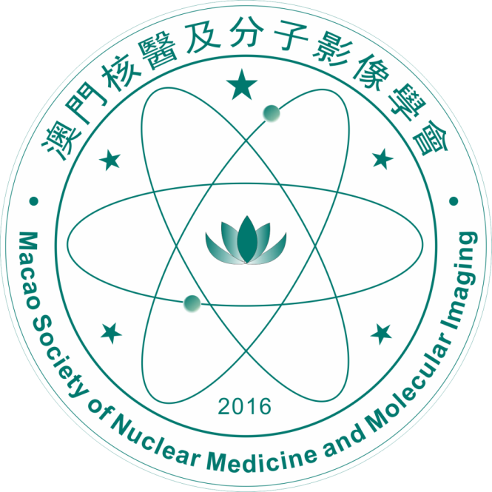

3. Matters not stated in this Constitution will be governed by laws and regulations of Macao.

Note: Where any discrepancy arises between the English translation and the original Chinese version of the Constitution, the Chinese version shall prevail.