# GoogleAdmob引入流程

## 接入背景:

### **二选一:**

**看doc或者直接导入MyAdmob.unitypackage**

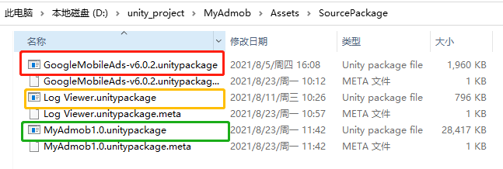

|  |
| --- |
| **Unity2018.4.20f1以上**  **GoogleMobileAds-v6.0.2.unitypackage**  **Andriod 19 API以上**  <https://developers.google.com/admob/unity/quick-start> |

## 导入unitypackage包

|  |
| --- |
| 必选插件:GoogleMobileAds-v6.0.2.unitypackage |

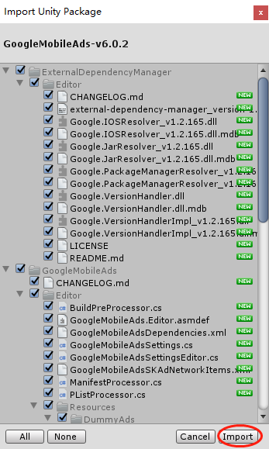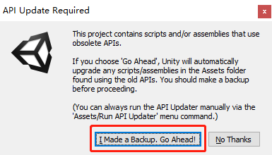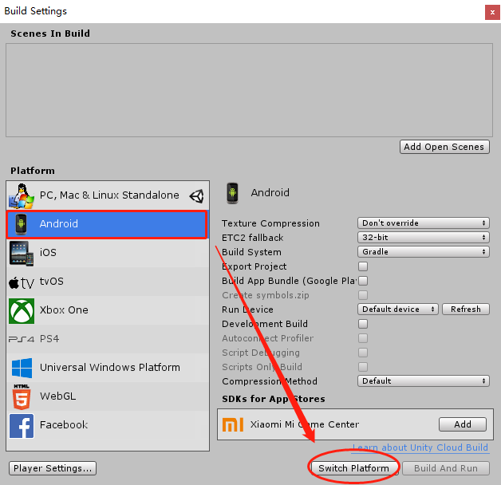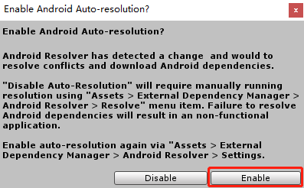

|  |
| --- |
| 可选日志包(LogViewer): Log Viewer.unitypackage  <https://blog.csdn.net/YuAnHandSome/article/details/102624296> |

## **运行Admob(配置打包)**

### **2.1主要Demo场景:Assets/MySDK/Demo.scene**

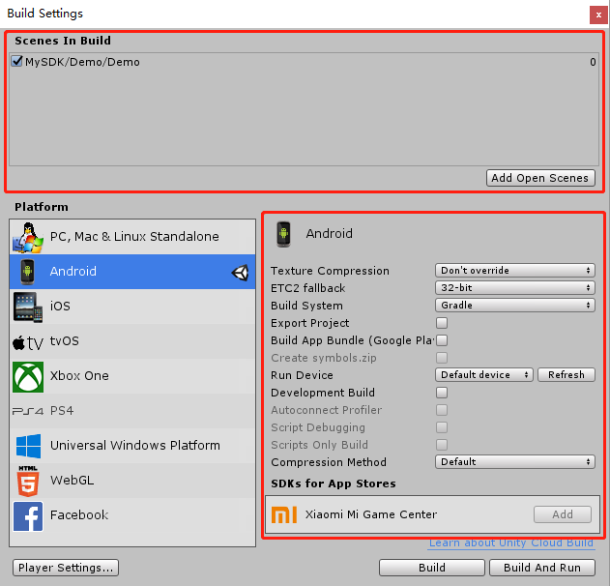 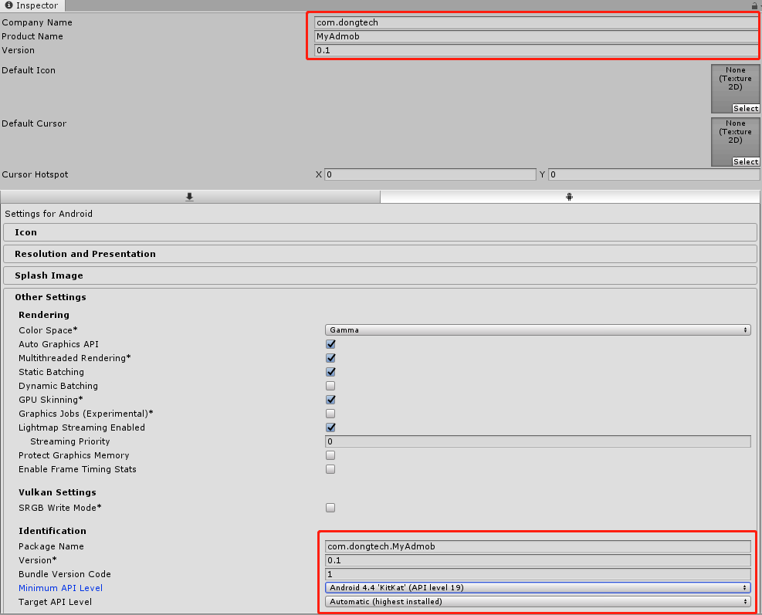

### **2.2配置GoogleAdmob:**

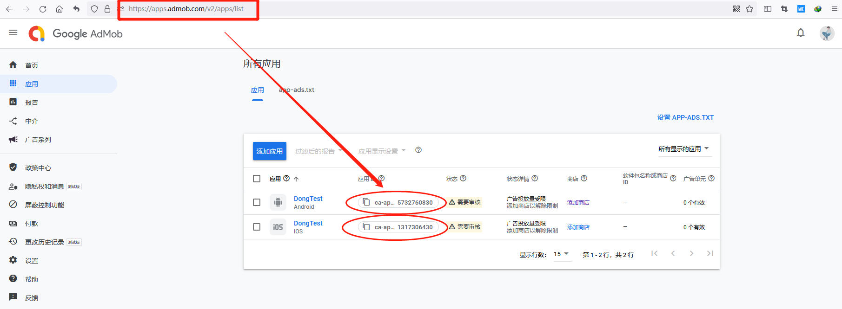

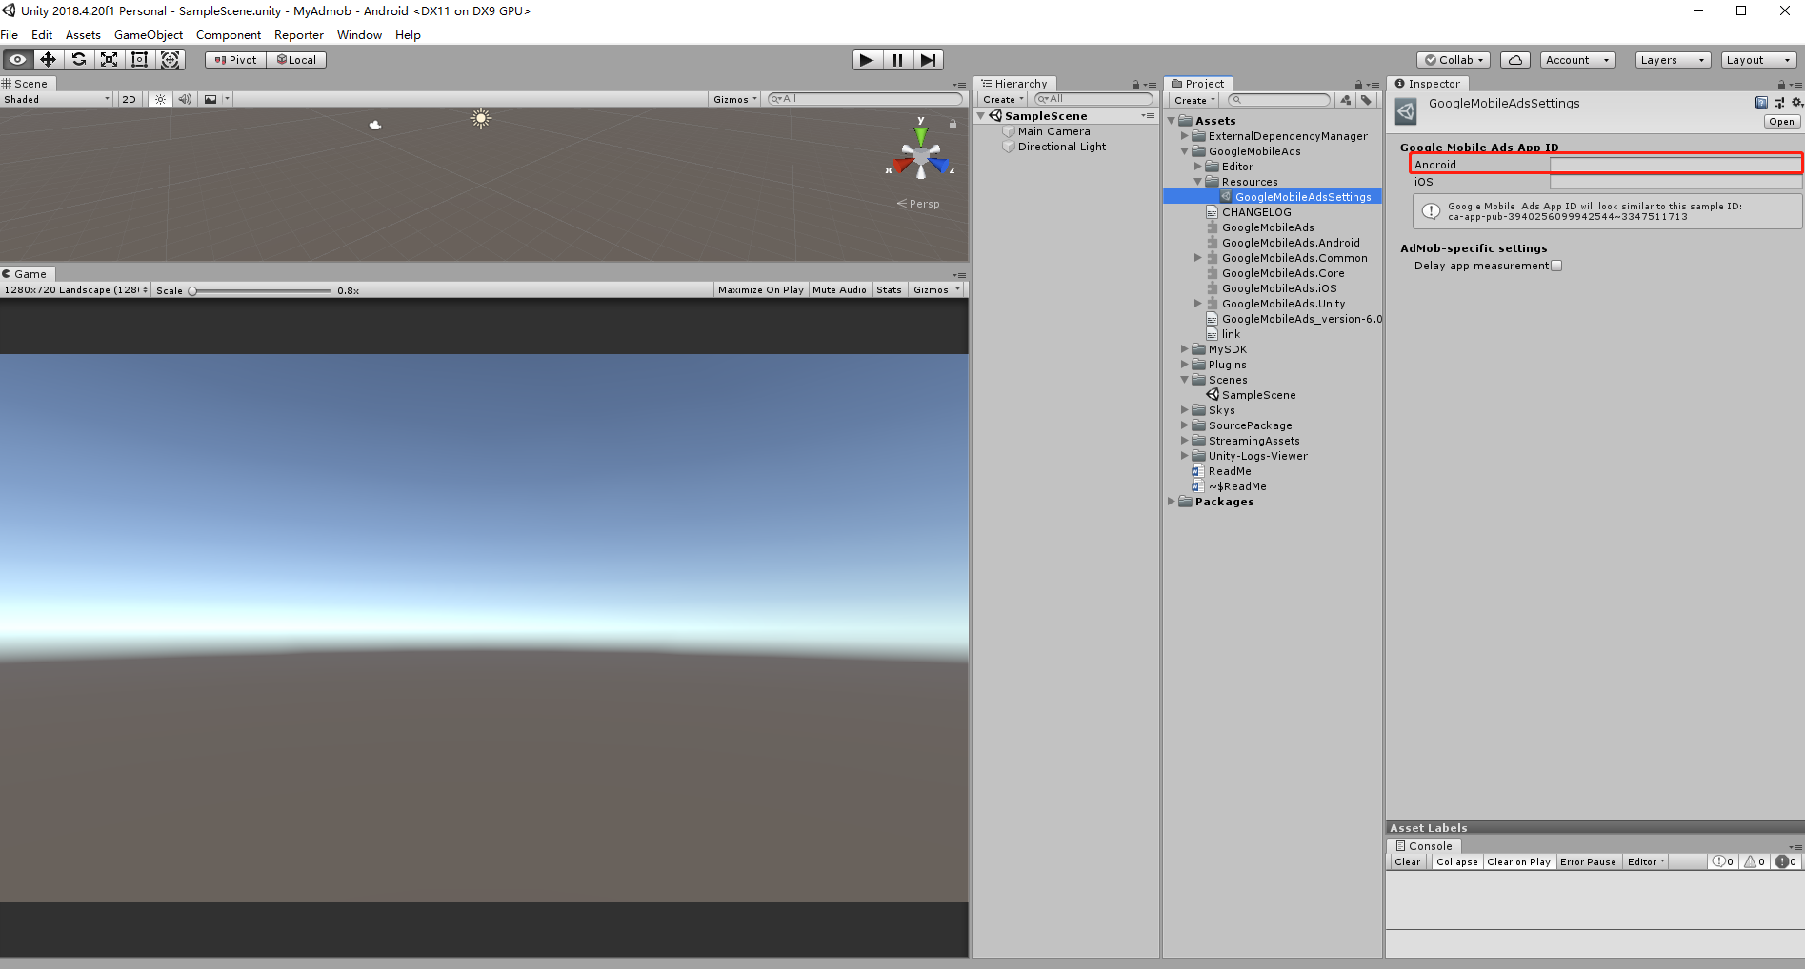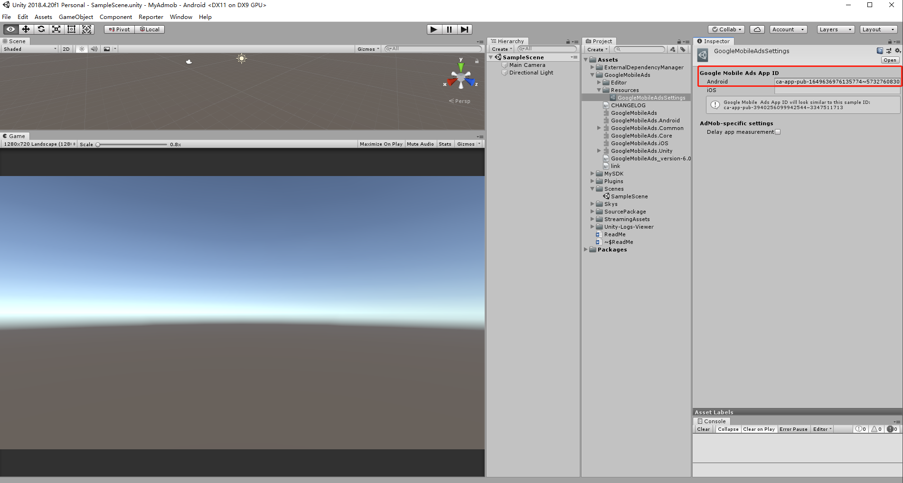

### **3.3打包(Andriod):两种模式都可以**

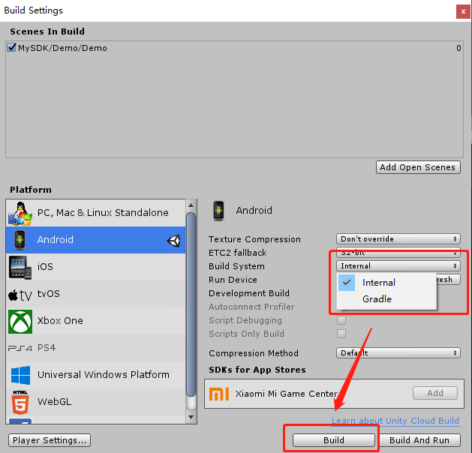 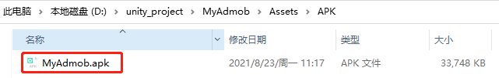

## 3.测试运行(逍遥安卓虚拟机)

<https://developers.google.com/admob/unity/test-ads>

<https://www.xyaz.cn/>

### 3.1需要安装一个**Go安装器**

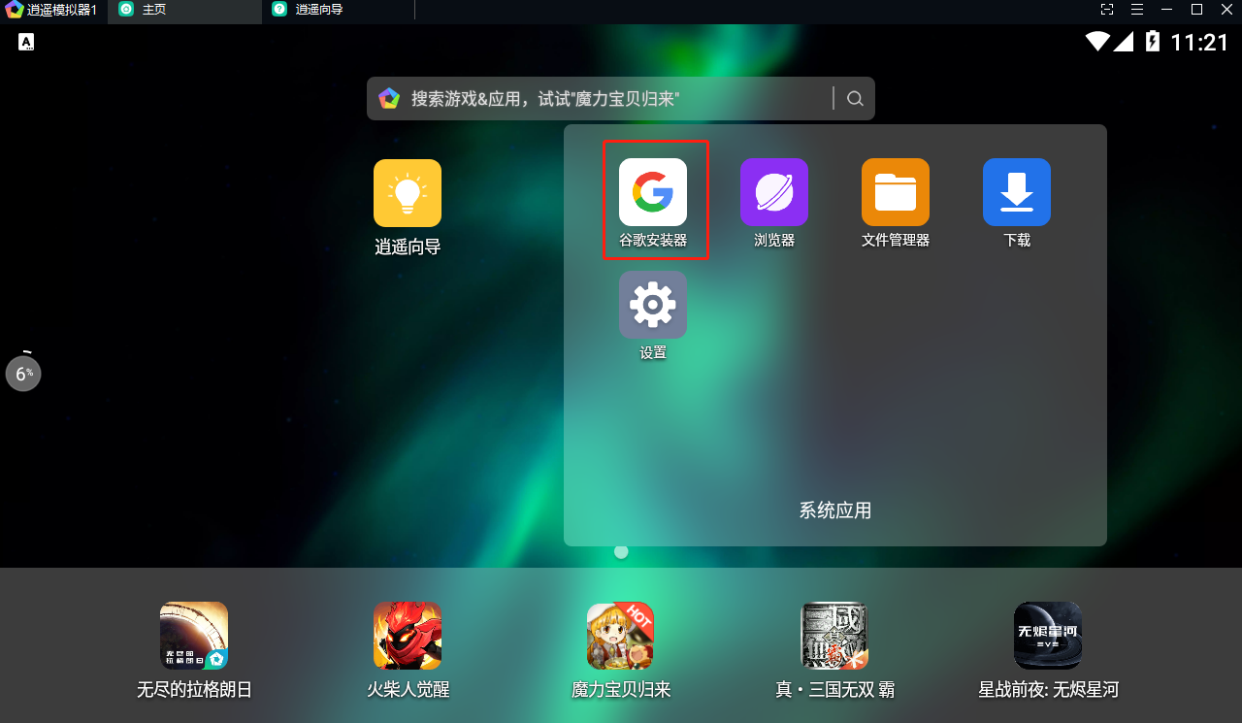 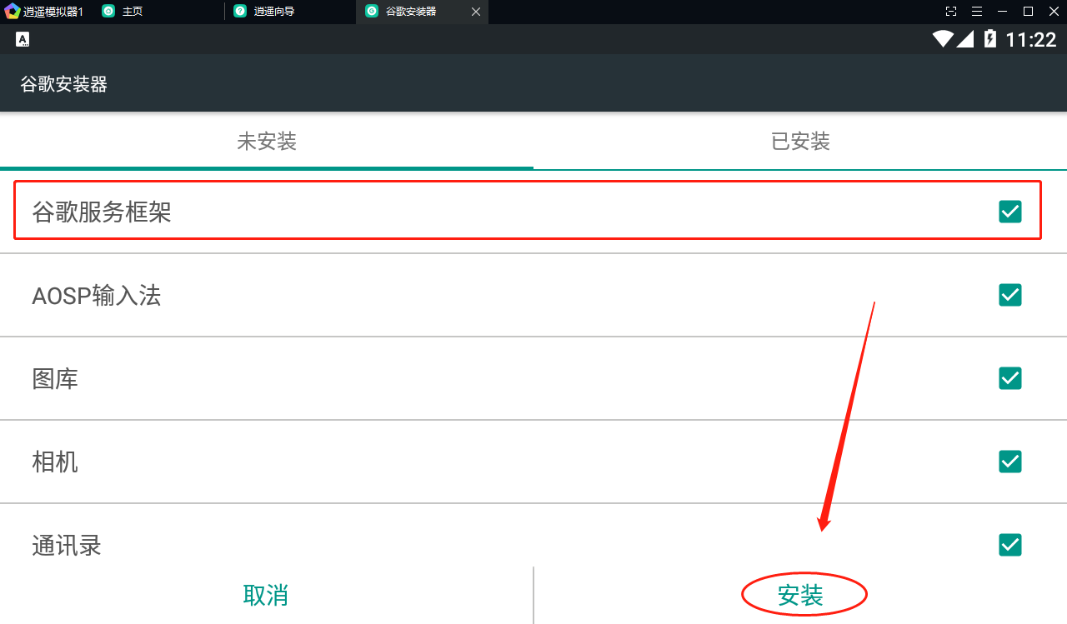

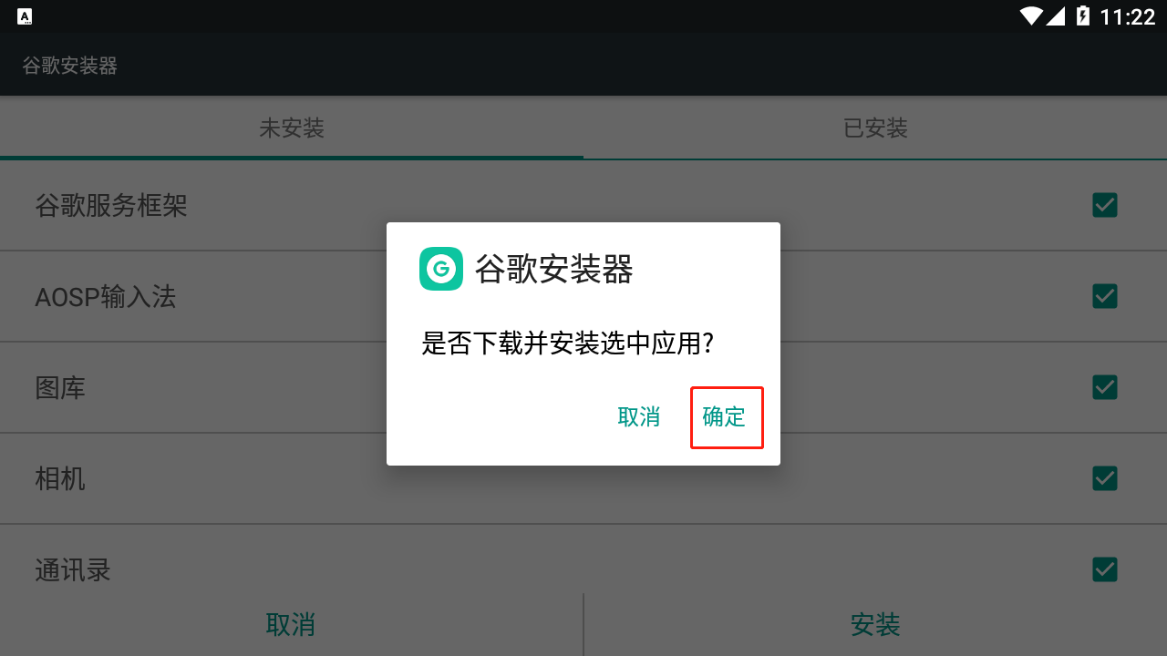 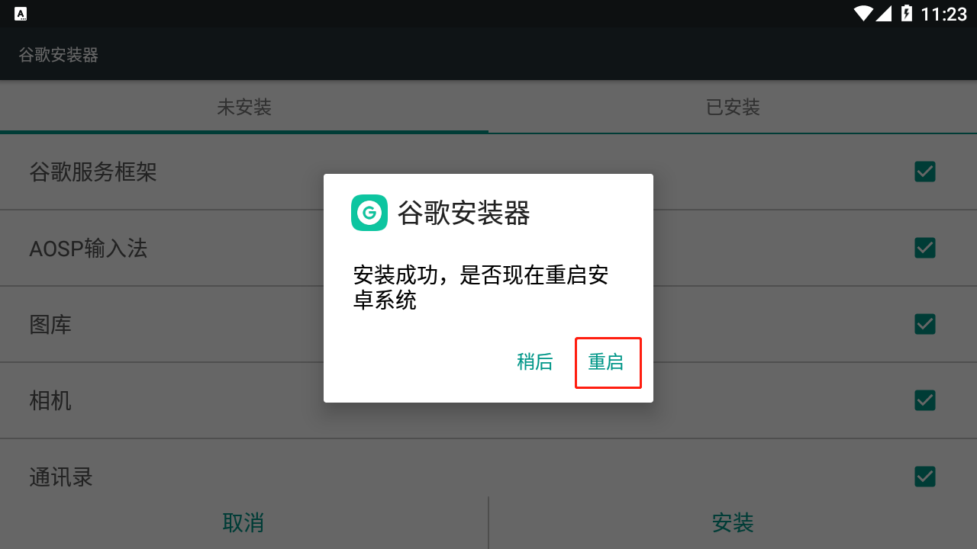

### 3.2 运行APK:出现测试广告证明成功!!!

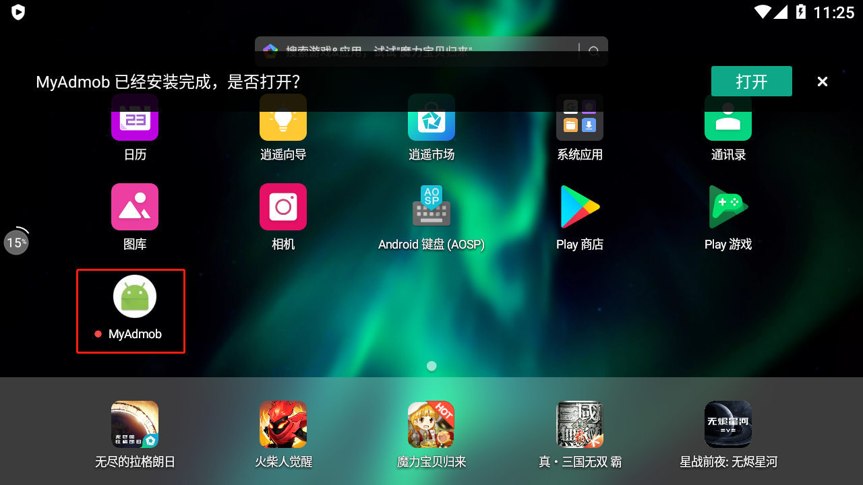 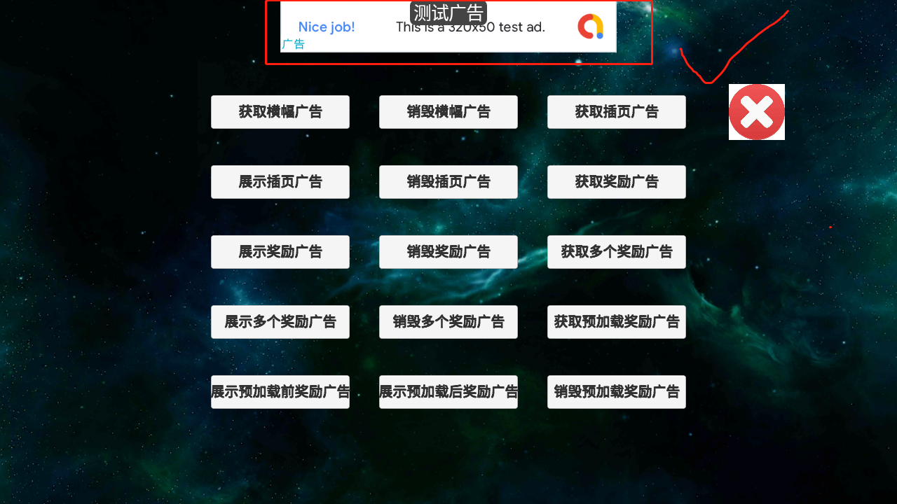

## 4.其他问题:

### 4.1获取谷歌测试设备id

https://developers.google.com/admob/unity/test-ads

|  |
| --- |
| **可以通过逍遥安卓模拟器来实现测试**  <https://www.xyaz.cn/>  https://www.cnblogs.com/kanekiken/p/9527697.html |

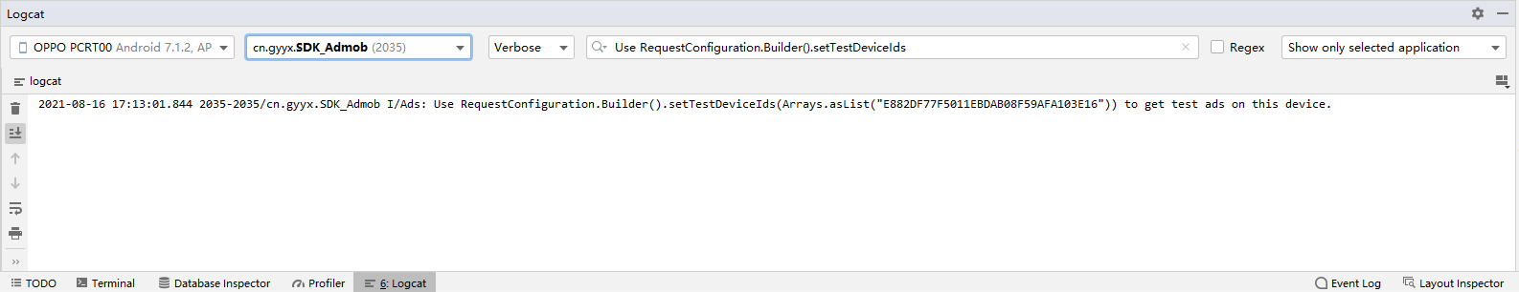

|  |
| --- |
| **2021-08-16 17:14:13.574 2035-2035/cn.gyyx.SDK_Admob I/Ads: Use RequestConfiguration.Builder().setTestDeviceIds(Arrays.asList("E882DF77F5011EBDAB08F59AFA103E16")) to get test ads on this device.** |

### 4.2 Cannot fit requested classes in a single Dex file methods: 67335 > 65536 ?

**Unity2018/Unity2019解决方案:**

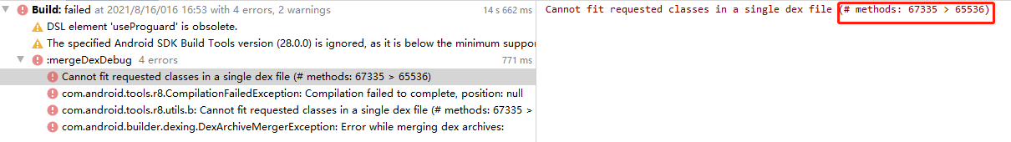

<https://www.cnblogs.com/whycxb/p/9792192.html>

|  |
| --- |
| multiDexEnabled true    implementation(**name**: **'androidx.multidex.multidex-2.0.1'**, **ext**:**'aar'**) |
| 特别:如果**multidex**已经存在,则不需要引入**multidex,只加**multiDexEnabled true |

### 4.3 Google Admob错误码对照表:

https://blog.csdn.net/sxk874890728/article/details/88949720

|  |  |  |
| --- | --- | --- |
| 0 | ERROR_CODE_INTERNAL_ERROR | 内部错误 |
| 1 | ERROR_CODE_INVALID_REQUEST | 无效的请求 |
| 2 | ERROR_CODE_NETWORK_ERROR | 网络错误 |
| 3 | ERROR_CODE_NO_FILL | 广告无填充 |

### 4.4 unity接入admob会报manifest错误:

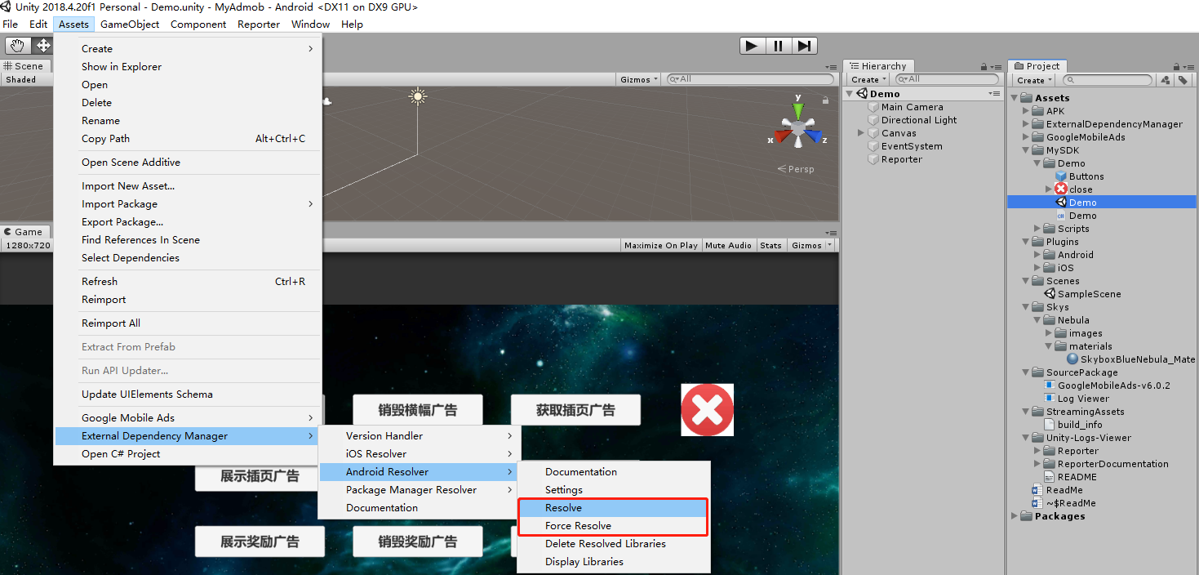

**此时可按图执行**

1. **Assets/External Dependency Manager/Andriod Resolver/Resolve**
2. **Assets/External Dependency Manager/Andriod Resolver/Force Resolve**

**重新处理manifest兼容问题**

### 4.5 Admob常见问题:

<https://support.google.com/admob/answer/9905175>

### 4.6 Admob中介广告联盟:

<https://developers.google.com/admob/unity/mediate>

中介广告测试套件:

<https://developers.google.com/admob/unity/mediation-test-suite>