GoogleAdmob引入流程

接入背景:

二选一:
看doc或者直接导入MyAdmob.unitypackage
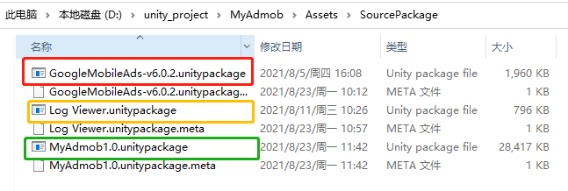
Unity2018.4.20f1以上
GoogleMobileAds-v6.0.2.unitypackage
Andriod 19 API以上
https://developers.google.com/admob/unity/quick-start

导入unitypackage包
必选插件:GoogleMobileAds-v6.0.2.unitypackage
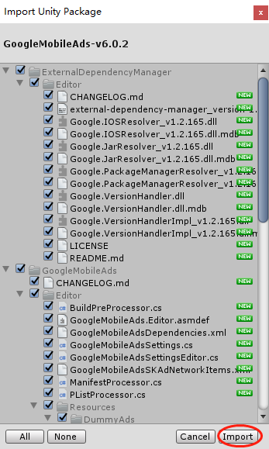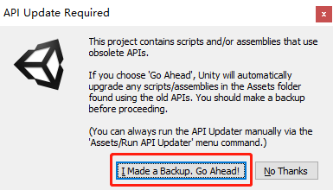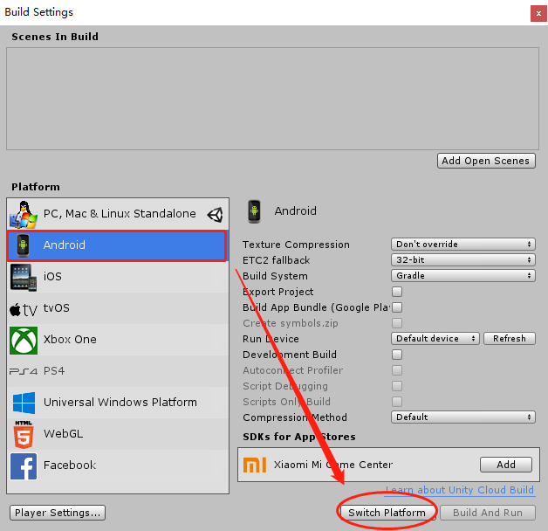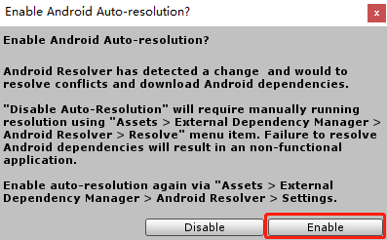
可选日志包(LogViewer): Log Viewer.unitypackage
https://blog.csdn.net/YuAnHandSome/article/details/102624296

运行Admob(配置打包)

2.1主要Demo场景:Assets/MySDK/Demo.scene
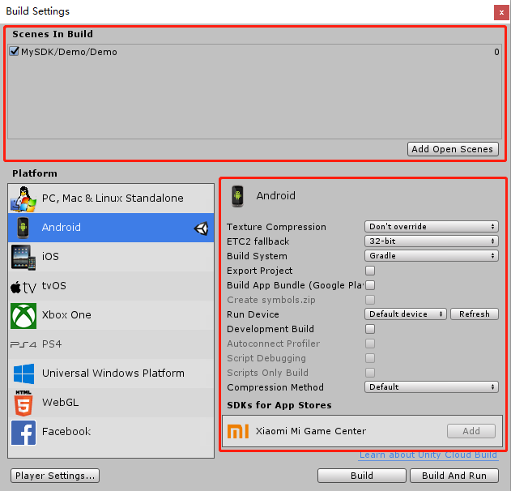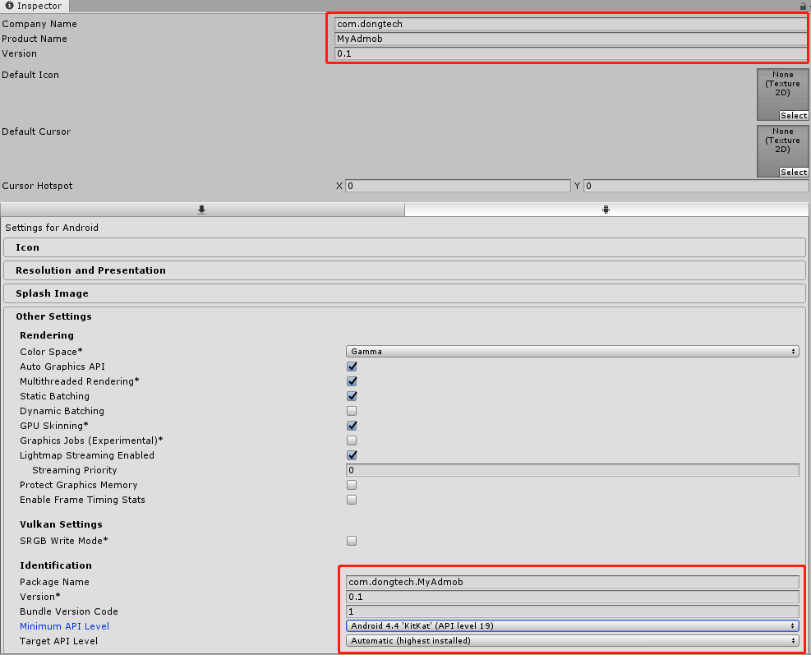

2.2配置GoogleAdmob:
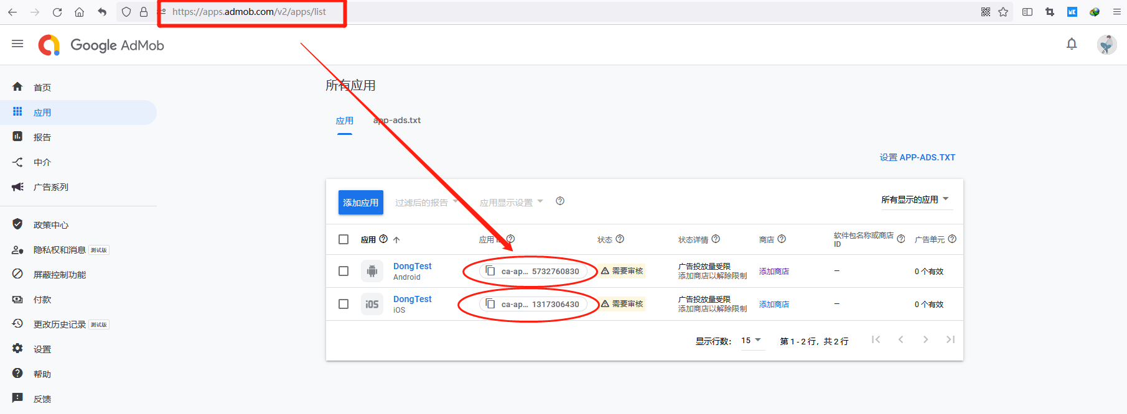
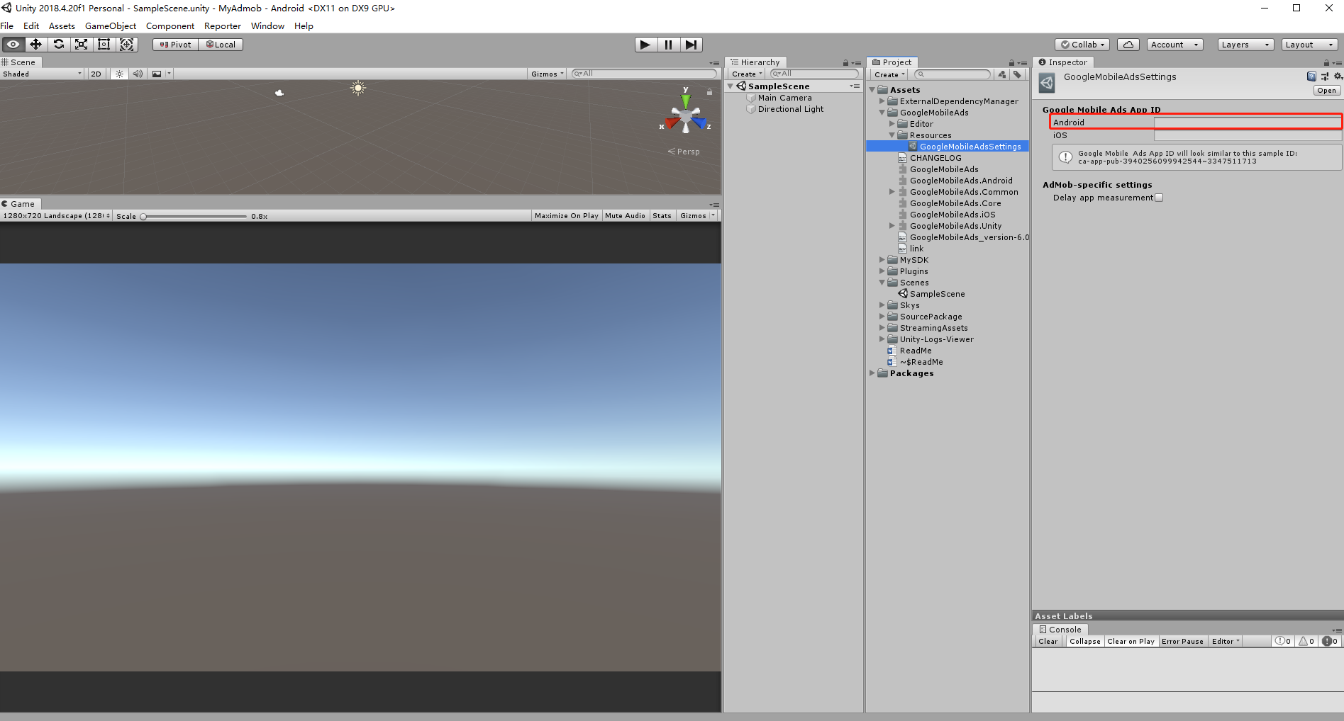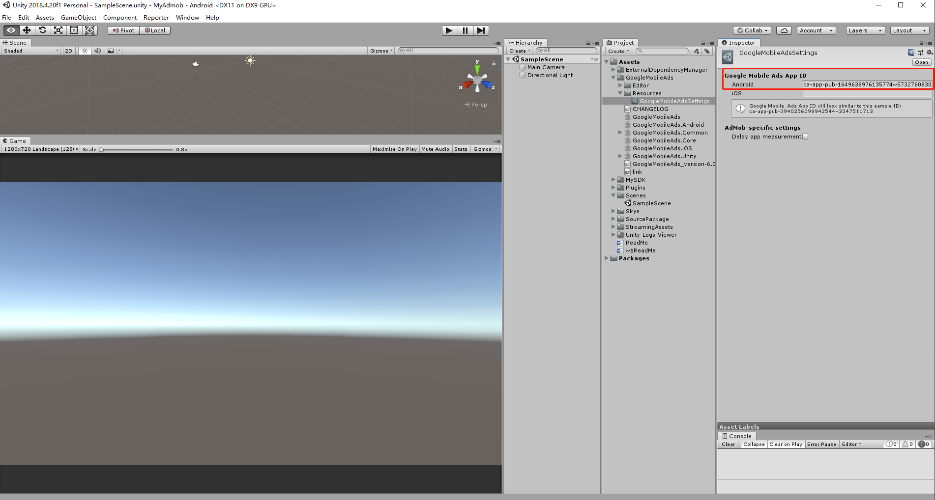

3.3打包(Andriod):两种模式都可以
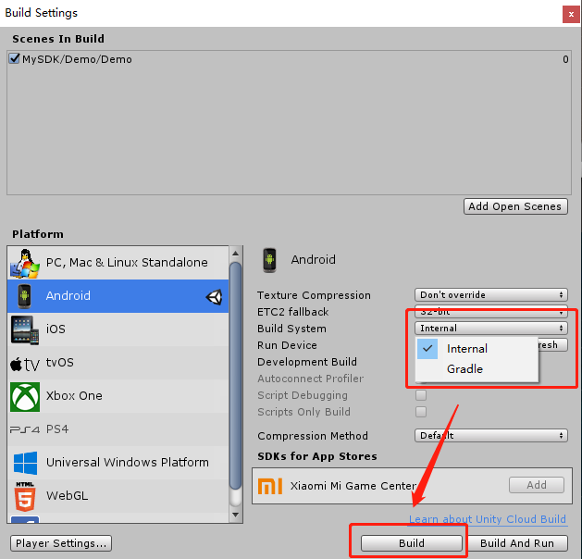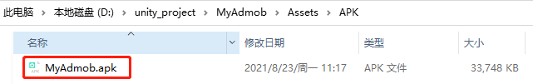

3.测试运行(逍遥安卓虚拟机)
https://developers.google.com/admob/unity/test-ads
https://www.xyaz.cn/

3.1需要安装一个Go安装器
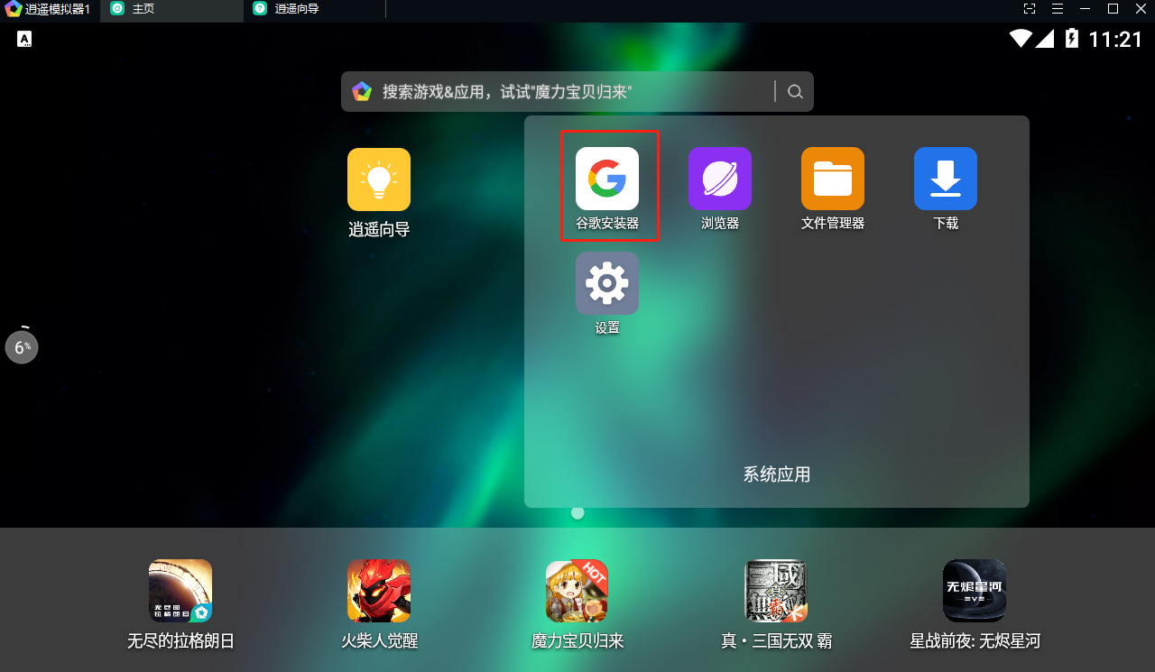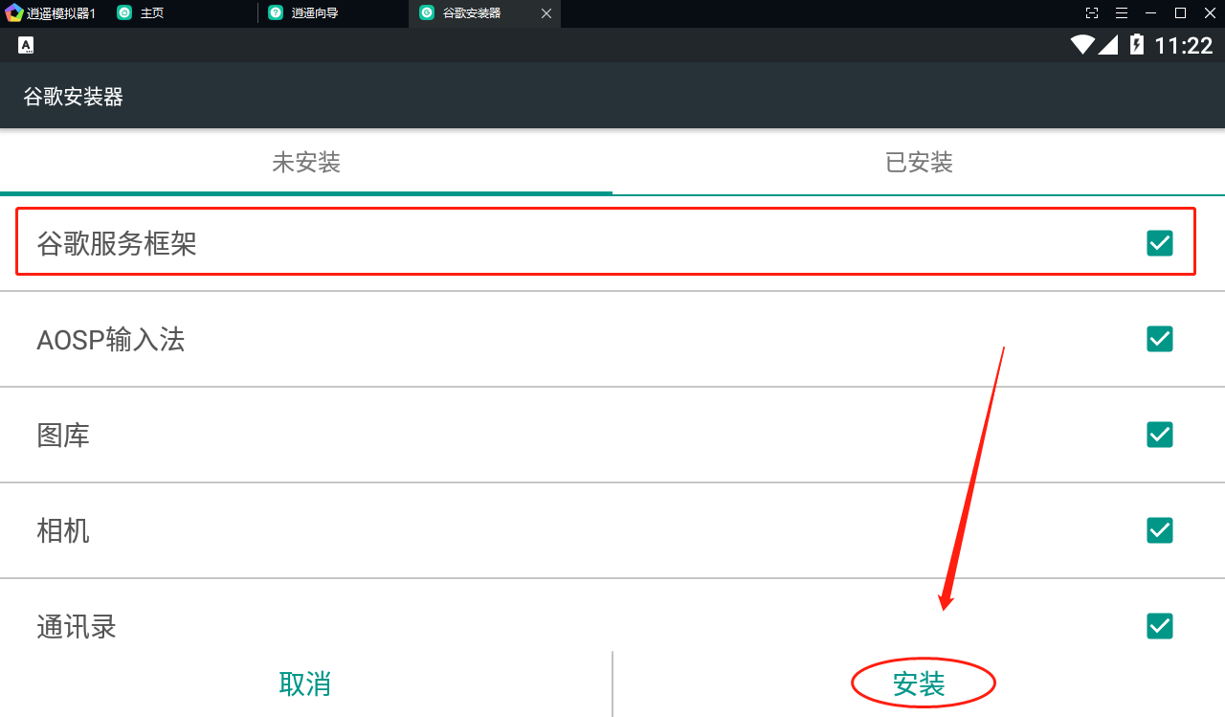
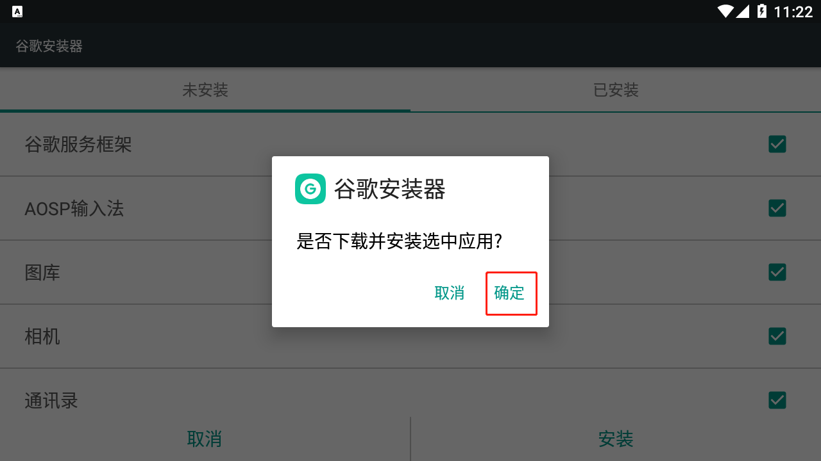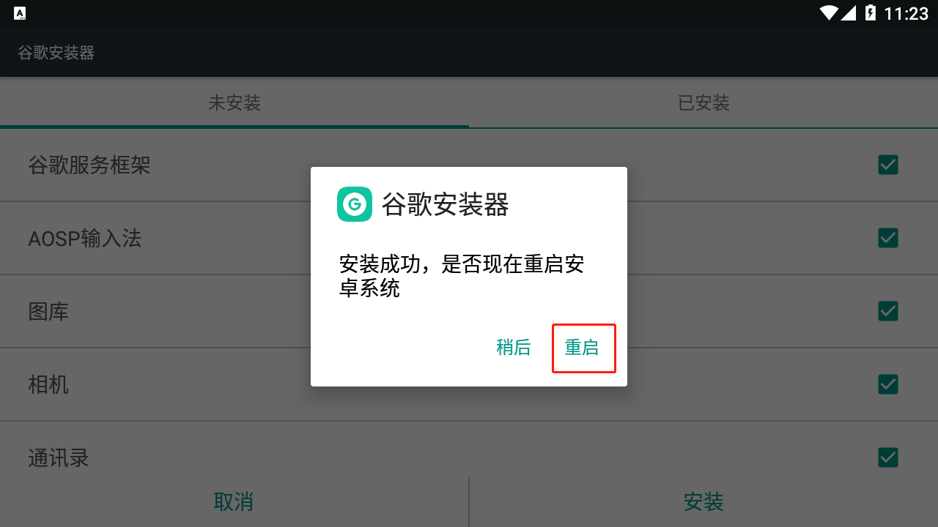

3.2 运行APK:出现测试广告证明成功!!!
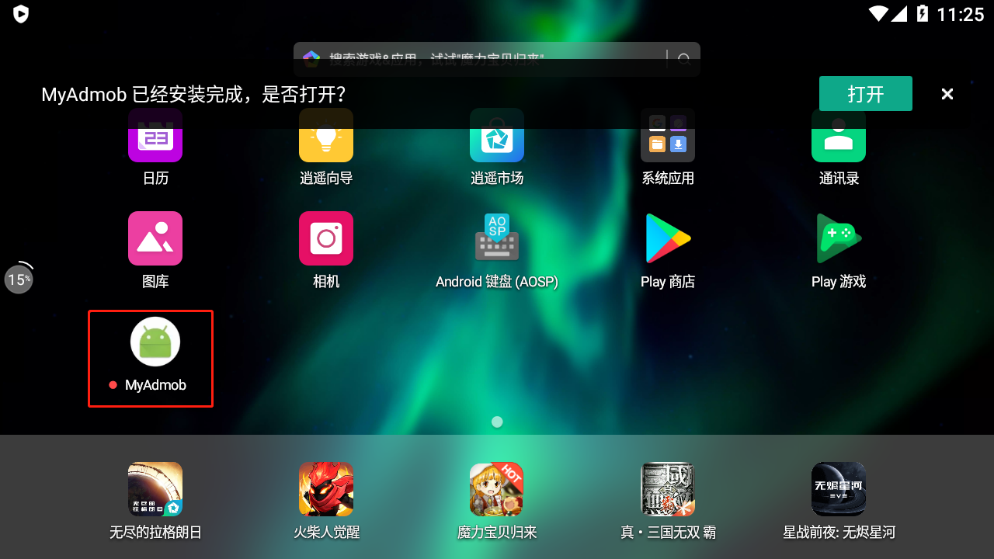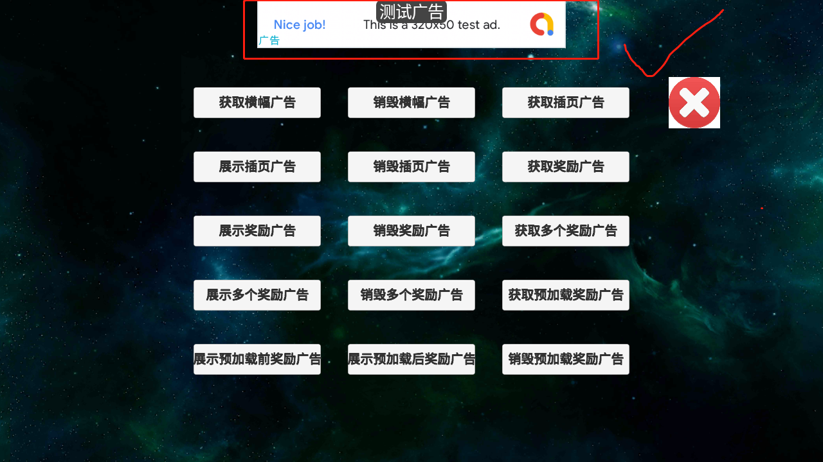

4.其他问题:

4.1获取谷歌测试设备id
https://developers.google.com/admob/unity/test-ads
可以通过逍遥安卓模拟器来实现测试
https://www.xyaz.cn/
https://www.cnblogs.com/kanekiken/p/9527697.html
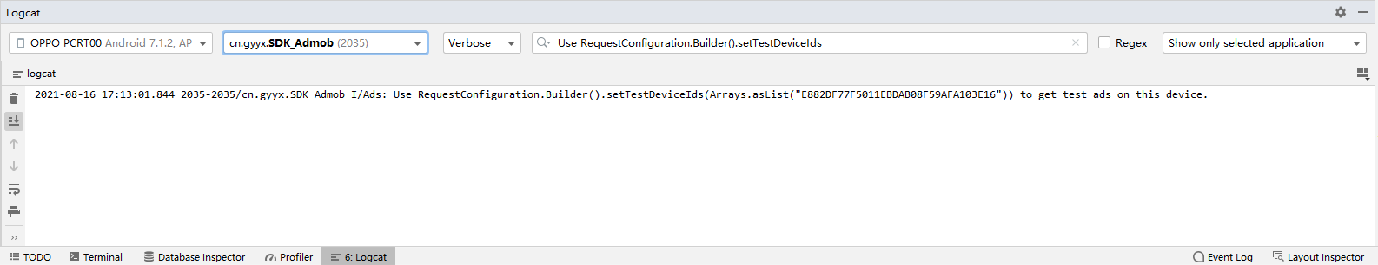
2021-08-16 17:14:13.574 2035-2035/cn.gyyx.SDK_Admob I/Ads: Use RequestConfiguration.Builder().setTestDeviceIds(Arrays.asList("E882DF77F5011EBDAB08F59AFA103E16")) to get test ads on this device.

4.2 Cannot fit requested classes in a single Dex file methods: 67335 > 65536 ?
Unity2018/Unity2019解决方案:
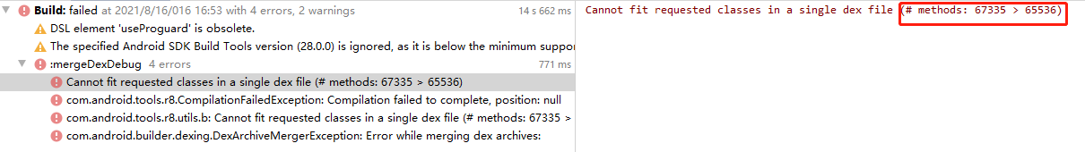
https://www.cnblogs.com/whycxb/p/9792192.html
multiDexEnabled true

implementation(name: 'androidx.multidex.multidex-2.0.1', ext:'aar')
特别:如果multidex已经存在,则不需要引入multidex,只加multiDexEnabled true

4.3 Google Admob错误码对照表:
https://blog.csdn.net/sxk874890728/article/details/88949720
0 | ERROR_CODE_INTERNAL_ERROR | 内部错误
1 | ERROR_CODE_INVALID_REQUEST | 无效的请求
2 | ERROR_CODE_NETWORK_ERROR | 网络错误
3 | ERROR_CODE_NO_FILL | 广告无填充

4.4 unity接入admob会报manifest错误:
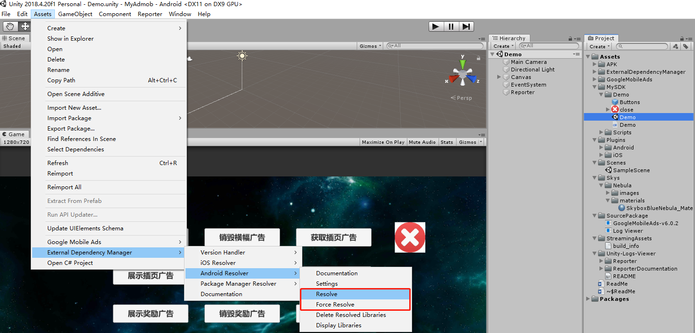
此时可按图执行
- Assets/External Dependency Manager/Andriod Resolver/Resolve
- Assets/External Dependency Manager/Andriod Resolver/Force Resolve
重新处理manifest兼容问题

4.5 Admob常见问题:
https://support.google.com/admob/answer/9905175

4.6 Admob中介广告联盟:
https://developers.google.com/admob/unity/mediate

中介广告测试套件:
https://developers.google.com/admob/unity/mediation-test-suite

