**Sangyun Lee**

**Cs325**

**Q1**

1. **The shortest path from A to G is 19 (a – f – e – g = 10 + 2 +7)**

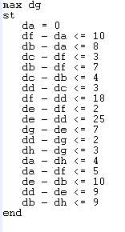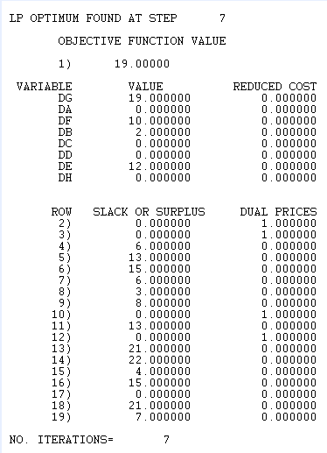

1. **Shortest path a to all other vertices (since we found the shortest path to g above, so I didn’t include here)**

**(**the sum of the shortest distances method**)**

**From A**

* **To a = 0 / To b = 8 / To c = 12 / To d = 15 / To e = 12 / To f = 10 / To h = 22**

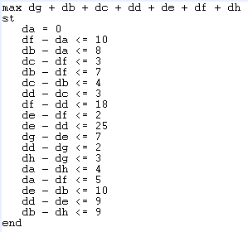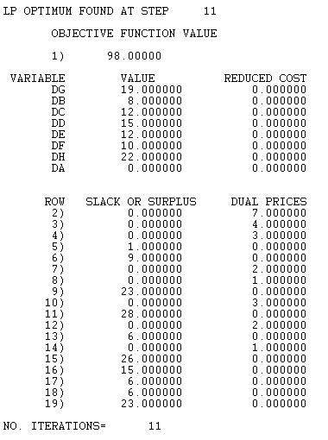

(Individually computed way)

-from A to A = 0

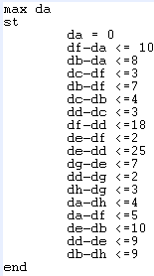 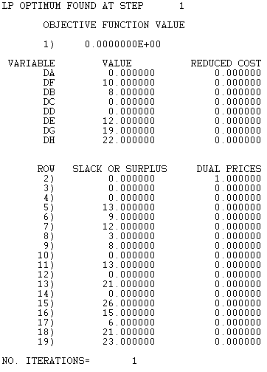

-from A to B = 8

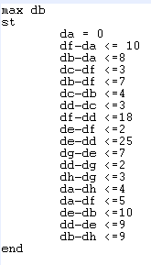 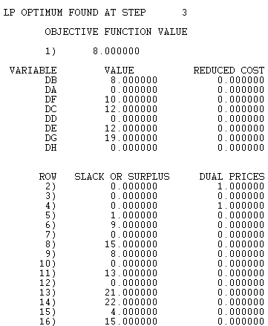

-From A to C = 12

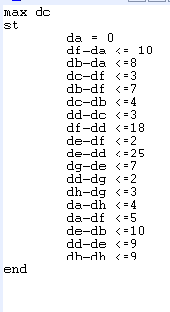 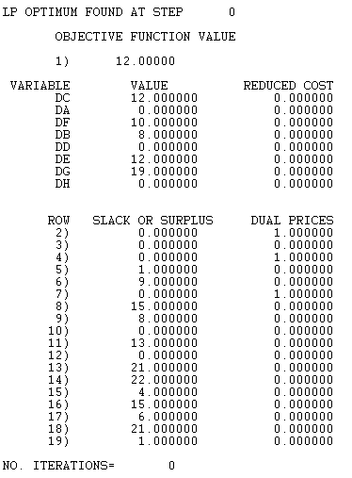

-From A to D = 15

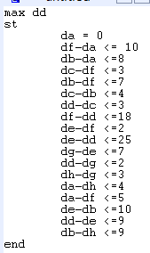 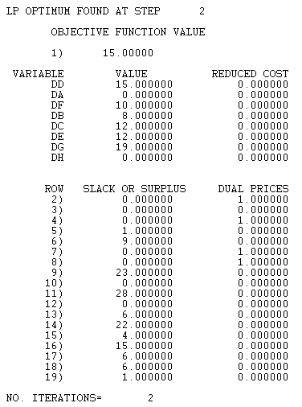

-From A to E = 12

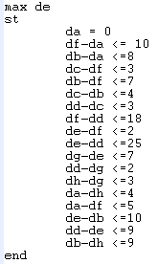 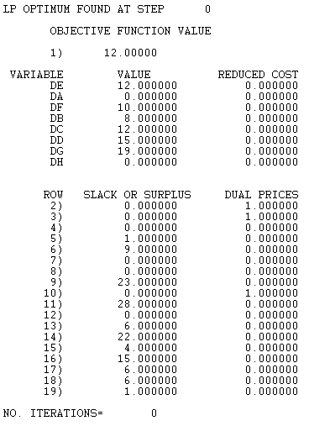

-From A to F = 10

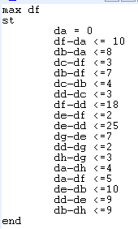 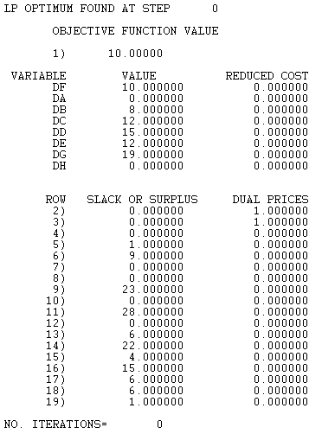

From A to H = 22

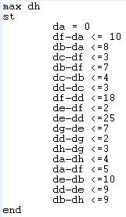 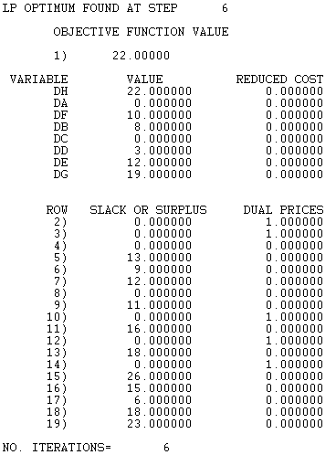

**Q2**

-Linear program code

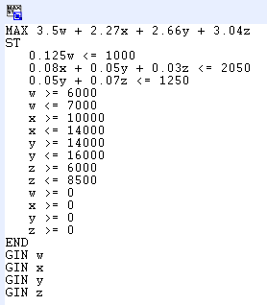

-Output

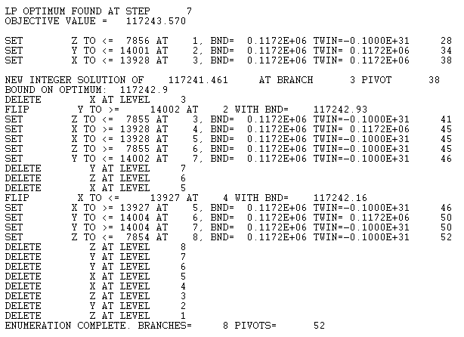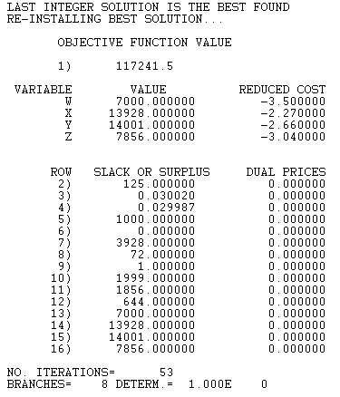

-Answer: in order to maximize the profit, *this company should produce 7000 of silk ties, 13928 of polyester ties, 14001 of blend 1 ties, and 7856 blend2 ties.*

**Q3**

1. Linear program code & output

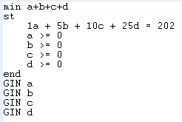

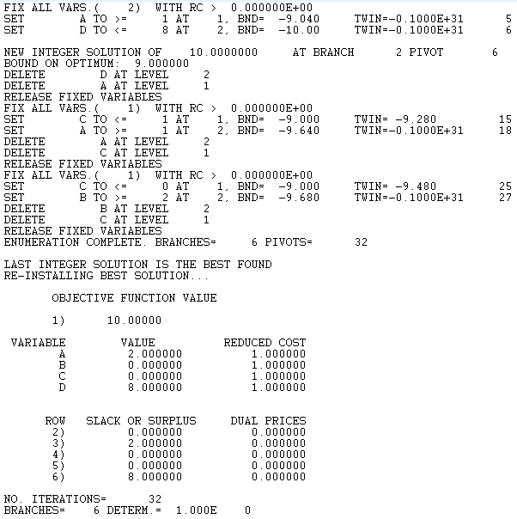

In order to minimize the number of coin used for the amount of 202: *you can include 8 of D-coin (25) and 2 of A-coin (1).*

1. Linear program code & output

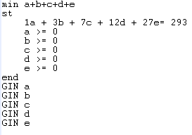

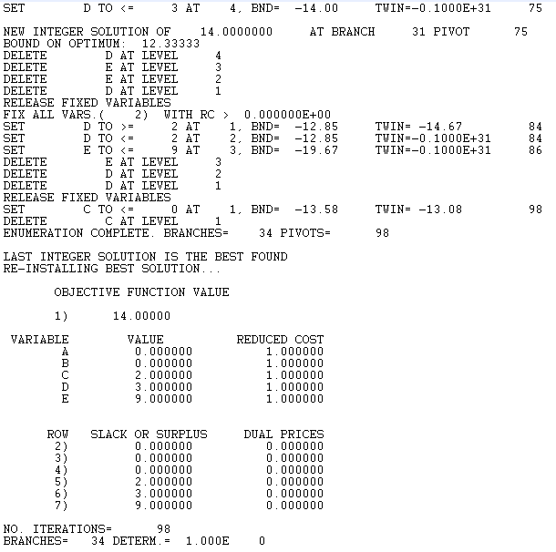

In order to minimize the number of coin used for the amount of 293: you can *include 9 of E-coin (27), 3 of D-coin (12), and 2 of C-coin (7).*

**Q4**

first, make the formula to standard form, and then make it to slack form

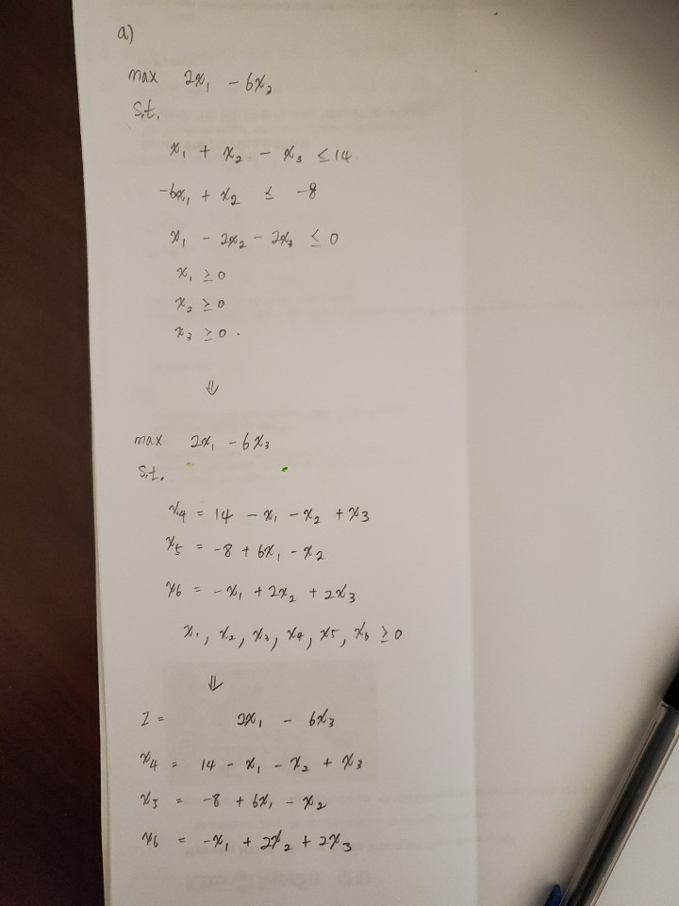

1. Since the left-hand side of equality is basic variable, x4, x5, x6 are basic variables. And right-hand side of equality is nonbasic variable, x1, x2, x3 are nonbasic variables