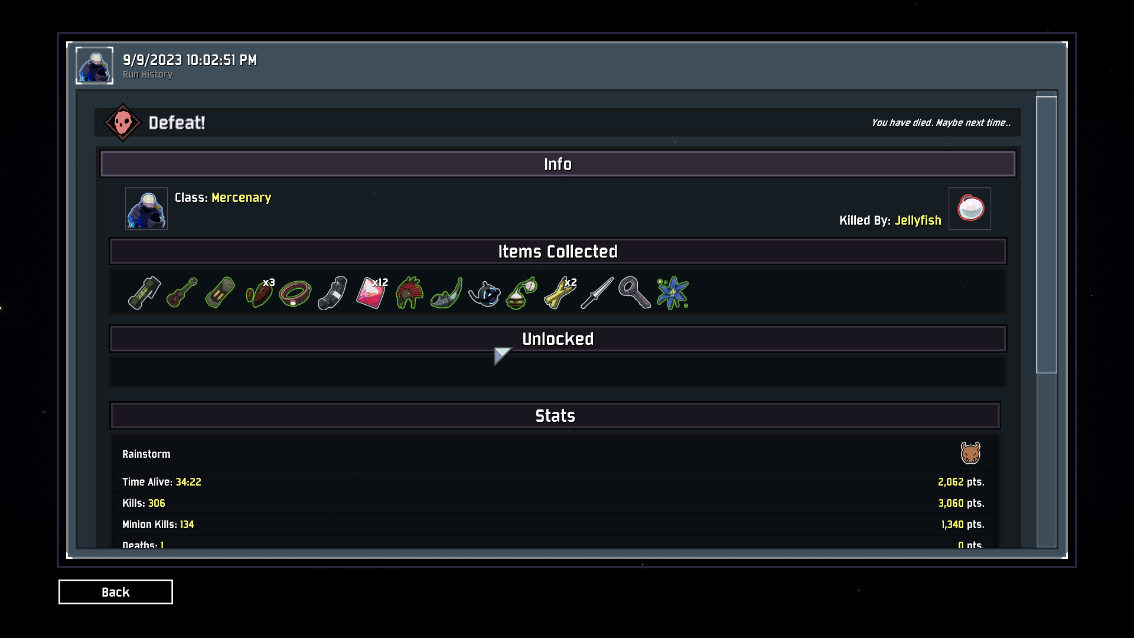

Risk of rain 2 is alot better than risk of rain 1. The change from 3d to 2d helped the game greatly as the game feels more chaotic but less cluttered. In 2d the game felt too cluttered as there would be multiple enemies on one platform. 3d helped add more dimension and depth to the gameplay and made the swarms feel realistic unlike 2d where 20 enemies would clip into one space.

I would pitch risk of rain 2 as a replayable action packed shooter as the gameplay is really fun and replayable. It differs in that added sense of depth to the worlds as it breaks the chains of only being able to move left and right. You feel more free in a sense as you can dodge attacks by many ways.

Honestly the game is perfect as it is, the characters and enemies feel well balanced and theres somewhat of a challenge even if you get alot of items. However I feel like the main problem is that the runs feel too rng on whether you will be doing good or not. From wishing you get the right items to hoping the level has certain printers, the game feels too rng focused like risk of rain 1. Additionally the game also struggles with add more challenges if you do get the right items. For example with enough backup magazines any character can be amazing and that is just one of the many good items. Just getting one hardlight afterburner can make your character so much more powerful than before. At a certain point it just comes down to if you are able to get certain good items and if you do get them you easily go through the levels. The final boss is challenging but with the right items it becomes pretty easy. For me atleast I wish there was more harder levels or bosses but with a progression where you can choose the items you get. So thus the difficulty scales more but you can make your character more better as you can choose which items to boost your character.

2 potential game ideas:

* One idea is a game similar to risk of rain 2 but you can design your own characters. Your charcater could start off as a robot/human/angel/whatever, and you can add special perks to your character. Finally you can choose a weapon for your characters. To make your character stronger doe you must find items that could make your character strong and you can also level up your character. A feature that I wish to add is that after every certain amount of levels, you can edit your dna/programming/whaetver to add perks or improve existing ones. This way you can create a character while the difficult scales to match your level. However I do want to make the game challenging so the best way is to make the bosses more dark souls like. Instead of a giant monster that does slow damage I can make the bosses more of a dodge/block then attack cycle where your perks/weapons really matter.
* Another idea for a game idea could be similar to the one i proposed earlier but purley based on robots. You start off a a simple droid with little programming but you can change your programming along as you play. I want the player to feel as in control as possible so you can edit your robot’s systems at any time. The only exception is that the robot will need to reboot to prcoess the changes. However I want to make the game enjoyable to all people so “programming the robot” will be more like designing its attacks via a custom tool tab, and its movement pallet. Weapons will require you to make changes and I will add the option to save robots’s coding so you do not have to repogram the robot every time. Essentially this game will be mainly be about designing a combat robot and then putting it to the test in a risk of rain 2 type games where you can find items and fight bosses.