**Quiz Quest Game Environmental Scenario**

**Group 8 - Jonathon Repta, Amal Syed, Edward Liang, Jennifer Alonso**

*Quiz Quest* is a location based game that inspires players to explore and learn about various new locations through engaging quizzes and community oriented features. *Quiz Quest* engages players of all ages by providing a wide variety of question difficulties. Players will be incentivized to explore and complete as many quizzes as possible through a robust ranking/leaderboard system. This scenario briefly covers what happens when a new player first opens the game and explores an environment.

**Scenario: Quiz Quest Game Environment**

Upon opening the application, the user will have the option of either playing as a guest or creating an account. If the new player decides to create an account, the player will need to make a sign up by creating a username and password. Returning players will be able to login and have all of their information automatically retrieved from the database.

Once inside the game, the user will be able to see a map and their current location. The game will utilize GPS apis so that the player’s location is accurately reported. There will be pre-specified quiz locations on the map GUI that the player can preview. Within a certain radius of the quiz location, the game will offer interesting facts about the destination and display available quizzes to the player for a quiz. If the player selects said test, they will be able to take the test and challenge their skills.

If a question is answered correctly, the player will gain a certain amount of points and this will be added to their overall score/experience. Once a player is done with a given quiz, they can either choose a different site to visit or stay and learn more about the site through more challenging questions.

There will be a “**Quiz History**” in the menu for which will show all of the previous quizzes taken so players can review without being physically there. They can return back to the map screen when pressing the “**X**” button.

When the players want to leave the game, they can go to the menu and click **EXIT**. All updated information regarding the players points, past quizzes, leaderboard ranking, etc will be stored and accessible when the user returns.

We will use a relational database to store information about users, questions, locations, and so on. There will be at least four tables - one for users, one for questions, one for answers (so as to allow questions to have a variable number of answers), and one for keeping track of which quizzes a user has already completed so as to prevent them from seeing duplicates. The following figure shows the database’s design.

**Database Diagram[1]:**

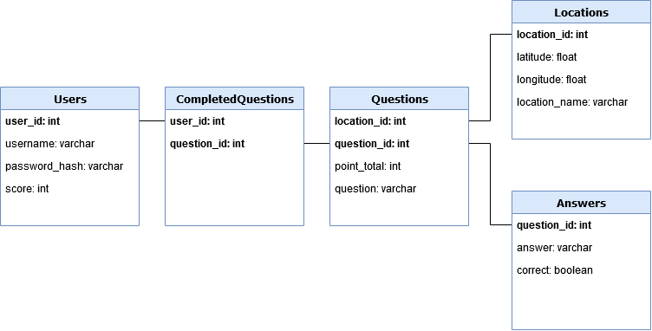

**UI mockup:**

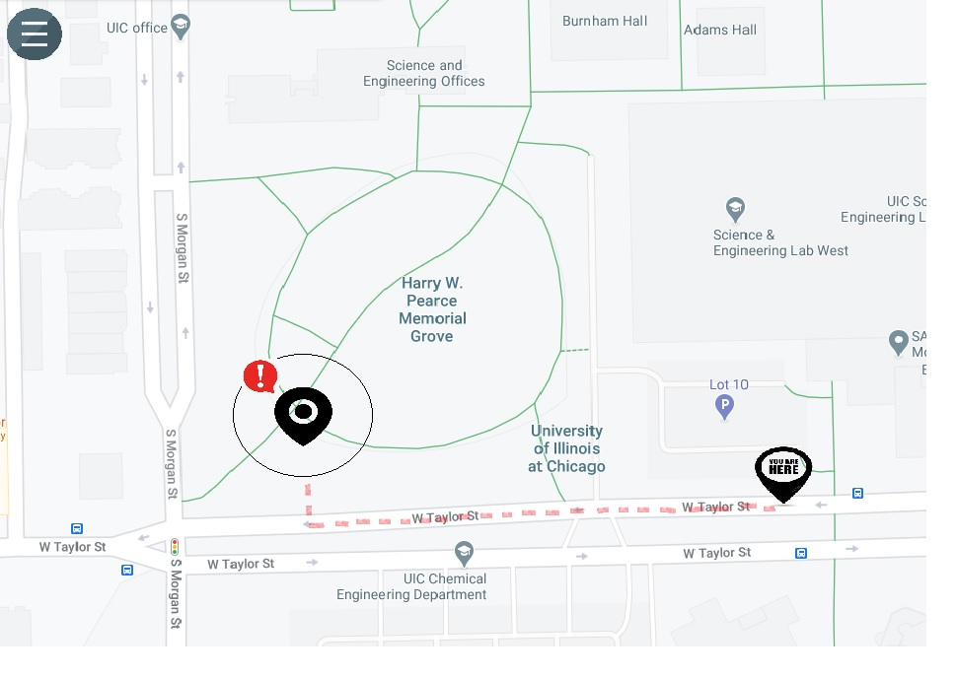

1. Database implementation subject to change