**QuizQuest: 2nd Environmental Scenario**

**Group 8 - Jonathon Repta, Amal Syed, Edward Liang, Jennifer Alonso**

*QuizQuest* is a location-based game that inspires players to explore and learn about various locations through engaging quizzes and community oriented features. *QuizQuest* engages players of all ages by providing a wide variety of question difficulties. Players are incentivized to explore and complete as many quizzes as possible through a robust ranking/leaderboard system.

In addition, individual users will be able to submit their own locations and create associated quizzes, questions, and answers. Once submitted, these quizzes will be reviewed by moderators of the site and either approved or denied entry into the list of available quizzes for all users.

**Scenario: Quiz Quest Game Environment**

When the player enters the website, they can choose to play either as a guest or to sign-in/signup. If the player chooses to play as a guests, they will be directed to the map and immediately be able start taking quizzes. If they choose to sign up, they will be prompted for a username and password so that their account information can be saved. If they are a returning player, they can use their username and password to sign in and gain access to all of their account information.

The basic requirement of this game is a stable internet and a computer. As long as the user/guest can remain connected to the internet, the map will track their location and report the nearest quiz sites. Once the player is in the vicinity of a quiz location, players can start the quiz right away or choose to read a brief passage about the location. Every question within the quiz is assigned an appropriate point total in regards to its relative difficulty. Accumulating enough points will grant the player a spot in the leaderboard. Once a quiz has been completed, it will be marked as “completed” for the user, however the user may retake it as many times as they please. To preserve the integrity of the leaderboard, the initial score received by the player for a given quiz is the score that will count towards their overall ranking. This challenges the players to take the quiz seriously and removes the ability for them to game their way to the top of the leaderboard.

In addition to being able to select from a list of premade quizzes, every user will be able to create their own quizzes and submit them for approval for use on the site. Users will be given the freedom to write quizzes for nearly any location of their choosing. However, there will be a strict verification process for the quizzes to maintain a high quality selection of quizzes. To submit a quiz, the player needs provide all the necessary information, including but not limited to: location coordinates, an image of the location, a quiz description, and at least five questions for the quiz. Users will be able to assign a preset amount of points as they see fit and write as many questions for the quiz as they like. Once the user submits a quiz for approval, the final step will be the verification process from the moderators.

To this end, there will be a special type of account called a moderator account. Moderators will have special rights that will allow them to review and approve pending quizzes/questions from a dedicated GUI. When a user submits a quiz, it will be stored apart from regular questions, and instead be in tables specifically for pending locations, quizzes, questions, and answers. If a given quiz is approved, said quiz will be moved to the regular table, and other users will be able to access the newly approved quiz. If the quiz is rejected, said quiz will be removed from the pending tables and the moderator will no longer see them on the ‘user submitted quizzes’ page. Having an easy to navigate GUI will allow moderators to easily curate quizzes without needing to understand the underlying database schema.

To logout the user can simply close the tab that *QuizQuest* resides in or select to logout from a dropdown manually. Their information will automatically be saved in the database regardless of which option they choose. Upon their next log in, all their information (past quizzes, points, leaderboard ranking) will be accessible.

**ER diagram for the database[1]**

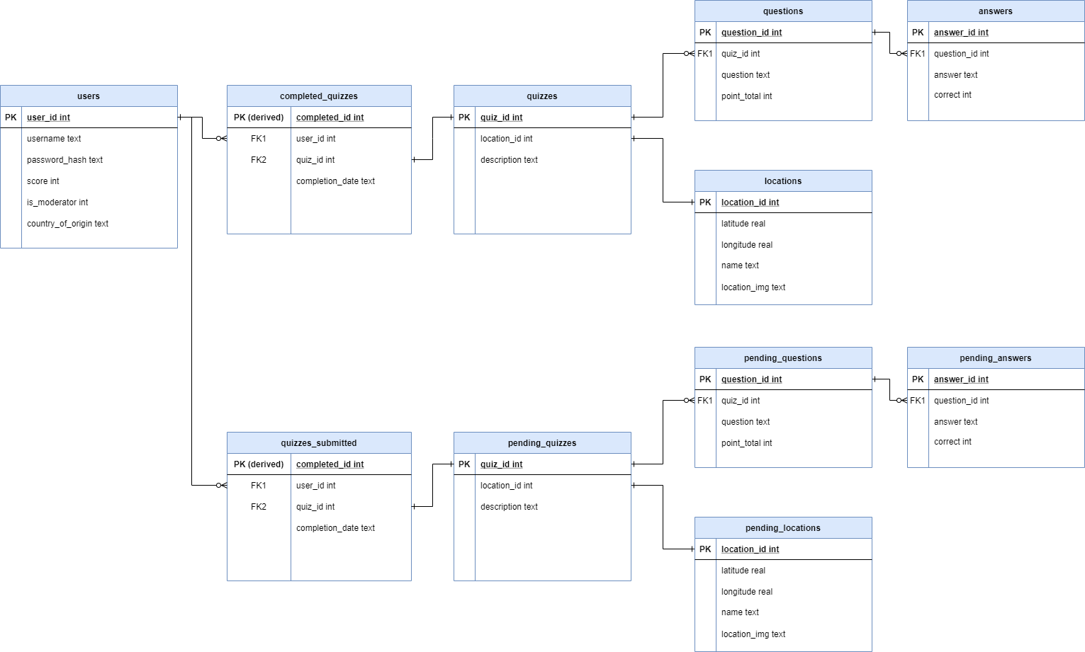

1. Implementation subject to change