Emotional Distress Drives Adolescent Digital Use Symptom Networks
Jing Zhang¹, Ling Zhang², Xizhe Zhang¹·²*
¹ Nanjing Children's Hospital, Nanjing Medical University, Nanjing, China
² School of Biomedical Engineering and Informatics, Nanjing Medical University, Nanjing, China
* Corresponding author: Xizhe Zhang, Nanjing Children's Hospital and School of Biomedical Engineering and Informatics, Nanjing Medical University, Nanjing, China. Email: zhangxizhe@njmu.edu.cn
Running title: Emotion in adolescent digital use networks

Abstract
Adolescent problematic digital use rarely stands alone; it sits within a broader system of emotional, sleep, diet, activity and behavioral symptoms, and which domain drives system-level change is unclear. In a school-based cohort of 10,356 Chinese adolescents, 6,092 matched across two waves, we combined item-level network control with longitudinal directionality. The baseline 104-node, six-domain network had a compact structural-control core: diet, behavior and emotion items dominated the static topology yet were distinct from the most central symptoms. Over time, emotional distress was the strongest upstream predictor of change across digital use, insomnia, behavior and diet (net directionality +0.249, 95% CI 0.086–0.418), with behavior and activity downstream. A Bayesian directed graph converged independently on the same emotion-outgoing pattern (r = 0.75). The emotional hub held across 147,506 young adults in 240 countries, and a UK cohort reproduced the screen-sink pattern. Emotional distress is the principal temporal driver of these networks.
Keywords: emotional distress; adolescent digital use; symptom network; network control; cross-lagged panel network; Bayesian network

Introduction
Adolescent problematic digital use rarely occurs on its own¹. It clusters with emotional distress, insomnia, disordered eating, physical inactivity and behavioral difficulties, and together these form a broader health-symptom system that is especially pronounced in adolescence^{2–4}. This clustering is usually read in one of two ways: as simple comorbidity, or as a downstream consequence of too much screen time^{5–9}. Both readings leave the key question open — where, within the system, does the upstream influence actually sit? Does problematic digital use organize the later mental-health burden, or does emotional and behavioral dysregulation come first and drive the intensification of digital-use-related symptoms^{10,11}?
The network approach to psychopathology is well suited to this question^{12–15}. Instead of collapsing co-occurring symptoms into a single latent disorder, it treats symptoms and health domains as mutually reinforcing parts of a connected system^{16,17}. The question then shifts from whether digital use correlates with depression, poor sleep or conduct problems to which parts of the network occupy strategic positions — structurally and in time. Centrality analysis answers part of this by flagging the most connected nodes^{18,19}, but high connectivity alone signals neither structural leverage nor temporal priority.
Network control theory adds a further lens by asking which nodes govern the static topology of the system^{20,21}. Minimum-dominating-set and module-control methods pick out small sets of nodes whose neighborhoods cover the whole network, exposing potential structural levers that need not be the highest-strength symptoms²². Applied to adolescent digital-use-related symptoms, this points to a source–relay–sink arrangement spanning diet, behavior, emotional distress, digital use, insomnia and physical activity. What remains unresolved is whether this static control map lines up with the temporal order in which symptoms actually change^{23,24}. A node can rule the instantaneous structure without being the domain that predicts later change elsewhere.
The distinction has practical stakes for adolescent mental health. If digital-use symptoms lead in time, then reducing digital behavior belongs at the center of prevention and intervention. If emotional distress leads instead, problematic digital use is better seen as one expression of a broader affective process, and lasting system-level change would mean targeting emotion²⁹. Telling these possibilities apart requires longitudinal network directionality — not cross-sectional association or static control topology alone²⁵.
Here we bring item-level structural control and longitudinal directional modelling together in one large school-based cohort. We reconstruct a 104-node, six-domain symptom network in 10,356 Chinese adolescents, estimate a cross-lagged panel network in 6,092 individuals matched across two waves about a year apart²⁵, and add a Bayesian directed graph as an independent directional check on the baseline wave. We then test whether the pattern travels: to a 240-country young-adult Global Mind Project sample for cross-cultural triangulation of the emotional hub, and to the UK Millennium Cohort Study for an independent longitudinal test of the internalizing-source and screen-sink anchors⁴¹. The design asks whether structural drivers and temporal drivers are the same nodes, and identifies emotional distress as the principal upstream domain of adolescent digital-use symptom networks.

Results

A compact structural control core sits outside centrality
The baseline network was densely interconnected across the six domains: 104 nodes, 2,777 edges, density 0.518, modularity 0.443 and global efficiency 0.759. Yet its structural control was compact — the minimum dominating set contained just three nodes across 10 equivalent solutions. The leading control-frequency nodes were DIET22 (CF 0.60), SDQ18 (0.50) and DASS14 (0.40), so diet, behavior and emotion items jointly governed the static control topology.
These structural drivers were not simply the best-connected symptoms. DIET22, the strongest driver, sat near the median of the node-strength distribution, and several high-strength symptoms never entered the minimum dominating set. Control frequency thus captured something that node strength did not, a reading confirmed by the node-metric analysis: it correlated only weakly with traditional centrality and loaded on its own principal component (Supplementary Fig. S15, Table S10).
Degree-preserving null models showed that this driver identity reflected the network's specific wiring rather than its density (Supplementary Fig. S19): a three-node dominating set was itself expected from the degree sequence, but the observed drivers entered the set two to three times more often than their degree-matched null expectation, and the compact driver core was characteristic of the cross-validated estimator (Supplementary Fig. S20). In the module control network, diet and behavior held the strongest source-side positions, emotional distress and digital use formed a relay layer, and insomnia and physical activity fell on the sink side.
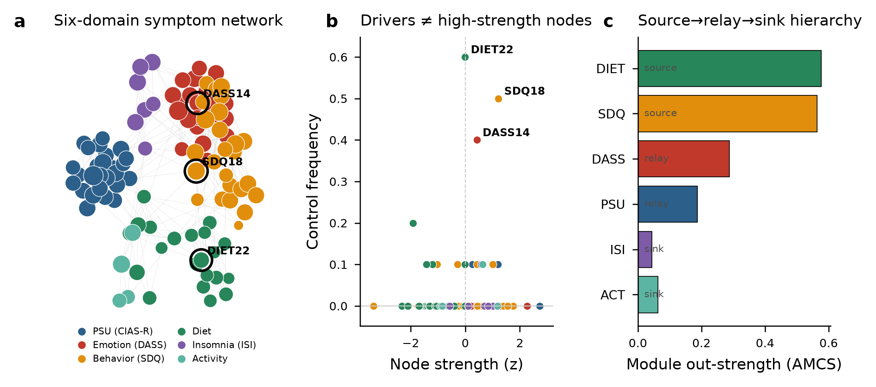
Figure 1. Baseline six-domain symptom network and its structural-control profile (N = 10,356). (a) Gaussian graphical model (top 500 edges); node colour = domain, node size ∝ strength; ringed nodes are the MDS driver core. (b) Node strength (z) versus control frequency: structural drivers are not the highest-strength nodes. (c) Module control network average control strength by domain, showing the undirected structural-control layout.

Emotional distress is the strongest temporal driver
Followed over time, the network reorganized along a temporal axis. Among the 6,092 adolescents matched across two waves about a year apart, emotional distress had the strongest net cross-lagged out-prediction (net directionality +0.249, 95% CI 0.086–0.418): higher Wave-1 emotional distress predicted later increases across digital use, insomnia, behavior and diet more strongly than any other domain predicted change elsewhere. Behavior (SDQ; −0.090, 95% CI −0.189 to −0.003) and physical activity (ACT; −0.145, 95% CI −0.218 to −0.060) sat downstream as sinks, while digital use, diet and insomnia were not net directional²⁸.
The strongest individual paths ran from emotion outward: DASS→digital use (0.160), DASS→insomnia (0.151), insomnia→DASS (0.150) and DASS→behavior (0.120). This ordering held after adjustment for age, sex and grade, under school-cluster-robust standard errors, under a significant-edges-only definition, and in a five-domain model that dropped diet (Supplementary Table S13). The temporal hierarchy therefore centers on emotional distress: the domain that best predicts future system-wide change is the emotional one, not the leading item-level structural driver.
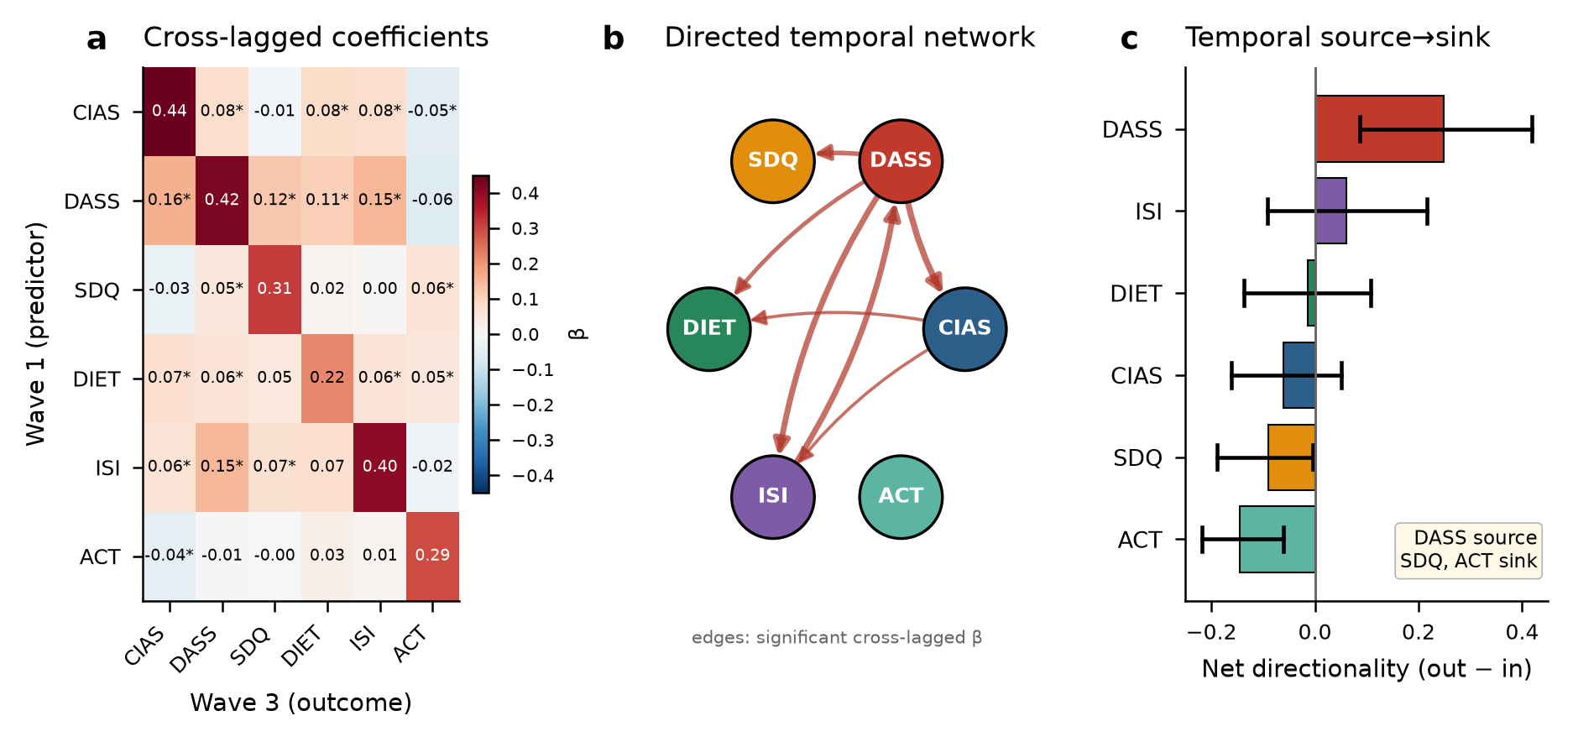
Figure 2. Cross-lagged panel network across two waves ~1 year apart (N = 6,092). (a) Cross-lagged coefficient matrix (rows = Wave-1 predictors, columns = Wave-3 outcomes; * = Bonferroni-significant; diagonal = autoregression). (b) Directed temporal network of significant cross-lagged effects. (c) Net temporal directionality (out − in) with 95% bootstrap CIs: emotional distress is the source; behavior and activity are sinks.

A Bayesian directed graph converges on the emotion outflow pattern
A Bayesian directed graph learned from the baseline scores pointed the same way. Emotional distress had the highest net out-degree, and its outgoing edges to behavior, digital use and diet were among the most bootstrap-stable in the graph. Across the six domains, net directionality from the longitudinal CLPN and from the Bayesian graph agreed closely (r = 0.75), placing emotional distress and insomnia on the source side and behavior, diet and activity on the sink side.
This agreement matters because the two analyses draw on different information — the CLPN on temporal ordering across waves, the Bayesian graph on cross-sectional baseline dependencies. That they converge suggests the emotion-outgoing pattern is not an artifact of one model. The DASS-outgoing solution also survived an alternative discretization and a continuous Gaussian Bayesian network fitted without discretization, further supporting emotion's dominant directional position (Supplementary Table S11).
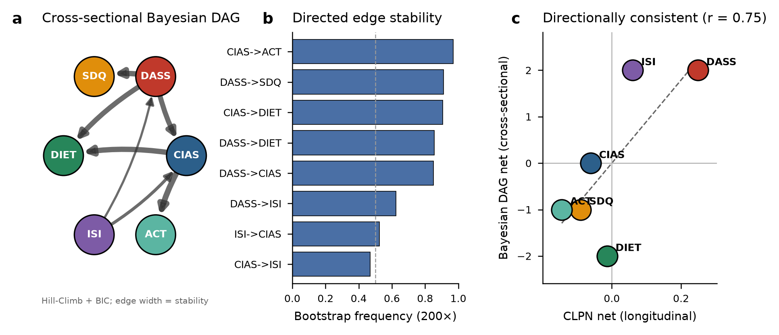
Figure 3. Cross-sectional Bayesian directed network and convergence with the longitudinal result. (a) Bayesian DAG (Hill-Climb + BIC); edge width ∝ bootstrap stability. (b) Most stable directed edges. (c) Cross-sectional (DAG) versus longitudinal (CLPN) net directionality per domain agree at r = 0.75.

The six-domain architecture and control dimension are stable across methods
Several checks confirmed the network's architecture. Six unsupervised community-detection algorithms recovered the six-domain organization without scale priors (ARI 0.61–0.73, NMI 0.78–0.84; Leiden returned exactly six communities²⁷; Supplementary Fig. S18). The structure was also stable across waves — cross-wave ARI 0.86, with only 8 of 89 comparable nodes changing community (Supplementary Fig. S8).
Control frequency behaved as its own metric, not a rebadged centrality. Across all 104 nodes it correlated weakly with strength, closeness, eigenvector centrality, expected influence and bridge measures, and PCA separated it from both the traditional-centrality and the strength–influence components (Supplementary Fig. S15). Bridge nodes and structural drivers were thus different sets: bridge centrality picks out cross-domain connectors, whereas control frequency picks out nodes that govern the static topology²⁶ (Supplementary Fig. S4).
Dynamic and perturbation analyses pointed the same way (Supplementary Fig. S10). Sustained perturbation of source-side modules produced larger system-wide activation than perturbation of sink-side modules, and targeted knockout showed that low-centrality structural drivers play a different role from high-betweenness or high-strength hubs. Taken together, the hierarchy is a reproducible property of the symptom system rather than a byproduct of any single metric.

The emotional hub generalizes across 240 countries
In 147,506 young adults from 240 countries in the Global Mind Project, the emotional domain was the strongest hub of the mapped six-domain network (strength 0.726), with bootstrap confidence intervals separated from every other domain. This global, different-instrument sample reproduced the emotional-hub signature seen in the adolescent cohort.
The adult social-media-frequency proxy, by contrast, was only weakly coupled to the rest of the network (strength 0.075). Far from weakening the adolescent result, this age-stratified contrast sharpens it: problematic digital use appears tightly woven into the health-symptom network during adolescence, whereas plain social-media frequency in young adulthood is not the same thing. The cross-cultural result thus supports a general emotional hub while hinting that the role of digital-use behavior is developmentally specific.
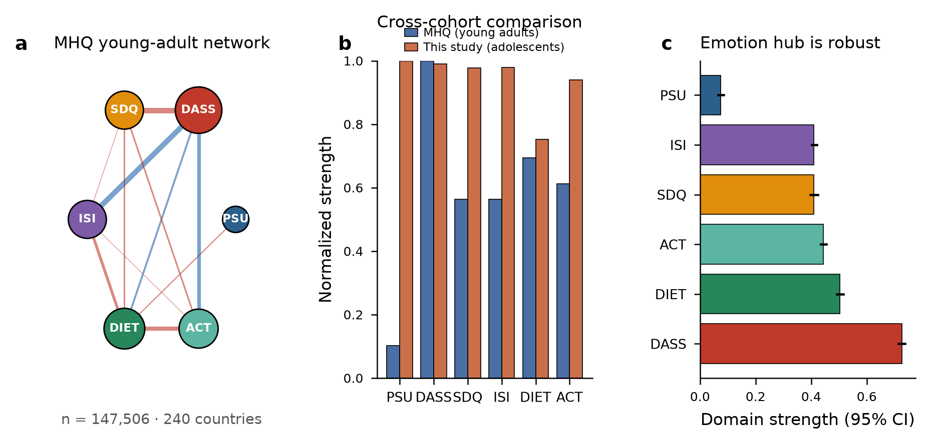
Figure 4. Cross-cultural triangulation in the Global Mind Project young-adult sample. (a) Six-domain young-adult network (n = 147,506, 240 countries); node size ∝ strength. (b) Normalized domain strength, young adults versus the adolescent cohort. (c) Domain strength with 95% bootstrap CIs: the emotional hub is robust.

An independent UK cohort confirms the screen sink pattern
A tougher test is whether the ordering recurs in a separate, culturally distinct cohort followed over time. In the UK Millennium Cohort Study, 9,520 adolescents were linked from age 14 to age 17 (7,838 complete cases in the CLPN), and screen and social-media use again occupied the strongest downstream position. Social-media use was the strongest net sink (−0.211, 95% CI −0.260 to −0.139), with gaming also downstream (−0.089, 95% CI −0.149 to −0.020).
On the source side, internalizing distress predicted later change (+0.105, 95% CI 0.023–0.154), alongside hyperactivity (+0.177) and conduct problems (+0.098). MCS thus confirms the screen-sink anchor in a different culture and broadens the source side: in later adolescence, the upstream role is shared by internalizing and externalizing symptoms. Together with the Nanjing CLPN, this independent cohort supports the view that screen-related behavior more often follows broader psychopathological processes than causes them.
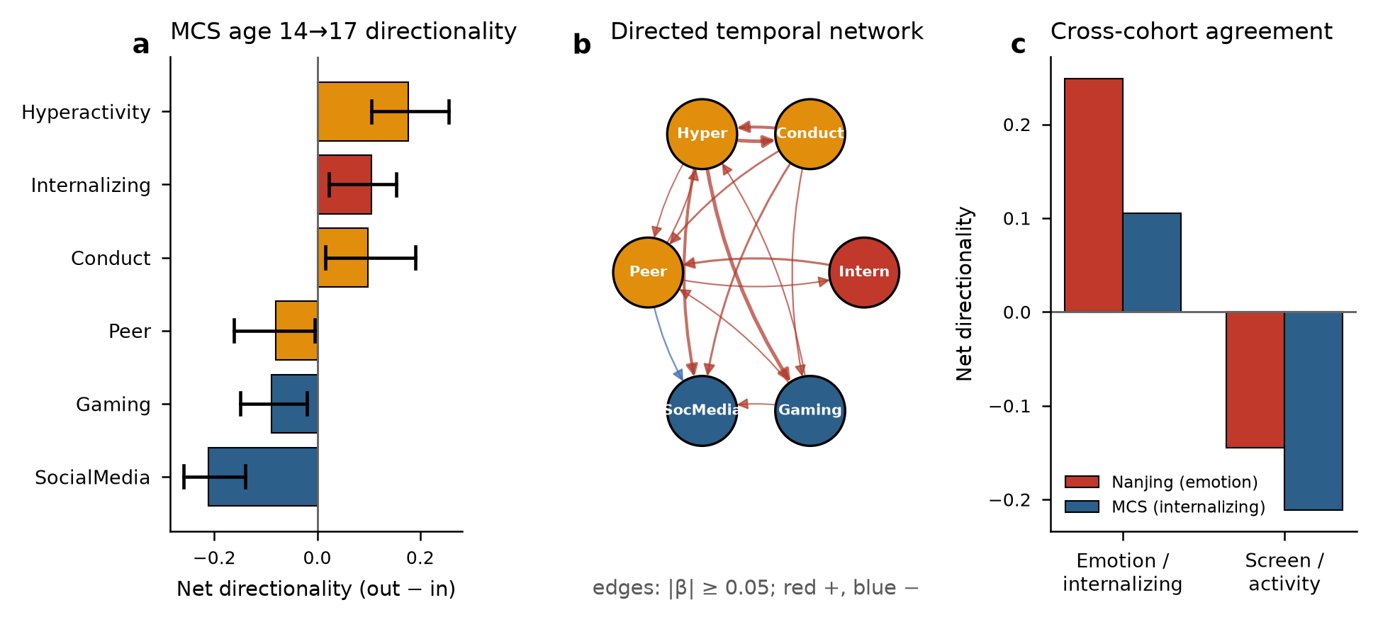
Figure 5. Independent longitudinal replication in the UK Millennium Cohort Study, age 14 → 17 (N = 7,838). (a) Net temporal directionality (out − in) with 95% bootstrap CIs; self-reported internalizing is a source, social-media use the strongest sink. (b) Directed temporal network of cross-lagged effects (red = positive, blue = negative; width ∝ coefficient). (c) Cross-cohort agreement: the emotion-source and screen-sink pattern recurs in both the Nanjing (DASS) and MCS (self-reported internalizing) cohorts.

Discussion
This study identifies emotional distress as the principal temporal driver of adolescent digital-use symptom networks. At baseline, the item-level network had a compact structural-control core spread across diet, behavior and emotion. Over time, however, emotional distress led, with behavior and physical activity downstream. A Bayesian directed graph converged on the same emotion-outgoing architecture, the emotional hub held across 240 countries, and an independent UK cohort confirmed that screen and social-media use sit downstream. The central point is not that adolescent digital use co-occurs with emotional, behavioral and somatic symptoms, but that emotional distress organizes how the wider system changes.
The finding also clarifies a recurring confusion in network psychopathology: static control topology and temporal directionality answer different questions. Structural control identifies the nodes that dominate a network's instantaneous topology; longitudinal directionality identifies the domains that predict later change elsewhere. Estimating both in the same phenotype shows how a symptom system can have low-centrality structural drivers while being organized in time around emotion. Holding the two apart keeps the value of network control analysis while stopping static topology from being mistaken for temporal sequence.
The clinical read-out is straightforward. For lasting, system-level change in adolescent digital-use-related symptoms, emotional distress is the natural leading target²⁹. Depression, anxiety, stress reactivity and emotional dysregulation may precede escalation across digital use, insomnia, conduct and diet, whereas digital-use behavior itself tends to sit downstream of broader affective and behavioral dysregulation. Structural-driver nodes remain useful for understanding instantaneous leverage, but the longitudinal evidence puts emotion first as the domain most likely to propagate change over months.
Replication strengthens this reading. In the UK Millennium Cohort Study, social-media use and gaming were downstream from age 14 to 17, while internalizing distress was one of the upstream sources, alongside externalizing symptoms^{30,31}. This broadens the source side in later adolescence from emotion alone to internalizing plus externalizing psychopathology, while preserving the core screen-sink result. In the Global Mind Project, the emotional domain was the dominant hub across 240 countries, showing that the network's emotional center is not culture-bound. The weak coupling of adult social-media frequency further suggests that adolescent problematic digital use is woven into the mental-health network in a developmentally specific way that plain adult use frequency is not^{32,33}. Unlike gaming disorder, problematic digital use is not yet a recognized diagnosis³⁴, which makes a network-level account of its symptom relations especially useful.
A few features set the scope of the evidence and the next steps. Digital use was measured with the CIAS-R, which indexes generalized problematic internet and digital-media use; smartphone-specific instruments would sharpen the construct. The two-wave CLPN estimates between-person lagged directionality over about a year; studies with three or more waves and intensive repeated measures could separate stable individual differences from within-person dynamics^{35,36}. The UK and Global Mind Project analyses are construct-level replications, built to test the directional anchors and the generality of the emotional hub across instruments and cultures. None of this changes the central conclusion: across complementary structural, longitudinal, directed and external analyses, emotional distress occupies the dominant upstream position in adolescent digital-use symptom networks.

Methods

Participants and design
Data came from a school-based cohort in three cities of Jiangsu Province, China (11 schools). The first wave was collected between September 2022 and February 2023. Of 11,640 initial records, 1,284 (11.0%) were removed by quality control (response-time and score-variability criteria), leaving N = 10,356 (52.2% male; mean age 13.96 years, SD 2.42). A third wave was exported in April 2024, ~1 year after the first. The study was approved by the institutional ethics committee (approval 2022-KY095-02) and conducted in accordance with the Declaration of Helsinki; written informed consent was obtained from participating adolescents and their guardians.

Measures
Six health domains were assessed with 104 items in total: problematic internet/digital-media use (Chinese Internet Addiction Scale–Revised, CIAS-R; 26 items, 1–4)³⁷, which indexes generalized problematic internet and digital-media use rather than a smartphone-specific construct, emotional distress (DASS-21; 21 items, 0–3)³⁸, conduct/behavioral difficulties (Strengths and Difficulties Questionnaire, SDQ; 25 difficulty items, 0–2)³⁹, insomnia (Insomnia Severity Index, ISI; 7 items, 0–4)⁴⁰, diet (21 items), and physical activity (4 items). SDQ items 7, 11, 14, 21 and 25 were reverse-scored; the prosocial subscale was excluded; diet item 3 and activity items 5–6 were dropped per the original protocol.

Longitudinal matched sample
Because the two waves used independent record identifiers, individuals were matched deterministically on a de-identified hash key (name + date of birth + biological sex; SHA-based, truncated). After removing within-wave duplicates (three in Wave 1, one in Wave 3), 6,092 individuals had complete six-domain data in both waves. One instrument changed between waves: diet items 10–22 shifted from binary (0/1) in Wave 1 to an eight-point scale (1–8) in Wave 3, so item-level diet comparisons were not possible; the primary longitudinal analysis was therefore conducted at the six-domain-score level (within-wave z-standardized), which is robust to instrument-version differences and is the level at which the original module-control and regression analyses were defined. Cross-wave test–retest correlations of domain scores were CIAS 0.58, DASS 0.63, SDQ 0.43, DIET 0.34, ISI 0.57, ACT 0.31.

External triangulation sample
The Global Mind Project / Mental Health Million dataset (MHQ; Sapien Labs) comprises 2,218,157 adult self-report records from 240 countries. We extracted the 18–24-year young-adult subsample; 147,506 had complete data across the six mapped domains. The MHQ uses its own assessment; domains were mapped by item content (emotion: fear/anxiety, sad/hopeless, mood swings, anger; behavior: restless/hyperactive, aggression, impulsivity; sleep: sleep frequency and quality; diet: ultra-processed-food, fruit/vegetable, sugary-food frequency, appetite; activity: exercise frequency; digital-use proxy: social-media frequency). This supports a concept-level, not instrument-level, replication.

Independent longitudinal cohort (Millennium Cohort Study)
To test the temporal-directionality result in a second, culturally distinct longitudinal cohort, we used the UK Millennium Cohort Study (MCS), Sweep 6 (age 14; N = 11,852) and Sweep 7 (age 17; N = 10,343), obtained under licence from the UK Data Service (SN 8156 and 8682)⁴¹. Cohort members were linked across sweeps by de-identified family and cohort-member identifiers, yielding 9,520 adolescents observed at both 14 and 17 years. We defined six comparable nodes present at both ages: self-reported internalizing distress (13-item Short Mood and Feelings Questionnaire at 14⁴²; Kessler K6 at 17⁴³), and, from the Strengths and Difficulties Questionnaire, conduct, hyperactivity/inattention, and peer-problem subscales, plus self-reported hours of social-media use and of electronic gaming. Scores were within-wave z-standardized; a cross-lagged panel network was estimated exactly as in the Cross-lagged panel network subsection (each age-17 node regressed on all age-14 nodes with HC3 robust errors), and net directionality with 95% CIs was obtained from 500 nonparametric bootstraps. The complete-case network comprised 7,838 adolescents. This is an independent, cross-national, instrument-different longitudinal replication at the construct level; because MCS lacks the CIAS-R and a directly comparable diet scale, it tests the directionality of emotional distress and screen use rather than the full six-domain model.

Network reconstruction
Item scores were transformed with a nonparanormal (Gaussian-copula) transform (QuantileTransformer to a normal target). A Gaussian graphical model was estimated by graphical Lasso^{18,19}; the regularization parameter λ was selected by likelihood-based K-fold cross-validation over a 100-point geometric grid from λ_max = 0.824 to 1% of that value, yielding λ = 0.0581. Partial correlations were derived from the precision matrix. This reproduced the published baseline (density 0.5187; 2,778 edges vs. 0.518/2,777). Reporting follows current standards for cross-sectional psychological-network analyses²³.

Control analysis
Minimum dominating sets (MDS) were enumerated exhaustively^{20,21}; control frequency (CF) is the fraction of minimal MDS solutions containing a node. The module control network (MCN) summarizes inter-module structural control via average module control strength (AMCS)²². Average and modal controllability, and control energy to drive the sink modules, were computed from the discrete-time linear controllability Gramian on the absolute-weight adjacency matrix. Target controllability was estimated by greedy set-cover of a target module set. The MDS/CF construct is a structural graph-theoretic quantity: it measures how consistently a node is required to cover the network under the dominating-set definition, indexing instantaneous structural leverage rather than dynamical or causal control. Directional claims in this paper rest on the longitudinal CLPN and the Bayesian directed graph (Cross-lagged panel network and Bayesian DAG subsections).

Cross-lagged panel network
In the 6,092 matched individuals, each Wave-3 domain score was regressed on all six Wave-1 domain scores (including its own autoregression), using HC3 robust standard errors and Bonferroni correction (α = 0.05/30 = 0.0017)²⁵. Net temporal directionality of a domain is its summed absolute cross-lagged out-strength minus in-strength; 95% CIs came from 1,000 nonparametric bootstraps. To assess whether the directionality result depends on analytic choices, we recomputed net directionality under a significant-edges-only and an all-edges definition, and in a five-domain model excluding diet (the one domain whose instrument changed across waves) (Supplementary Materials).

Bayesian DAG and structural controllability
Domain scores were discretized into tertiles; a directed acyclic graph was learned by Hill-Climb search with the BIC score (pgmpy). Directed-edge stability was assessed over 200 bootstraps. Structural controllability (minimum driver-node count N_D) was computed via maximum matching²⁰. We treat the DAG as a directional benchmark: a learned DAG represents a Markov-equivalence class, and edge orientations can be sensitive to discretization and to unmeasured confounding. The Supplementary Materials therefore report the CPDAG/equivalence class, alternative discretizations (quartiles and a continuous Gaussian Bayesian network), and bootstrap edge-direction stability.

Multi-method convergence
Six community-detection algorithms (Louvain, Leiden, Walktrap, Spinglass, Fast-Greedy, Infomap) were compared against the six a-priori domains (adjusted Rand index, ARI; normalized mutual information, NMI) and across waves. We computed signed expected influence (1- and 2-step), bridge strength/expected-influence/betweenness²⁶, and, per node, average and modal controllability. Fourteen node-level metrics were correlated (Spearman) and reduced by PCA. A node-knockout attack removed nodes by four orderings (CF drivers, strength, bridge, betweenness) plus a random baseline, tracking largest-connected-component and global efficiency. A linear-threshold dynamical model (x_{t+1} = tanh(g·A_norm·x_t + u), g = 0.9) simulated sustained perturbation of each module. Group-level network structures were compared with a permutation-based network comparison test³¹.

Software
Analyses used Python (scikit-learn, networkx, python-igraph, leidenalg, python-louvain, statsmodels, pgmpy). Random seed 42 throughout.

Data Availability
Individual-level cohort data are restricted by ethics approval 2022-KY095-02 and cannot be shared publicly. The Global Mind Project data are available from Sapien Labs, and Millennium Cohort Study data are available to registered users from the UK Data Service under its End User Licence. Derived group-level adjacency matrices, partial-correlation matrices, cross-lagged coefficients, bootstrap outputs, Bayesian-network edge lists, null-model distributions, machine-readable result tables and analysis scripts are deposited in an anonymized reviewer-accessible repository and will be made public upon acceptance. No individual-level records are included in these deposits.

Code Availability
Analysis scripts for network reconstruction, cross-lagged panel networks, Bayesian directed graphs, community detection, controllability analyses, null models and figure generation are deposited in an anonymized reviewer-accessible repository and will be released publicly upon acceptance.

Acknowledgments
This work was supported by the NSFC–Jiangsu Joint Fund (U24A20701), and the Hong Kong Research Grants Council (STG1/M-501/23-N). The funders had no role in study design, data collection and analysis, the decision to publish, or preparation of the manuscript.

Author Contributions
X.Z. conceived and designed the study. J.Z. and L.Z. curated the data. X.Z., J.Z. and L.Z. conducted the statistical and network analyses. X.Z. supervised the work. J.Z., L.Z. and X.Z. interpreted the findings. X.Z. drafted the manuscript. All authors approved the final version.

Ethics Declaration
The study was approved by the institutional ethics committee of the participating hospital (approval number 2022-KY095-02) and was conducted in accordance with the Declaration of Helsinki. Written informed consent was obtained from all participating adolescents and their legal guardians prior to data collection. The Global Mind Project and Millennium Cohort Study analyses used de-identified secondary data collected under the ethical approvals of their respective providers.

Competing Interests
The authors declare no competing interests.

References
1. Auerbach, R. P. et al. WHO World Mental Health Surveys International College Student Project: Prevalence and distribution of mental disorders. J. Abnorm. Psychol. 127, 623–638 (2018). https://doi.org/10.1037/abn0000362
2. Sohn, S. Y., Rees, P., Wildridge, B., Kalk, N. J. & Carter, B. Prevalence of problematic smartphone usage and associated mental health outcomes amongst children and young people: a systematic review, meta-analysis and GRADE of the evidence. BMC Psychiatry 19, 356 (2019). https://doi.org/10.1186/s12888-019-2350-x
3. Shiferaw, B. D. et al. Impact of digital addiction on youth health: a systematic review and meta-analysis. J. Behav. Addict. 14, 1129–1158 (2025). https://doi.org/10.1556/2006.2025.00081
4. Elhai, J. D., Dvorak, R. D., Levine, J. C. & Hall, B. J. Problematic smartphone use: a conceptual overview and systematic review of relations with anxiety and depression psychopathology. J. Affect. Disord. 207, 251–259 (2016). https://doi.org/10.1016/j.jad.2016.08.030
5. Odgers, C. L. & Jensen, M. R. Annual Research Review: adolescent mental health in the digital age: facts, fears, and future directions. J. Child Psychol. Psychiatry 61, 336–348 (2020). https://doi.org/10.1111/jcpp.13190
6. Boers, E., Afzali, M. H., Newton, N. & Conrod, P. Association of screen time and depression in adolescence. JAMA Pediatr. 173, 853–859 (2019). https://doi.org/10.1001/jamapediatrics.2019.1759
7. Lemola, S., Perkinson-Gloor, N., Brand, S., Dewald-Kaufmann, J. F. & Grob, A. Adolescents’ electronic media use at night, sleep disturbance, and depressive symptoms in the smartphone age. J. Youth Adolesc. 44, 405–418 (2014). https://doi.org/10.1007/s10964-014-0176-x
8. Elhai, J. D., Yang, H., Fang, J., Bai, X. & Hall, B. J. Depression and anxiety symptoms are related to problematic smartphone use severity in Chinese young adults: fear of missing out as a mediator. Addict. Behav. 101, 105962 (2019). https://doi.org/10.1016/j.addbeh.2019.04.020
9. Alimoradi, Z. et al. Internet addiction and sleep problems: a systematic review and meta-analysis. Sleep Med. Rev. 47, 51–61 (2019). https://doi.org/10.1016/j.smrv.2019.06.004
10. Orben, A. & Przybylski, A. K. The association between adolescent well-being and digital technology use. Nat. Hum. Behav. 3, 173–182 (2019). https://doi.org/10.1038/s41562-018-0506-1
11. Roberston, L., Twenge, J. M., Joiner, T. E. & Cummins, K. Associations between screen time and internalizing disorder diagnoses among 9- to 10-year-olds. J. Affect. Disord. 311, 530–537 (2022). https://doi.org/10.1016/j.jad.2022.05.071
12. Borsboom, D. A network theory of mental disorders. World Psychiatry 16, 5–13 (2017). https://doi.org/10.1002/wps.20375
13. Bringmann, L. F. et al. Psychopathological networks: theory, methods and practice. Behav. Res. Ther. 149, 104011 (2021). https://doi.org/10.1016/j.brat.2021.104011
14. Cramer, A. O., Waldorp, L. J., van der Maas, H. L. & Borsboom, D. Comorbidity: a network perspective. Behav. Brain Sci. 33, 137–150 (2010). https://doi.org/10.1017/S0140525X09991567
15. Robinaugh, D. J., Hoekstra, R. H. A., Toner, E. R. & Borsboom, D. The network approach to psychopathology: a review of the literature 2008–2018 and an agenda for future research. Psychol. Med. 50, 353–366 (2019). https://doi.org/10.1017/S0033291719003404
16. Monteleone, A. M. & Cascino, G. A systematic review of network analysis studies in eating disorders: is time to broaden the core psychopathology to non specific symptoms. Eur. Eat. Disord. Rev. 29, 531–547 (2021). https://doi.org/10.1002/erv.2834
17. Heeren, A., Jones, P. J. & McNally, R. J. Mapping network connectivity among symptoms of social anxiety and comorbid depression in people with social anxiety disorder. J. Affect. Disord. 228, 75–82 (2017). https://doi.org/10.1016/j.jad.2017.12.003
18. Epskamp, S. & Fried, E. I. A tutorial on regularized partial correlation networks. Psychol. Methods 23, 617–634 (2018). https://doi.org/10.1037/met0000167
19. Epskamp, S., Borsboom, D. & Fried, E. I. Estimating psychological networks and their accuracy: a tutorial paper. Behav. Res. Methods 50, 195–212 (2018). https://doi.org/10.3758/s13428-017-0862-1
20. Liu, Y. Y., Slotine, J. J. & Barabási, A. L. Controllability of complex networks. Nature 473, 167–173 (2011). https://doi.org/10.1038/nature10011
21. Nacher, J. C. & Akutsu, T. Minimum dominating set-based methods for analyzing biological networks. Methods 102, 57–63 (2016). https://doi.org/10.1016/j.ymeth.2015.12.017
22. Pan, C. et al. Module control of network analysis in psychopathology. iScience 27, 110302 (2024). https://doi.org/10.1016/j.isci.2024.110302
23. Burger, J. et al. Reporting standards for psychological network analyses in cross-sectional data. Psychol. Methods 28, 806–824 (2022). https://doi.org/10.1037/met0000471
24. Fried, E. I. & Cramer, A. O. J. Moving forward: challenges and directions for psychopathological network theory and methodology. Perspect. Psychol. Sci. 12, 999–1020 (2017). https://doi.org/10.1177/1745691617705892
25. Ye, X., Fong, T. C. T. & Yip, P. S. F. A cross-lagged panel network model on internet gaming disorder and depressive symptoms concerning preferences for game genres. J. Affect. Disord. 375, 27–34 (2025). https://doi.org/10.1016/j.jad.2025.01.006
26. Jones, P. J., Ma, R. & McNally, R. J. Bridge centrality: a network approach to understanding comorbidity. Multivariate Behav. Res. 56, 353–367 (2019). https://doi.org/10.1080/00273171.2019.1614898
27. Christensen, A. P., Gross, G. M., Golino, H. F., Silvia, P. J. & Kwapil, T. R. Exploratory graph analysis of the Multidimensional Schizotypy Scale. Schizophr. Res. 206, 43–51 (2018). https://doi.org/10.1016/j.schres.2018.12.018
28. Rodriguez-Ayllon, M. et al. Role of physical activity and sedentary behavior in the mental health of preschoolers, children and adolescents: a systematic review and meta-analysis. Sports Med. 49, 1383–1410 (2019). https://doi.org/10.1007/s40279-019-01099-5
29. Lunansky, G. et al. Intervening on psychopathology networks: evaluating intervention targets through simulations. Methods 204, 29–37 (2021). https://doi.org/10.1016/j.ymeth.2021.11.006
30. Brosnan, B. et al. Screen use at bedtime and sleep duration and quality among youths. JAMA Pediatr. 178, 1147–1154 (2024). https://doi.org/10.1001/jamapediatrics.2024.2914
31. van Borkulo, C. D. et al. Comparing network structures on three aspects: a permutation test. Psychol. Methods 28, 1273–1285 (2022). https://doi.org/10.1037/met0000476
32. Orben, A. & Przybylski, A. K. Teenage sleep and technology engagement across the week. PeerJ 8, e8427 (2020). https://doi.org/10.7717/peerj.8427
33. Nagata, J. M. et al. Screen time and mental health: a prospective analysis of the Adolescent Brain Cognitive Development (ABCD) Study. BMC Public Health 24, 2686 (2024). https://doi.org/10.1186/s12889-024-20102-x
34. Fuss, J. et al. Mental health professionals’ use of the ICD-11 classification of impulse control disorders and behavioral addictions: an international field study. J. Behav. Addict. 13, 276–292 (2024). https://doi.org/10.1556/2006.2023.00083
35. Hamaker, E. L., Kuiper, R. M. & Grasman, R. P. A critique of the cross-lagged panel model. Psychol. Methods 20, 102–116 (2015). https://doi.org/10.1037/a0038889
36. Siepe, B. S. et al. Time-varying network models for the temporal dynamics of depressive symptomatology in patients with depressive disorders: secondary analysis of longitudinal observational data. JMIR Ment. Health 11, e50136 (2024). https://doi.org/10.2196/50136
37. Mak, K. K. et al. Psychometric properties of the Revised Chen Internet Addiction Scale (CIAS-R) in Chinese adolescents. J. Abnorm. Child Psychol. 42, 1237–1245 (2014). https://doi.org/10.1007/s10802-014-9851-3
38. Henry, J. D. & Crawford, J. R. The short-form version of the Depression Anxiety Stress Scales (DASS-21): construct validity and normative data in a large non-clinical sample. Br. J. Clin. Psychol. 44, 227–239 (2005). https://doi.org/10.1348/014466505X29657
39. Goodman, R. The Strengths and Difficulties Questionnaire: a research note. J. Child Psychol. Psychiatry 38, 581–586 (1997). https://doi.org/10.1111/j.1469-7610.1997.tb01545.x
40. Bastien, C. H., Vallières, A. & Morin, C. M. Validation of the Insomnia Severity Index as an outcome measure for insomnia research. Sleep Med. 2, 297–307 (2001). https://doi.org/10.1016/s1389-9457(00)00065-4
41. Connelly, R. & Platt, L. Cohort profile: UK Millennium Cohort Study (MCS). Int. J. Epidemiol. 43, 1719–1725 (2014). https://doi.org/10.1093/ije/dyu001
42. Turner, N., Joinson, C., Peters, T. J., Wiles, N. & Lewis, G. Validity of the Short Mood and Feelings Questionnaire in late adolescence. Psychol. Assess. 26, 752–762 (2014). https://doi.org/10.1037/a0036572
43. Kessler, R. C. et al. Short screening scales to monitor population prevalences and trends in non-specific psychological distress. Psychol. Med. 32, 959–976 (2002). https://doi.org/10.1017/s0033291702006074

