Emotional Distress Drives Adolescent Digital Use Symptom Networks
Jing Zhang¹, Ling Zhang², Xizhe Zhang¹, ²*
¹ Nanjing Children's Hospital, Nanjing Medical University, Nanjing, China
² School of Biomedical Engineering and Informatics, Nanjing Medical University, Nanjing, China
* Corresponding author: Xizhe Zhang, Nanjing Children's Hospital and School of Biomedical Engineering and Informatics, Nanjing Medical University, Nanjing, China. Email: zhangxizhe@njmu.edu.cn
Running title: Emotion in adolescent digital use networks

Abstract
Adolescent problematic digital use rarely stands alone; it sits within a broader system spanning emotional distress, insomnia, disordered eating, physical inactivity and behavioral symptoms, and which domain drives system-level change is unclear. In a school-based cohort of 10,356 Chinese adolescents, of whom 6,092 were matched across two waves, we combined item-level network control with longitudinal directionality. The baseline 104-node, six-domain network had a compact structural-control core: diet, behavioral and emotional items dominated the structural-control topology, yet this core was distinct from the highest-strength symptoms, which primarily reflected prolonged online use, anxiety-related worry, concentration difficulties and negative mood. Longitudinally, emotional distress was the strongest upstream predictor of later change across digital use, insomnia, behavior and diet (net directionality +0.249, 95% CI 0.086–0.418), with behavior and activity downstream. A Bayesian directed graph converged independently on the same emotion-as-source pattern (r = 0.75). The emotional hub generalized to a multinational young-adult sample, and an independent UK cohort supported the screen-as-sink ordering. At the concept level, emotional distress emerges as the principal temporal driver of these networks.
Keywords: emotional distress; adolescent digital use; symptom network; network control; cross-lagged panel network; Bayesian network

Introduction
Adolescent problematic digital use rarely occurs on its own¹. It clusters with emotional distress, insomnia, disordered eating, physical inactivity and behavioral difficulties, together forming a broader mental-health symptom system that is especially pronounced during adolescence^{2–4}. This clustering is commonly viewed as comorbidity, meaning that the symptoms co-occur. However, this view does not clarify their internal upstream–downstream order. Does problematic digital use organize the subsequent mental-health burden, or do emotional and behavioral dysregulation arise first and drive the intensification of digital-use-related symptoms^{5, 6}? An alternative interpretation places screen use upstream, treating the accompanying emotional, sleep, dietary and behavioral symptoms as its downstream consequences⁷⁻¹¹.
The network approach to psychopathology is well suited to this question^{12–15}. Instead of collapsing co-occurring symptoms into a single latent disorder, it treats symptoms and health domains as mutually reinforcing parts of a connected system^{16,17}. The question then shifts from whether digital use correlates with depression, poor sleep or conduct problems to which parts of the network occupy strategic positions — structurally and in time. Centrality analysis answers part of this by flagging the most connected nodes^{18,19}, but high connectivity alone signals neither structural leverage nor temporal priority.
Network control theory adds a further lens by asking which nodes govern the static topology of the system^{20,21}. Minimum-dominating-set and module-control methods pick out small sets of nodes whose neighborhoods cover the whole network, exposing potential structural levers that need not be the highest-strength symptoms²². Applied to adolescent digital-use-related symptoms, this points to a source–relay–sink arrangement spanning diet, behavior, emotional distress, digital use, insomnia and physical activity. In this structural sense, ‘sources’ denote symptom domains whose structural coverage over the network is high and asymmetric; ‘relays’ denote domains that both receive substantial upstream dominance and transmit influence further; and ‘sinks’ denote domains that are predominantly receivers. What remains unresolved is whether this static control map lines up with the temporal order in which symptoms actually change^{23,24}. A node can rule the instantaneous structure without being the domain that predicts later change elsewhere.
The distinction has practical stakes for adolescent mental health. If digital-use symptoms lead in time, then reducing digital behavior belongs at the center of prevention and intervention. If emotional distress leads instead, problematic digital use is better seen as one expression of a broader affective process, and lasting system-level change would mean targeting emotion²⁵. Telling these possibilities apart requires longitudinal network directionality — not cross-sectional association or static control topology alone²⁶.
Here we bring item-level structural control and longitudinal directional modeling together in one large school-based cohort. We estimate a 104-node, six-domain symptom network in 10,356 Chinese adolescents at Wave 1 (hereafter the baseline network), and fit a cross-lagged panel network in the 6,092 of these adolescents who were matched across two waves about a year apart (that is, the same individuals re-assessed at the second wave rather than a separate sample)²⁶, and add a Bayesian directed graph as an independent directional check on the baseline wave. We then test whether the pattern travels: to a 240-country young-adult Global Mind Project sample for cross-cultural triangulation of the emotional hub, and to the UK Millennium Cohort Study for an independent longitudinal test of the internalizing-source and screen-sink anchors²⁷. The design asks whether structural drivers and temporal drivers are the same nodes, and identifies emotional distress as the principal upstream domain of adolescent digital-use symptom networks.

Results

A compact structural control core sits outside centrality
The baseline network was densely interconnected across the six domains, denoted throughout as DASS (emotional distress), ISI (insomnia), SDQ (behavior), CIAS (problematic digital use), ACT (physical activity) and DIET (diet): 104 nodes, 2,777 edges, density 0.518, modularity 0.443 and global efficiency 0.759. Its structural control was compact — the minimum dominating set (MDS) contained just three nodes across 10 equivalent solutions. The leading control frequency (CF) nodes were DIET22 (CF = 0.60), SDQ18 (CF = 0.50) and DASS14 (CF = 0.40), so diet, behavior and emotion items jointly governed the static control topology (DIET22: “worried about eating too much”; SDQ18: “often lies or cheats”; DASS14: “unable to tolerate anything that stopped me from getting on with what I was doing”).
These structural drivers were not simply the best-connected symptoms. DIET22, the strongest driver, sat near the median of the node-strength distribution, and several high-strength symptoms never entered the minimum dominating set. The highest-strength symptoms instead included prolonged online use (CIAS6), panic-related worry (DASS9), distractibility and concentration difficulties (SDQ15), poor attention after reverse scoring (SDQ25), low mood when offline (CIAS10), and unhappiness or tearfulness (SDQ13); none of these appeared among the three leading structural-control nodes. Across the network, driver status and node strength were only loosely coupled: knowing how strongly a symptom connected to its neighbors said little about whether it was required to dominate the network. Control frequency therefore indexed a network property that is related to, but not reducible to, node strength — a dissociation the node-metric analysis confirmed: control frequency correlated only weakly with traditional centrality measures and loaded on its own principal component (Supplementary Fig. S15, Table S10).
A compact three-node dominating set could be expected in a network with this degree sequence. Degree-preserving null models confirmed that the MDS size itself was not unusual; however, the identities of the observed drivers were non-random. DIET22, SDQ18 and DASS14 entered the MDS two to three times more often than under the degree-matched null networks (Supplementary Fig. S19). Thus, the null analysis supported the specificity of the driver identities rather than the exceptional compactness of the MDS. Separately, estimator-sensitivity analyses showed that sparser networks produced larger MDSs, whereas the primary cross-validated model yielded a three-node core (Supplementary Table S17 and Fig. S20). In the module control network — a purely structural, undirected description of instantaneous control, which is not the same as the temporal source/sink ordering examined below — diet and behavior held the strongest (structural) source-side positions, emotional distress and digital use formed a relay layer, and insomnia and physical activity fell on the (structural) sink side. Notably, digital use never entered the minimum dominating set and occupied only a relay position in the module control network, indicating that structural leverage therefore did not lie with digital use, the domain of primary clinical concern.
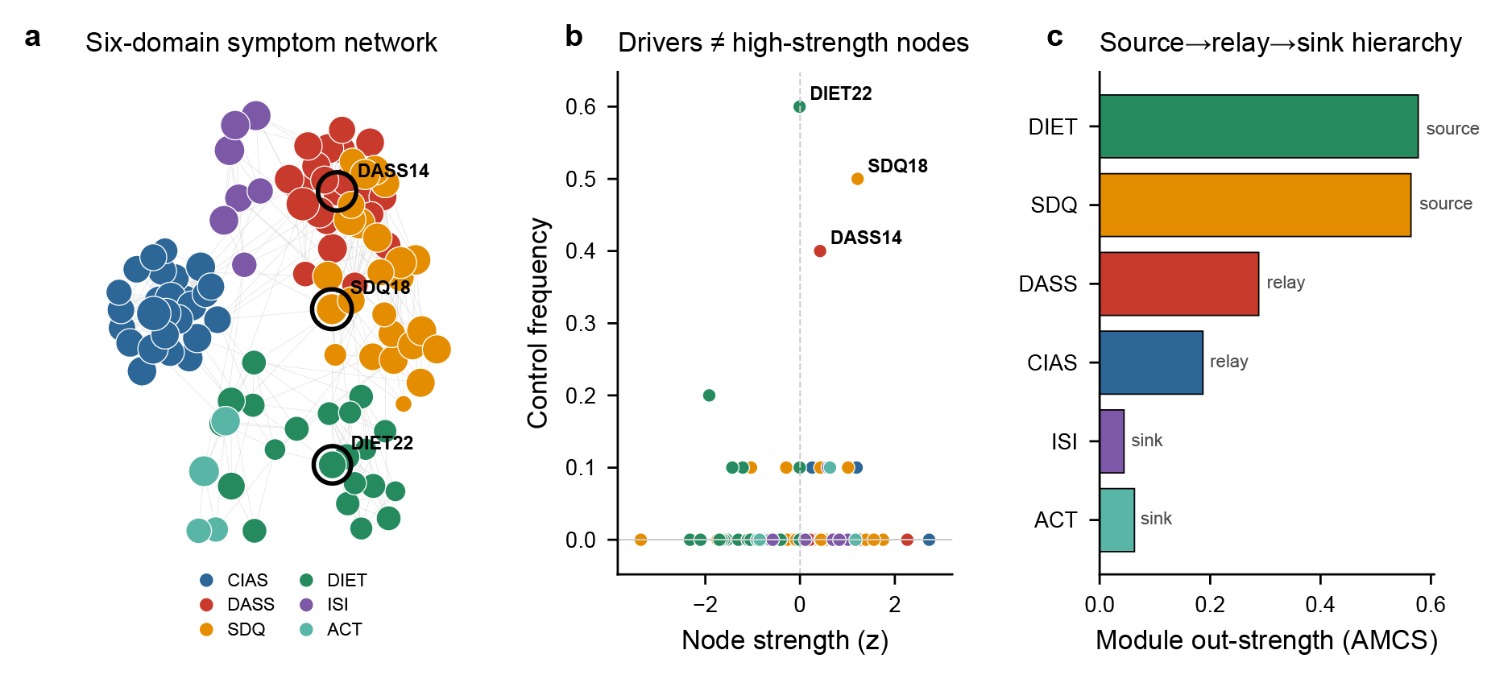
Figure 1. Baseline six-domain symptom network and its structural-control profile (N = 10,356). (a) Gaussian graphical model (top 500 edges); node color = domain, node size ∝ strength; ringed nodes are the MDS driver core. (b) Node strength (z) versus control frequency: structural drivers are not the highest-strength nodes. (c) Module control network average control strength by domain, showing the undirected structural-control layout.

The six-domain architecture and control dimension are stable across methods
Several checks confirmed the network's architecture. Six unsupervised community-detection algorithms recovered the six-domain organization without scale priors (ARI 0.61–0.73, NMI 0.78–0.84; Leiden returned exactly six communities²⁸; Supplementary Fig. S18). The structure was also stable across waves — cross-wave ARI 0.86, with only 8 of 89 comparable nodes changing community (Supplementary Fig. S8).
Control frequency behaved as its own metric, not a rebadged centrality. Across all 104 nodes it correlated weakly with strength, closeness, eigenvector centrality, expected influence and bridge measures, and PCA separated it from both the traditional-centrality and the strength–influence components (Supplementary Fig. S15). Bridge nodes and structural drivers were thus different sets: bridge centrality picks out cross-domain connectors, whereas control frequency picks out nodes that govern the static topology²⁹ (Supplementary Fig. S4).
Dynamic and perturbation analyses pointed the same way (Supplementary Fig. S10 and Supplementary Fig. S11). Sustained perturbation of source-side modules produced larger system-wide activation than perturbation of sink-side modules, and targeted knockout showed that low-centrality structural drivers play a different role from high-betweenness or high-strength hubs. Taken together, the hierarchy is a reproducible property of the symptom system rather than a byproduct of any single metric.

Emotional distress is the strongest temporal driver
We next asked how the six domains predicted one another across the two waves. In the domain-level cross-lagged panel network estimated among the 6,092 adolescents who were matched across both waves (about a year apart; the same individuals re-assessed, not a new sample), DASS had the strongest net cross-lagged out-prediction (net directionality +0.249, 95% CI 0.086–0.418): higher Wave-1 emotional distress predicted later increases across CIAS, ISI, SDQ and DIET more strongly than any other domain predicted change elsewhere. Behavior (SDQ; −0.090, 95% CI −0.189 to −0.003) and physical activity (ACT; −0.145, 95% CI −0.218 to −0.060) sat downstream as net sinks, whereas CIAS, DIET and ISI showed no net directionality (neither net source nor net sink)³⁰.
Examining the individual cross-lagged coefficients, we found that the strongest paths were dominated by emotional distress: DASS→CIAS (0.160), DASS→ISI (0.151) and DASS→SDQ (0.120) all ran outward from emotion, while the reciprocal ISI→DASS path (0.150) was of comparable magnitude, indicating a partially bidirectional coupling between emotional distress and insomnia rather than a strictly one-way outflow. This ordering held after adjustment for age, sex and grade, under school-cluster-robust standard errors, under a significant-edges-only definition, and in a five-domain model that dropped diet (Supplementary Table S13). Taken together, the temporal hierarchy centers on DASS: the domain that best predicts future system-wide change is the emotional one, not the leading item-level structural driver.
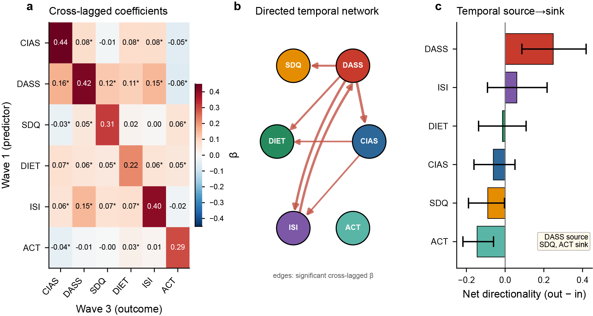
Figure 2. Cross-lagged panel network across two waves approximately 1 year apart (N = 6,092). (a) Cross-lagged coefficient matrix (rows = Wave-1 predictors, columns = Wave-3 outcomes; * = Bonferroni-significant; diagonal = autoregression). (b) Directed temporal network of significant cross-lagged effects; edge width is proportional to the coefficient. The four strongest paths were DASS→CIAS (0.160), DASS→ISI (0.151), ISI→DASS (0.150), and DASS→SDQ (0.120). Only Bonferroni-significant edges are displayed, so non-significant paths (including several digital-use edges) are omitted by this threshold rather than absent. (c) Net temporal directionality (out − in) with 95% bootstrap CIs: emotional distress is the net source; behavior and activity are net sinks.
A Bayesian directed graph converges on the emotion outflow pattern
If the emotion-as-source pattern reflects a directional property of the system rather than an artifact of the cross-lagged model's assumptions, a different method applied to the same baseline scores should recover a similar ordering. We therefore learned an exploratory Bayesian directed graph from those scores, which encodes direction through cross-sectional conditional dependencies rather than temporal precedence. It pointed the same way (Fig. 3a). DASS had the highest net out-degree, and its outgoing edges to SDQ, CIAS and DIET were among the most bootstrap-stable in the graph. Across the six domains, net directionality from the longitudinal CLPN and from the Bayesian graph agreed closely (r = 0.75), placing DASS and ISI on the source side and SDQ, DIET and ACT on the sink side.
This agreement matters because the two analyses draw on different information — the CLPN on temporal ordering across waves, the Bayesian graph on cross-sectional baseline dependencies. That they converge suggests the emotion-as-source pattern is not an artifact of one model. The DASS-outgoing solution also survived an alternative discretization and a continuous Gaussian Bayesian network fitted without discretization, further supporting emotion's dominant directional position (Supplementary Table S11).
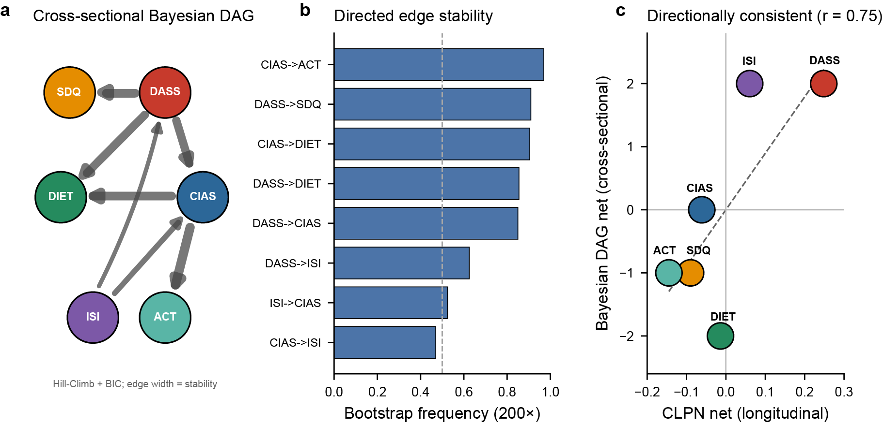
Figure 3. Cross-sectional exploratory Bayesian directed network and its qualitative convergence with the longitudinal result. (a) Exploratory Bayesian DAG (Hill-Climb + BIC); edge width ∝ bootstrap stability; only edges above the bootstrap-stability display threshold are shown. (b) Most stable directed edges. (c) Cross-sectional (DAG) versus longitudinal (CLPN) net directionality per domain agree at r = 0.75; because the two models define directionality differently, the agreement is qualitative (shared ordering) rather than an equality of quantities.
The emotional hub recurs in a pooled multinational young-adult sample
In 147,506 young adults aged 18–24 years from 240 countries in the Global Mind Project, the emotional domain was the strongest hub of the mapped six-domain network (strength 0.726), with bootstrap confidence intervals separated from every other domain. Here ‘hub’ refers to undirected connectedness (node strength) rather than to structural control or temporal precedence, so this analysis speaks to the centrality of the emotional domain, one necessary condition for it to act as a system-level driver, rather than re-testing its temporal priority. This global, different-instrument sample recovered the emotional-hub signature seen in the adolescent cohort at the concept level.
The young adult social-media-frequency proxy, by contrast, was only weakly coupled to the rest of the network (strength 0.075). Far from weakening the adolescent result, this age-stratified contrast sharpens it: problematic digital use appears tightly woven into the health-symptom network during adolescence, whereas plain social-media frequency in young adulthood is not the same thing. The cross-cultural result thus supports a general emotional hub while hinting that the role of digital-use behavior is developmentally specific.
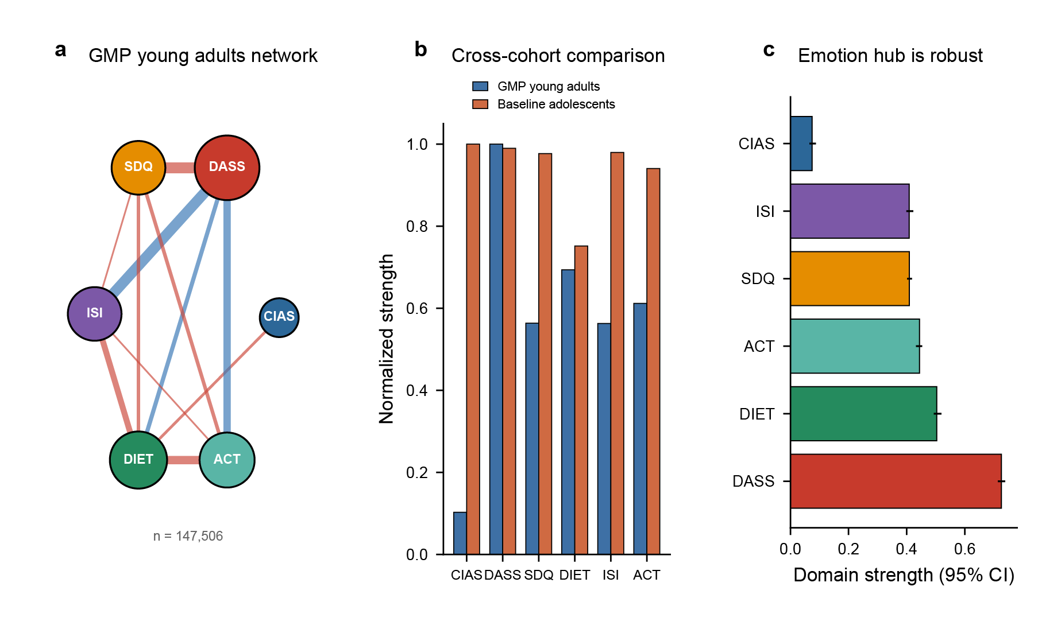
Figure 4. Cross-cultural triangulation in the Global Mind Project young-adult sample. (a) Six-domain young-adult network (N = 147,506, aged 18–24 years, 240 countries); node size ∝ strength. (b) Normalized domain strength in the GMP young-adult network versus the baseline adolescent network. This is a construct-level comparison because the two samples were assessed using different instruments. (c) Domain strength with 95% bootstrap CIs: the emotional hub is robust. For consistency across figures, the GMP social-media-frequency proxy is displayed under the CIAS label; this represents a construct-level mapping and does not indicate administration of the CIAS-R.

An independent UK cohort supports the screen-as-sink pattern
A more demanding test is whether the ordering recurs in a separate, culturally distinct cohort assessed longitudinally with different instruments. In the UK Millennium Cohort Study (MCS), 9,520 adolescents were linked from age 14 to age 17 (7,838 complete cases in the CLPN), and screen and social-media use occupied the strongest downstream position. Social-media use was the strongest net sink (−0.211, 95% CI −0.260 to −0.139), with gaming also downstream (−0.089, 95% CI −0.149 to −0.020). The MCS analysis extends the emotion-upstream/screen-downstream ordering to a setting where the screen-as-sink anchor is directly testable, rather than merely repeating an already-established finding.
The MCS counterpart of the DASS emotional domain is self-reported internalizing distress. On the source side, internalizing distress predicted later change (+0.105, 95% CI 0.023–0.154), but it was not the strongest source: hyperactivity/inattention (+0.177) and, to a lesser degree, conduct problems (+0.098) also predicted later change, and hyperactivity/inattention was in fact the leading upstream domain in this cohort. MCS therefore supports the screen-as-sink anchor in a different culture while showing that the upstream side in later adolescence is not emotion alone but is shared by internalizing and externalizing (notably hyperactivity) symptoms. Together with the discovery-cohort CLPN, this independent cohort is consistent with the view that screen-related behavior more often follows broader psychopathological processes than drives them.
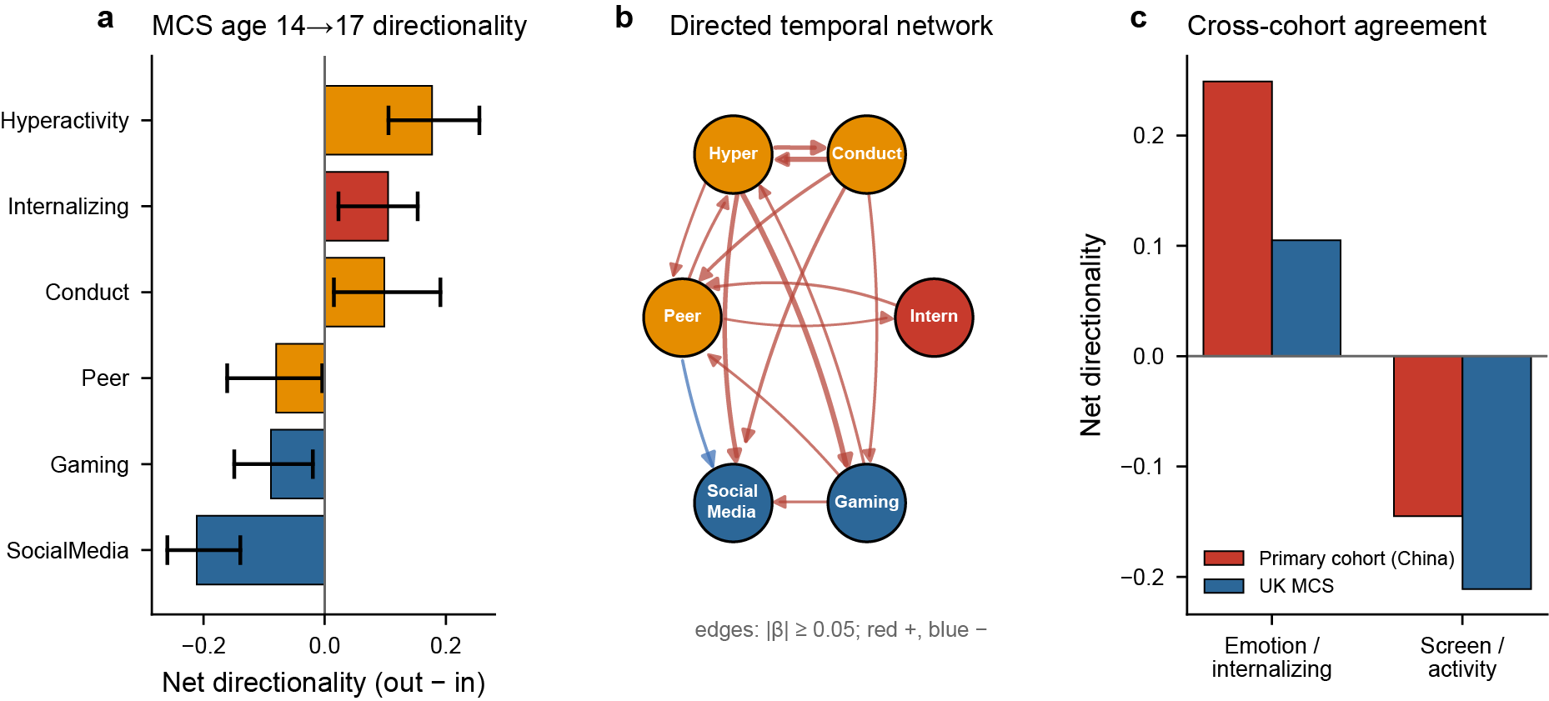
Figure 5. Independent longitudinal replication in the UK Millennium Cohort Study, age 14 to age 17 (N = 9,520 linked; 7,838 complete cases). (a) Net temporal directionality (out − in) with 95% bootstrap confidence intervals: hyperactivity/inattention, internalizing distress and conduct problems are net sources, whereas social-media use is the strongest net sink, with gaming also downstream. (b) Directed temporal network from age-14 predictors to age-17 outcomes; edges shown where |β| ≥ 0.05 (red, positive; blue, negative), a more permissive threshold than the Bonferroni criterion used in Fig. 2b. (c) Cross-cohort agreement on the two directional anchors. The discovery-cohort sink bar is physical activity, because digital use showed no net directionality in that cohort; panel c therefore compares source–sink ordering rather than the same domain.

Discussion
This study identifies emotional distress as the principal temporal driver of adolescent digital-use symptom networks. At baseline, the item-level network had a compact structural-control core spread across diet, behavior and emotion. Over time, however, emotional distress led, with behavior and physical activity downstream. A Bayesian directed graph converged on the same emotion-outgoing architecture, the emotional hub held across 240 countries, and an independent UK cohort confirmed that screen and social-media use sit downstream. The central point is not that adolescent digital use co-occurs with emotional, behavioral and somatic symptoms, but that emotional distress organizes how the wider system changes.
The finding also clarifies a recurring confusion in network psychopathology: static control topology and temporal directionality answer different questions. Structural control identifies the nodes that dominate a network's instantaneous topology; longitudinal directionality identifies the domains that predict later change elsewhere. Estimating both in the same phenotype shows how a symptom system can have low-centrality structural drivers while being organized in time around emotion. Holding the two apart keeps the value of network control analysis while stopping static topology from being mistaken for temporal sequence.
The clinical implication is that emotional distress may be a promising priority target for achieving lasting, system-level change in adolescent digital-use-related symptoms²⁵. Depression, anxiety, stress reactivity and emotional dysregulation may precede escalation across digital use, insomnia, conduct and diet, whereas digital-use behavior itself tends to sit downstream of broader affective and behavioral dysregulation. Structural-driver nodes remain useful for understanding instantaneous leverage, but the longitudinal evidence puts emotion first as the domain most likely to propagate change over months.
External validation in an independent cohort strengthens this reading. In the UK Millennium Cohort Study, social-media use and gaming were downstream from age 14 to 17, while internalizing distress was one of the upstream sources, alongside externalizing symptoms — with hyperactivity/inattention the leading source in that cohort. This broadens the source side in later adolescence from emotion alone to internalizing plus externalizing psychopathology, while preserving the core screen-as-sink result. In the Global Mind Project, the emotional domain was the dominant hub across 240 countries, showing that the network's emotional center is not culture-bound. The weak coupling of adult social-media frequency further suggests that adolescent problematic digital use is woven into the mental-health network in a developmentally specific way that plain adult use frequency is not^{31,32}. Unlike gaming disorder, problematic digital use is not yet a recognized diagnosis³³, which makes a network-level account of its symptom relations especially useful.
A few features set the scope of the evidence and the next steps. Digital use was measured with the Chen Internet Addiction Scale–Revised (CIAS-R). Although this scale indexes generalized problematic internet and digital-media use rather than a smartphone-specific construct, most adolescent internet access now occurs through smartphones; the scale's core features (loss of control, salience, withdrawal and functional impairment) align closely with smartphone-addiction phenotypes; and the two constructs share substantial mechanistic overlap. The CIAS-R has also shown good reliability and validity in large adolescent samples, so it remains an appropriate index here, even though a dedicated smartphone-specific instrument would sharpen the construct. The two-wave CLPN estimates between-person lagged directionality over about a year; studies with three or more waves and intensive repeated measures could separate stable individual differences from within-person dynamics^{34, 35}. In the MCS, self-reported internalizing distress was operationalized with the SMFQ at age 14 and the K6 at age 17. Both are validated measures of general internalizing distress and were harmonized at the standardized domain level, but the use of non-identical instruments does not permit formal longitudinal measurement-invariance testing. The MCS finding is therefore interpreted as a construct-level directional validation rather than a scale-level replication. The UK and Global Mind Project analyses are therefore interpreted as construct-level external validations rather than instrument-level replications. With this scope in mind, emotional distress was the strongest net cross-lagged source in the SEARCH cohort, while the external analyses supported its broader structural prominence and the downstream positioning of screen-related behavior.

Methods

Participants and design
Data came from the School-based Evaluation Advancing Response for Child Health (SEARCH), a mixed longitudinal school-based cohort conducted across 11 schools in three cities of Jiangsu Province, China³⁶. The first wave was collected between September 2022 and February 2023. Of 11,640 unique student records in the Wave 1 analytic export, 1,284 (11.0%) were excluded because either the participant-level median item-response time or the within-participant standard deviation across the 104 analyzed item scores fell outside sample-derived 1.5 × IQR bounds, leaving N = 10,356 (52.2% male; mean age 13.96 years, SD 2.42). A third wave was exported in April 2024, approximately 1 year after the first. The study was approved by the institutional ethics committee (approval 2022-KY095-02) and conducted in accordance with the Declaration of Helsinki; written informed consent was obtained from participating adolescents and their guardians.

Measures
Six health domains were assessed with 113 items in total: problematic internet/digital-media use (Chen Internet Addiction Scale–Revised, CIAS-R; 26 items, 1–4)³⁷, which indexes generalized problematic internet and digital-media use rather than a smartphone-specific construct; emotional distress (DASS-21; 21 items, 0–3)³⁸; conduct/behavioral difficulties (Strengths and Difficulties Questionnaire, SDQ; 31 items, including 25 core items scored 0–2 and six impact-supplement items)³⁹; insomnia (Insomnia Severity Index, ISI; 7 items, 0–4)⁴⁰; diet (22 items, DIET), comprising nine cohort-specific dietary-behavior questions and 13 items from the Chinese version of the Modified Yale Food Addiction Scale 2.0 (mYFAS 2.0)^{41,42}; and physical activity (6 items, ACT), of which items 1–4 were adapted from the International Physical Activity Questionnaire–Short Form (IPAQ-SF)^{43,44} and items 5–6 assessed recreational screen time. Of these 113 items, nine were excluded before network estimation. The six SDQ impact-supplement items (items 26–31) were excluded because they assessed the duration, distress and functional impact of overall difficulties rather than individual symptoms. DIET item 3 was excluded because it was a multiple-response item and was not directly comparable with the remaining scalar items. ACT items 5 and 6 were excluded because they assessed recreational screen time rather than physical activity.
After these exclusions, the final item-level network contained 104 items: 26 CIAS-R, 21 DASS-21, 25 SDQ, 7 ISI, 21 DIET and 4 ACT items. SDQ items 7, 11, 14, 21 and 25 were reverse-scored so that higher scores indicated greater difficulties. The CIAS-R, DASS-21, SDQ and ISI have established reliability and validity in Chinese adolescent samples.

Longitudinal matched sample
Because the two waves used independent record identifiers, individuals were matched deterministically on a de-identified hash key (name + date of birth + biological sex; SHA-based, truncated). After removing within-wave duplicates (three in Wave 1, one in Wave 3), 6,092 individuals had complete six-domain data in both waves. One instrument changed between waves: diet items 10–22 shifted from binary (0/1) in Wave 1 to an eight-point scale (1–8) in Wave 3, so item-level diet comparisons were not possible; the primary longitudinal analysis was therefore conducted at the six-domain-score level (within-wave z-standardized), which is robust to instrument-version differences and is the level at which the original module-control and regression analyses were defined. Cross-wave test–retest correlations of domain scores were CIAS 0.58, DASS 0.63, SDQ 0.43, DIET 0.34, ISI 0.57, ACT 0.31. Linkage keys were generated using SHA-1 and truncated to 16 hexadecimal characters; ambiguous within-wave keys were excluded before cross-wave linkage.

External triangulation sample
The Global Mind Project / Mental Health Million dataset^{45, 46} (MHQ; Sapien Labs) comprises 2,218,156 adult self-report records from 240 countries. We extracted the 18–24-year young-adult subsample; 147,506 had complete data across the six mapped domains. The MHQ uses its own assessment; domains were mapped by item content (emotion: fear/anxiety, sad/hopeless, mood swings, anger; behavior: restless/hyperactive, aggression, impulsivity; sleep: sleep frequency and quality; diet: ultra-processed-food, fruit/vegetable, sugary-food frequency, appetite; activity: exercise frequency; digital-use proxy: social-media frequency).
After complete-case selection, the six mapped domain scores were transformed to normal marginals and a six-node Gaussian graphical model was estimated using GraphicalLassoCV. Domain strength was defined as the sum of absolute partial correlations, with percentile 95% confidence intervals obtained by re-estimating the network in 300 nonparametric bootstrap resamples.

Independent longitudinal cohort (Millennium Cohort Study)
To test the temporal-directionality result in a second, culturally distinct longitudinal cohort, we used the UK Millennium Cohort Study (MCS), Sweep 6⁴⁷ (age 14; N = 11,852) and Sweep 7⁴⁸ (age 17; N = 10,343), obtained under license from the UK Data Service (SN 8156 and 8682)²⁷. Cohort members were linked across sweeps by de-identified family and cohort-member identifiers, yielding 9,520 adolescents observed at both 14 and 17 years. We defined six comparable nodes present at both ages: self-reported internalizing distress (13-item Short Mood and Feelings Questionnaire at 14⁴⁹; Kessler K6 at 17⁵⁰), and, from the Strengths and Difficulties Questionnaire, conduct, hyperactivity/inattention, and peer-problem subscales, plus self-reported hours of social-media use and of electronic gaming. Scores were within-wave z-standardized; a cross-lagged panel network was estimated exactly as in the Cross-lagged panel network subsection (each age-17 node regressed on all age-14 nodes with HC3 robust errors), and net directionality with 95% CIs was obtained from 500 nonparametric bootstraps. The complete-case network comprised 7,838 adolescents. Because MCS lacks the CIAS-R and a directly comparable diet scale, it tests the directionality of emotional distress and screen use rather than the full six-domain model.

Network reconstruction
Item scores were transformed with a nonparanormal (Gaussian-copula) transform (QuantileTransformer to a normal target). A Gaussian graphical model was estimated by graphical Lasso^{18,19}; the regularization parameter λ was selected by likelihood-based K-fold cross-validation over a 100-point geometric grid from λ_max = 0.824 to 1% of that value, yielding λ = 0.0581. Partial correlations were derived from the precision matrix. Reporting follows current standards for cross-sectional psychological-network analyses²³.

Control analysis
Minimum dominating sets (MDS) were enumerated exhaustively^{20,21}; control frequency (CF) is the fraction of minimal MDS solutions containing a node. The module control network (MCN) summarizes inter-module structural control via average module control strength (AMCS)²². Average and modal controllability, and control energy to drive the sink modules, were computed from the discrete-time linear controllability Gramian on the absolute-weight adjacency matrix. Target controllability was estimated by greedy set-cover of a target module set. The MDS/CF construct is a structural graph-theoretic quantity: it measures how consistently a node is required to cover the network under the dominating-set definition, indexing instantaneous structural leverage rather than dynamical or causal control. To distinguish MDS size from driver identity, 500 degree-preserving null networks were generated by double-edge-swap randomization, and each node's observed control frequency was compared with its node-specific null distribution. Directional claims in this paper rest on the longitudinal CLPN and the Bayesian directed graph (Cross-lagged panel network and Bayesian DAG subsections).

Cross-lagged panel network
In the 6,092 matched individuals, each Wave-3 domain score was regressed on all six Wave-1 domain scores (including its own autoregression), using HC3 robust standard errors and Bonferroni correction (α = 0.05/30 = 0.0017)^{26, 34}. Net temporal directionality of a domain is its summed absolute cross-lagged out-strength minus in-strength; 95% CIs came from 1,000 nonparametric bootstraps. To assess whether the directionality result depends on analytic choices, we recomputed net directionality under a significant-edges-only and an all-edges definition, and in a five-domain model excluding diet (the one domain whose instrument changed across waves) (Supplementary Materials).

Bayesian DAG and structural controllability
Domain scores were discretized into tertiles; a directed acyclic graph was learned by Hill-Climb search with the BIC score (pgmpy). Directed-edge stability was assessed over 200 bootstraps. Structural controllability (minimum driver-node count N_D) was computed via maximum matching²⁰. We treat the DAG as a directional benchmark: a learned DAG represents a Markov-equivalence class, and edge orientations can be sensitive to discretization and to unmeasured confounding. The Supplementary Materials therefore report the CPDAG/equivalence class, alternative discretizations (quartiles and a continuous Gaussian Bayesian network), and bootstrap edge-direction stability.

Multi-method convergence
Six community-detection algorithms (Louvain, Leiden, Walktrap, Spinglass, Fast-Greedy, Infomap) were compared against the six a-priori domains (adjusted Rand index, ARI; normalized mutual information, NMI) and across waves. We computed signed expected influence (1- and 2-step), bridge strength/expected-influence/betweenness²⁹, and, per node, average and modal controllability. Fourteen node-level metrics were correlated (Spearman) and reduced by PCA. A node-knockout attack removed nodes by four orderings (CF drivers, strength, bridge, betweenness) plus a random baseline, tracking largest-connected-component and global efficiency. A linear-threshold dynamical model (${\text{x}}_{\text{t}\text{+1}}\text{=}\text{tan}\text{h(}\text{g}\text{·}{\text{A}}_{\text{n}}\text{orm}\text{·}{\text{x}}_{\text{t}}\text{+}\text{u}\text{)}$, g = 0.9) simulated sustained perturbation of each module. Group-level network structures were compared with a permutation-based network comparison test⁵¹.
Statistics and reproducibility
All analyses used the available eligible records; no a priori sample-size calculation was performed. The primary item-level network included 10,356 participants, the SEARCH cross-lagged panel network included 6,092 complete matched cases, the GMP analysis included 147,506 complete cases, and the MCS cross-lagged panel network included 7,838 complete cases. No missing-data imputation was performed. Cross-lagged regressions used standardized coefficients and HC3 robust standard errors. Two-sided P values for the 30 cross-lagged paths were evaluated using a Bonferroni-adjusted α of 0.0017. Percentile 95% confidence intervals were obtained using nonparametric bootstrap resampling (1,000 resamples for the SEARCH CLPN, 300 for the GMP network and 500 for the MCS CLPN). Bayesian edge stability was assessed over 200 bootstrap resamples, and degree-preserving MDS null distributions were estimated from 500 randomized networks. Sensitivity analyses adjusted for age, sex and grade, accounted for school clustering, and repeated the CLPN using significant edges only, all edges, and a five-domain model excluding diet. Random seed 42 was used throughout.

Software
Analyses used Python (scikit-learn, networkx, python-igraph, leidenalg, python-louvain, statsmodels, pgmpy). Random seed 42 throughout.

Data Availability
Individual-level cohort data are restricted by ethics approval 2022-KY095-02 and cannot be shared publicly. The Global Mind Project data are available from Sapien Labs, and Millennium Cohort Study data are available to registered users from the UK Data Service under its End User license. Derived group-level adjacency matrices, partial-correlation matrices, cross-lagged coefficients, bootstrap outputs, Bayesian-network edge lists, null-model distributions, machine-readable result tables and analysis scripts are deposited in an anonymized reviewer-accessible repository and will be made public upon acceptance. No individual-level records are included in these deposits.

Code Availability
Analysis scripts for network reconstruction, cross-lagged panel networks, Bayesian directed graphs, community detection, controllability analyses, null models and figure generation are deposited in an anonymized reviewer-accessible repository and will be released publicly upon acceptance.

Acknowledgments
This work was supported by the NSFC–Jiangsu Joint Fund (U24A20701), and the Hong Kong Research Grants Council (STG1/M-501/23-N). The funders had no role in study design, data collection and analysis, the decision to publish, or preparation of the manuscript.

Author Contributions
X.Z. conceived and designed the study. J.Z. and L.Z. curated the data. X.Z., J.Z. and L.Z. conducted the statistical and network analyses. X.Z. supervised the work. J.Z., L.Z. and X.Z. interpreted the findings. X.Z. drafted the manuscript. All authors approved the final version.

Ethics Declaration
The study was approved by the institutional ethics committee of the participating hospital (approval number 2022-KY095-02) and was conducted in accordance with the Declaration of Helsinki. Written informed consent was obtained from all participating adolescents and their legal guardians prior to data collection. The Global Mind Project and Millennium Cohort Study analyses used de-identified secondary data collected under the ethical approvals of their respective providers.

Competing Interests
All authors declare no financial or non-financial competing interests.

References
- Auerbach, R. P. et al. WHO World Mental Health Surveys International College Student Project: Prevalence and distribution of mental disorders. J. Abnorm. Psychol. 127, 623–638 (2018). https://doi.org/10.1037/abn0000362
- Sohn, S. Y., Rees, P., Wildridge, B., Kalk, N. J. & Carter, B. Prevalence of problematic smartphone usage and associated mental health outcomes amongst children and young people: a systematic review, meta-analysis and GRADE of the evidence. BMC Psychiatry 19, 356 (2019). https://doi.org/10.1186/s12888-019-2350-x
3. Shiferaw, B. D. et al. Impact of digital addiction on youth health: a systematic review and meta-analysis. J. Behav. Addict. 14, 1129–1158 (2025). https://doi.org/10.1556/2006.2025.00081
4. Elhai, J. D., Dvorak, R. D., Levine, J. C. & Hall, B. J. Problematic smartphone use: a conceptual overview and systematic review of relations with anxiety and depression psychopathology. J. Affect. Disord. 207, 251–259 (2017). https://doi.org/10.1016/j.jad.2016.08.030
5. Orben, A. & Przybylski, A. K. The association between adolescent well-being and digital technology use. Nat. Hum. Behav. 3, 173–182 (2019). https://doi.org/10.1038/s41562-018-0506-1
6. Roberston, L., Twenge, J. M., Joiner, T. E. & Cummins, K. Associations between screen time and internalizing disorder diagnoses among 9- to 10-year-olds. J. Affect. Disord. 311, 530–537 (2022). https://doi.org/10.1016/j.jad.2022.05.071
7. Odgers, C. L. & Jensen, M. R. Annual Research Review: adolescent mental health in the digital age: facts, fears, and future directions. J. Child Psychol. Psychiatry 61, 336–348 (2020). https://doi.org/10.1111/jcpp.13190
8. Boers, E., Afzali, M. H., Newton, N. & Conrod, P. Association of screen time and depression in adolescence. JAMA Pediatr. 173, 853–859 (2019). https://doi.org/10.1001/jamapediatrics.2019.1759
9. Lemola, S., Perkinson-Gloor, N., Brand, S., Dewald-Kaufmann, J. F. & Grob, A. Adolescents’ electronic media use at night, sleep disturbance, and depressive symptoms in the smartphone age. J. Youth Adolesc. 44, 405–418 (2015). https://doi.org/10.1007/s10964-014-0176-x
10. Elhai, J. D., Yang, H., Fang, J., Bai, X. & Hall, B. J. Depression and anxiety symptoms are related to problematic smartphone use severity in Chinese young adults: fear of missing out as a mediator. Addict. Behav. 101, 105962 (2020). https://doi.org/10.1016/j.addbeh.2019.04.020
11. Alimoradi, Z. et al. Internet addiction and sleep problems: a systematic review and meta-analysis. Sleep Med. Rev. 47, 51–61 (2019). https://doi.org/10.1016/j.smrv.2019.06.004
12. Borsboom, D. A network theory of mental disorders. World Psychiatry 16, 5–13 (2017). https://doi.org/10.1002/wps.20375
13. Bringmann, L. F. et al. Psychopathological networks: theory, methods and practice. Behav. Res. Ther. 149, 104011 (2022). https://doi.org/10.1016/j.brat.2021.104011
14. Cramer, A. O. J., Waldorp, L. J., van der Maas, H. L. J. & Borsboom, D. Comorbidity: a network perspective. Behav. Brain Sci. 33, 137–150 (2010). https://doi.org/10.1017/S0140525X09991567
15. Robinaugh, D. J., Hoekstra, R. H. A., Toner, E. R. & Borsboom, D. The network approach to psychopathology: a review of the literature 2008–2018 and an agenda for future research. Psychol. Med. 50, 353–366 (2020). https://doi.org/10.1017/S0033291719003404
16. Monteleone, A. M. & Cascino, G. A systematic review of network analysis studies in eating disorders: is time to broaden the core psychopathology to non-specific symptoms. Eur. Eat. Disord. Rev. 29, 531–547 (2021). https://doi.org/10.1002/erv.2834
17. Heeren, A., Jones, P. J. & McNally, R. J. Mapping network connectivity among symptoms of social anxiety and comorbid depression in people with social anxiety disorder. J. Affect. Disord. 228, 75–82 (2018). https://doi.org/10.1016/j.jad.2017.12.003
18. Epskamp, S. & Fried, E. I. A tutorial on regularized partial correlation networks. Psychol. Methods 23, 617–634 (2018). https://doi.org/10.1037/met0000167
19. Epskamp, S., Borsboom, D. & Fried, E. I. Estimating psychological networks and their accuracy: a tutorial paper. Behav. Res. Methods 50, 195–212 (2018). https://doi.org/10.3758/s13428-017-0862-1
20. Liu, Y. Y., Slotine, J. J. & Barabási, A. L. Controllability of complex networks. Nature 473, 167–173 (2011). https://doi.org/10.1038/nature10011
21. Nacher, J. C. & Akutsu, T. Minimum dominating set-based methods for analyzing biological networks. Methods 102, 57–63 (2016). https://doi.org/10.1016/j.ymeth.2015.12.017
22. Pan, C. et al. Module control of network analysis in psychopathology. iScience 27, 110302 (2024). https://doi.org/10.1016/j.isci.2024.110302
23. Burger, J. et al. Reporting standards for psychological network analyses in cross-sectional data. Psychol. Methods 28, 806–824 (2023). https://doi.org/10.1037/met0000471
24. Fried, E. I. & Cramer, A. O. J. Moving forward: challenges and directions for psychopathological network theory and methodology. Perspect. Psychol. Sci. 12, 999–1020 (2017). https://doi.org/10.1177/1745691617705892
25. Lunansky, G. et al. Intervening on psychopathology networks: evaluating intervention targets through simulations. Methods 204, 29–37 (2022). https://doi.org/10.1016/j.ymeth.2021.11.006
26. Ye, X., Fong, T. C. T. & Yip, P. S. F. A cross-lagged panel network model on internet gaming disorder and depressive symptoms concerning preferences for game genres. J. Affect. Disord. 375, 27–34 (2025). https://doi.org/10.1016/j.jad.2025.01.006
27. Connelly, R. & Platt, L. Cohort profile: UK Millennium Cohort Study (MCS). Int. J. Epidemiol. 43, 1719–1725 (2014). https://doi.org/10.1093/ije/dyu001
28. Traag, V. A., Waltman, L. & van Eck, N. J. From Louvain to Leiden: guaranteeing well-connected communities. Sci. Rep. 9, 5233 (2019). https://doi.org/10.1038/s41598-019-41695-z
29. Jones, P. J., Ma, R. & McNally, R. J. Bridge centrality: a network approach to understanding comorbidity. Multivariate Behav. Res. 56, 353–367 (2021). https://doi.org/10.1080/00273171.2019.1614898
30. Rodriguez-Ayllon, M. et al. Role of physical activity and sedentary behavior in the mental health of preschoolers, children and adolescents: a systematic review and meta-analysis. Sports Med. 49, 1383–1410 (2019). https://doi.org/10.1007/s40279-019-01099-5
31. Orben, A. & Przybylski, A. K. Teenage sleep and technology engagement across the week. PeerJ 8, e8427 (2020). https://doi.org/10.7717/peerj.8427
32. Nagata, J. M. et al. Screen time and mental health: a prospective analysis of the Adolescent Brain Cognitive Development (ABCD) Study. BMC Public Health 24, 2686 (2024). https://doi.org/10.1186/s12889-024-20102-x
33. Fuss, J. et al. Mental health professionals’ use of the ICD-11 classification of impulse control disorders and behavioral addictions: an international field study. J. Behav. Addict. 13, 276–292 (2024). https://doi.org/10.1556/2006.2023.00083
34. Hamaker, E. L., Kuiper, R. M. & Grasman, R. P. P. P. A critique of the cross-lagged panel model. Psychol. Methods 20, 102–116 (2015). https://doi.org/10.1037/a0038889
35. Siepe, B. S. et al. Time-varying network models for the temporal dynamics of depressive symptomatology in patients with depressive disorders: secondary analysis of longitudinal observational data. JMIR Ment. Health 11, e50136 (2024). https://doi.org/10.2196/50136
36. Zhang, R. et al. School-based Evaluation Advancing Response for Child Health (SEARCH): a mixed longitudinal cohort study from multifaceted perspectives in Jiangsu, China. BMJ Ment. Health 26, e300861 (2023). https://doi.org/10.1136/bmjment-2023-300861
37. Mak, K. K. et al. Psychometric properties of the revised Chen Internet Addiction Scale (CIAS-R) in Chinese adolescents. J. Abnorm. Child Psychol. 42, 1237–1245 (2014). https://doi.org/10.1007/s10802-014-9851-3
38. Henry, J. D. & Crawford, J. R. The short-form version of the Depression Anxiety Stress Scales (DASS-21): construct validity and normative data in a large non-clinical sample. Br. J. Clin. Psychol. 44, 227–239 (2005). https://doi.org/10.1348/014466505X29657
39. Goodman, R. The Strengths and Difficulties Questionnaire: a research note. J. Child Psychol. Psychiatry 38, 581–586 (1997). https://doi.org/10.1111/j.1469-7610.1997.tb01545.x
40. Bastien, C. H., Vallières, A. & Morin, C. M. Validation of the Insomnia Severity Index as an outcome measure for insomnia research. Sleep Med. 2, 297–307 (2001). https://doi.org/10.1016/S1389-9457(00)00065-4
41. Schulte, E. M. & Gearhardt, A. N. Development of the Modified Yale Food Addiction Scale Version 2.0. Eur. Eat. Disord. Rev. 25, 302–308 (2017). https://doi.org/10.1002/erv.2515
42. Zhang, H. et al. Translation of the Chinese version of the modified Yale Food Addiction Scale 2.0 and its validation among college students. J. Eat. Disord. 9, 116 (2021). https://doi.org/10.1186/s40337-021-00471-z
43. Craig, C. L. et al. International physical activity questionnaire: 12-country reliability and validity. Med. Sci. Sports Exerc. 35, 1381–1395 (2003). https://doi.org/10.1249/01.MSS.0000078924.61453.FB
44. Wang, C., Chen, P. & Zhuang, J. Validity and reliability of International Physical Activity Questionnaire–Short Form in Chinese youth. Res. Q. Exerc. Sport 84, S80–S86 (2013). https://doi.org/10.1080/02701367.2013.850991
45. Newson, J. & Thiagarajan, T. Dynamic dataset of global population mental wellbeing. PsyArXiv (2021). https://doi.org/10.31234/osf.io/vtzne
46. Newson, J. J., Sukhoi, O. & Thiagarajan, T. C. MHQ: constructing an aggregate metric of population mental wellbeing. Popul. Health Metr. 22, 16 (2024). https://doi.org/10.1186/s12963-024-00336-y
47. University of London, Institute of Education, Centre for Longitudinal Studies. Millennium Cohort Study: Age 14, Sweep 6, 2015. 8th edn, UK Data Service, SN 8156 (2025). https://doi.org/10.5255/UKDA-SN-8156-8
48. University of London, Institute of Education, Centre for Longitudinal Studies. Millennium Cohort Study: Age 17, Sweep 7, 2018. 2nd edn, UK Data Service, SN 8682 (2024). https://doi.org/10.5255/UKDA-SN-8682-2
49. Turner, N., Joinson, C., Peters, T. J., Wiles, N. & Lewis, G. Validity of the Short Mood and Feelings Questionnaire in late adolescence. Psychol. Assess. 26, 752–762 (2014). https://doi.org/10.1037/a0036572
50. Kessler, R. C. et al. Short screening scales to monitor population prevalences and trends in non-specific psychological distress. Psychol. Med. 32, 959–976 (2002). https://doi.org/10.1017/S0033291702006074
51. van Borkulo, C. D. et al. Comparing network structures on three aspects: a permutation test. Psychol. Methods 28, 1273–1285 (2023). https://doi.org/10.1037/met0000476

