Lab 3

Adding Custom IP Lab: MicroBlaze

Adding Custom IP Lab: MicroBlaze

Introduction

This lab guides you through the process of adding a custom OPB peripheral to a processor system by using the Import Peripheral Wizard.

Objectives

After completing this lab, you will be able to:
- Add a custom IP to your design
- Modify the UCF file
- Implement the design

Procedure

The purpose of this lab exercise is to complete the hardware design started in Lab 1 and extended in Lab 2. Lab 1 included the MicroBlaze™ processor, mb_opb, debug_module, OPB UART, two GPIOs, DLMB controller, ILMB controller, and LMB BRAM. Lab 2 added the remaining IP, except for a GPIO instance for the 7-segment LEDs, to extend the hardware design.

In this lab, you will use the Import Peripheral Wizard of Xilinx Platform Studio (XPS) to create a user peripheral from an HDL module, add an instance of the imported peripheral, and modify the system.ucf file to provide an interface to the on-board 7-segment LED module.

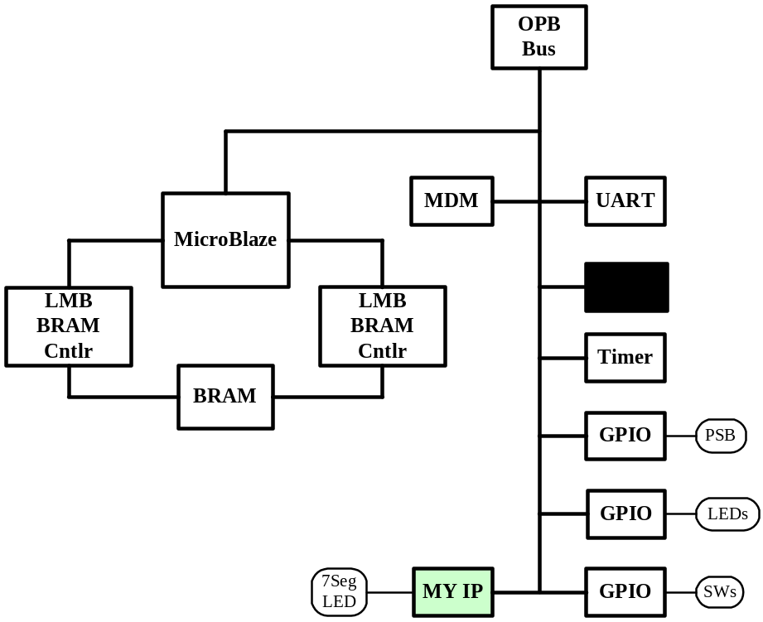

Figure 7c-1. Completed Design

This lab comprises several steps involving the addition of a custom OPB peripheral. Although the change to the hardware is simple, the lab illustrates the integration of a user peripheral through the importing peripheral wizard. The lab also illustrates the use of an existing peripheral to provide the OPB bus interface.

Below each general instruction for a given procedure, you will find accompanying step-by-step directions and illustrated figures providing more detail for performing the general instruction. If you feel confident about a specific instruction, feel free to skip the step-by-step directions and move on to the next general instruction in the procedure.

Note: If you are unable to complete the lab at this time, you can download the lab files for this module from the Xilinx University Program site at http://university.xilinx.com

Opening the Project Step 1

Create a lab3mb folder under c:\xup\embedded\labs\. If you wish to continue with your completed design from lab2 then copy the contents of the lab2mb folder into the lab3mb folder, otherwise, if you wish to start with a known good design, then copy the contents of c:\xup\embedded\mb_completed\lab2mb into the lab3mb folder. Launch Xilinx Platform Studio (XPS) and open the project file located in c:\xup\embedded\labs\lab3mb.

- Create a lab3mb folder in the c:\xup\embedded\labs directory. If you wish to continue with your completed design from lab2 then copy the contents of the lab2mb folder into the lab3mb folder, otherwise, if you wish to start with a known good design, then copy the contents of c:\xup\embedded\mb_completed\lab2mb into the lab3mb directory.

- Open XPS by clicking Start → Programs → Xilinx Platform Studio 6.2i → Xilinx Platform Studio

- Click File → Open Project and browse to the project which in the directory: c:\xup\embedded\labs\lab3mb

- Select system.xmp in the lab3mb directory to open the project

Creating a Custom OPB Peripheral using Wizard Step 2
Use Tools → Create - Import Peripheral Wizard to create a custom OPB peripheral.

- Click Tools → Create - Import Peripheral Wizard in XPS

The Introduction screen for the Create - Import Peripheral Wizard will appear (Figure 7c-2)

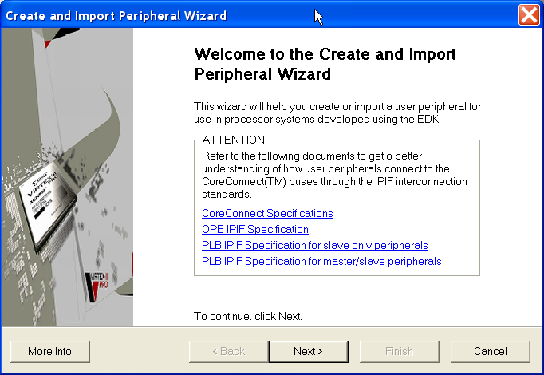
Figure 7c-2. Create and Import Peripheral Wizard Introduction Screen
- Click Next and the Create and Import Peripheral Wizard’s flow selection will appear

This wizard will help you create templates for a new EDK compliant peripheral or help you import an existing peripheral into an XPS project or EDK repository. For this project we will create an EDK-compliant peripheral.

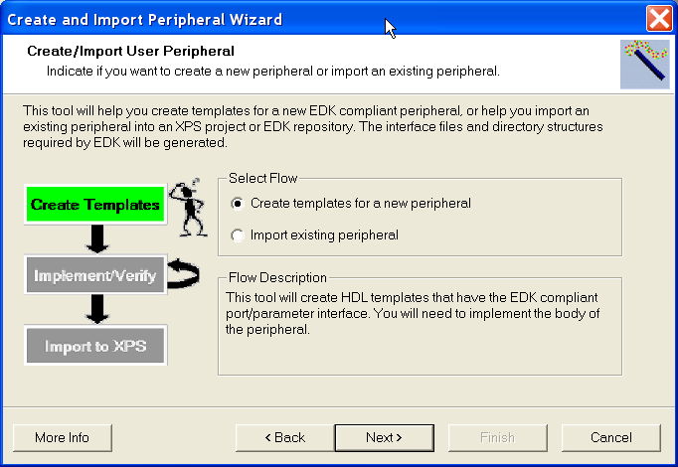
Figure 7c-3. Create/Import User Peripheral Screen

- The default selection is Create template for a new peripheral. Ensure the radio button is on for this selection Click Next and the Create and Import Peripheral Wizard’s target selection will appear

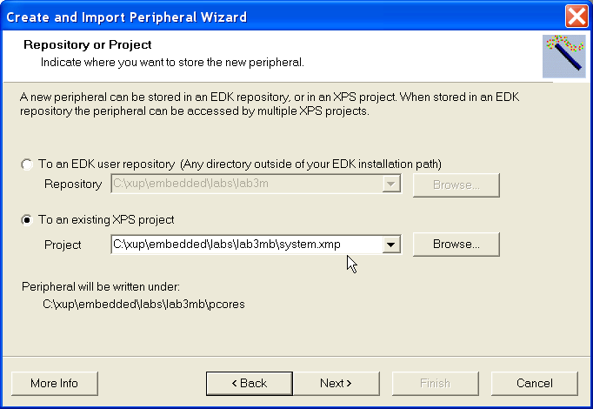
Figure 7c-4. Repository or Project Screen
- Make sure the radio button for To an existing XPS project is selected, and navigate to lab3mb\system.xmp. Click Next and the Create Peripheral – Step 1 dialogue will appear for you to indicate the name of the peripheral.

- Enter opb_7segled in the name field and check the User Version Name check-box, as shown in Figure 7c-5

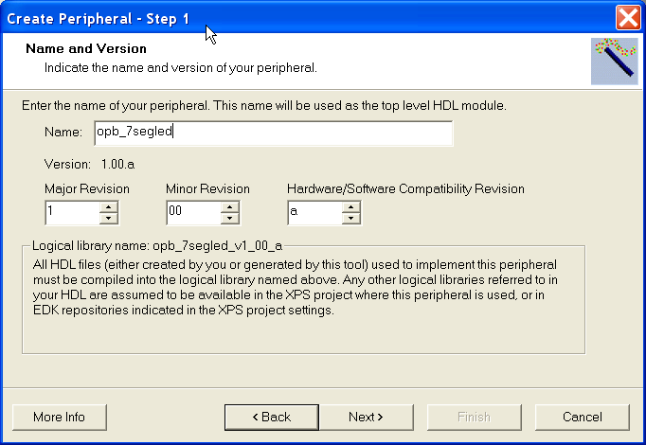
Figure 7c-5. Provide Core Name and Version Number
- Click Next to select the bus attachment

Setup the features required by the custom peripheral. Go through the steps, and generate the peripheral core template

- This is an OPB peripheral so leave the default settings and click Next

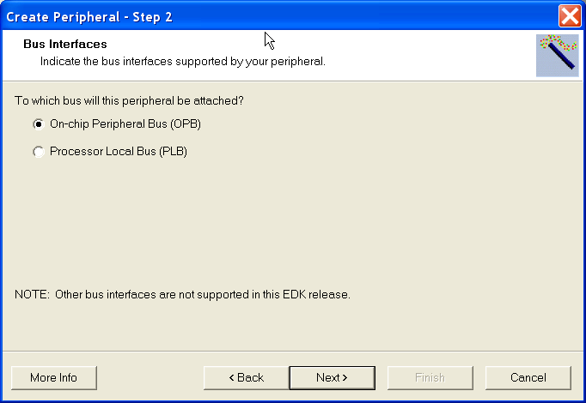
Figure 7c-6. Select the Bus Interface

- In the IPIF Services window, you select the IPIF features you want to support in your peripheral. For the 7-Segment LED we only need registers for the digit values. Select User Logic S/W Register Support as shown below and click Next

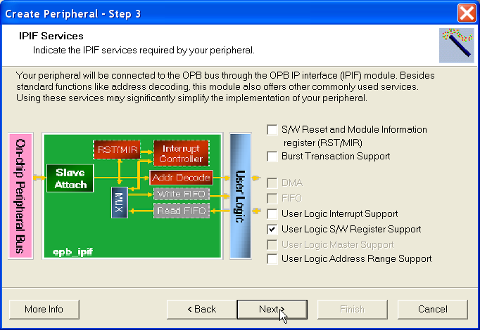
Figure 7c-7. Select IPIF Services

- We need four registers (one for each digit to display) and each register will be 8-bits wide. Select the values as shown in Figure 7c-8 and click Next.

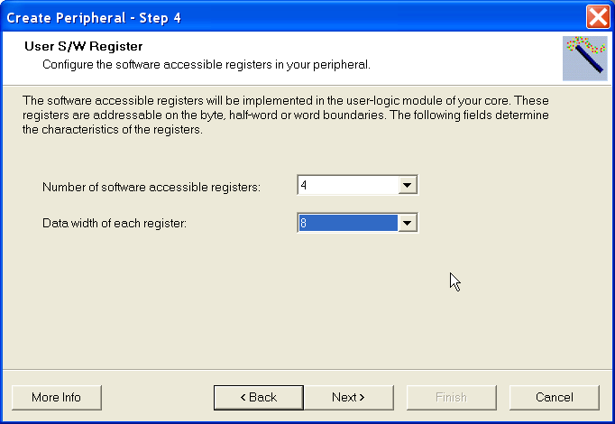
Figure 7c-8. Configure Registers

- The IP Interconnect (IPIC) lets you customize the signals in the interface between the custom logic and the IPIF. For this peripheral the default connections are all that are needed, click Next.

- Step 6, Review Design Flow, gives the option of setting up and ISE project if that is where the peripheral HDL will be developed. This example will be done in XPS, click Next.

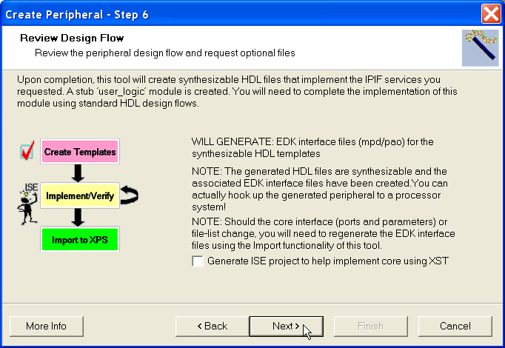
Figure 7c-9. Select Design Flow

- This completes the Peripheral template generation, click Finish.

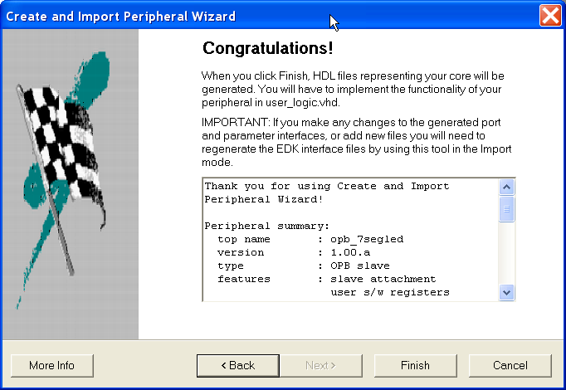
Figure 7c-10. Template Complete

-  The peripheral directories are scanned at the time a project is opened. XPS will ask if the project should be closed to make the new peripheral available. It is not ready to use, so select NO.

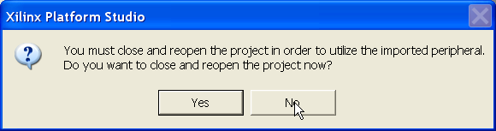
Figure 7c-11. Close Project

- Use Windows Explorer to browse to your project directory and ensure that the following structure has been created by the Importing Peripheral Wizard
MPD
PAO
ipwiz.log
Lab3mb
opb_7segled_v1_00_a
data
hdl
pcores
devl

vhdl

opb_7segled
user_logic

Figure 7c-12. Structure Created by the Importing Peripheral Wizard

Note: The ipwiz.log is the importing peripheral wizard log file

Customizing the Peripheral Step 3

The intent of this section is not to cover HDL coding, but to highlight the area within the templates that custom logic will be added.

Open the vhdl source for the 7segled custom peripheral and add the user logic.

- Open the opb_7segled.vhd file by clicking File → Open → c:\xup\embedded\labs\lab3mb\pcores\opb_7segled_v1_00_a\hdl\vhdl\opb_7segled.vhd from XPS

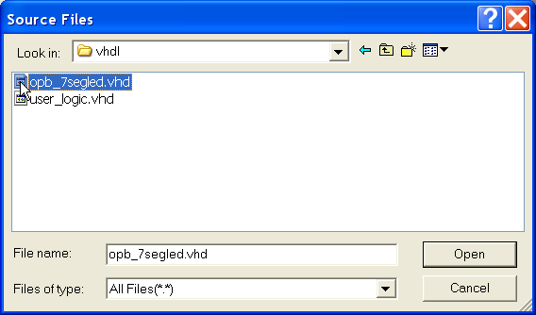
Figure 7c-13. Open VHDL source

Sections to add user code will be marked with commented sections similar to that below.

-- ADD USER GENERICS BELOW THIS LINE ---------------
--USER generics added here
-- ADD USER GENERICS ABOVE THIS LINE ---------------
-- DO NOT EDIT BELOW THIS LINE ---------------------
- First ports need to be added for the I/O signals that will connect to the 7 segment LCD module. Edit line 122 (area between comments for adding USER PORTS to be the following:

-- ADD USER PORTS BELOW THIS LINE ------------------
digit : out std_logic_vector(0 to 3);
segment : out std_logic_vector(0 to 7);
-- ADD USER PORTS ABOVE THIS LINE ------------------
- Next the ports need to be added to the component instantiation. Edit line 373 (area between comments for mapping USER PORTS to be the following:

-- MAP USER PORTS BELOW THIS LINE ------------------
digit => digit,
segment => segment,
-- MAP USER PORTS ABOVE THIS LINE ------------------
- That completes the changes to the opb_7segled definition. Save and close the file.

- The opb_7segled.vhd file defines the connectivity of the custom core and includes the OPB and IPIF attachment files. The user_logic.vhd file is where the actual function is implemented. Open the user_logic.vhd file by clicking File → Open → c:\xup\embedded\labs\lab3mb\pcores\opb_7segled_v1_00_a\hdl\vhdl\user_logic.vhd from XPS

- Again we begin by adding the user ports to the entity declaration. Edit line 101 (area between comments for adding USER PORTS to be the following:

-- ADD USER PORTS BELOW THIS LINE ------------------
digit : out std_logic_vector(0 to 3);
segment : out std_logic_vector(0 to 7);
-- ADD USER PORTS ABOVE THIS LINE ------------------
- The final step is to add the HDL logic. This is best done by cut and pasting the following over the entire architecture section. This text can be copied from this Word document, or by using the file provided in the lab sources directory. To copy from the lab sources directory, open C:\xup\embedded\lab_sources\lab3_sources\opb_7segled_user_logic_vhdl.TXT and copy and paste its contents over the architecture section.

--------------------------------------------------------------------------------
-- Architecture section
--------------------------------------------------------------------------------
architecture IMP of user_logic is
----------------------------------------
-- User logic S/W accessible registers
----------------------------------------
signal reg0 : std_logic_vector(0 to C_DWIDTH-1);
signal reg1 : std_logic_vector(0 to C_DWIDTH-1);
signal reg2 : std_logic_vector(0 to C_DWIDTH-1);
signal reg3 : std_logic_vector(0 to C_DWIDTH-1);
signal reg_write_select : std_logic_vector(0 to 3);
signal reg_read_select : std_logic_vector(0 to 3);
signal digit_select : std_logic_vector(0 to 1);
signal digit_i : std_logic_vector(0 to 3);
signal segment_i : std_logic_vector(0 to 7);
signal mhertz_count : std_logic_vector(5 downto 0);
signal khertz_count : std_logic_vector(9 downto 0);
signal mhertz_en : std_logic;
signal khertz_en : std_logic;
begin
----------------------------------------
-- Map user logic S/W register read/write select signal
----------------------------------------
reg_write_select <= Bus2IP_WrCE;
reg_read_select <= Bus2IP_RdCE;
----------------------------------------
-- User logic S/W accessible registers write example
----------------------------------------
REG_WRITE_PROC : process( Bus2IP_Clk ) is
begin
if Bus2IP_Clk'event and Bus2IP_Clk = '1' then
if Bus2IP_Reset = '1' then
reg0 <= (others => '0');
reg1 <= (others => '0');
reg2 <= (others => '0');
reg3 <= (others => '0');
else
case reg_write_select is
when "1000" => reg0 <= Bus2IP_Data;
when "0100" => reg1 <= Bus2IP_Data;
when "0010" => reg2 <= Bus2IP_Data;
when "0001" => reg3 <= Bus2IP_Data;
when others => null;
end case;
end if;
end if;
end process REG_WRITE_PROC;
----------------------------------------
-- User logic S/W accessible registers read example
----------------------------------------
REG_READ_PROC : process( reg_read_select, reg0, reg1, reg2, reg3 ) is
begin
case reg_read_select is
when "1000" => IP2Bus_Data <= reg0;
when "0100" => IP2Bus_Data <= reg1;
when "0010" => IP2Bus_Data <= reg2;
when "0001" => IP2Bus_Data <= reg3;
when others => IP2Bus_Data <= (others => '0');
end case;
end process REG_READ_PROC;
----------------------------------------
-- Clock Dividers
----------------------------------------
GEN_1MHZ : process (Bus2IP_Clk) is
begin
if Bus2IP_Clk'event and Bus2IP_Clk = '1' then
if Bus2IP_Reset = '1' then
mhertz_count <= (others => '0');
mhertz_en <= '0';
else
mhertz_count <= mhertz_count + 1;
if mhertz_count = "110010" then
mhertz_en <= '1' ;
mhertz_count <= (others => '0');
else
mhertz_en <= '0';
end if;
end if;
end if;
end process GEN_1MHZ;
GEN_1KHZ : process (Bus2IP_Clk) is
begin
if Bus2IP_Clk'event and Bus2IP_Clk = '1' then
if Bus2IP_Reset = '1' then
khertz_count <= (others => '0');
khertz_en <= '0';
else
if mhertz_en = '1' then
khertz_count <= khertz_count + 1;
if khertz_count = "1111101000" then
khertz_en <= '1';
khertz_count <= (others => '0');
end if;
else
khertz_en <= '0';
end if;
end if;
end if;
end process GEN_1KHZ;
----------------------------------------
-- User logic display update
----------------------------------------
CYC_DISP_PROC : process( Bus2IP_Clk ) is
begin
if Bus2IP_Clk'event and Bus2IP_Clk = '1' then
if Bus2IP_Reset = '1' then
digit_select <= (others => '0');
digit_i <= (others => '1');
segment_i <= (others => '1');
else
if khertz_en = '1' then
digit_select <= digit_select + 1 ;
case digit_select is
when "00" => segment_i <= reg0; digit_i <= "1110";
when "01" => segment_i <= reg1; digit_i <= "1101";
when "10" => segment_i <= reg2; digit_i <= "1011";
when "11" => segment_i <= reg3; digit_i <= "0111";
when others => null;
end case;
end if;
end if;
end if;
end process CYC_DISP_PROC;
----------------------------------------
-- Simple example to drive IP2Bus signals
----------------------------------------
IP2Bus_Ack <= Bus2IP_WrCE(0) or Bus2IP_WrCE(1) or Bus2IP_WrCE(2) or Bus2IP_WrCE(3) or Bus2IP_RdCE(0) or Bus2IP_RdCE(1) or Bus2IP_RdCE(2) or Bus2IP_RdCE(3);
IP2Bus_Error <= '0';
IP2Bus_Retry <= '0';
IP2Bus_ToutSup <= '0';
digit <= digit_i;
segment <= segment_i;
end IMP;

- That completes the changes to the user_logic implementation. Save and close the file.

- The ports that were added to the peripheral need to be added to the peripheral description file (MPD). This can be done by rerunning the peripheral wizard as a peripheral import instead of creating a peripheral. This can also be done by editing the underlying text file.

Open the opb_7segled.mpd file by clicking File → Open → c:\xup\embedded\labs\lab3mb\pcores\opb_7segled_v1_00_a\data\opb_7segled.mpd from XPS.

Add the PORT definitions at line 27 so the file now looks like the following:

## Ports
PORT digit = "", DIR = O, VEC = [0:3]
PORT segment = "", DIR = O, VEC = [0:7]
PORT OPB_Clk = "", DIR = I, SIGIS = Clk, BUS = SOPB

Save and Close the file.

- Close the project so that the peripheral can be seen by XPS, File → Close Project.

Adding the Custom Peripheral to the System Step 4
Open the project again and add the led custom peripheral to your system by using Project → Add/Edit Cores (dialog).

- Open the project by clicking File → Recent Projects → c:\xup\embedded\labs\lab3mb\system.xmp from XPS

- Click Project → Add/Edit Cores (dialog)

- In the Peripherals tab, select opb_7segled from the available IPs list, and click ADD to add the peripheral to the system

- Change the base address to 0x80002A00 and the end address to 0x80002AFF

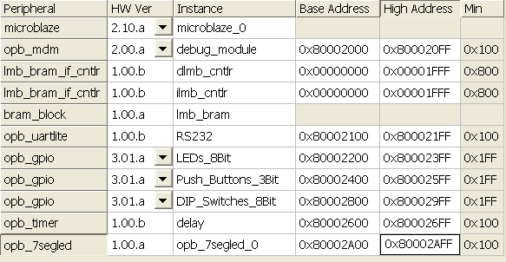
Figure 7c-14. Change the Base and End Address
- In the Bus Connection tab, assign the opb_7segled_0 instance to the OPB bus as a slave device

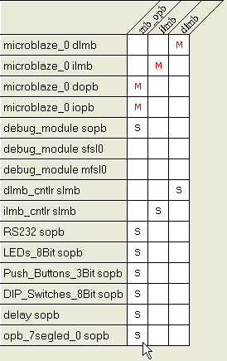
Figure 7c-15. Assign the opb_7segled_0 Instance
- In the Ports tab, filter on opb_7segled_0, select the following ports and add them:

OPB_CLK
Digit
segment

- The ports for the opb_7segled_0 instance need to be adjusted

Change the net name connected to the segment port to segment and give it a Range of [0:7].

Change the net name connected to the digit port to digit and give it a Range of [0:3].

Change the net name connected to the OPB_CLK port to sys_clk_s and make it internal.

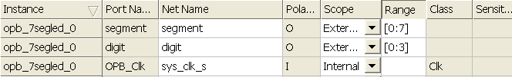
Figure 7c-16. Change the Net Name and Make It Internal

- Click the OK button to accept the settings and close the dialog window

Modify the UCF file to assign opb_7segled connections.
- Open the system.ucf file by double-clicking the UCF File: data\system.ucf entry under Project Files in the System BSP window

- Add the following lines at the end of the file to assign pins to the opb_7segled ports, or copy and paste the contents of the file: C:\xup\embedded\lab_sources\lab3_sources\opb_7segled_user_logic_ucf.TXT

NET digit<3> LOC=d14;
NET digit<2> LOC=g14;
NET digit<1> LOC=f14;
NET digit<0> LOC=e13;

NET segment<7> LOC=e14;
NET segment<6> LOC=g13;
NET segment<5> LOC=n15;
NET segment<4> LOC=p15;
NET segment<3> LOC=r16;
NET segment<2> LOC=f13;
NET segment<1> LOC=n16;
NET segment<0> LOC=p16;

- Save and close the file

Testing the system Step 5
Set the project flow to XFLOW via the Options → Project Options → Hierarchy and Flow tab. Implement the system by using Tools → Generate Bitstream.

- In XPS, click the Options → Project Options → Hierarchy and Flow tab

- Select XPS(XFLOW) flow and click OK to accept the settings

- Click Tools → Download implement the design.

Observe the implementation process in the console window as it progresses

- The output on the terminal display is still the same, but the 7 Segment LEDs should now be all fully ON.

Conclusion

The Import Peripheral Wizard can be used to integrate your user peripheral into an existing processor system. The wizard creates the necessary directory structure and adds the necessary files (MPD, PAO) to the project directory. After the peripheral is imported, you can use the peripheral in the design by using the same XPS flows that you have seen in previous labs.

A

Completed MHS File

# ##############################################################################
# Created by Base System Builder Wizard for Xilinx EDK 6.2.2 Build EDK_Gm.13.6
# Mon Aug 16 14:59:56 2004
# Target Board: Xilinx Spartan-3 Starter Board Rev E
# Family: spartan3
# Device: XC3S200
# Package: FT256
# Speed Grade: -4
# Processor: Microblaze
# System clock frequency: 50 MHz
# Debug interface: On-Chip HW Debug Module
# On Chip Memory : 8 KB
# ##############################################################################

PARAMETER VERSION = 2.1.0

PORT sys_clk = sys_clk_s, DIR = IN, SIGIS = CLK
PORT sys_rst = sys_rst_s, DIR = IN
PORT segment = segment, VEC = [0:7], DIR = O
PORT digit = digit, VEC = [0:3], DIR = O
PORT RS232_TX = RS232_TX, DIR = O
PORT RS232_RX = RS232_RX, DIR = I
PORT Push_Buttons_3Bit_GPIO_in = Push_Buttons_3Bit_GPIO_in, VEC = [0:2], DIR = I
PORT LEDs_8Bit_GPIO_d_out = LEDs_8Bit_GPIO_d_out, VEC = [0:7], DIR = O
PORT DIP_Switches_8Bit_GPIO_in = DIP_Switches_8Bit_GPIO_in, VEC = [0:7], DIR = I

BEGIN microblaze
PARAMETER INSTANCE = microblaze_0
PARAMETER HW_VER = 2.10.a
PARAMETER C_DEBUG_ENABLED = 1
PARAMETER C_NUMBER_OF_PC_BRK = 2
PARAMETER C_NUMBER_OF_RD_ADDR_BRK = 1
PARAMETER C_NUMBER_OF_WR_ADDR_BRK = 1
BUS_INTERFACE DLMB = dlmb
BUS_INTERFACE ILMB = ilmb
BUS_INTERFACE DOPB = mb_opb
BUS_INTERFACE IOPB = mb_opb
PORT DBG_UPDATE = DBG_UPDATE_s
PORT DBG_CAPTURE = DBG_CAPTURE_s
PORT DBG_TDI = DBG_TDI_s
PORT DBG_CLK = DBG_CLK_s
PORT DBG_REG_EN = DBG_REG_EN_s
PORT CLK = sys_clk_s
PORT DBG_TDO = DBG_TDO_s
END

BEGIN opb_v20
PARAMETER INSTANCE = mb_opb
PARAMETER HW_VER = 1.10.b
PARAMETER C_EXT_RESET_HIGH = 1
PORT SYS_Rst = sys_rst_s
PORT OPB_Clk = sys_clk_s
END

BEGIN opb_mdm
PARAMETER INSTANCE = debug_module
PARAMETER HW_VER = 2.00.a
PARAMETER C_MB_DBG_PORTS = 1
PARAMETER C_USE_UART = 1
PARAMETER C_UART_WIDTH = 8
PARAMETER C_BASEADDR = 0x80002000
PARAMETER C_HIGHADDR = 0x800020FF
BUS_INTERFACE SOPB = mb_opb
PORT DBG_CLK_0 = DBG_CLK_s
PORT DBG_REG_EN_0 = DBG_REG_EN_s
PORT OPB_Clk = sys_clk_s
PORT DBG_CAPTURE_0 = DBG_CAPTURE_s
PORT DBG_UPDATE_0 = DBG_UPDATE_s
PORT DBG_TDO_0 = DBG_TDO_s
PORT DBG_TDI_0 = DBG_TDI_s
END

BEGIN lmb_v10
PARAMETER INSTANCE = ilmb
PARAMETER HW_VER = 1.00.a
PARAMETER C_EXT_RESET_HIGH = 1
PORT SYS_Rst = sys_rst_s
PORT LMB_Clk = sys_clk_s
END

BEGIN lmb_v10
PARAMETER INSTANCE = dlmb
PARAMETER HW_VER = 1.00.a
PARAMETER C_EXT_RESET_HIGH = 1
PORT SYS_Rst = sys_rst_s
PORT LMB_Clk = sys_clk_s
END

BEGIN lmb_bram_if_cntlr
PARAMETER INSTANCE = dlmb_cntlr
PARAMETER HW_VER = 1.00.b
PARAMETER C_MASK = 0x80000000
PARAMETER C_BASEADDR = 0x00000000
PARAMETER C_HIGHADDR = 0x00001FFF
BUS_INTERFACE SLMB = dlmb
BUS_INTERFACE BRAM_PORT = dlmb_port
END

BEGIN lmb_bram_if_cntlr
PARAMETER INSTANCE = ilmb_cntlr
PARAMETER HW_VER = 1.00.b
PARAMETER C_MASK = 0x80000000
PARAMETER C_BASEADDR = 0x00000000
PARAMETER C_HIGHADDR = 0x00001FFF
BUS_INTERFACE SLMB = ilmb
BUS_INTERFACE BRAM_PORT = ilmb_port
END

BEGIN bram_block
PARAMETER INSTANCE = lmb_bram
PARAMETER HW_VER = 1.00.a
BUS_INTERFACE PORTA = ilmb_port
BUS_INTERFACE PORTB = dlmb_port
END

BEGIN opb_uartlite
PARAMETER INSTANCE = RS232
PARAMETER HW_VER = 1.00.b
PARAMETER C_BAUDRATE = 9600
PARAMETER C_DATA_BITS = 8
PARAMETER C_ODD_PARITY = 0
PARAMETER C_USE_PARITY = 0
PARAMETER C_CLK_FREQ = 50000000
PARAMETER C_BASEADDR = 0x80002100
PARAMETER C_HIGHADDR = 0x800021FF
BUS_INTERFACE SOPB = mb_opb
PORT TX = RS232_TX
PORT RX = RS232_RX
PORT OPB_Clk = sys_clk_s
END

BEGIN opb_gpio
PARAMETER INSTANCE = LEDs_8Bit
PARAMETER HW_VER = 3.01.a
PARAMETER C_GPIO_WIDTH = 8
PARAMETER C_IS_DUAL = 0
PARAMETER C_IS_BIDIR = 0
PARAMETER C_ALL_INPUTS = 0
PARAMETER C_BASEADDR = 0x80002200
PARAMETER C_HIGHADDR = 0x800023FF
BUS_INTERFACE SOPB = mb_opb
PORT OPB_Clk = sys_clk_s
PORT GPIO_d_out = LEDs_8Bit_GPIO_d_out
END

BEGIN opb_gpio
PARAMETER INSTANCE = Push_Buttons_3Bit
PARAMETER HW_VER = 3.01.a
PARAMETER C_GPIO_WIDTH = 3
PARAMETER C_IS_DUAL = 0
PARAMETER C_IS_BIDIR = 0
PARAMETER C_ALL_INPUTS = 1
PARAMETER C_BASEADDR = 0x80002400
PARAMETER C_HIGHADDR = 0x800025FF
BUS_INTERFACE SOPB = mb_opb
PORT OPB_Clk = sys_clk_s
PORT GPIO_in = Push_Buttons_3Bit_GPIO_in
END

BEGIN opb_gpio
PARAMETER INSTANCE = DIP_Switches_8Bit
PARAMETER HW_VER = 3.01.a
PARAMETER C_BASEADDR = 0x80002800
PARAMETER C_HIGHADDR = 0x800029FF
PARAMETER C_GPIO_WIDTH = 8
PARAMETER C_ALL_INPUTS = 1
PARAMETER C_IS_DUAL = 0
BUS_INTERFACE SOPB = mb_opb
PORT OPB_Clk = sys_clk_s
PORT GPIO_in = DIP_Switches_8Bit_GPIO_in
END

BEGIN opb_timer
PARAMETER INSTANCE = delay
PARAMETER HW_VER = 1.00.b
PARAMETER C_BASEADDR = 0x80002600
PARAMETER C_HIGHADDR = 0x800026FF
PARAMETER C_COUNT_WIDTH = 32
PARAMETER C_ONE_TIMER_ONLY = 1
PARAMETER C_TRIG0_ASSERT = 1
PARAMETER C_GEN0_ASSERT = 1
BUS_INTERFACE SOPB = mb_opb
PORT CaptureTrig0 = net_gnd
PORT OPB_Clk = sys_clk_s
END

BEGIN opb_7segled
PARAMETER INSTANCE = opb_7segled_0
PARAMETER HW_VER = 1.00.a
PARAMETER C_BASEADDR = 0x80002A00
PARAMETER C_HIGHADDR = 0x80002AFF
BUS_INTERFACE SOPB = mb_opb
PORT segment = segment
PORT digit = digit
PORT OPB_Clk = sys_clk_s
END

