package com.db1;

import java.sql.Connection;

import java.sql.DriverManager;

import java.sql.ResultSet;

import java.sql.Statement;

public class db1 {

//配置mysql连接数据库

public static Connection getConn()

{

Connection con=null;

try{

Class.forName("org.gjt.mm.mysql.Driver");

String url="jdbc:mysql://localhost/testshop?useUnicode=true&characterEncoding=UTF-8";

con = DriverManager.getConnection(url, "root", "");

}catch(Exception e)

{

e.printStackTrace();

}

return con;

}

//配置查询并输出表内所有值

public String CheckLogin(){

String id = null;

String name=null;

String sql="select * from role ";

Statement stat = null;

ResultSet rs = null;

Connection conn = new db1().getConn();

try{

stat = conn.createStatement();

rs = stat.executeQuery(sql);

System.out.println("role_id role_name");

while (rs.next()) {

id = rs.getString("role_id");

name=rs.getString("role_name");

System.out.println(id+" "+name);

}

} catch(Exception e){

e.printStackTrace();

}finally{

try{

rs.close();

stat.close();

conn.close();

}catch(Exception e){e.printStackTrace();}

}

return id;

}

public static void main(String[] args)

{

new db1().getConn();

new db1().CheckLogin();

System.out.println("连接成功！");

}

}

数据库表：

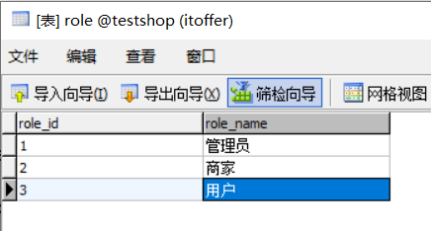

运行结果：

role_id role_name

1 管理员

2 商家

3 用户

连接成功！