Installation MySQL , Apache, PHP a partir codes sources:

1-MySQL:
~$ sudo su
~# cd /usr/local/etc
Telechargement d’un code source mysql
Etap 1:Decompression et desarchivage:
~/cd/usr/local/src # bunzip2 /home/user/mysql-8.0.36
~/cd/usr/local/src # tar -xvf /home/user/mysql-8.0.36
~/cd/usr/local/src # cd mysql-8.0.36
Etape 2:Installation :dependance boost-1-77-0
Telechargement d’un code source boost
Decompression et desarchivage:
~/cd/usr/local/src/ #bunzip2 /home/user/boost-1-77-0.tar.bz2
~/cd/usr/local/src/mysql-8.0.36 $ tar -xvf /home/user/boost-1-77-0 .tar

~/cd/usr/local/src/mysql-8.0.36 # cd boost-1-77-0
~/cd/usr/local/src/mysql-8.0.36 /boost-1-77-0#ls -a
~/cd/usr/local/src/mysql-8.0.36/boost-1-77-0# README
~/cd/usr/local/src/mysql-8.0.36/boost-1-77-0# ./bootstrap.sh
~/cd/usr/local/src/mysql-8.0.36# ./b2
~/cd/usr/local/src/ mysql-8.0.36 # ./b2 install
Etape 3:installation mysql
~/cd/usr/local/src/mysql-8.0.36/ boost-1-77-0 #mkdir build
~/cd/usr/local/src/mysql-8.0.36/boost-1-77-0# cd build
~/cd/usr/local/src/mysql-8.0.36/boost-1-77-0/build# cmake
no error
~/cd/usr/local/src/ mysql-8.0.36/boost-1-77-0/build# make
~/cd/usr/local/src/mysql-8.0.36/boost-1-77-0/build# make install
verification : mysql --version

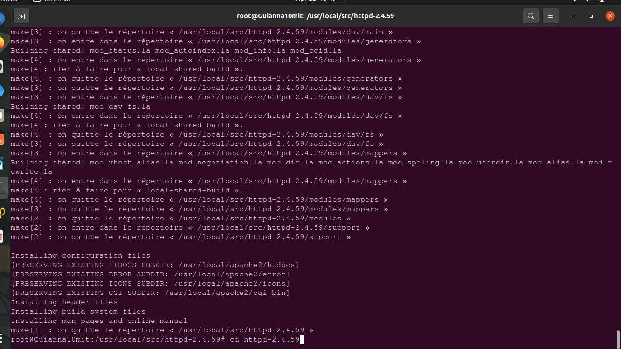
2-Apache2:
~$ sudo su
~# cd /usr/local/src
Decompression et desarchivage:
~/cd/usr/local/src # bunzip2 /home/mit/httpd_version.tar.bz2
~/cd/usr/local/src # tar -xvf /home/mit/httpd_version.tar

Etape1:Installation des dependances :
apr:
Decompression et desarchivage :
~/cd/usr/local/src #cd httpd_version
~/cd/usr/local/src/httpd #gunzip2 /home/mit/apr_version.tar.gz
~/cd/usr/local/src/httpd # tar -xvf /home/mit/apr_version.tar

~/cd/usr/local/src/httpd #cd apr_version
~/cd/usr/local/src/httpd/apr_version #./configure
~/cd/usr/local/src/httpd/apr_version r#make
~/cd/usr/local/src/httpd/apr_version# make install

~/cd/usr/local/src/httpd/apr_version #cd ..
apr-util:
Decompression et desarchivage;

~/cd/usr/local/src/httpd #cd apr-util_version
~/cd/usr/local/src/httpd/apr-util_version# ./configure
Eroor : ./configure not found
~/cd/usr/local/src/httpd/apr-util_version# ./configure –with-apr=/usr/local/apr/bin/apr-1-config
~/cd/usr/local/src/httpd/apr-util_version #make && make install
prce :
Decompression et desarchivage;
~/cd/usr/local/src/httpd#cd prce_version
~/cd/usr/local/src/httpd/cd prce_version# ./configure
fatal-error:expart.h:no such file
~/cd/usr/local/src/httpd/cd prce_version#apt install libexpat1.dev
~/cd/usr/local/src/httpd/cd prce_version# ./configure
~/cd/usr/local/src/httpd/cd prce_version# make && make install
Etape 2: Installation apache2

~/cd/usr/local/src/httpd_version$#./configure –prefix=/usr/local/apache2 –with-prce=/usr/local/bin –enable-so
~/cd/usr/local/src/httpd_version# make && make install
verification: apache2 -v
3-PHP:

~$sudo su
~# php_source
~#cd php_source
telechargement d’un code source php
Etape 1:
~/php_source#gunzip /home/mit/php-8.3.6.tar.zip
~/php_source#tar -xvf /home/mit/php-8.3.6.tar
~/php_source# cd php-8.3.6
~/php_sources/php-8.3.6#more README.md
Etape 2: installation php en suivant les instructions données par README.md
~/php_xources/php-8.3.6# apt install -y pkg-conf build-essential autoconf bison re2c \ libxm12-dev libsqlete3-dev
~/php_sources/php-8.3.6# ./buildconf
~/php_sources/php-8.3.6# ./configure
~/php_sources/php-8.3.6# make
sans erreur
~/php_sources/php-8.3.6# make installer
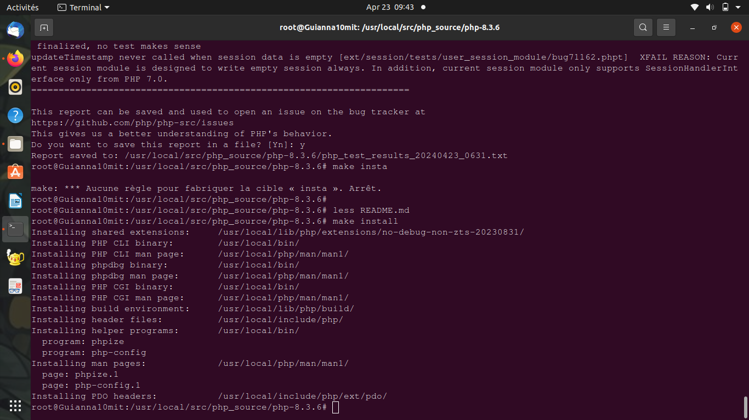
verification:php --version

