2.课程目标达成评价表
学生信息 |  |  | 课程目标1 |  |  |  |  |  | 课程目标2
序号 | 学号 | 姓名 | 过程性考核成绩  （平时成绩）（40%） |  |  |  | 期末考试  成绩(60%) | 达成度 | 过程性考核成绩  （平时成绩）（40%） |  |  |  | 期末考试成绩(60%) | 达成度
 |  |  | 平时作业(25分) | 实验操作  (10分) | 实验报告（10分） | 课堂表现  (5分) | 考试试卷  (50)分 |  | 平时作业(25分) | 实验操作  (10分) | 实验报告（10分） | 课堂表现  (5分) | 考试试卷  (50)分
1 | 202121010429 | 李源鑫 | 22.0 | 8.0 | 8.0 | 3.0 | 27.0 | 0.65 | 23.0 | 9.0 | 9.0 | 4.0 | 21.0 | 0.61
2 | 202201130622 | 吴志浩 | 20.0 | 12.0 | 8.0 | 2.0 | 34.0 | 0.74 | 21.5 | 6.0 | 7.5 | 2.0 | 29.0 | 0.64
3 | 202208020306 | 冯杰 | 24.0 | 7.0 | 8.0 | 4.0 | 26.0 | 0.66 | 23.0 | 9.0 | 8.0 | 4.0 | 31.0 | 0.72
4 | 202221010201 | 杨硕 | 0.0 | 0.0 | 0.0 | 0.0 | 0.0 | 0.00 | 0.0 | 0.0 | 0.0 | 0.0 | 0.0 | 0.00
5 | 202221010209 | 左超 | 25.0 | 9.0 | 9.0 | 5.0 | 40.0 | 0.86 | 24.0 | 9.0 | 9.0 | 5.0 | 40.0 | 0.86
6 | 202221010213 | 王贺兵 | 23.0 | 8.0 | 9.0 | 3.0 | 28.0 | 0.68 | 20.0 | 8.0 | 9.0 | 3.0 | 28.0 | 0.66
7 | 202221010215 | 刘子豪 | 23.0 | 9.0 | 9.0 | 5.0 | 37.0 | 0.81 | 22.0 | 9.0 | 9.0 | 3.0 | 28.0 | 0.68
8 | 202221010301 | 张伦嘉 | 18.0 | 8.0 | 8.0 | 2.0 | 24.0 | 0.58 | 24.0 | 9.0 | 9.0 | 3.0 | 31.0 | 0.73
9 | 202221010303 | 刘晨阳 | 22.0 | 7.0 | 9.0 | 3.0 | 36.0 | 0.76 | 23.0 | 7.0 | 9.0 | 4.0 | 30.0 | 0.70
10 | 202221010312 | 张海天 | 24.0 | 9.0 | 9.5 | 4.5 | 33.0 | 0.77 | 22.0 | 7.0 | 7.0 | 4.0 | 36.0 | 0.75
11 | 202221010414 | 吴楚云 | 24.0 | 8.0 | 8.0 | 3.0 | 30.0 | 0.70 | 22.0 | 7.0 | 8.0 | 2.0 | 31.0 | 0.68
12 | 202221010514 | 周雨豪 | 23.0 | 8.5 | 8.5 | 5.0 | 33.0 | 0.76 | 20.0 | 8.0 | 8.0 | 4.0 | 30.0 | 0.68
13 | 202306150210 | 刘星宇 | 22.0 | 8.0 | 6.5 | 3.0 | 33.0 | 0.71 | 21.5 | 7.5 | 6.5 | 3.0 | 33.0 | 0.70
14 | 202321010101 | 蔡宗旭 | 24.0 | 9.0 | 9.0 | 4.0 | 40.0 | 0.85 | 24.0 | 8.0 | 9.0 | 4.0 | 38.0 | 0.82
15 | 202321010103 | 冯创毅 | 0.0 | 0.0 | 0.0 | 0.0 | 0.0 | 0.00 | 0.0 | 0.0 | 0.0 | 0.0 | 0.0 | 0.00
16 | 202321010106 | 林炬宏 | 24.0 | 8.5 | 7.5 | 4.0 | 28.0 | 0.69 | 22.0 | 7.5 | 6.5 | 4.0 | 22.0 | 0.58
17 | 202321010107 | 刘锦亿 | 25.0 | 8.0 | 9.0 | 5.0 | 38.0 | 0.83 | 24.0 | 10.0 | 9.0 | 5.0 | 41.0 | 0.88
18 | 202321010110 | 邵杨 | 24.0 | 9.5 | 9.5 | 4.0 | 32.0 | 0.76 | 19.5 | 8.5 | 7.0 | 4.0 | 26.0 | 0.62
19 | 202321010111 | 石权 | 23.0 | 8.0 | 9.0 | 5.0 | 33.0 | 0.76 | 22.0 | 8.0 | 9.0 | 4.0 | 31.0 | 0.72
20 | 202321010115 | 田武杰 | 21.0 | 7.0 | 8.5 | 4.5 | 29.0 | 0.68 | 24.0 | 9.0 | 8.5 | 4.5 | 29.0 | 0.72
21 | 202321010116 | 王锦 | 23.0 | 9.0 | 7.5 | 1.5 | 32.0 | 0.71 | 21.0 | 8.0 | 10.0 | 5.0 | 34.0 | 0.76
22 | 202321010117 | 谢文俊 | 22.0 | 7.0 | 8.0 | 3.0 | 29.0 | 0.67 | 23.0 | 9.5 | 8.5 | 2.0 | 28.0 | 0.68
23 | 202321010118 | 徐凤铎 | 24.0 | 8.0 | 8.0 | 5.0 | 28.0 | 0.70 | 24.0 | 8.0 | 9.0 | 4.0 | 27.0 | 0.68
24 | 202321010119 | 杨俊熙 | 24.0 | 9.0 | 8.5 | 3.5 | 27.0 | 0.68 | 21.0 | 7.0 | 4.0 | 4.0 | 36.0 | 0.72
25 | 202321010121 | 游展 | 25.0 | 9.0 | 9.0 | 4.0 | 39.0 | 0.84 | 24.0 | 10.0 | 9.0 | 5.0 | 40.0 | 0.86
26 | 202321010123 | 袁智勇 | 23.0 | 8.0 | 7.0 | 3.0 | 24.0 | 0.62 | 22.5 | 8.5 | 8.0 | 4.0 | 28.0 | 0.68
27 | 202321010214 | 罗玉辉 | 18.0 | 9.0 | 7.0 | 3.0 | 20.0 | 0.54 | 18.0 | 9.0 | 6.0 | 3.0 | 12.0 | 0.43
28 | 202321010221 | 王品一 | 22.0 | 7.0 | 8.0 | 3.0 | 11.0 | 0.45 | 22.5 | 4.0 | 6.5 | 2.0 | 16.0 | 0.47
29 | 202321010223 | 王琦 | 23.0 | 8.0 | 9.0 | 3.0 | 35.0 | 0.76 | 23.0 | 8.0 | 9.0 | 4.0 | 31.0 | 0.72
30 | 202321010224 | 王晟 | 21.0 | 9.0 | 8.0 | 3.0 | 34.0 | 0.74 | 24.0 | 8.0 | 8.0 | 4.0 | 29.0 | 0.70
31 | 202321010228 | 杨超 | 22.0 | 7.0 | 9.0 | 3.0 | 29.0 | 0.68 | 20.0 | 9.0 | 9.0 | 4.0 | 26.0 | 0.65
32 | 202321010229 | 袁海 | 23.0 | 8.0 | 7.0 | 3.0 | 30.0 | 0.69 | 24.0 | 9.5 | 9.0 | 4.5 | 27.0 | 0.70
33 | 202321010231 | 赵少雄 | 21.0 | 7.0 | 9.0 | 1.5 | 31.0 | 0.68 | 20.0 | 8.0 | 7.5 | 3.0 | 41.0 | 0.80
34 | 202321010301 | 陈冠杰 | 23.0 | 7.5 | 9.0 | 2.5 | 31.0 | 0.71 | 24.0 | 7.5 | 9.0 | 3.5 | 34.0 | 0.76
35 | 202321010302 | 成晗 | 22.0 | 8.0 | 6.5 | 3.5 | 29.0 | 0.67 | 21.0 | 8.0 | 6.5 | 3.5 | 35.0 | 0.73
36 | 202321010303 | 邓宇杰 | 24.5 | 9.5 | 8.5 | 4.5 | 0.0 | 0.38 | 24.5 | 9.5 | 9.5 | 4.5 | 0.0 | 0.38
37 | 202321010314 | 吕金城 | 25.0 | 9.0 | 9.0 | 5.0 | 44.0 | 0.91 | 24.0 | 10.0 | 10.0 | 5.0 | 45.0 | 0.93
38 | 202321010316 | 粟永总 | 23.0 | 8.0 | 7.5 | 4.5 | 33.0 | 0.74 | 23.0 | 8.0 | 6.5 | 3.5 | 27.0 | 0.65
39 | 202321010322 | 徐维阳 | 24.0 | 9.0 | 9.0 | 5.0 | 41.0 | 0.87 | 24.0 | 10.0 | 9.0 | 5.0 | 41.0 | 0.88
40 | 202321010326 | 张顺翔 | 24.0 | 8.0 | 8.0 | 4.0 | 37.0 | 0.80 | 20.0 | 8.0 | 8.5 | 4.5 | 24.0 | 0.62
41 | 202321010328 | 周洛 | 22.0 | 8.0 | 7.5 | 3.0 | 31.0 | 0.70 | 23.5 | 7.0 | 7.0 | 3.0 | 32.0 | 0.71
42 | 202321010329 | 周兴诚 | 23.5 | 7.5 | 7.5 | 4.5 | 23.0 | 0.62 | 23.0 | 7.5 | 8.5 | 4.0 | 19.0 | 0.57
43 | 202321010401 | 陈小康 | 23.0 | 8.0 | 7.0 | 4.0 | 33.0 | 0.73 | 24.0 | 8.0 | 8.0 | 4.0 | 31.0 | 0.72
44 | 202321010416 | 彭真 | 22.0 | 7.0 | 7.5 | 4.5 | 28.0 | 0.66 | 21.0 | 8.0 | 6.5 | 2.5 | 26.0 | 0.62
45 | 202321010417 | 邱富霖 | 25.0 | 9.0 | 9.0 | 5.0 | 35.0 | 0.80 | 24.0 | 9.0 | 10.0 | 4.0 | 37.0 | 0.82
46 | 202321010419 | 田志 | 23.0 | 8.0 | 6.5 | 4.5 | 0.0 | 0.34 | 24.0 | 8.0 | 7.5 | 3.5 | 0.0 | 0.34
47 | 202321010426 | 张永江 | 22.0 | 8.0 | 8.0 | 5.0 | 29.0 | 0.69 | 23.0 | 8.0 | 9.0 | 5.0 | 28.0 | 0.70
48 | 202321010427 | 张桀 | 21.0 | 7.5 | 9.0 | 4.5 | 39.0 | 0.80 | 20.0 | 7.5 | 9.0 | 4.5 | 39.0 | 0.80
49 | 202321010428 | 周宇航 | 22.0 | 8.0 | 8.0 | 4.0 | 35.0 | 0.76 | 24.0 | 9.0 | 9.0 | 5.0 | 24.0 | 0.66
50 | 202321010430 | 朱俞凭 | 22.0 | 7.5 | 7.0 | 4.5 | 32.0 | 0.71 | 22.5 | 7.5 | 7.0 | 3.0 | 28.0 | 0.66
51 | 202321010431 | 胥博 | 20.0 | 7.0 | 7.0 | 3.0 | 10.0 | 0.42 | 18.0 | 7.0 | 7.0 | 1.0 | 13.0 | 0.42
52 | 202321010503 | 邓浪 | 24.0 | 8.0 | 8.0 | 4.0 | 28.0 | 0.69 | 23.0 | 8.0 | 9.0 | 3.0 | 32.0 | 0.73
53 | 202321010504 | 邓云珑 | 22.0 | 8.0 | 9.0 | 3.0 | 29.0 | 0.68 | 22.0 | 8.0 | 7.0 | 3.0 | 42.0 | 0.82
54 | 202321010508 | 黎济玮 | 22.0 | 7.0 | 8.5 | 4.5 | 31.0 | 0.71 | 24.5 | 7.0 | 7.0 | 4.5 | 32.0 | 0.73
55 | 202321010509 | 李欣 | 18.0 | 8.5 | 7.0 | 4.5 | 34.0 | 0.71 | 22.0 | 8.0 | 6.0 | 4.0 | 39.0 | 0.79
56 | 202321010514 | 刘鑫 | 21.0 | 8.5 | 9.0 | 4.5 | 26.0 | 0.66 | 20.0 | 8.0 | 8.0 | 4.0 | 42.0 | 0.82
57 | 202321010516 | 毛宇 | 22.0 | 9.0 | 8.0 | 4.5 | 25.0 | 0.65 | 22.0 | 9.0 | 9.0 | 4.5 | 34.0 | 0.76
58 | 202321010518 | 王佳瑜 | 23.0 | 8.5 | 8.0 | 4.5 | 22.0 | 0.62 | 20.0 | 8.5 | 8.0 | 3.5 | 28.0 | 0.66
59 | 202321010528 | 张智钦 | 17.0 | 9.5 | 5.5 | 4.5 | 37.0 | 0.74 | 21.5 | 9.5 | 5.5 | 4.0 | 29.0 | 0.67
60 | 202321010529 | 赵焕州 | 22.5 | 7.5 | 9.0 | 3.0 | 24.0 | 0.62 | 20.0 | 6.0 | 6.0 | 3.0 | 25.0 | 0.58
 |  | 平均值 | 21.7 | 7.9 | 7.9 | 3.7 | 28.6 | 0.67 | 21.5 | 7.9 | 7.7 | 3.6 | 28.6 | 0.67

表2 三年课程目标对比表
 | 课程目标1 | 课程目标2
2020级达成值 | 0.65 | 0.78
2022级达成值 | 0.65 | 0.67
2023级达成值 | 0.67 | 0.67

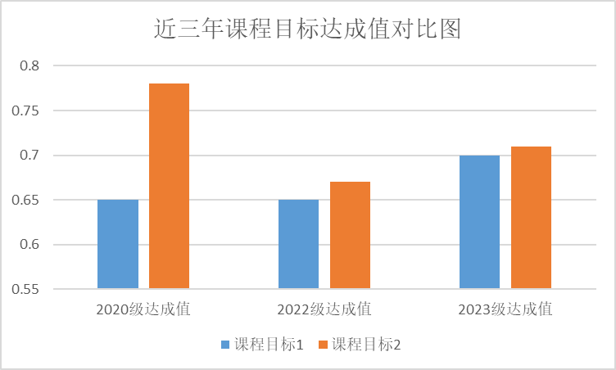
图1三年课程目标对比
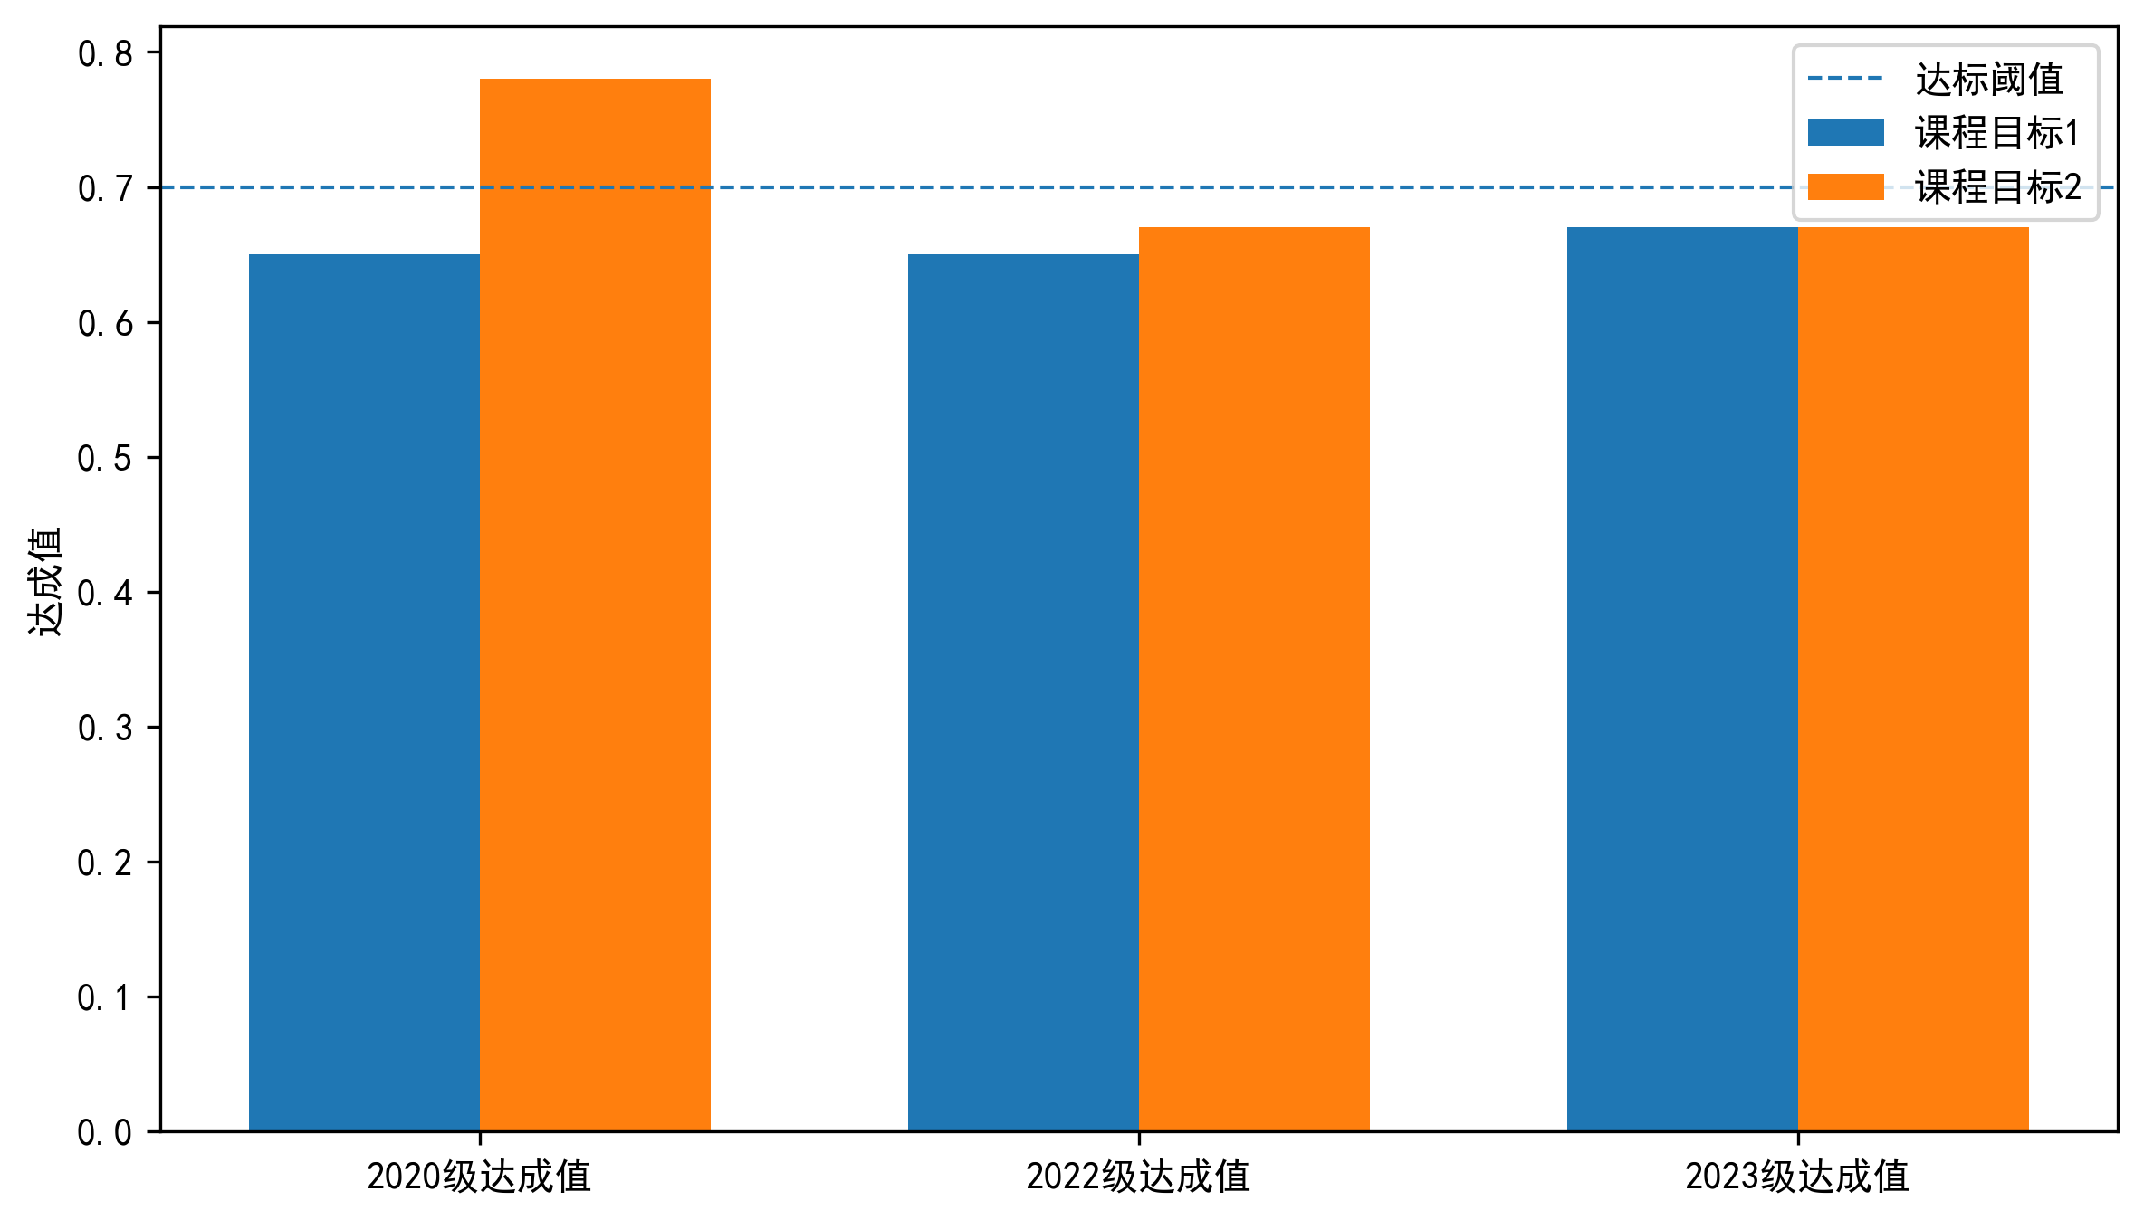

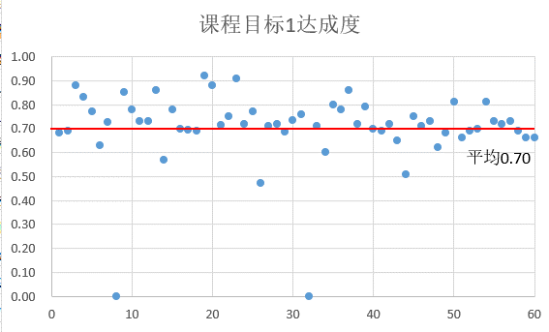
图2 课程目标1达成度值散点图
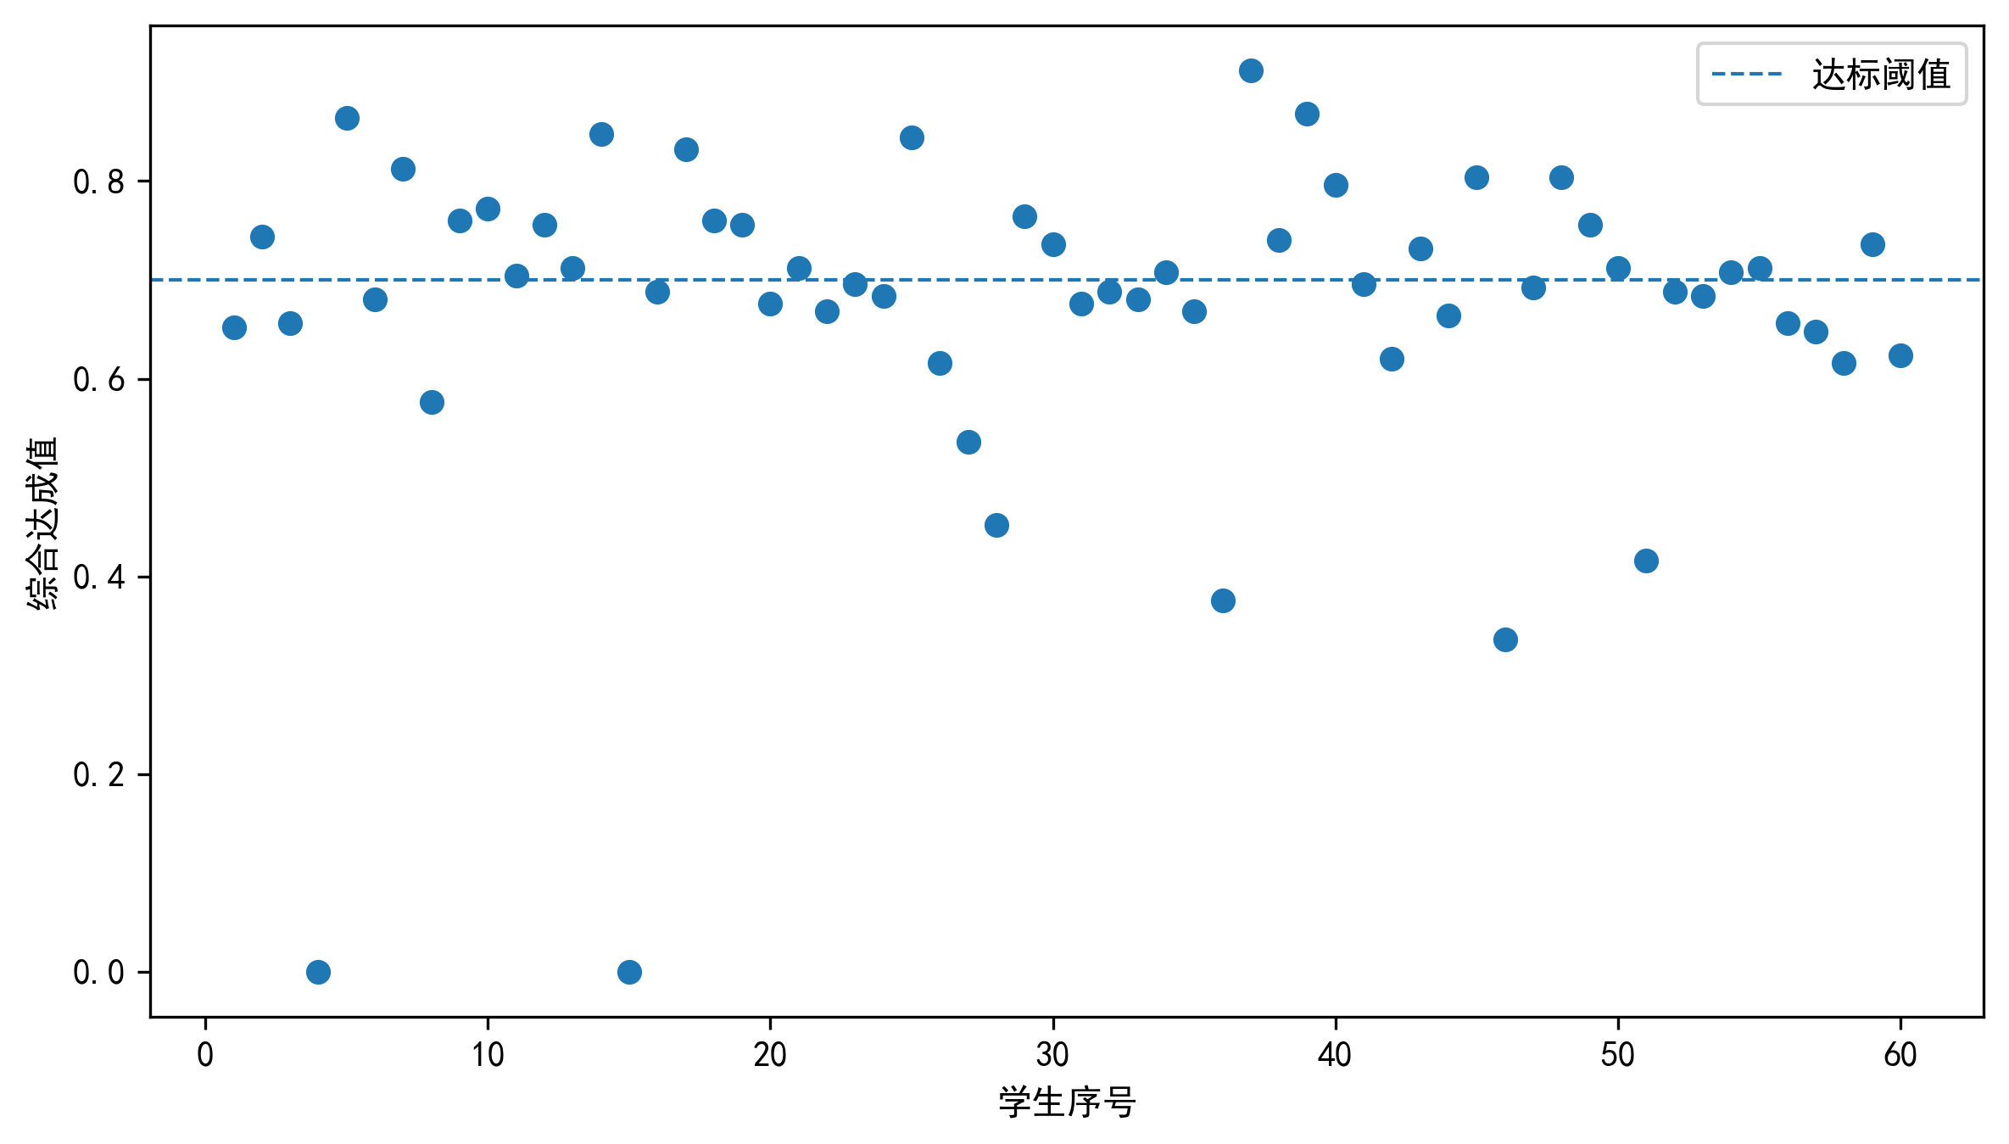
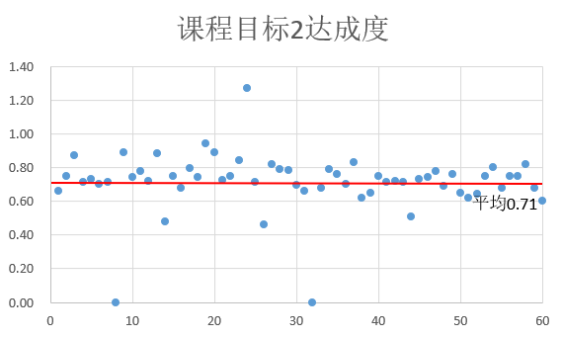
图3 课程目标2达成度值散点图
