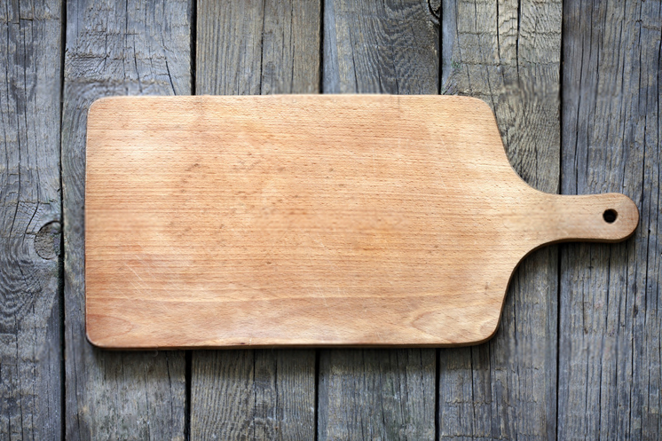

Family Recipes

Asian Barbecue Chicken

Ingredients

¼ cup packed brown sugar

¼ cup low sodium soy sauce

1 tablespoon fresh lime juice

½ tsp crushed red pepper

¼ tsp curry powder

3 cloves of garlic minced

8 (6 ounce) chicken thighs, skinned

Cooking spray

Lime wedges (optional)

Green onions (optional)

Instructions

Combine first 6 ingredients and let chicken marinate for 4 hours

Au jus

Ingredients

olive oil

¼ cup onion (red)

1 tsp garlic

1/8 cup white wine

1 tablespoon Worcestershire sauce

2 ½ cup beef broth

1 tsp flour

Instructions

Caramelize onions in oil.

Add garlic and let cook 1 to 2 min more

Add wine, then Worcestershire sauce and wait 1 min

add broth, reduce heat to simmer for 30 min

Strain return to pot, and add flour

Let simmer for 5 more minutes

Balsamic Glazed Lamb Chops

Ingredients

8 lamb rib chops, 1 inch thick

1/4 teaspoon salt

1/4 teaspoon black pepper

1/2 cup orange juice

1/4 cup balsamic vinegar

1 tablespoon honey

1 tablespoon reduced sodium soy sauce

Instructions

Remove fat for meat

Season with salt and pepper

Stir liquid ingredients together

Mix with meat in Ziplocs

Marinate for 4 hours in fridge

Boil marinade for 15 minutes for glaze

Grill lamb, covering with glaze about halfway through

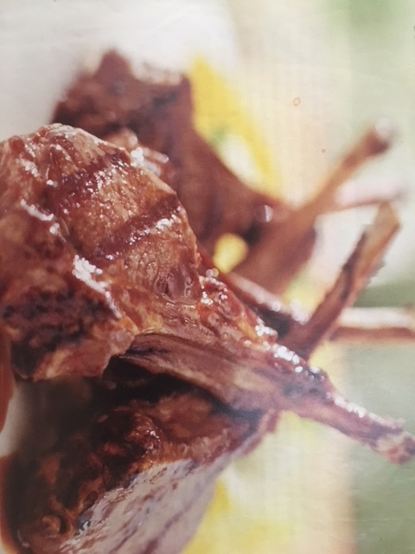

Williams and Sonoma Banana Bread

Ingredients

1 2/3 Cups all-purpose flout

2 tsp baking powder

½ tsp salt

¼ tsp baking soda

3 tsp bananas

2/3 cups sugar

1/3 cups vegetable oil

2 eggs

1 ½ tsp vanilla

¼ tsp cinnamon

1/8 tsp cloves

pinch of nutmeg

Instructions

Bake at 350 degrees

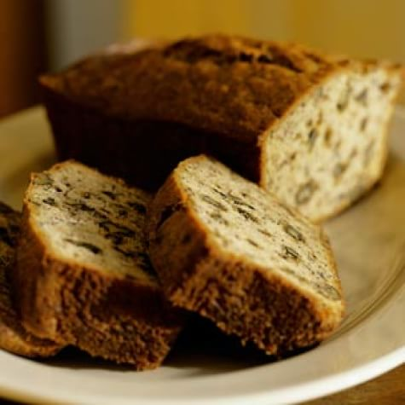

Beef and Mushroom Kabobs

Ingredients

1/3 cup balsamic vinegar

2 Tbsp olive oil

2 tsp water

1 medium shallot

2 tablespoons chopped fresh oregano or 2 teaspoons dried

1 1/2 tsp chopped fresh thyme or 1/2 tsp dried

2 cloves minced garlic

3/4 tsp salt

1/2 tsp pepper

1 1/2 lbs. beef tenderloin or boneless sirloin 1-inch cubes

8 oz mushrooms

12 cherry tomatoes

Instructions

combine first 9 ingredients to make marinade.

Place half of marinade in bowl or bag with steak

Do the same with the vegetables

let sit at least 20 minutes

Cook on kabobs over the grill

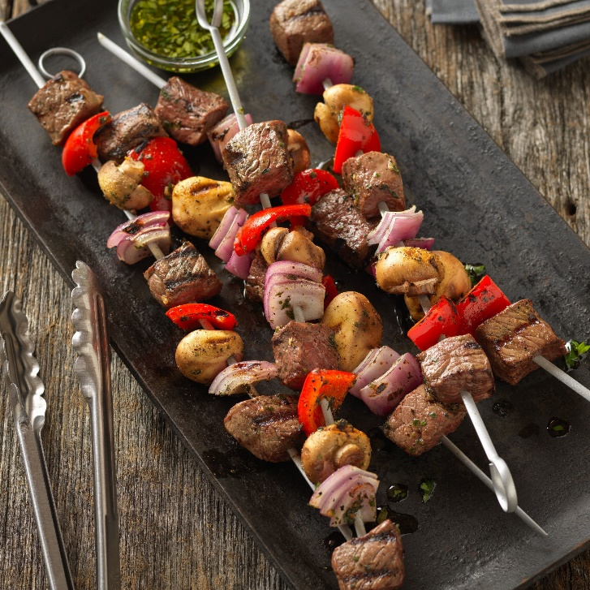

Blackberry Pie

Ingredients

5 cups frozen blackberries

1/2 - 3/4 cup sugar

1 t lemon zest

1 t lemon juice

1/2 t cinnamon

1/4 t almond extract

3 Tbs quick cooking instant tapioca

Instructions

Mix and let sit for 30 minutes

Preheat oven to 400 degrees

Cook for 30 min

Top with aluminum foil

Reduce to bake 350 degrees

Cook another 30 minutes

Chicken Souvlakia

Ingredients

½ cup thinly sliced onion

2 tablespoons olive oil

1 ½ tsp fresh lemon juice

1 ½ tsp finely chopped fresh parsley

¼ tsp dried oregano

1 bay leaf

1 lb. skinless boneless chicken breast cut into ~32 bite size pieces

½ red onion cut into 8 ~1-inch size pieces

½ large green bell pepper cut into ~1-inch size pieces

8 button mushrooms

8 large cherry tomatoes

¼ teaspoon salt

¼ teaspoon black pepper

Cooking spray

Instructions

Combine first 6 ingredients in a large zip lock plastic bag, add chicken. Seal and marinate in refrigerator for 3 hours; turn occasionally

Soak skewers

Prepare grill

Add meat and veggies to skewers

grill ~12 minutes or until chicken comes up to temp, turning once

Optionally serve with Tzatziki sauce

Chili Chicken and Pasta

Ingredients

6 oz. Dried angel hair pasta

3 ears corn on the cob

4 small skinless boneless chicken breast halves

1 1/12 tsp chili powder

¼ cup olive oil or cooking oil

3 Tbsp lime juice

2 medium tomatoes sliced

Salt

Pepper

Instructions

Cook pasta

Cut corn from cob; add to pasta last 2 minutes of cooking (optionally grill corn and add without cooking in water)

Drain, rinse with cold water

Sprinkle chicken with 1 tsp of the chili powder and ¼ tsp each salt and pepper

Cook chicken in ~1 Tbsp oil in skillet for 8 to 10 minutes (~170F)

For dressing: combine remaining oil, remaining ½ tsp chili powder and lime juice

Chimichurri Sauce

Ingredients

4 garlic cloves

2 cups fresh parsley leaves

1 cup fresh cilantro leaves

1 jalapeño stemmed and seeded

¾ cup extra virgin olive oil

2 Tbsp lemon juice

2 Tbsp rice wine vinegar (or red wine vinegar)

2 tsp dried oregano

2 tsp ground cumin

1 tsp salt

pepper to taste

Instructions

Mince garlic, parsley, cilantro, and jalapeño in a food processor

Add olive oil, lemon juice, vinegar, oregano, cumin, salt and pepper

Mix

Corn Bread

Ingredients

1 cup all-purpose flour

1 cup yellow, white, or blue cornmeal

2 to 4 tablespoons sugar

1 tablespoon baking powder

1/2 teaspoon salt

2 eggs

1 cup milk

1/4 cup cooking oil or shortening melted

Instructions

Mix dry ingredients, mix wet ingredients, mix, then bake at 425 degrees for 20 to 25 minutes or until golden brown

Country Potatoes Au Gratin

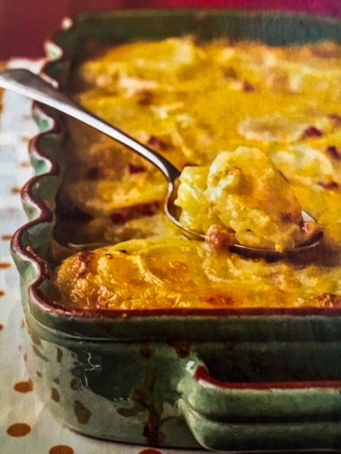Ingredients

2 tsp butter

1/2 medium onion thinly sliced

3 garlic cloves minced

4 cups 2% reduced fat milk

1 tsp salt

1/4 tsp pepper

3 oz. all-purpose flour (~2/3 cups)

6 oz. Shredded cheddar cheese (1 1/2 cups)

6 oz diced ham (1 1/4 cups)

3 lbs. peeled baking potatoes cut in 1/8-inch-thick slices

cooking spray

Instructions

Preheat oven to 350

melt butter in pan at medium high heat

add onion and garlic, sauté for 5 minutes

combine milk, salt, pepper, flour

add milk mixture to pan

simmer and cook until slightly thick (about 2 min)

add just over half of cheese and all ham, stirring until cheese melts

stir in potatoes

place potato mixture in 13-9 coated pan

cover with remaining cheese

cover with foil also coated with cooking spray

bake at 350 for 45 minutes

uncover and bake additional 30 min or until lightly browned

let stand 15 min

Crispy Orange Glazed Salmon

Ingredients

2/3 cups orange juice

3 tablespoons rice wine vinegar

2 tablespoons lite soy sauce

1 small red Thai Chile pepper thinly sliced

1 tsp crushed red pepper flakes

1 (1 inch) piece fresh ginger, grated

1 Tablespoon olive oil

4 (4 to 6 ounce) salmon fillets

Salt

Pepper

Honey

Instructions

Stir first six ingredients

Drizzle oil on salmon

Add salmon to marinade

Marinate at least 30 minutes, then add salt and pepper

Cook the salmon and about 3 minutes before done, add honey

Crockpot Chipotle Adobo Beef

Ingredients

1 cup water

2/3 cup salsa

1 Tbsp cumin

~1 can (little less spicy) Chipotle and Adobo

1 tsp chili powder

1/2 tsp paprika

pinch of chipotle powder

salt and pepper

Instructions

Leave in crockpot for 6 to 7 hours

Crunchy Cabbage Salad

Ingredients:

6 cups shredded cabbage

1 Grated Carrot

Crunchy Chou Mein Noodles

1 Red Bell Pepper

2 cups cubed cooked chicken

1/2 can mandarin oranges

2 tablespoons toasted sesame seeds (or almonds)

Instructions

Combine Ingredients and top with Dressing.

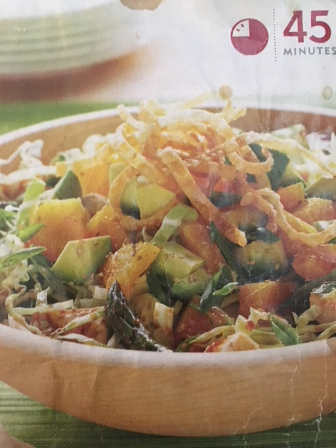

Fried Rice

Ingredients

3 eggs

½ cup edamame

1/3 cup peas

½ pepper

1 carrot

¼ cup onion

3 Tablespoons soy sauce

3 cups rice

2 cloves garlic

~4 tsp olive oil

~1 tsp sesame oil

~1/2 Tablespoon butter

Instructions

None

Fruit Danish

Ingredients

8 count tube refrigerated crescent rolls

Flour

Jam (and or chocolate)

Instructions

Heat oven to 400F

Cut dough into square pieces

Flour the work surface to prevent sticking

Place Jam inside center and fold edges around, pinching at the top to close

Cook for ~11-13 minutes

Garbanzo Bean Chocolate Cake

Ingredients

1 and 1/2 cups semisweet chocolate chips

1 can (19 oz.) garbanzo beans, rinsed and drained

4 eggs

3/4 cup white sugar

1/2 tsp baking powder

1 Tbsp vanilla extract

1 Tbsp confectioner's sugar

Raspberries

Instructions

1 Preheat the oven to 350 degrees

2 Grease an 8-inch round cake pan

3 Melt the chocolate chips in the microwave

4 Combine the beans and eggs in a food processor, or mix by hand

5 Add the sugar and baking powder and continue to mix

6 Pour into pan

7 Bake for 40 minutes, or until knife comes out clean when inserted.

8 Cool for 10 to 15 minutes

9 Invert onto serving plate

10 Dust with confectioner's sugar and raspberries

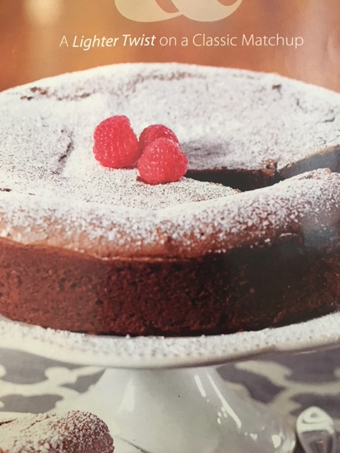

Honey Lime Drumsticks

Ingredients

3 tablespoons low sodium soy sauce

2 tablespoons honey

2 tablespoons hot water

2 tablespoons fresh lime juice

1 tablespoon canola oil

1 tablespoon graded peeled fresh ginger

2 garlic cloves grated

8 chicken drumsticks skinned

1/2 tsp pepper

Cooking spray

Instructions

Preheat oven to 375

Combine soy sauce and next 6 ingredients (through garlic)

Cut a 1/2-inch-deep slit in meaty end of each drumstick

sprinkle pepper on chicken

coat pan with cooking spray

Add drumsticks, cook for 4 minutes

add sauce, turn to coat

place pan in oven

bake at 375 for 15 minutes, turning occasionally

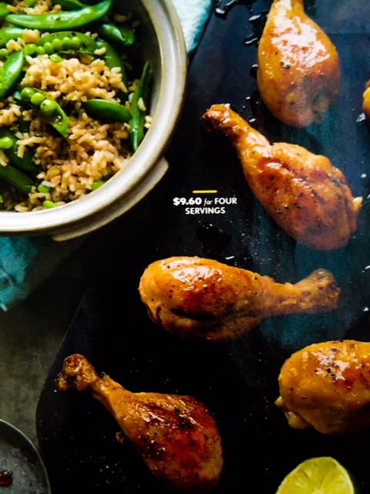

Lemon Bars

Ingredients

1/2 cup whole wheat flour

1/2 cup all-purpose flour

1/4 cup granulated sugar

1 teaspoon finely grated lemon zest

1/4 cup finely chopped walnuts

4 tablespoons unsalted butter softened to room temperature

1/3 cup buttermilk

1/2 cup fat free frozen egg substitute (like Egg Beaters) thawed

2 tablespoons all-purpose flour

3/4 cup granulated sugar

1 tablespoon lemon zest

3 tablespoons fresh lemon juice

1/4 teaspoon baking powder

1/4 cup confectioner's sugar

Instructions

Preheat oven to 375

Combine Flour through buttermilk and mix into dough

Press dough into lightly greased 8x8x2 pan

Bake until crust is light brown (about 15 minutes)

Mix egg substitute through baking powder

Pour over crust layer

bake for another 12 minutes

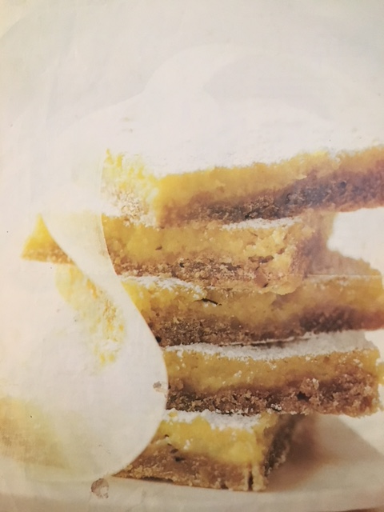 let cool on wire rack

add confectioner's sugar dusting to top

Oatmeal Cookies

Ingredients

1 Cup all-purpose flour

1 tsp baking powder

½ tsp baking soda

¼ tsp salt

2 cups oats

½ cup chopped nuts (optional)

8 Tablespoon butter (room temp)

½ cups lightly packed brown sugar

½ cups granulated sugar

1 egg

¼ cup maple syrup

½ tsp vanilla

¾ cup semisweet chocolate chips

Instructions

Bake at 350 degrees

Poppy Seed Salad Dressing

Ingredients

3 tablespoons sugar

3 tablespoons light mayo

2 tablespoons fat free milk

1 tablespoon poppy seeds

1 tablespoon white wine vinegar

Instructions

Combine and mix thoroughly

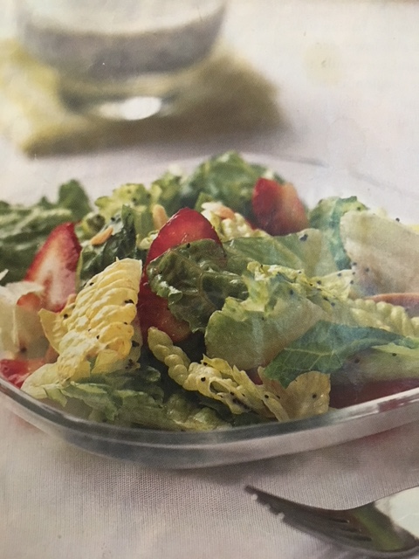

Sichuan-Style Stir-Fried Chicken

Ingredients

2 tablespoons low sodium soy sauce

2 tablespoons rice wine or sake

1 teaspoon cornstarch

1 teaspoon dark sesame oil

1 1/2 lbs. skinless, boneless chicken

2 tablespoons vegetable oil

1/2 cup fat free chicken broth

2 tablespoons sugar

2 1/2 tablespoons low sodium soy sauce

2 tablespoons rice wine or sake

1 tablespoon Chinese black vinegar (or Worcestershire sauce)

1 1/4 teaspoons cornstarch

1 teaspoon dark sesame oil

2 tablespoons minced green onions

1 1.2 tablespoons minced peeled fresh ginger

1 1/2 tablespoons minced garlic (about 7 cloves)

1 teaspoon Chile paste with garlic

1 1/2 cups drained, sliced water chestnuts

1 cup sliced green onion tops

3/4 cup peanuts

6 cups hot cooked long grain rice

Instructions

1 Combine first 5 ingredients (marinade the chicken)

2 Let sit 20 minutes in fridge

3 Add first tablespoon of oil to pan, allow to heat

4 Add chicken and fry for 4 minutes or until chicken is thoroughly cooked

5 Combine broth and next 6 ingredients (broth through sesame oil)

6 Heat second tablespoon oil in pan

7 Add green onions, ginger, garlic, Chile paste, fry for a few seconds,

8 Add broth mixture

9 Cook for about 1 minute

10 Stir in cooked chicken, water chestnuts, green onion tops, peanuts, and cook 1 minute

11 Serve on cooked rice

Smoky Tomato-Bacon Soup

Ingredients

1 Tbsp olive oil

3 thick strips of bacon thinly sliced

1 large yellow onion diced (about 1 ½ cups)

Kosher salt

1 Tbsp unbleached all-purpose flour

1 Tbsp chopped fresh thyme

½ tsp smoky paprika (perhaps a little more)

(optionally add pinch of chipotle seasoning)

28 oz can while tomatoes and juices

2 cups low salt chicken broth

2 Tbsp heavy cream

Freshly ground black pepper

Ingredients

Cook bacon

Using the same pan brown onions with oil and ½ tsp salt

Stir in flour, 2 tsp thyme and paprika, let cook 1 minute

Add tomatoes and chicken broth, bring to boil, then let simmer for about 20 minutes, stirring occasionally

Purée, then add cream and bring back to boil

Salt and pepper as needed

Serve with thyme and bacon

Spicy soy-ginger (Crunchy Cabbage Salad) Dressing

Ingredients

2 Tablespoons rice wine vinegar

2 Tablespoons brown sugar

1 ½ tablespoons soy sauce

1 tablespoon Asian red Chile sauce (Such as Sriracha)

1/4 tsp grated fresh ginger

less than ¼ cup of olive oil

Salt

Instructions

None

Teriyaki Sauce

Ingredients

1/4 cup and 2 Tablespoons soy sauce

1/4 cup water

2 1/2 Tablespoons rice vinegar

4 Tablespoons pineapple juice

1 clove garlic minced

1 Tablespoon cornstarch

5 Tbsp sugar

1-2 Tbsp orange marmalade (usually 1)

Instructions

Mix in pot

Heat, stirring constantly until thickened

Thousand Island Dressing

Ingredients

1/2 cup mayo

2 T ketchup

1 T white vinegar

2 tsp sugar

2 tsp sweet relish

1 tsp white onion

1/8 tsp salt

dash of pepper

Instructions

Combine all ingredients

Tortilla Soup

Ingredients

1 Large Onion Chopped

1 TBSP Ground Cumin

1 TBSP Cooking oil

2 14 oz. Cans reduced sodium chicken broth

1 28 oz can of fire roasted diced tomatoes (sub cup of salsa and 1 can diced tomatoes)

4 cups chopped cooked chicken

1 1 0 oz. package frozen sweet whole kernel corn

Chipotle seasoning to taste

Cilantro

Monterey Jack Cheese

Instructions

1 Cook onions with cumin for approximately 5 minutes until tender

2 Add broth, tomatoes, chicken, corn and bring to boil.

3 Reduce the heat to simmer

4 Let simmer for 15 minutes

5 Garnish with optional cilantro and Monterey Jack

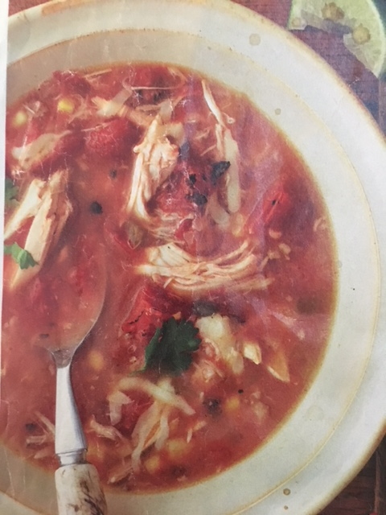

Tzatziki Sauce

Ingredients

1 cup finely chopped seeded peeled cucumber

¼ teaspoon salt

1 (8 ounce) carton plain low-fat yogurt

1 ½ tsp chopped fresh parsley

½ tsp fresh lemon juice

½ tsp olive oil

1/8 tsp black pepper

1 Gallic clove minced

Instructions

None