Purpose:
The point was to create cheap Drum-Machine MIDI sequencer which can be connected via MIDI cable to some music keyboard or Tone Generator with drums sound bank. Drum Machine will have Sync-Out 2ppq compatible with Korg’s Volca series musical equipment, Swing option with control via Potentiometer, and ability to saving few patterns. There also second MIDI female connector, MIDI clock out which sends clock timer via MIDI cable to devices without jack 3,5 sync in.

Parameters:
- 7 Drums to choice, which can play simultaneously
- BPM range between 70 – 300 bpm
- Swing Mode
- Sync-Out
- Note length change (useful for hats)
- Saving and Loading created drum patterns

Used Parts:
- Arduino Nano (and USB cable for programming / power supply)
- 2 * MIDI Female Connector
- Audio Jack 3,5 Female Connector
- LCD 16x2 screen with I2C converter
- Numeric Keyboard
- 2 * 200ohm resistors
- 2 * 100k ohm potentiometer
- On-Off Switch
- DC 2.1/5.5 female connector
- Keyboard Keys stickers

Scheme:
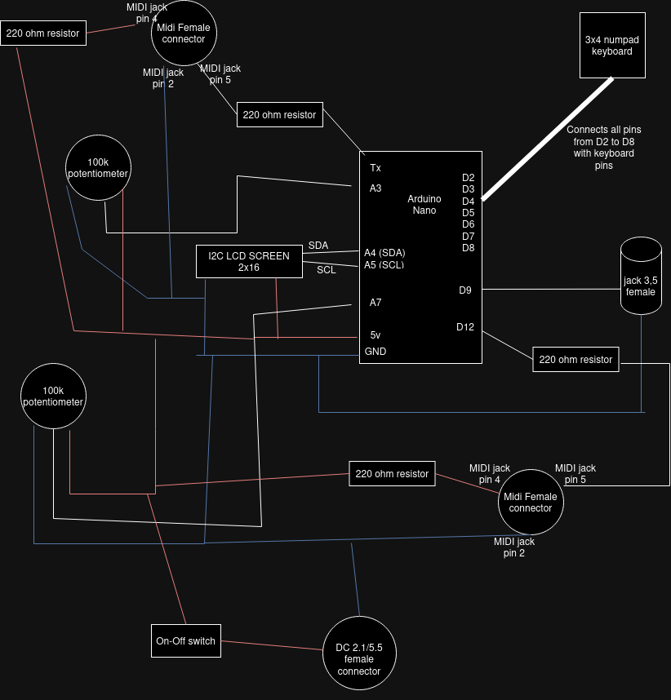

Display:
To display information to user, drum machine is using 2x16 LCD screen. 16 notes are exact number needed for typical 4x4 musical pattern, but still displayed info is rather limited. So the names of each drum will be abbreviated for 3 letter (e.g kick – kck, full list paragraph bellow)
Default displayed info is always Kick pattern (here with 4x4 beat, 140 BPM):

$$$$$$$$$$$$$$$$$$ # - note on
$#_ # # # $ | - to help count which note is pointed
$|kck|> m|BPM|140$ _ - blinking pointer
$$$$$$$$$$$$$$$$$$ kck – chosen drum abrv. (here kick)
> - Device is in playing mode

On the screen we can see pointer on second quarter note – when [5] button will be clicked a note will be added (if there would be a note already in that place, it would be deleted). To move pointer left or right, you need to push [4] or [6] buttons.

With buttons [2] and [8] you can toggle up and down between drums available.
Lets say you click [2], the next will be snare:
$$$$$$$$$$$$$$$$$$ snr - snare
$_ # # $ = - Device is not in playing mode
$|snr|= m|BPM|140$ m - this drum is muted
$$$$$$$$$$$$$$$$$$

Note: Some thing (like muting drum) are possible to do only when playing, other (like saving pattern) only when device is not playing.

Abreviations:
- kck – kick
- snr - snare
- clp - clap
- cld – closed hi-hat
- ope – open hi-hat
- rid - riddle
- mar - maracas

Inputs:
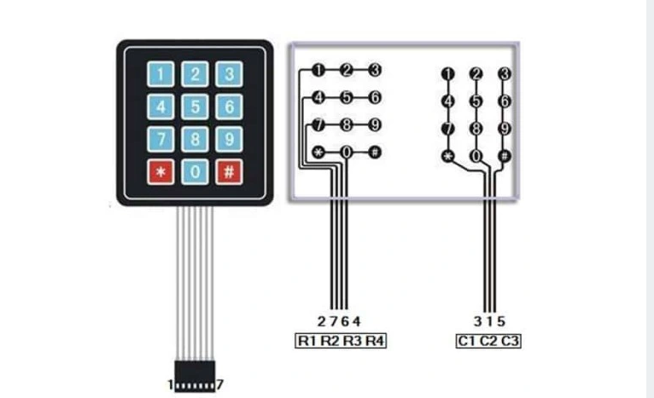
Keyboard used in this project.

List of Inputs:
[sticker] – [key] - Action
[↑] - [2] - Toggle up drum
[↓] - [8] - Toggle down drum
[←] - [4] – Move pointer left
[→] - [6] – Move pointer right
[-] - [1] – Volume down selected drum (only when device is playing)
[+] - [3] – Volume up selected drum (only when device is playing)
[*] - Mute / Unmute Selected Drum
[#] - Clear selected drum pattern
[Insert] - [5] – Write note / Delete note
[>] - [0] – Play / Stop

potentiometer 1 – change BPM
potentiometer 2 – change SWING

[S] - [9] then keys from [1]-[6] to save patterns (only when device is not playing)
[L] - [7] then keys from [1]-[6] to load patterns (only when device is not playing)

