Open sleeve and separate core
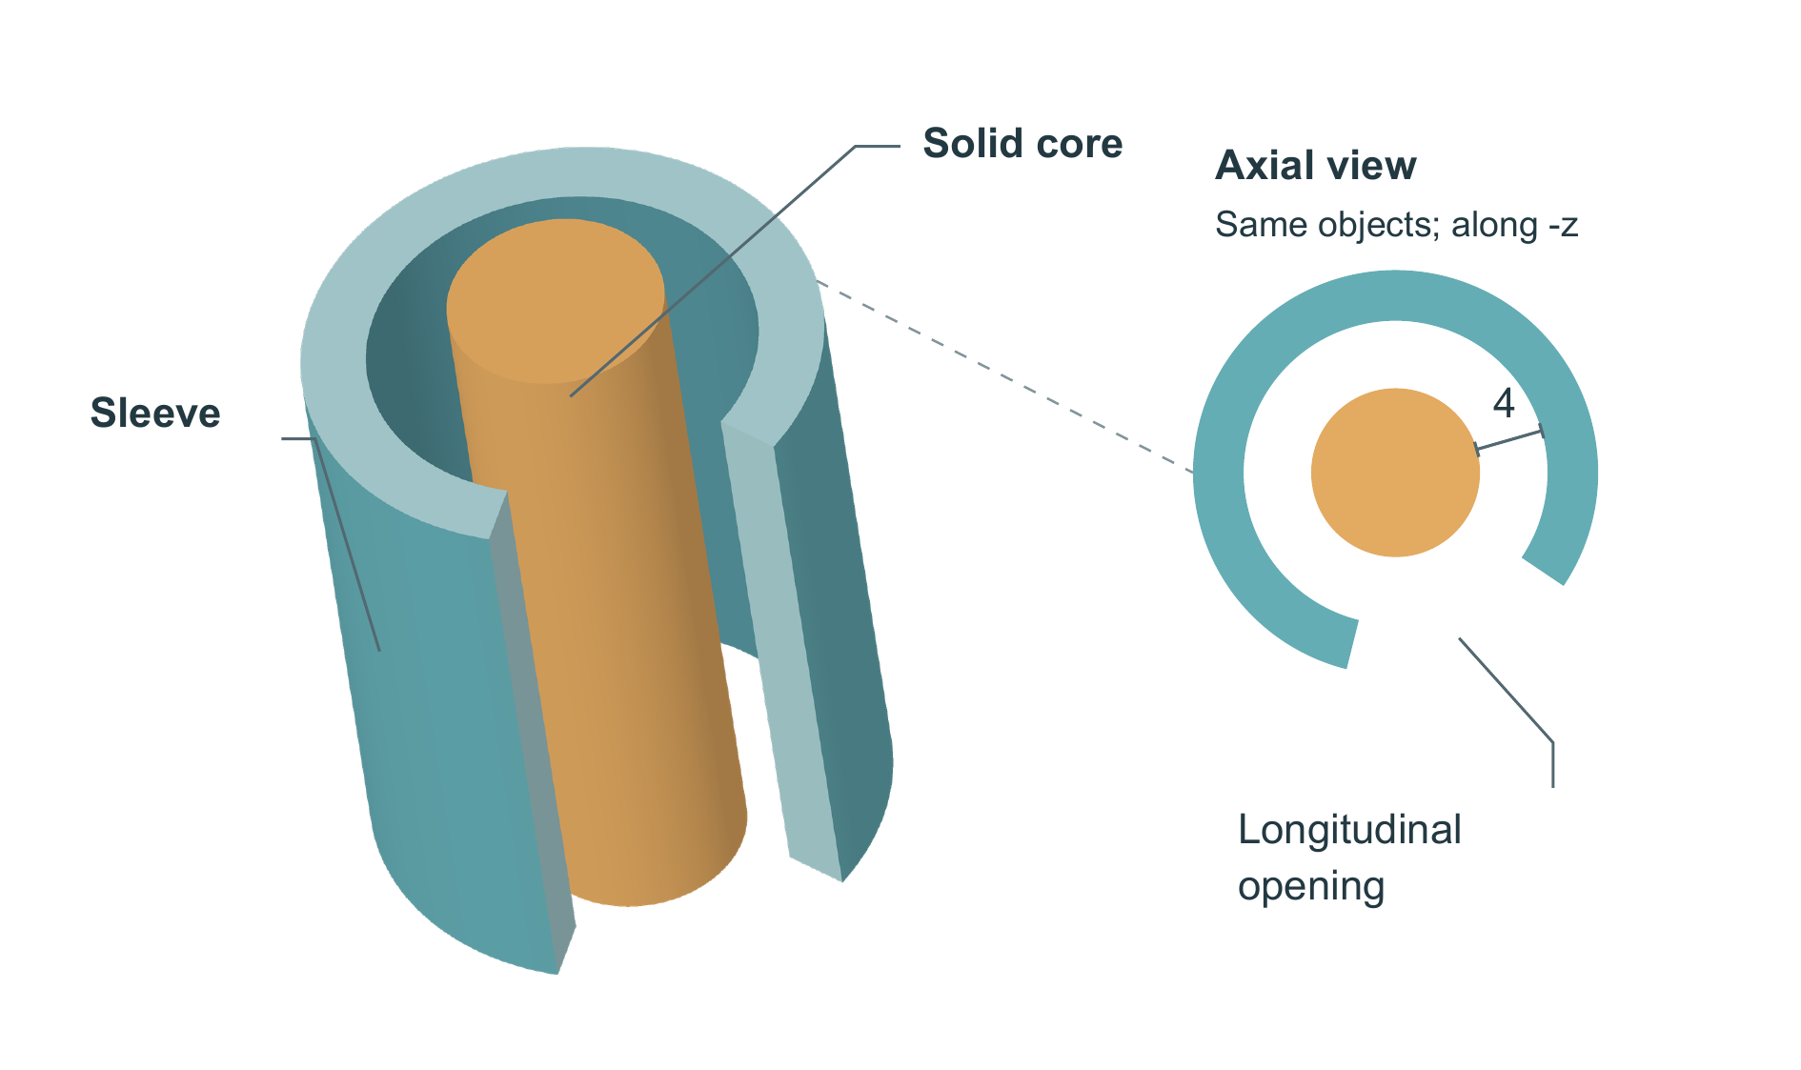
Original geometric demonstration of one continuous sleeve and one separate coaxial solid core. The oblique view shows the existing longitudinal opening, exposed inner wall and core. The smaller axial projection shows the same objects along -z; white space separates the core from every retained wall direction. Its dashed link identifies the corresponding upper sleeve end. The sleeve has outer/inner radii 12/9, spans z = 0-30, and is open at both axial ends. A pre-existing sector from -35 to +35 degrees is absent through its full thickness and length; azimuth is measured from +x toward +y. The solid core has radius 5 and spans z = -3-33. The marked radial gap is 4 wherever sleeve wall remains. All coordinates are arbitrary drawing units. Axial and oblique views share azimuth and roll, at relative linear scales 0.769:1. Shading only aids shape reading; no support, contact, motion, transport or physical function is specified.

