Guard and separated insert
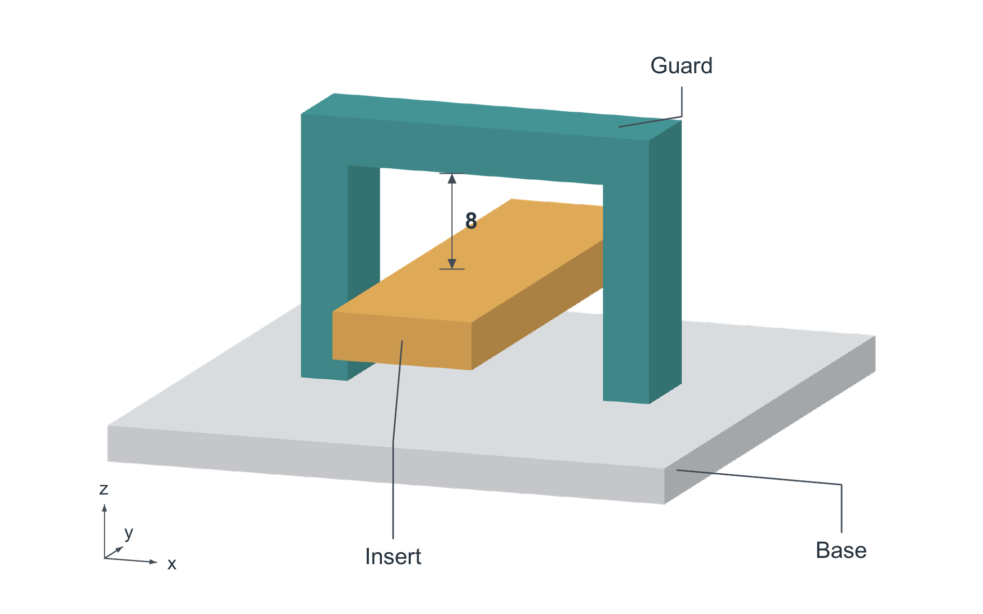
Original geometry DEMO in arbitrary length units. An orthographic view shows one continuous U-shaped guard with both feet contacting the base at z = 0. The rectangular insert extends along y through the opening without touching the guard or base. The marked upper clearance is 8; lateral clearance is 5 on each side and base-to-insert clearance is 6. Positions are specified only; no support or stability is asserted. Surface tones aid orientation and do not represent material properties.

