Co-wound layers on a hollow core
Three adjacent layers are co-wound for two turns around a hollow core and continue into one straight tail. The layers remain in contact throughout the curved and straight portions. This original geometric DEMO has no assigned device function, transport process, or measured performance.
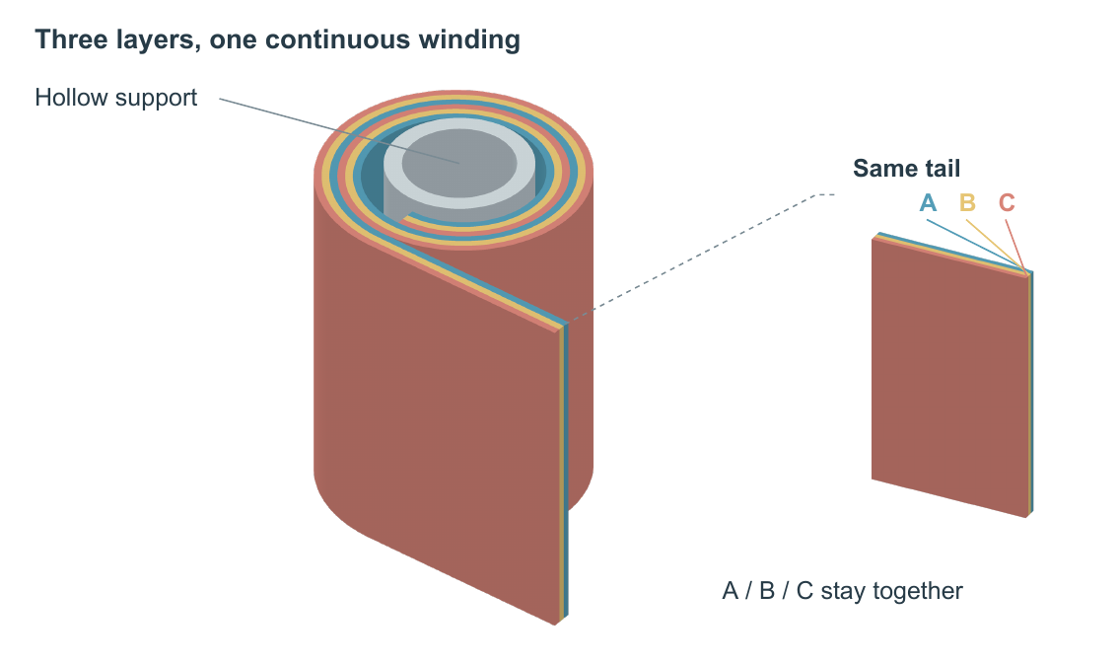
Figure 1. Co-wound laminate DEMO. Blue, gold, and coral identify layers A, B, and C. The enlarged view repeats the same straight tail; the hollow core is a separate neutral body. Dimensions are illustrative, without physical units.

