Co-wound layers on a hollow core
Three adjacent layers are co-wound for two turns around a hollow core and continue into one straight tail. The layers remain in contact throughout the curved and straight portions. This original geometric DEMO has no assigned device function, transport process, or measured performance.
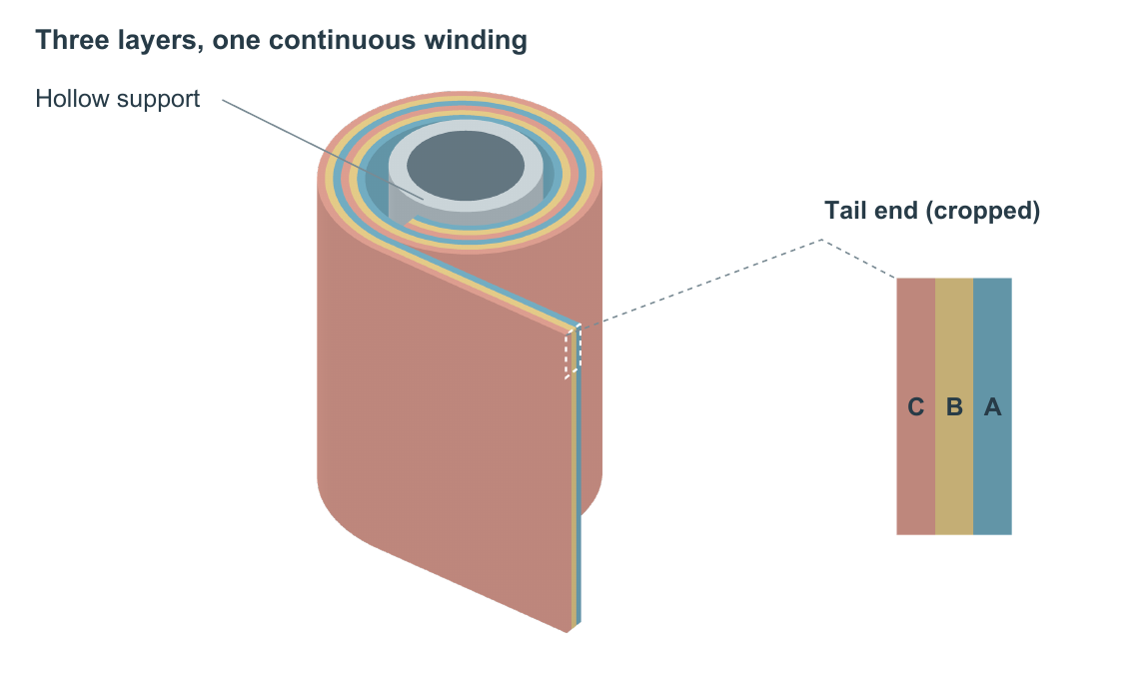
Figure 1. Co-wound laminate DEMO. Blue, gold, and coral identify layers A, B, and C. The marked corner at the tail end links the complete object to a cropped end-face view of the same three layers. The crop covers the upper four coordinate units of the 28-unit axial width; both axes use the same display scale. It is neither an additional stack nor a thickness exaggeration. Geometry is illustrative, without physical units.

