A continuous ribbon over a through-opening
The geometric DEMO comprises three continuous entities: a monolithic frame, a thin ribbon, and a metal trace. A rectangular opening passes through the full thickness of the frame. The ribbon bridges this opening and rests on the frame at both ends, leaving its central span unsupported. A single metal trace follows a repeated folded path on the upper surface of the ribbon and terminates on the ribbon itself. This construction specifies spatial relationships only; no device application or performance is assigned.
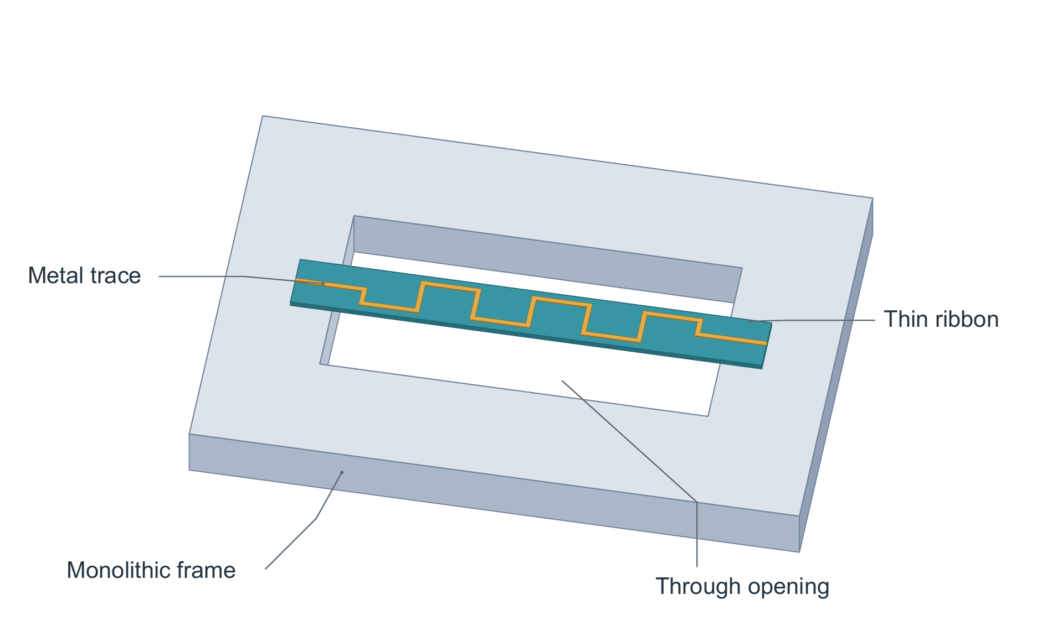
Figure 1. Suspended-ribbon geometry DEMO. An orthographic view shows a monolithic frame with a rectangular through-opening, a continuous ribbon contacting the frame at both ends, and a continuous metal trace on the ribbon's upper surface. The opening has no bottom plate, and the central ribbon span has no supporting pillar. Colors identify the three entities; fine gray leaders identify features without implying physical transport. The geometry is fictional and carries no measurement units or performance data.

