A continuous ribbon over a through-opening
The fictional structural model comprises a one-piece frame, a continuous thin ribbon, and a continuous metal line (Fig. 1). The ribbon rests on the frame at its two ends and spans the rectangular through-opening between them. Its lower surface coincides with the frame top, leaving the central span open underneath. A meandering metal line follows the ribbon top and terminates at its ends without additional pads or terminal boxes. The longitudinal section exposes the same element at the ribbon centerline; the separated metal intersections arise from the continuous meander crossing the section plane. This model specifies geometry only and supplies no measured or simulated performance data.
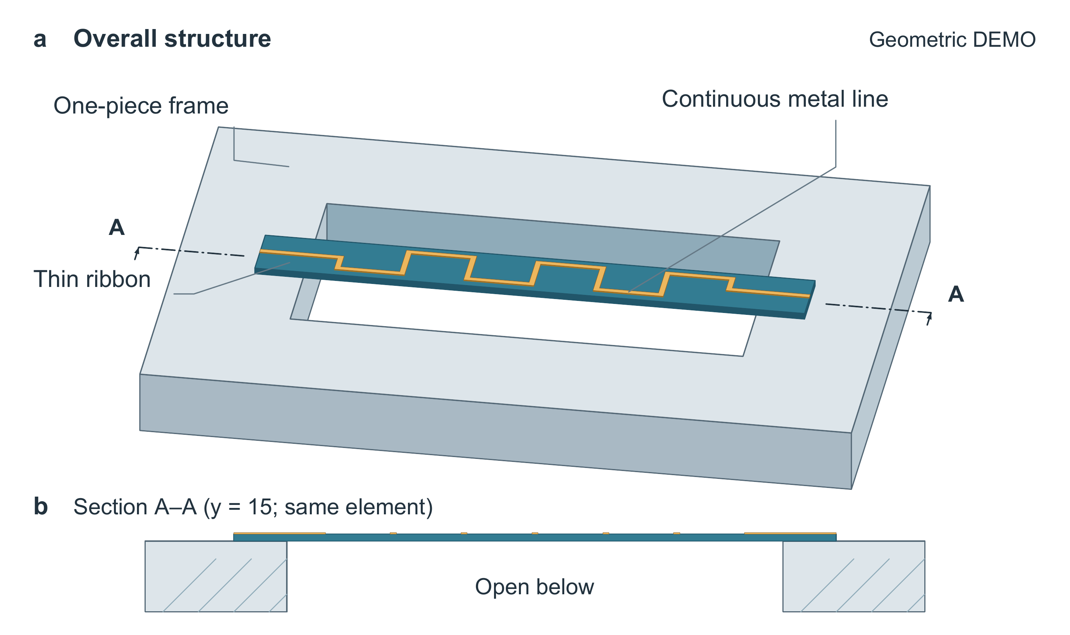
Figure 1. Geometry of a fictional suspended ribbon bridge. (a) Orthographic oblique view of the one-piece frame, continuous ribbon, and continuous metal line. The rectangular opening traverses the full frame thickness; the ribbon contacts the frame only at its two ends. (b) Longitudinal section A–A of the same element at y = 15, showing the open region beneath the ribbon. The A–A end marks in (a) locate the cutting plane, with arrows indicating the section viewing direction. The intervening cutting line is omitted to keep the ribbon and metal visible. The separated metal marks in (b) are intersections of the continuous meandering line with this plane. Frame hatching identifies cut material. The two panels retain geometric proportions within each view; their display scales differ. Coordinates are illustrative and have no assigned physical unit. No bottom plate, intermediate support, or additional terminal body is present.

