Three layers, one continuous winding
Three adjacent layers are co-wound for two turns around a hollow core and continue into one straight tail. The layers remain in contact throughout the curved and straight portions. This original geometric DEMO has no assigned device function, transport process, or measured performance.
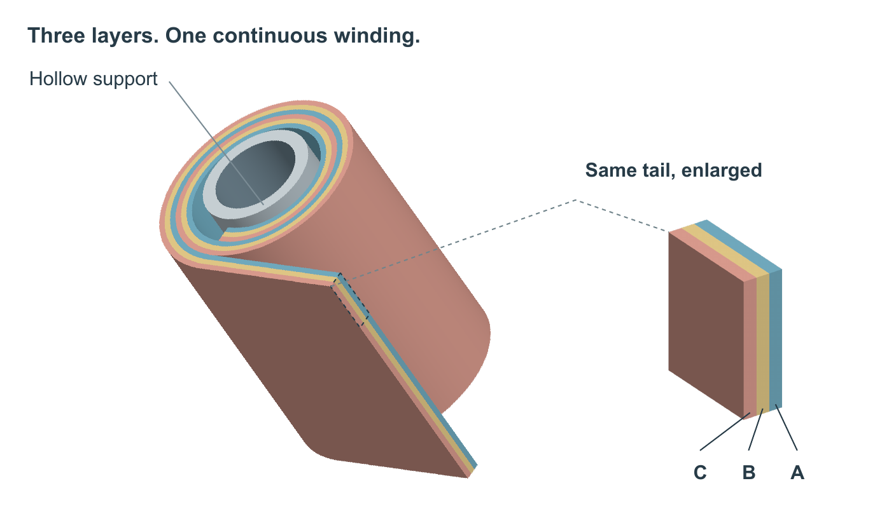
Three adjacent layers A (blue), B (gold) and C (coral) follow the same two-turn spiral around a hollow support. The three layers continue together into a straight tangent tail without separation. The enlarged view repeats the marked region of that same tail; it is not an additional set of layers. Geometry and thicknesses are illustrative, with no measured field or performance encoding.

