DEMO: A cup with a central post
The illustrative assembly consists of an open-topped cup resting on a planar support plate. A single cylindrical post rises vertically from the centre of the closed cup base, leaving a continuous clearance from the surrounding wall and terminating below the rim (Fig. 1). The cutaway makes the base connection and the separation between the post and wall visible in one view.
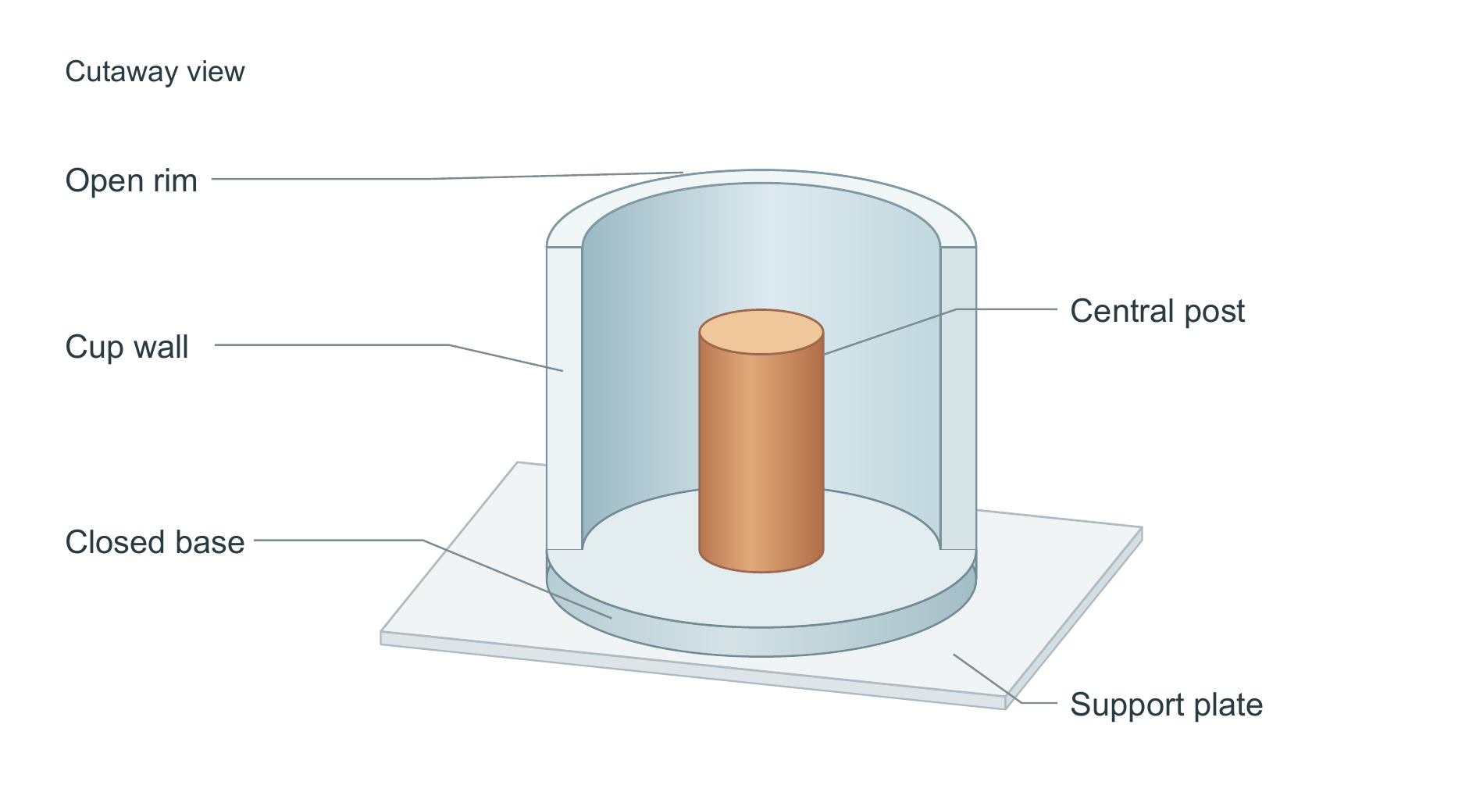
Figure 1. Cup with a central cylindrical post. The front half of the cup wall is omitted to expose the interior; the closed base and the post are shown intact. Colours distinguish the cup, post and support plate. This fictional structural demonstration is schematic and not to scale; it contains no experimental or performance data.
DEMO — fictional structure; no experimental results.
This round replaces the figure. Yellow marks changed text only; unchanged paragraphs have no highlight. This is not native Word Track Changes.

