DEMO: A one-piece plate
The fictional structure in Fig. 1 is a single plate of uniform thickness. A circular central platform is connected to a continuous outer ring by three straight radial bridges of equal width, spaced uniformly around the platform. The regions between adjacent bridges are open through the full plate thickness. The platform, bridges, and ring therefore form one continuous piece; the illustration describes geometry only and is not based on measured dimensions or experimental tests.
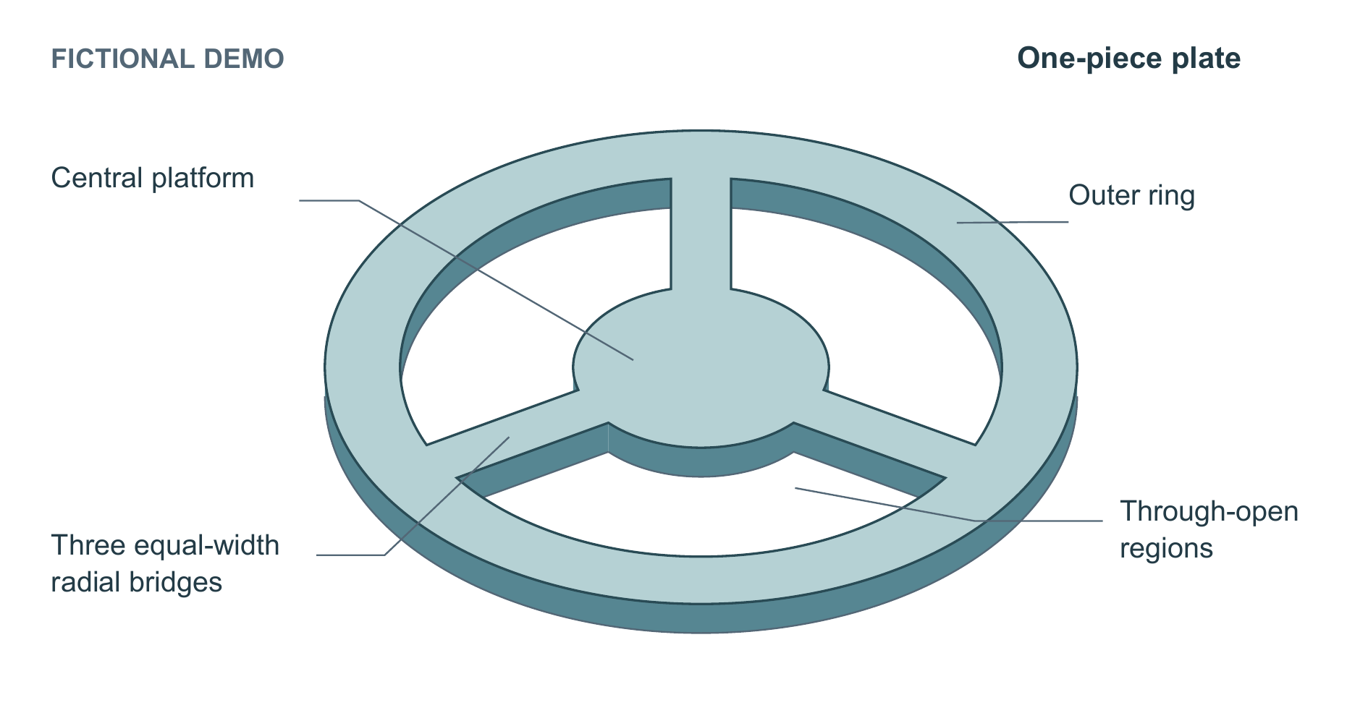
Figure 1. Fictional DEMO of a one-piece plate comprising a circular central platform, a continuous outer ring, and three equal-width radial bridges at uniform angular intervals. The three intervening regions are through-openings. The oblique view exposes the uniform plate thickness; darker faces indicate surface orientation within the same piece. Proportions are illustrative, with no measured dimensions or test results.
DEMO — fictional structure; no experimental results.
This round replaces the figure. Yellow marks changed text only; unchanged paragraphs have no highlight. This is not native Word Track Changes.

