DEMO: Consistent Snapshots for Conductance Reuse in Explicit Heat Transport
DEMO FICTION. This paper describes an invented engineering study. All workloads, timings, errors, residuals, and implementation outcomes are stipulated editing material. There is no executable solver, measured performance, physical experiment, or claim of actual novelty.

Abstract
Temperature-dependent heat-transport solvers repeatedly evaluate conductances that may change little between steps. Reusing them can save work, but independently refreshed cell groups must judge each stored conductance against the temperatures that produced it. We keep both endpoint snapshots with the face coefficient's owner, so a neighbor's refresh cannot change that reference state. The resulting group test bounds local coefficient drift; global temperature accuracy remains a separate check. In a stipulated six-case accounting study, guarded reuse meets the 0.010 K comparison limit and saves total time in three of five nonconstant cases. Its useful advantage over a fixed four-step schedule occurs for a boundary ramp and a moving heat source, where that cheaper schedule fails the error limit. Fixed scheduling is preferable for slow heating; full refresh avoids the guard's losses on switching loads and a small mesh. Active guarding reserves 50% more array memory. These results identify the conditions for evaluating reuse, rather than demonstrate measured solver acceleration.

1. Reuse must follow the changing temperature field
A slowly heated plate may need many time steps without appreciable changes in its face conductances. Recomputing every conductance can then repeat work. A moving heat source changes the decision: some regions may retain useful coefficients while others need fresh ones. Updating every fourth step avoids decisions, but the elapsed step count alone does not describe how much the temperature field has changed.
The difficult case is a face shared by two cell groups. Its coefficient depends on temperatures at both endpoints. Suppose the group that owns the coefficient reuses it while its neighbor refreshes. If the neighbor also replaces the stored endpoint temperature used by the owner's test, that test no longer refers to the state that produced the retained coefficient. The design in Figure 1 prevents this mismatch by keeping both snapshots with the coefficient's owner. Groups can refresh independently while each reuse decision retains a consistent reference state.
This ownership rule supports a bound on coefficient change, not a guarantee of final-temperature accuracy or lower runtime. Method G pays for snapshot reads and one exponential test per active group; it is useful only when avoided face evaluations repay that cost and the separate temperature comparison passes. The method therefore presents two linked questions: can the reuse test refer to the correct state, and when is making that decision worthwhile?
The comparison separates this choice from inherited optimizations. Reference V already uses contiguous, vector-friendly coefficient loops, one flux per face, and one-time evaluation for constant conductances. P4 keeps the same flux and temperature-update code but refreshes every four accepted steps. Neither reuse in general nor these inherited choices is claimed as new, and no literature search establishes priority. We derive the ownership-based test, specify what must happen when a proposed step fails, and compare G with V and P4 using matched fictional accounting. Figure 2 keeps time, accuracy and the cost of the guard in the same reading path.

2. Model and the quantities that reuse must preserve
The two-dimensional finite-volume mesh is rectangular; all demonstration domains are square. External faces are insulated. Prescribed cell power changes the heating pattern without changing connectivity. For an interior face f between cells i and j, G0 is a fixed positive scalar, beta is fixed and nonnegative, and T_ref is a fixed reference temperature. Temperature differences are in kelvin even when temperatures are expressed in degrees Celsius.
$\text{G_f(T) = G0 × exp[beta × ((T_i + T_j)/2 − T_ref)]}$
$\text{q_f = G_f × (T_i − T_j)}$
$\text{C_i × (T_i,next − T_i)/dt = P_i − Σ_f s_if × q_f}$
Here C_i is strictly positive heat capacity and P_i is prescribed power. The sign s_if is positive for a face directed out of cell i and negative for a face directed into it. Every flux uses the immutable old-temperature array. One oriented flux is stored per face and enters the two adjacent balances with opposite signs; a separate pass writes the next-temperature array. Summing cell balances therefore cancels internal exchange even with approximate cached conductances. Cancellation does not establish that the conductances match the current law or that temperatures are accurate.
The diffusive update is a convex combination for nonnegative conductances when its row sum is at most one. The design uses the stricter operational threshold 0.95, calculated from the coefficients actually selected for the trial:
$\text{sigma_i = dt × Σ_f G_used,f / C_i}$
This condition excludes source terms. It neither limits prescribed cooling nor proves positivity under arbitrary sources, and it is not a global temperature-error estimator.

3. Making the reuse bound refer to the right state

3.1. The coefficient and its reference state stay together
Consider a boundary face whose coefficient belongs to group A and whose second endpoint lies in group B. When B refreshes its own coefficients, A may still retain its earlier one. Both temperature snapshots used to test that retained coefficient must therefore remain at A's refresh, even though one snapshot describes an endpoint in B. Figure 1 makes this distinction explicit: a temperature's location does not decide who may replace its stored reference value.
The mesh is divided into 16 × 16 cell groups. Each face is oriented from the smaller to the larger row-major cell index; the first endpoint's group owns it. That owner stores the coefficient and both required endpoint snapshots under its own refresh counter. A nonowner cannot overwrite those snapshots. This is the necessary bookkeeping behind independent group decisions, rather than an additional claim of acceleration.
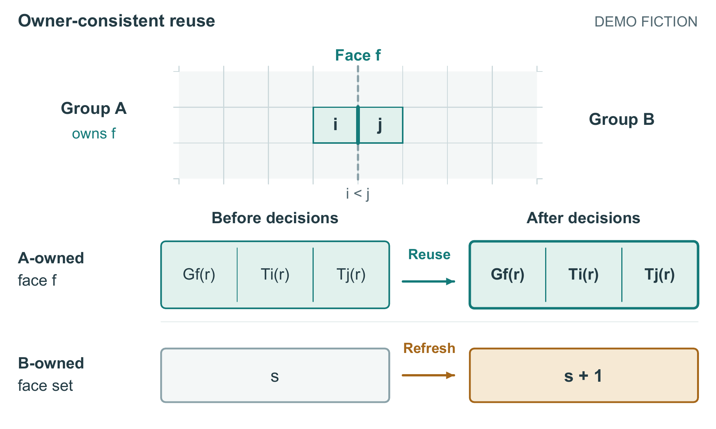
Figure 1. One face record survives its neighbor's refresh. The mesh is a cropped detail of two 16 × 16 groups; i < j assigns face f to A. Across the same decision event, A retains its coefficient and both endpoint snapshots from refresh r while B advances its own face set from s to s + 1. Arrows below the mesh denote state transitions, not heat flow. The two views of A's record are the same stored record, not duplicate allocations.
Let D be the largest absolute change from an owner's snapshots among all endpoints its faces require. The change of each face-mean temperature is at most D. For the stated fixed, nonnegative beta and positive cached conductance, the exponential law yields:
$\text{bound = exp(beta × D) − 1}$
$\text{abs(G_current − G_cached) / G_cached ≤ bound}$
G reuses a group's coefficients when bound is at most the user-selected local tolerance eta, including equality. Otherwise, it refreshes every owned face and its snapshots. A small hot region can therefore trigger an entire group's refresh, while each active group pays for an exponential test and snapshot reads. Reserved storage rises from 64 to 96 bytes per cell, or 50% (Section 4). Smaller subgroups and their metadata and branching costs are unaccounted for. At beta = 0, all methods evaluate coefficients once; G bypasses snapshots and the extra allocation.

3.2. Completing or discarding a proposed step
Passing the reuse test permits a coefficient to be used; the trial still has to qualify for commitment. Every trial first validates old temperatures, capacities, dt, and current source values: all must be finite, with positive capacities and dt. Invalid inputs abort. Initialization, restart, and retry require a global refresh; otherwise the selected method makes its refresh decisions. Nonfinite intermediate values are rejected. All decisions finish before any row sums or fluxes are formed, keeping the selected coefficients fixed throughout accumulation.
The reason for separating abort from retry is that reducing dt can repair an excessive diffusive row sum but cannot repair a constitutive evaluation at unchanged old temperatures. Every selected coefficient must be finite and strictly positive; exponential overflow or underflow to zero exits with INVALID_COEFFICIENT. Invalid inputs likewise never enter the retry loop. If the maximum sigma exceeds 0.95, the trial is discarded, dt is halved, and all coefficients are refreshed on retry. Eight halvings are permitted; continued failure exits with RETRY_LIMIT and preserves the last accepted state.
The face pass then writes each flux once, and the cell pass constructs the next temperatures. Nonfinite outputs cause INVALID_OUTPUT and retain the old array. Acceptance commits the array swap, simulated time, and accepted-step count together. Only accepted steps accumulate source energy as dt × sum(P_i). Discarded trials add neither energy nor time. Temporary refreshed caches are invalidated on abort; restart always refreshes globally. A parallel implementation would also require a completed face-pass barrier before the cell pass, but none has been constructed.

3.3. Arithmetic and exception examples
For two isolated cells at 40 and 20 °C, with capacities 100 J/K, G0 = 2 W/K, beta = 0.01 K⁻¹, T_ref = 20 °C, and dt = 1 s, the conductance is 2.21034184 W/K and flux is 44.20683672 W. The next temperatures are 39.55793163 and 20.44206837 °C. Their capacity-weighted sum is unchanged within displayed rounding; each sigma is approximately 0.0221034. At D = 0.2 K, the bound is approximately 0.00200200 and passes eta = 0.003; at D = 0.4 K, approximately 0.00400801 triggers refresh. These arithmetic examples do not guarantee accuracy over multiple steps.
Three constructed exception traces specify different exits. R1 starts with a full-refresh sigma of 1.10 at dt = 1 s, discards that trial, and accepts dt = 0.5 s with sigma = 0.55 because old temperatures are unchanged. It ends at 0.5 s, not at the original one-second endpoint. R2 supplies a NaN source and exits INVALID_INPUT before coefficient decisions. R3 supplies an exponent of 800 in binary64 arithmetic and exits INVALID_COEFFICIENT on overflow. R2 and R3 commit no steps. All three are excluded from the accounting tables and are control descriptions, not execution logs.

4. What the fictional comparisons measure
V supplies the full-refresh cost; P4 tests whether a fixed schedule already suffices. Table 1 retains all records with matched meshes, source sequences, constitutive parameters, time grids, and endpoints. Each case stipulates 1,000 accepted steps at dt = 0.1 s, ending at 100 s, with maximum sigma below 0.95 and zero rejected trials. These shared conditions make time and final-error comparisons meaningful within the accounting model.
The square meshes have 64 × 64, 512 × 512, or 1024 × 1024 cells. Nonconstant cases use G0 = 2 W/K, beta = 0.01 K⁻¹, T_ref = 20 °C, uniform capacity 100 J/K, and initial temperature 20 °C. Sources may change with accepted-step number: the slow plate has a broad, gradually changing stationary source; the boundary ramp heats cells along one edge while external faces remain insulated; the moving source translates a compact heated region; switching load alternates two source regions. The small mesh also has an alternating source. Static conduction uses a stationary source and beta = 0. Exact source arrays are absent, so these remain scenario descriptions rather than executable workloads.
Total time is guard plus coefficient plus transport time. Transport includes validation, sigma checks, flux construction, temperature update, and bookkeeping. Startup is included; I/O, checkpoint serialization, visualization, and mesh construction are excluded. Nonconstant coefficient time scales linearly with the stipulated fraction of V's full-refresh face evaluations, ignoring vector occupancy and cache effects. Face fractions include startup and divide by refreshing every interior face over all 1,000 steps. Thus P4 uses 25%, while every beta-zero method uses 0.1%.
Errors are maximum absolute final-temperature differences over cells from V, whose discretization error is unknown. There is no time-history norm. Accuracy passes at error ≤ 0.010 K, including equality. ACCEPTED only means the stipulated stepping path completes; it does not imply accuracy. The relative energy residual is abs(sum_i C_i × (T_i,final − T_i,initial) − E_source) divided by max(abs(E_source), 1 J). Source totals are nonnegative but unprovided, preventing independent residual recomputation. This residual concerns net energy, not spatial temperature accuracy.
The common allocation is 64 bytes per cell: two temperature arrays use 16 bytes, capacity and source arrays 8 each, and padded face-coefficient and face-flux storage 16 each. Two faces per cell are reserved even at boundaries. Active G adds 32 bytes per cell for snapshots, indices, counters, and aligned metadata: 96 bytes total, a 50% increase. The reserve includes padding; not every byte holds snapshot data. Group dimensions divide every mesh dimension. P4 and the beta-zero bypass retain the common allocation. One MiB is 1,048,576 bytes; program text, stack, allocator, libraries, and operating-system memory are excluded.

5. Savings depend on overhead and acceptable error
G's useful cases are the boundary ramp and moving source: it saves time over V where P4 fails the error limit. Figure 2 places these cases beside P4's qualifying slow-plate result and G's two timing losses.
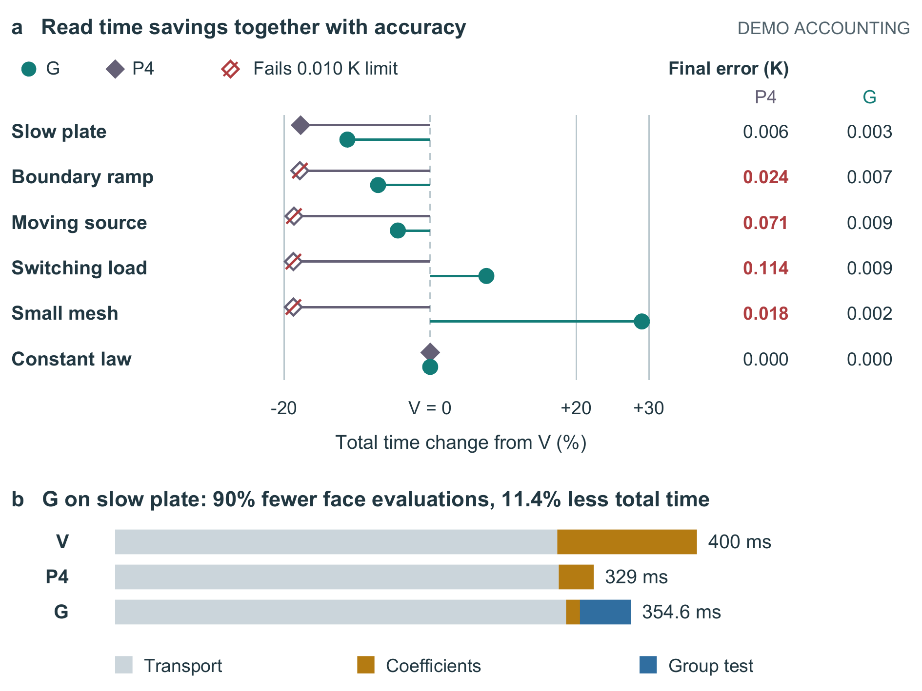
Figure 2. Read modeled savings with final-temperature error. G uses eta = 0.003 and reserves 50% more array memory when active; the constant-law bypass adds none. (a) Total-time change from V is (t_method/t_V − 1) × 100%; negative values are faster. Crossed diamonds fail the 0.010 K limit. V defines zero change and zero comparison error in each case. (b) Complete slow-plate costs: G removes 90% of face evaluation but only 11.35% of total time. Values are stipulated, without sampled uncertainty; the full accounting records remain in Table 1.
For the slow plate, G reduces total time from 400 to 354.6 ms, an 11.35% reduction using V as denominator. Removing 90% of face evaluation saves 86.4 ms of coefficient work, but a 35 ms guard and 6 ms more transport leave only 45.4 ms net savings. P4 is faster and uses less memory while also meeting the error limit: 329 ms and 0.006 K error.
The boundary ramp and moving source reduce G totals from 420 to 390 ms and from 1580 to 1510 ms, with errors of 0.007 and 0.009 K. P4 is faster at 345 and 1285 ms, but its respective errors of 0.024 and 0.071 K fail the limit. G therefore offers an acceptable stipulated alternative in these cases at smaller savings and greater memory cost.
Switching load reverses the timing result: G evaluates 96% of faces and takes 1723.2 ms versus V's 1600 ms. The small mesh also loses, at 10.32 versus 8 ms with 91% face evaluation. G passes the error rule in both; P4 takes 1300 and 6.5 ms but fails at 0.114 and 0.018 K. Constant conductance gives identical 300 ms totals and memory for all methods. These negative and bypass cases rule out a universal timing advantage in the accounting model.
Table 1. Complete runtime accounting records. Every row has provenance DEMO_STIPULATED, accepted_steps = 1,000, dt_s = 0.1, final_time_s = 100, accuracy_limit_K = 0.010, rejected_trials = 0, and status = ACCEPTED. Eta is 0.003 for G and NA for V/P4. Faces denotes face_eval_pct; energy residual denotes energy_balance_rel. Times are milliseconds; memory is reserved arrays in MiB.
Case | Cells | Method | Faces (%) | Guard | Coefficient | Transport | Total | Error (K) | Accuracy pass | Energy residual | Memory (MiB)
plate_slow | 262144 | V | 100 | 0 | 96 | 304 | 400 | 0 | TRUE | 1.7e-14 | 16
plate_slow | 262144 | P4 | 25 | 0 | 24 | 305 | 329 | 0.006 | TRUE | 2.1e-14 | 16
plate_slow | 262144 | G | 10 | 35 | 9.6 | 310 | 354.6 | 0.003 | TRUE | 2.4e-14 | 24
boundary_ramp | 262144 | V | 100 | 0 | 100 | 320 | 420 | 0 | TRUE | 2.0e-14 | 16
boundary_ramp | 262144 | P4 | 25 | 0 | 25 | 320 | 345 | 0.024 | FALSE | 2.6e-14 | 16
boundary_ramp | 262144 | G | 36 | 36 | 36 | 318 | 390 | 0.007 | TRUE | 2.8e-14 | 24
moving_source | 1048576 | V | 100 | 0 | 400 | 1180 | 1580 | 0 | TRUE | 3.0e-14 | 64
moving_source | 1048576 | P4 | 25 | 0 | 100 | 1185 | 1285 | 0.071 | FALSE | 3.7e-14 | 64
moving_source | 1048576 | G | 51 | 120 | 204 | 1186 | 1510 | 0.009 | TRUE | 4.1e-14 | 96
switching_load | 1048576 | V | 100 | 0 | 420 | 1180 | 1600 | 0 | TRUE | 3.2e-14 | 64
switching_load | 1048576 | P4 | 25 | 0 | 105 | 1195 | 1300 | 0.114 | FALSE | 4.5e-14 | 64
switching_load | 1048576 | G | 96 | 130 | 403.2 | 1190 | 1723.2 | 0.009 | TRUE | 4.8e-14 | 96
small_mesh | 4096 | V | 100 | 0 | 2 | 6 | 8 | 0 | TRUE | 8.0e-15 | 0.25
small_mesh | 4096 | P4 | 25 | 0 | 0.5 | 6 | 6.5 | 0.018 | FALSE | 8.8e-15 | 0.25
small_mesh | 4096 | G | 91 | 2.3 | 1.82 | 6.2 | 10.32 | 0.002 | TRUE | 9.0e-15 | 0.375
static_conduction | 262144 | V | 0.1 | 0 | 0.1 | 299.9 | 300 | 0 | TRUE | 1.5e-14 | 16
static_conduction | 262144 | P4 | 0.1 | 0 | 0.1 | 299.9 | 300 | 0 | TRUE | 1.5e-14 | 16
static_conduction | 262144 | G | 0.1 | 0 | 0.1 | 299.9 | 300 | 0 | TRUE | 1.5e-14 | 16

The next question is whether changing eta removes this tradeoff. Table 2 varies only eta for the moving source; its 0.003 row repeats Table 1's setting and is not an independent observation.
Table 2. Complete tolerance-sweep records. All rows have provenance DEMO_STIPULATED, case moving_source, method G, cells = 1,048,576, accepted_steps = 1,000, dt_s = 0.1, final_time_s = 100, accuracy_limit_K = 0.010, memory_MiB = 96, rejected_trials = 0, and status = ACCEPTED. Times are milliseconds; faces and energy residual use Table 1's definitions.
Eta | Faces (%) | Guard | Coefficient | Transport | Total | Error (K) | Accuracy pass | Energy residual
0.0005 | 88 | 120 | 352 | 1186 | 1658 | 0.001 | TRUE | 3.3e-14
0.001 | 72 | 120 | 288 | 1186 | 1594 | 0.003 | TRUE | 3.6e-14
0.002 | 61 | 120 | 244 | 1186 | 1550 | 0.006 | TRUE | 3.8e-14
0.003 | 51 | 120 | 204 | 1186 | 1510 | 0.009 | TRUE | 4.1e-14
0.006 | 32 | 120 | 128 | 1186 | 1434 | 0.019 | FALSE | 4.3e-14
0.01 | 18 | 120 | 72 | 1186 | 1378 | 0.038 | FALSE | 4.7e-14

At eta = 0.0005 and 0.001, totals of 1658 and 1594 ms exceed V's 1580 ms despite passing accuracy. Values 0.002 and 0.003 both save time and pass. Values 0.006 and 0.010 reduce time further but fail at 0.019 and 0.038 K. Thus a local coefficient tolerance cannot by itself select acceptable solution error. There is no automatic eta controller. Small energy residuals across passing and failing rows also show why energy accounting cannot replace the temperature comparison.

6. What the comparison establishes and leaves open
The relevant decision is not how many face evaluations can be removed, but which qualifying alternative is cheapest. P4 supplies this test: when it passes the error limit, guarding must justify its additional decision and storage costs; when P4 fails, G must be compared with V. This separates a useful reuse policy from a large local work reduction. The stipulated cases exercise both sides rather than establish a universal schedule.
Coefficient drift, energy accounting, and final-temperature error answer different questions. The tolerance sweep makes this distinction observable: smaller work totals eventually cease to qualify, whereas energy residuals remain small. A reuse bound therefore supports a decision about coefficients; it does not select eta for a required solution error.
The bound and two-cell arithmetic are directly checkable. The times, face fractions, final errors, and floating-point residuals are stipulated, with no solver trajectories or sampled variance behind them. Missing source arrays and trajectories prevent solver reproduction. Snapshot traffic, cache behavior, vector occupancy, parallel scaling, mixed materials, and time-dependent beta remain untested. Arithmetic reproducibility therefore does not establish measured benefit. Without literature validation, novelty and superiority to published methods remain unresolved; neither statistical significance nor production readiness is established.

7. Conclusion
Keeping both endpoint snapshots with a face's owner ties reuse to the state that produced its coefficient across independent group refreshes. Paired fluxes and accepted-state rules address the separate obligations of energy accounting and time-step commitment. Within the fictional accounting, G is useful on the boundary ramp and moving source; P4 is preferable on the slow plate, and full refresh avoids G's timing losses in the other two nonconstant cases. This connects a consistent reuse decision to explicit costs and limits, while leaving global temperature accuracy subject to a separate comparison.

