An aligned reference base for a three-channel pressure fixture
DEMO: all records and values in this manuscript are synthetic. They are not results from a physical device.

Abstract
Restoring three separate reference hoses can complicate replacement work in a modular pressure fixture. This DEMO study replaces those hoses with one removable reference base while keeping the three sample modules in position. The base exposes all three sensor reference sides to one connected volume; diaphragms preserve sample isolation. Two locating pins and one gasket register and seal the common interface. In three fixed synthetic paired conditions, the base reduces setup time from 8.0–8.6 to 3.0–3.3 min, with both assemblies passing all three leak checks. Maximum absolute differences from matched reference readings increase by 0.01 kPa in two conditions and remain unchanged in the third. Removing the pins shortens attempts further but produces two failed leak checks in three attempts. The comparison therefore links replacement time to sealing qualification, without establishing physical performance or reliability.

1 Introduction
A three-channel pressure fixture can already compare each sample with a common reference by connecting three sensor reference ports to the same source through separate hoses. The remaining assembly question is how to restore those reference connections while leaving the sample modules in place. Here, a single removable base replaces the three hose segments. This changes the replacement interface, while retaining the common reference, sensors, diaphragms and differential calculation.
The interface must both locate the base and seal its three reference ports. The design couples two locating pins with a single gasket, so its shorter setup time must be read alongside leakage outcomes. The synthetic comparison below asks whether the complete assembly saves time in each paired condition and what is lost when the pins are omitted. It makes no claim of a new sensing principle or priority over published apparatus.

2 Fixture and procedure
Figure 1 shows three mutually isolated sample chambers, S1–S3, above a common reference base. Each sensor compares the pressure in its own sample chamber with the pressure on the opposite side of its diaphragm. The base contains one connected reference volume extending beneath all three sensors; the sample chambers communicate neither with one another nor with that volume. The diaphragms provide the physical separation, not a route for flow.
The hose baseline connects each reference side to the same source through its own hose. Replacing these hoses with the base leaves the sensor range and software difference calculation unchanged.
The upper surface of the base carries three sealing seats. Two locating pins register the base with those interfaces, and one gasket surrounds all three reference ports. Pressure must be released before the fixture is opened. A control omits the pins but can still be assembled, allowing the records to distinguish a quick attempt from an assembly that passes its leak check. A failed attempt retains its setup time and has no pressure result. An alternative with three disconnected reference boxes was neither manufactured nor tested and contributes no result.
The pressure quantity is the maximum absolute difference from the matched reference reading over the retained window. The first 60 s after each pressure change are excluded using the same time window for the hose and base assemblies. C1–C3 are fixed paired synthetic conditions, not random samples. Table 1 reports every assembly attempt, including failures; NA denotes a missing pressure result after a failed leak check, not zero. The records permit direct comparisons of these conditions, not population significance tests.
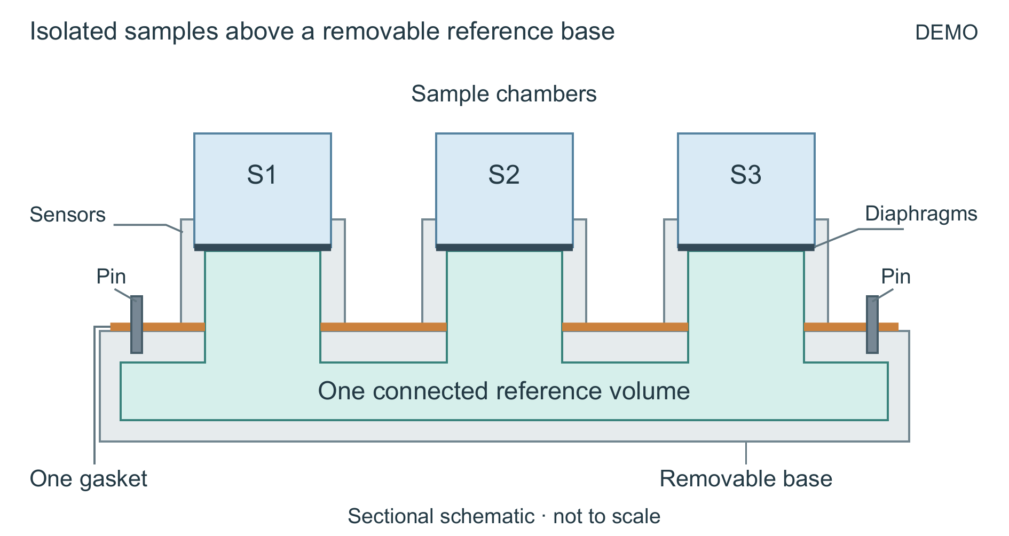
Fig. 1. DEMO sectional schematic of the removable reference base, not to scale. Three isolated sample chambers face one connected reference volume across three sensor diaphragms. The diaphragm boundaries remain closed. Two locating pins align the base; the orange segments are sections through one gasket around the three reference ports. The sample modules stay in position during replacement. Housing dimensions and the pin and gasket geometry are illustrative; pressure must be released before opening.

3 Results
For C1, C2 and C3, respectively, setup time falls from 8.4 to 3.1, 8.0 to 3.0, and 8.6 to 3.3 min when the three hoses are replaced by the aligned base (Table 1). The absolute reductions are 5.3, 5.0 and 5.3 min, equivalent to 63.1%, 62.5% and 61.6% of each matched hose time. Both assemblies pass all three leak checks. Their maximum absolute pressure differences are 0.12 versus 0.13 kPa in C1, 0.11 versus 0.12 kPa in C2, and 0.14 versus 0.14 kPa in C3. Thus the shorter setup is accompanied by a 0.01 kPa increase in two conditions and no change in the third; it is not a demonstrated accuracy improvement.
The pin-free attempts take 2.7, 2.6 and 2.8 min. C1 and C2 fail the leak check and have no pressure value; only C3 passes, with a maximum absolute difference of 0.15 kPa. The two failed attempts cannot be counted as additional usable time savings. The complete base comparison changes the reference packaging as a whole, so these records do not isolate the separate time contributions of the pins, gasket or hose removal.
Table 1. Complete DEMO records for the fixed paired conditions. Setup time is in minutes and maximum absolute difference is in kPa. NA follows a failed leak check.
condition | assembly | setup_min | max_abs_difference_kPa | leak_check
C1 | three hoses | 8.4 | 0.12 | pass
C1 | reference base | 3.1 | 0.13 | pass
C2 | three hoses | 8.0 | 0.11 | pass
C2 | reference base | 3.0 | 0.12 | pass
C3 | three hoses | 8.6 | 0.14 | pass
C3 | reference base | 3.3 | 0.14 | pass
C1 | base without pins | 2.7 | NA | fail
C2 | base without pins | 2.6 | NA | fail
C3 | base without pins | 2.8 | 0.15 | pass

4 Discussion and conclusion
The paired conditions make replacement an interface-level tradeoff. The hose baseline already passes every leak check; the base must retain that qualification while reducing setup time. It exchanges three individual hose connections for a single interface whose alignment and sealing must work together. Its recorded benefit is therefore the shorter setup of the complete, leak-passing assembly; the pin-free failures prevent treating the fastest attempt as the best usable configuration.
These records identify a design tradeoff to test, rather than validate a device. They do not establish pressure equivalence, resolution, response time, lifetime, fatigue or manufacturing reliability. Long-term leakage, repeated insertion and behavior during the discarded stabilization interval remain unknown. No physical fixture has been built or experimentally validated, and no literature comparison establishes novelty. Within the stated DEMO conditions, the aligned removable base offers a coherent replacement operation, with its time advantage contingent on passing the leak check.
Author statement: this is an original fictional example for evaluating editing and figure-generation workflows. No human participant, published result or real apparatus is represented.

