Assembly of a three-channel pressure fixture
DEMO: all records and values in this manuscript are synthetic. They are not results from a physical device.

Abstract
A fixture has three sample chambers, three pressure sensors, a reference base, two pins and one gasket. The sensors are processed with a differential measurement. A replacement base was designed and assembly times were collected. The fixture was compared with an assembly that uses three hoses. A control without pins was also prepared. Some values were missing in the control. The design, the test window and the results are described here.

1 Introduction
Modular test fixtures contain several connections that must be restored after a component is changed. A technician can spend time reconnecting these parts. This example concerns a pressure fixture with three sample modules. It includes a base and several sealing interfaces. The setup time and a pressure difference are reported. The example does not provide lifetime or fatigue data.

2 Fixture and procedure
Each sample chamber remains isolated from the other sample chambers. A diaphragm separates its sample pressure from a reference pressure. The earlier assembly connects the three reference sides to the same reference source through three individual hoses. Its sensors and difference calculation are unchanged in the base assembly. The replacement base occupies the lower part of the fixture and contains one connected reference volume facing all three reference sides. The three sample modules remain in their positions during a base replacement.
The new assembly has two locating pins and a single gasket. The pins register the base against the three sealing seats. Before opening the fixture, pressure must be released. A version without locating pins was included. The table reports a setup attempt even if its leak check failed; a failed assembly has no pressure result. No divided-reference-base design was built.
The reported quantity is the maximum absolute difference from the matched reference reading during the retained window. In each condition, the first 60 seconds after a pressure change are excluded in both assemblies. The three conditions are paired synthetic cases, not a statistical sample. The comparison does not establish resolution, response time or manufacturing lifetime.
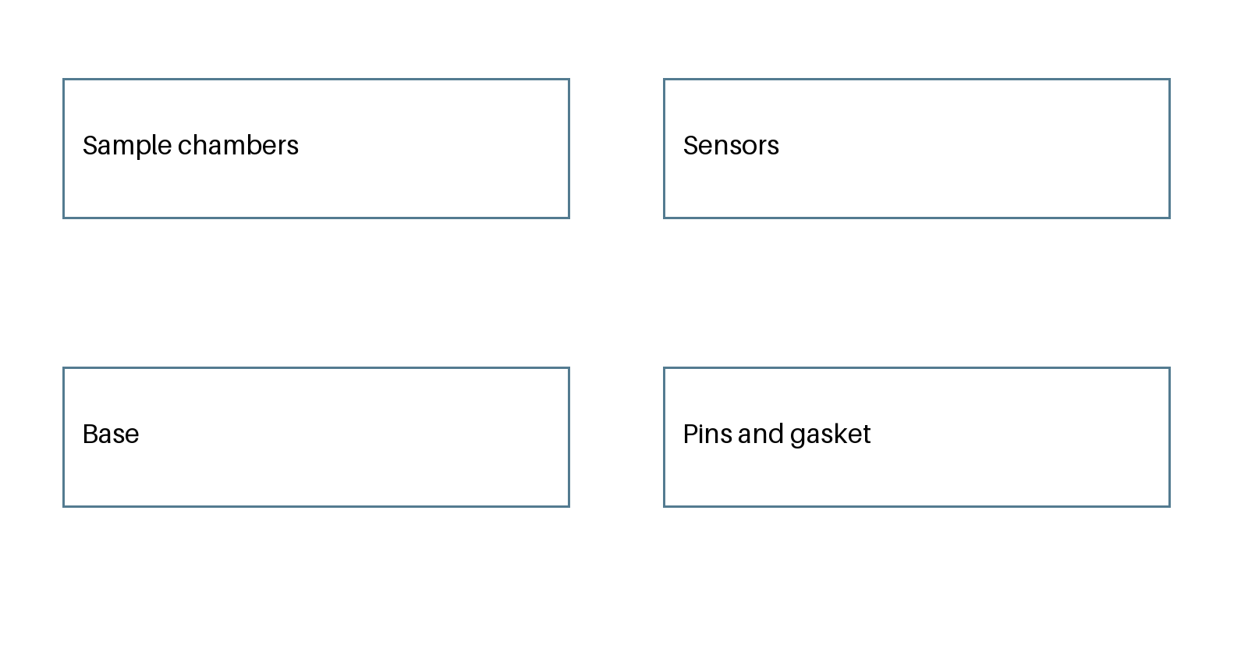
Fig. 1. Components listed for the fixture. The diagram is schematic and not to scale.

3 Results
The table contains three paired conditions and three attempts without locating pins. The base assembly has shorter setup times in the paired conditions. Pressure differences are similar in this small constructed set. The pin-free version is faster to assemble but two attempts fail the leak check. It should not be described as an additional usable improvement. NA denotes a missing result after failure and is not a zero.
Table 1. Fixed synthetic conditions; NA follows a failed leak check.
condition | assembly | setup_min | max_abs_difference_kPa | leak_check
C1 | three hoses | 8.4 | 0.12 | pass
C1 | reference base | 3.1 | 0.13 | pass
C2 | three hoses | 8.0 | 0.11 | pass
C2 | reference base | 3.0 | 0.12 | pass
C3 | three hoses | 8.6 | 0.14 | pass
C3 | reference base | 3.3 | 0.14 | pass
C1 | base without pins | 2.7 | NA | fail
C2 | base without pins | 2.6 | NA | fail
C3 | base without pins | 2.8 | 0.15 | pass

4 Discussion and conclusion
The base is a different way to package the reference connection. The common reference pressure and the differential sensor principle are also present in the hose assembly. The recorded values apply only to the synthetic conditions in Table 1. Long-term leakage, repeated insertion and behavior during the discarded stabilization interval remain unknown. The fixture has not been built or experimentally validated.
Author statement: this is an original fictional example for evaluating editing and figure-generation workflows. No human participant, published result or real apparatus is represented.

