CONSTRUCTED DEMO — NOT REAL RESEARCH RESULTS

When to lock a pivoting compression pad

Abstract
A pivoting pad can settle onto a sloping coupon, but leaving it free during compression may permit lateral drift. This constructed teaching study compares three operating sequences on one existing fixture: lock before approach (E), remain free (F), or seat under preload and then lock (L). For a 1 degree pitch slope, L gives a 2.3% coefficient of variation (CV) of endpoint force across reseatings and 19 micrometres drift, compared with 2.1% and 125 micrometres for F; seating takes 32 rather than 17 seconds. Early locking gives less drift but 7.2% force CV. Flat coupons show no repeatability benefit from L, and a slope across the available axis remains uncompensated. The records illustrate a conditional tradeoff in lock timing, without establishing material accuracy or a new joint design.

Introduction
A flat compression pad and a sloping coupon need not first meet across their full faces. Allowing the pad to pitch offers an existing way to accommodate a slope in one direction. Yet the freedom useful during seating remains available during the subsequent displacement ramp unless the operator closes the angular clamp. The practical question is whether that freedom should be retained throughout loading or used only to establish the seated pose.
We examine the timing of one existing friction clamp, keeping the frame, sensors, calibration, pad surface and analysis unchanged. The comparison separates a pitch slope that the pin can follow from a roll slope that it cannot. Flat coupons test whether the additional action is useful when alignment is already simple. Figure 1 makes the lock states and contact poses explicit. This is an operating-sequence comparison using constructed records [1,2]; it does not introduce a new pivot, controller or feedback algorithm.

Method
Mode E starts with the upper pad horizontal and locked before approach to 10 N. Mode F approaches with the clamp open and leaves it open during the ramp. Mode L approaches freely to 10 N, holds that preload, and closes the clamp without lifting the pad. A preload-hold acknowledgement is required before locking; its absence aborts the run. All supplied records contain the acknowledgement. Holding contact makes the locking action act on the seated pose rather than requiring a second approach. Displacement is zeroed after the prescribed approach or lock sequence, followed by the same 0.20 mm increment. The clamp is released only after unloading.
The crosshead carries a transverse pivot pin, perpendicular to the side-view plane. The rigid pad can pitch about that pin but cannot roll about another axis; its flat face presses the coupon against a fixed lower platen. The coupon tops are planar: flat, tilted 1 degree in pitch, or tilted 1 degree in roll. The 10 N preload and 0.20 mm increment are inherited teaching settings, not optimized values.
Force repeatability is calculated from the sample standard deviation s and mean μ of endpoint force after the 0.20 mm ramp across eight reseatings: $CV = 100 s / μ$. The value is reported in percent. It is not a measure of force accuracy.
Each row summarizes eight remove-and-reseat cycles of one coupon in that condition, not eight independent specimens. Geometry and synthetic inputs are identical across modes. The numbers are constructed demonstration values and have no uncertainty intervals.
Drift is the median magnitude of lateral pad displacement during the ramp. Seating time is the median interval from starting the approach to starting the ramp, including the hold and lock in L; it excludes unloading and specimen preparation. Full test duration was not measured. Mode order was not randomized, and raw force samples, pad-angle traces, lock-force measurements and pressure maps are unavailable. No automated correction was made.
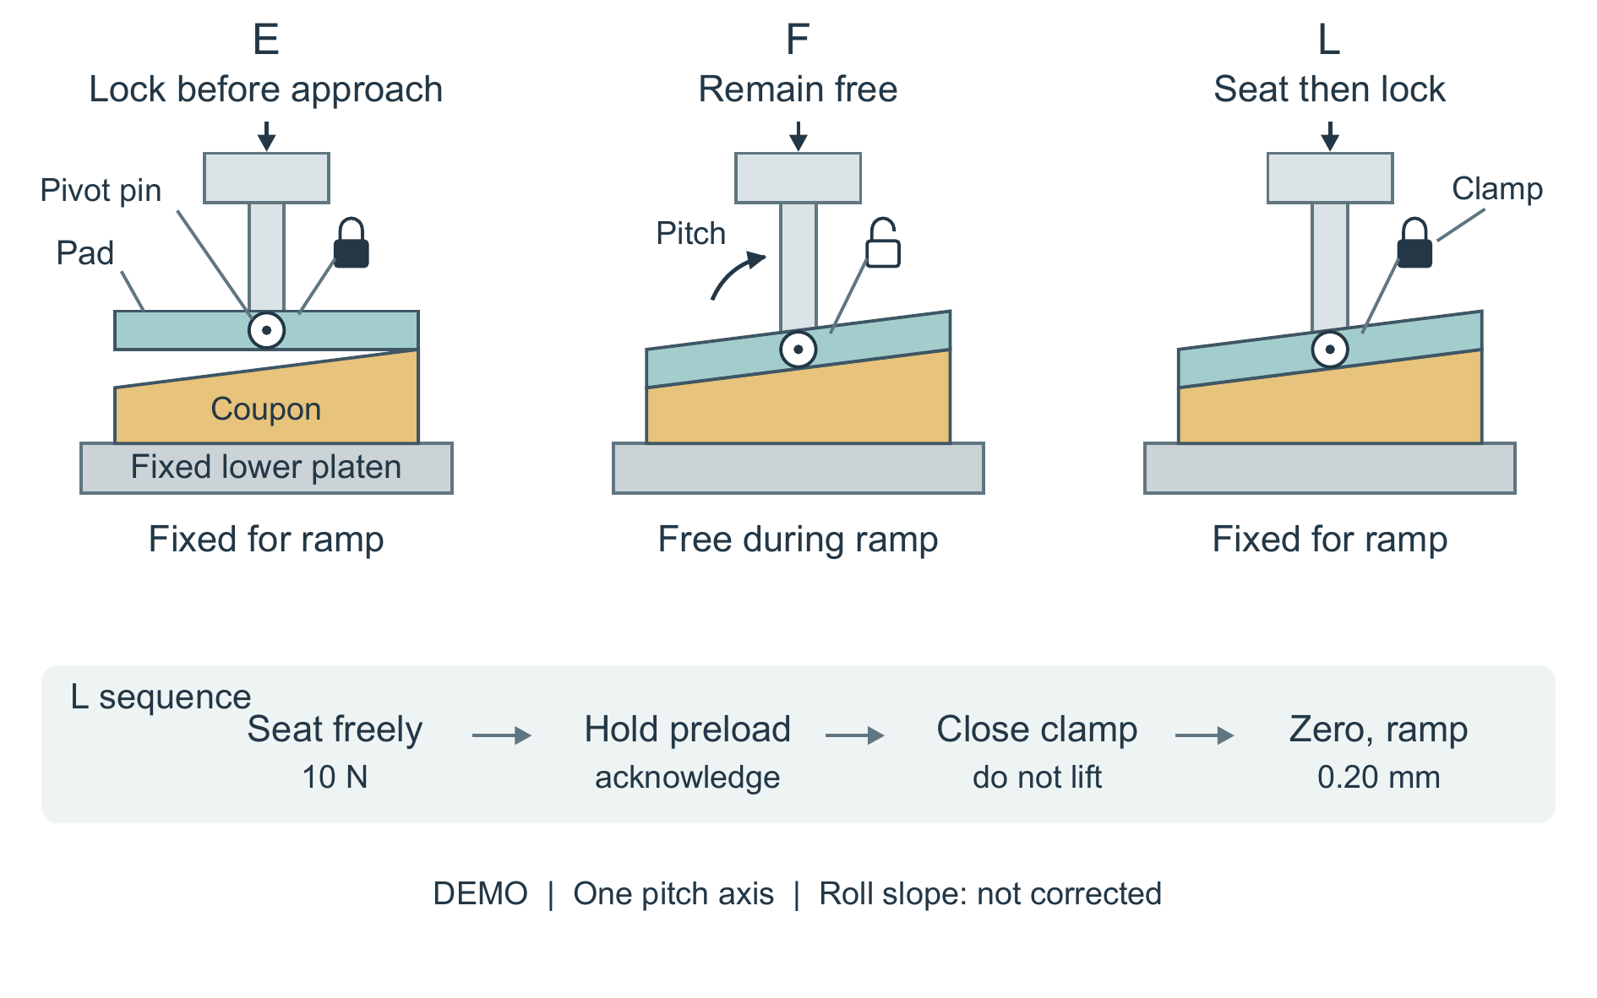
Figure 1. Three uses of the same single-axis compression pad on a pitch-sloped coupon. E fixes the horizontal pad before approach; F allows pitch rotation during seating and the ramp; L settles under 10 N, then locks during the acknowledged preload hold without lifting. Filled and open lock markers denote clamp state, not clamp construction. The side views repeat one fixture; the circular pin is viewed along its axis. The arc denotes permitted pitch rotation, not a measured angle. Slopes and the E-mode gap are exaggerated. The roll slope is outside the permitted motion. Poses are schematic, not contact-pressure maps.

Results
All records are listed in Table 1. The pitch condition tests whether locking after seating can retain low force variation while limiting ramp drift. Flat and roll conditions test whether that choice is broadly useful.
Table 1. Constructed repeated-mounting records.
Condition | Mode | Reseatings | Force CV (%) | Drift (µm) | Seating (s)
flat | E | 8 | 1.3 | 14 | 18
flat | F | 8 | 1.4 | 90 | 17
flat | L | 8 | 1.3 | 16 | 31
pitch_1deg | E | 8 | 7.2 | 12 | 18
pitch_1deg | F | 8 | 2.1 | 125 | 17
pitch_1deg | L | 8 | 2.3 | 19 | 32
roll_1deg | E | 8 | 7.0 | 14 | 18
roll_1deg | F | 8 | 6.8 | 126 | 17
roll_1deg | L | 8 | 6.9 | 20 | 32
On the pitch slope, E, F and L have force CVs of 7.2%, 2.1% and 2.3%, respectively. F already supplies the low-variation comparison that E lacks; L is therefore better understood as retaining that approximate level while restraining drift. Drift is 12, 125 and 19 micrometres, and seating takes 18, 17 and 32 seconds. L trades 15 additional seconds relative to F for 106 micrometres less median drift, rather than improving every metric. The small CV difference between F and L cannot be interpreted as equivalence or significance without uncertainty estimates.
The other conditions determine how far this choice can be extended. On flat tops, all CVs lie between 1.3% and 1.4%; L takes 31 seconds versus 18 for E, with drift of 16 versus 14 micrometres. Early locking is already adequate on these recorded metrics. Across the pivot direction, the roll condition remains at 6.8–7.0% CV in all modes. L reduces drift relative to F but does not repair that high variation. The single permitted rotation therefore limits the use of preload seating, even when a low drift value is obtained.

Conclusion
The constructed records support using the available pitch freedom for seating and then closing the clamp when the reduction in ramp drift justifies extra operator time. They do not support a universal preference for L: flat tops offer no repeatability gain, and roll slopes remain outside the joint's capability. Repeated mountings measure consistency of endpoint force, not unbiased force, modulus or pressure uniformity. With one coupon per condition and no physical experiments, this demonstration establishes an interpretable comparison and its limits, not validated fixture performance.

Sources
[1] Teaching implementation notes and mode definitions. [2] Constructed records

