Four-record seals for raster restart: replay savings, commit costs, and coordinate recovery
Synthetic engineering DEMO. All observations below come from a deterministic local model and constructed fault cases. No equipment, measured workload, external dataset, or real publication is represented.

Abstract
Restarting a raster job requires both a durable output boundary and a known physical position. This synthetic DEMO examines four-record block seals that preserve partial rows while retaining an existing alternating row checkpoint. We compare this block policy with whole-row commits and the simpler alternative of appending every record, using one 192-position geometry and twelve constructed interruption schedules. Blocks reduce payload buffering from 4096 to 1024 bytes relative to rows, but record appends require only 256 bytes. The configured block policy is 60.0 ms slower than rows without interruption and becomes the fastest policy in three diagnostic schedules; record appends remain faster in the ten-cut case. A separate prescribed displacement control misassigns all eight remaining row samples when anchoring is omitted. These results identify conditional storage and replay tradeoffs rather than a universal winner. Event ledgers and finite checks support the model accounting; physical latency, storage ordering, positioning behavior, and external originality remain untested.

1 Introduction
A power cut during a raster scan can erase two different kinds of progress: samples still in memory and the carriage's remembered position. Persisting a completed sample addresses the first loss, but does not establish where the next acquisition will occur. This distinction matters when reducing the amount of work repeated after reset. A restart procedure must first decide which logical records survived and then establish the physical coordinate associated with the first missing record. Here, acquisition and carriage motion are events in a synthetic engineering DEMO, not observations from equipment.
Whole-row commit (RC) retains sixteen 256-byte payloads before publishing a row. Its 4096-byte payload buffer motivates examining smaller persistence units, but immediate record append (AR) already offers a straightforward answer: publish each record with only 256 payload bytes buffered. The remaining question is whether four-record block sealing (BS) offers a useful intermediate choice. BS uses 1024 payload bytes and preserves completed blocks within an unfinished row, while retaining RC's alternating row checkpoints. It adds seal validation and checkpoint completion work; smaller buffering alone cannot establish its merit.
We evaluate that choice through complete event accounting rather than through the number of reacquired samples alone. All three policies traverse the same 192 positions, receive the same twelve deterministic cut schedules, and include homing and row anchoring. The comparison retains schedules in which either simple alternative wins. A separate displacement control asks whether valid stored data is sufficient to resume acquisition at the intended location. These two comparisons distinguish persistence cost from coordinate correctness without treating a checksum as a positioning guarantee.
The contribution is a source-inspectable analysis of this configured design choice: an inherited row checkpoint is extended with contiguous block recovery, and its benefit is evaluated alongside its costs and a necessary positioning action. The construction log records RC first, AR next, and BS afterward [S2]; it establishes only local implementation history. No external literature comparison, physical benchmark, or claim of historical originality is supported by the package. The resulting conclusions concern the specified DEMO and its assumptions.

2 Persistence and position recovery
The raster contains twelve rows and sixteen columns. With origin at sample center (0, 0), physical coordinates are x = 4c mm and y = 6r mm; the sample-center extent is 60 by 66 mm. Rows proceed in increasing r, but alternate horizontal direction. Traversal index k increases from 0 to 15 in every row: c = k for even rows and c = 15 − k for odd rows. Logical ordinal q = 16r + k consequently increases throughout the job [S1]. Figure 1 separates this logical order from physical column order at a restart boundary.
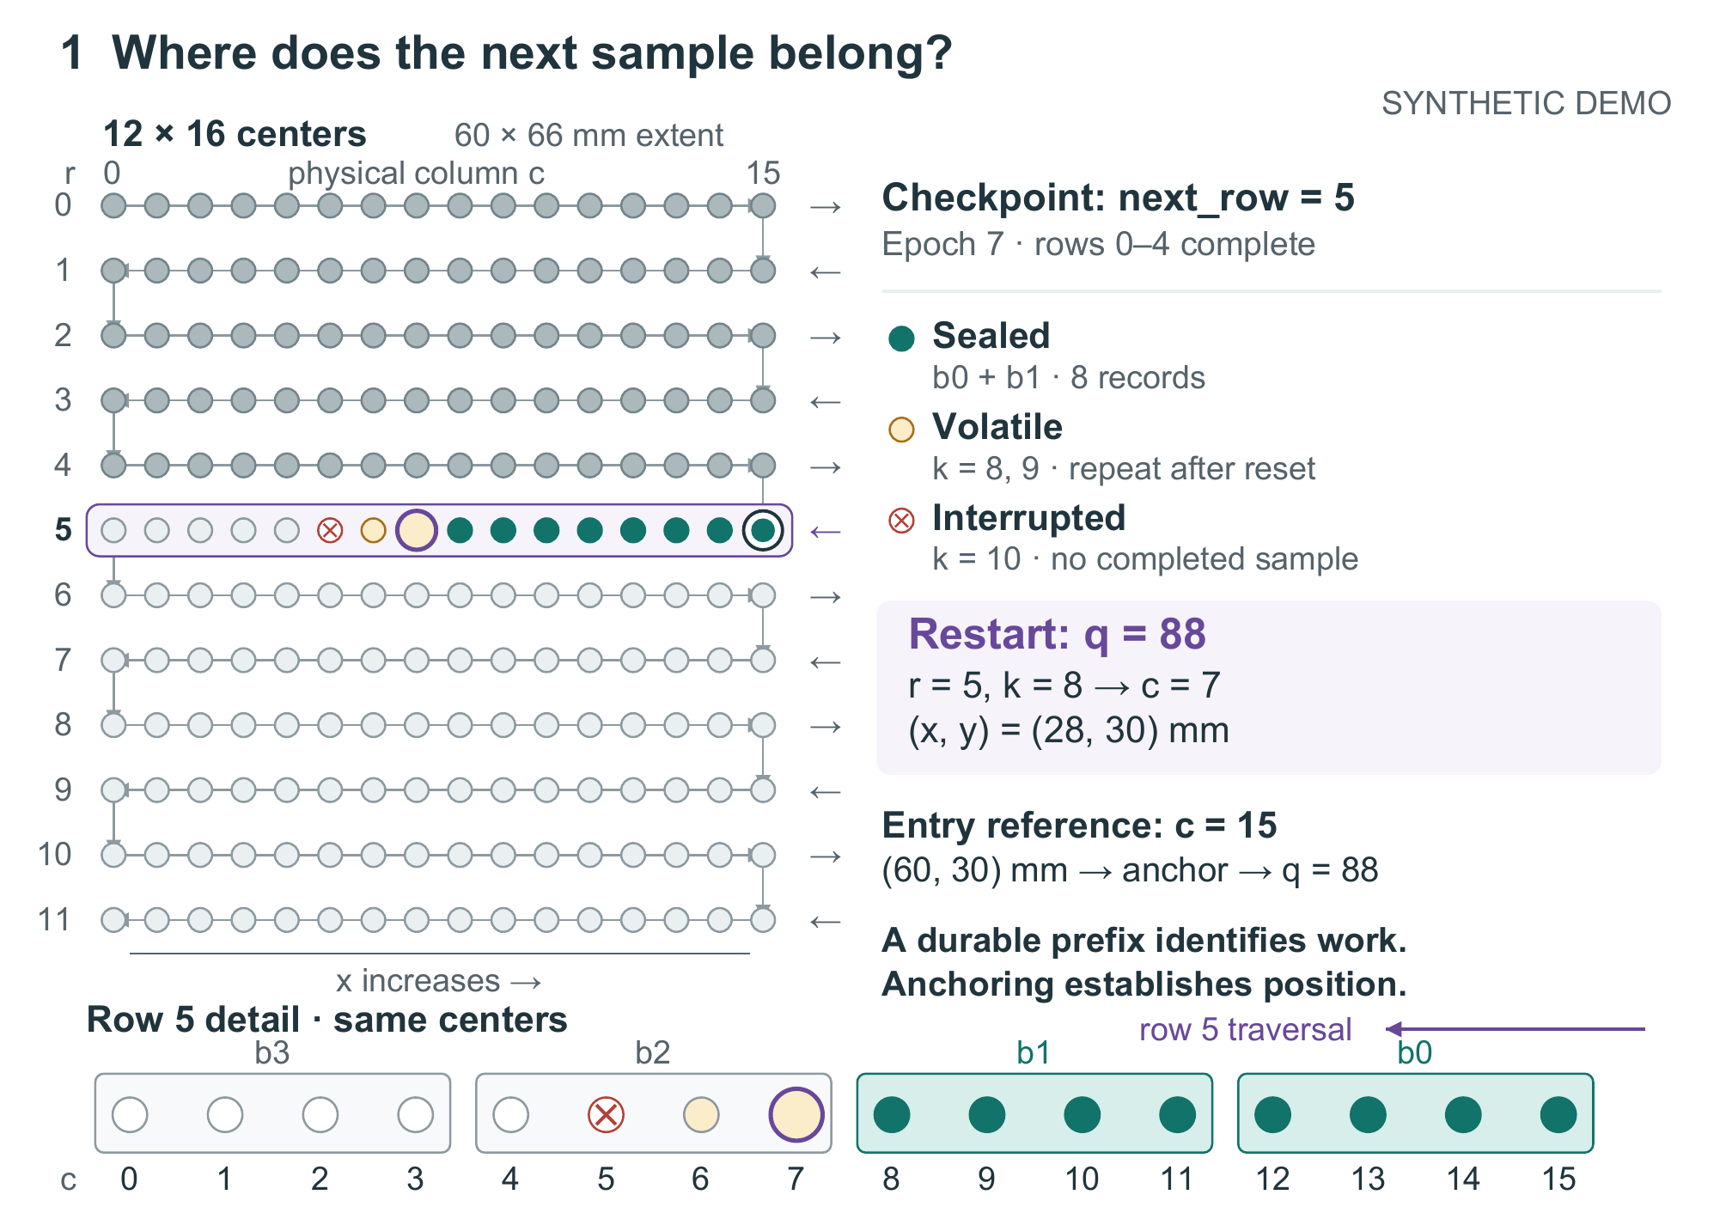
Figure 1. Constructed BS restart state, independent of the timing traces. The upper grid enumerates all 192 sample centers; the lower strip expands the same row 5, with columns increasing to the right and acquisition proceeding leftward. Rows 0–4 are complete. Sealed blocks b0 and b1 survive; the two volatile samples are repeated after reset. Epoch 7 and checkpoint next_row = 5 yield first missing q = 88, at (28, 30) mm. The row-entry reference remains at (60, 30) mm. Outlines and symbols supplement state colors.
Every startup, including restart, performs 120 ms of homing. Entering any row costs a further 30 ms for anchoring; after reset this includes travel from the known row-entry reference to the first missing position. The fixed cost does not depend on travel distance. Acquisition then costs 10 ms per sample, including its local move. A cut terminates the active event and discards volatile samples and the remembered coordinate. After homing, recovery lookup costs 1 ms for RC, 4 ms for AR, or 6 ms for BS; initial startup has no lookup charge.
RC stages a complete row and publishes its checkpoint in one 4 ms logical commit event. A cut before completion leaves that row unpublished. This all-or-nothing model outcome does not imply an atomic physical write of 4096 bytes. AR instead completes a 0.8 ms append after every acquisition. Each append contains 256 payload bytes and a 16-byte metadata allowance; only a completed append advances the durable contiguous record prefix. Thus AR is a strong simple comparison for BS: it preserves finer progress and requires a smaller payload buffer, at a higher configured commit cost per sample.
BS groups four successive traversal positions into a 1024-byte payload and a 24-byte seal allowance. Payload durability precedes seal publication within a combined 2 ms event. The seal identifies epoch, row, block index, record count, and payload CRC32. Four blocks complete a row; a separate 1 ms update advances its checkpoint. BS retains RC's two alternating 64-byte slots, rather than replacing the row protocol. The slot reader chooses the valid generation with the greatest number; a torn newer slot leaves the older valid slot usable [S2, S4]. These extra persistence boundaries are the mechanism's engineering cost.
Recovery reads the valid row checkpoint, then inspects blocks b = 0 through 3 in that row. Acceptance requires a seal, matching epoch, row and index, four records, 1024 payload bytes, and a valid CRC. Scanning stops at the first missing or invalid block: a later valid block cannot bridge a hole. If all four blocks survive while the row checkpoint is old, recovery completes that checkpoint before entering the next row. Figure 2 shows this accepted-prefix decision separately from the operation that establishes position; both must precede subsequent acquisition.
The state in Figure 1 makes the distinction concrete. Rows 0–4 are complete and row 5 runs from column 15 toward column 0. Sealed blocks b0 and b1 cover k = 0–7, or c = 15–8. Acquisitions k = 8 and 9, at columns 7 and 6, remain volatile; k = 10, at column 5, is interrupted. After reset, the first missing ordinal is q = 88: r = 5, k = 8, c = 7, at x = 28 mm and y = 30 mm. Anchoring uses the row-entry reference at c = 15, x = 60 mm, before returning to that point.
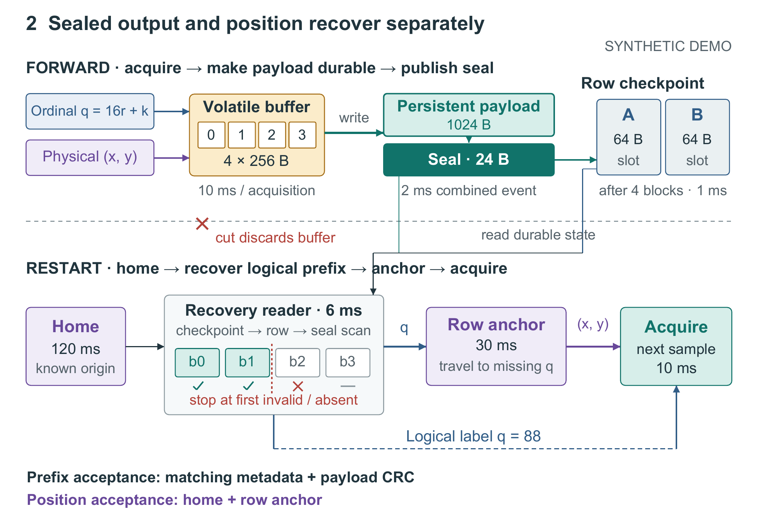
Figure 2. BS publication and restart paths. Forward operation fills four volatile records, makes the payload durable, publishes its seal, and updates an alternating row-checkpoint slot after four blocks. A cut discards the volatile buffer. Restart homes first, reads the checkpoint and validates the ordered block prefix, then anchors before acquisition. The illustrated prefix is the Figure 1 state; scanning stops at b2. Logical q and established physical position reach acquisition through distinct paths. If all four blocks survive, an old row checkpoint is completed before the next row is entered. Timings are assumed DEMO costs.
Equation 1 sums the configured duration d of each completed event in E_done and the elapsed duration τ of each interrupted event in E_cut. A cut exactly at an event's scheduled end wins before publication. Powered time excludes off intervals; elapsed time including them adds 40 ms per encountered cut [S1, S3]. Homing, lookup, and anchoring may themselves be interrupted, so counting only completed operations would omit consumed time. None of these three operations makes a record durable.
$$T_{power} = \sum_{e∈E_{done}}{d(e)} + \sum_{e∈E_{cut}}{τ(e)} (1)$$
All events execute serially, with no erase, wear, overlap, cache, or communication model. Durations are chosen assumptions rather than calibrated latencies. The correctness target is one durable result for every logical ordinal. A sample may be reacquired without external side effects. Completed reacquisitions equal completed acquisition events minus 192; interrupted acquisitions are excluded from this count, although their partial durations remain in powered time. The per-event ledger preserves both completed and interrupted work, keeping replay counts distinct from completion time.

3 Complete comparisons and failure controls
Table 1 retains all twelve profiles and all three policies [S3]. Cut times are absolute values on a cumulative powered clock that pauses during outages. The policies therefore receive identical cut times but can be interrupted in different event phases. T0 is uninterrupted; T1–T2 have two irregular cuts, T3–T4 six cuts, and T5 ten cuts. T6–T11 retain the complete regular two-cut set, with spacings of 500, 600, 700, 800, 900, and 1000 ms. These diagnostic schedules are not draws from an outage distribution, so no population average or statistical confidence interval is implied.
Trace | Cuts | RC (ms) | AR (ms) | BS (ms)
T0 | 0 | 2448.0 | 2553.6 | 2508.0
T1 | 2 | 2821.0 | 2868.0 | 2851.0
T2 | 2 | 2813.0 | 2842.4 | 2833.0
T3 | 6 | 3825.0 | 3526.8 | 3619.0
T4 | 6 | 3781.0 | 3518.0 | 3595.0
T5 | 10 | 5449.0 | 4138.0 | 4194.0
T6 | 2 | 3061.0 | 2873.6 | 2875.0
T7 | 2 | 2873.0 | 2870.8 | 2834.0
T8 | 2 | 3073.0 | 2868.0 | 2877.0
T9 | 2 | 2885.0 | 2876.0 | 2836.0
T10 | 2 | 2697.0 | 2873.2 | 2879.0
T11 | 2 | 2897.0 | 2870.4 | 2838.0
Table 1. Powered completion times (ms) for all constructed schedules. The native table retains the complete cut schedules and policy results. All 36 cases finish with 192 durable logical records. Off time adds 40 ms per cut; repeated-acquisition counts and complete event histories remain available in [S3]. Values are deterministic calculations, not averages of physical trials.
BS does not remove the ordinary cost of finer persistence. Without interruption, RC finishes in 2448.0 ms, BS in 2508.0 ms, and AR in 2553.6 ms: BS pays 60.0 ms over RC. BS becomes fastest in T7, T9, and T11. In T9 it takes 2836.0 ms, compared with 2885.0 ms for RC and 2876.0 ms for AR, differences of 49.0 and 40.0 ms. Yet the neighboring regular probe T10 reverses the result: RC needs 2697.0 ms and BS 2879.0 ms. An identical cut count is insufficient to predict which policy wins.
AR also remains competitive when replay is frequent. In T5, RC takes 5449.0 ms with 140 completed reacquisitions, BS takes 4194.0 ms with eleven, and AR takes 4138.0 ms with none. Blocks substantially reduce replay relative to rows in this case, but the simpler record policy still finishes 56.0 ms earlier. Conversely, T1 gives AR one completed reacquisition, BS two, and RC eight, yet RC finishes first at 2821.0 ms. Commit cost and the phases interrupted by later cuts participate in the outcome; the replay counter cannot serve as a substitute for the time ledger.
The supplied local validation reports sixteen passing named checks, including a finite sweep of 128 single-cut positions per policy. All 384 sweep cases reach 192 durable records. Other checks cover coordinate uniqueness, odd-row reversal, analytic no-cut totals, rejection of malformed seals, stopping at a prefix hole, and checkpoint-slot selection [S4]. These checks exercise a durable-prefix event simulator and separate byte-checksum routines. They do not form a byte-complete storage crash emulator or prove correctness for every possible sequence of cuts and corruptions.
The independent coordinate control injects a fixed +4 mm residual x displacement after reset at the Figure 1 state. It tests only the eight remaining samples of row 5. Anchoring gives zero incorrect assignments out of eight; omitting it shifts all eight by one column, from intended columns 7–0 to actual columns 8–1 [S4]. This is a prescribed arithmetic failure, not an observed drift rate. It exposes a failure that payload integrity checks cannot detect: correctly stored bytes may still be associated with an incorrect physical location.

4 Adoption conditions and limits
The storage comparison places the timing results in context. RC, AR, and BS require 4096, 256, and 1024 payload-buffer bytes respectively, excluding metadata, motion state, and runtime stack. Their simplified completed-job persistent allowances are 49280, 52224, and 50432 bytes: respectively 192 × 256 + 2 × 64, 192 × 272, and 48 × 1048 + 2 × 64. Alignment, allocators, and filesystems are excluded. BS reduces buffering relative to RC but does not beat AR on that criterion; it reduces the persistent allowance relative to AR but remains above RC. These byte counts do not determine the assumed write latencies.
BS earns its place when the cost of publishing every record matters, yet losing a whole row is too expensive. Its seals preserve partial rows while the inherited checkpoint protocol still recovers completed rows. The present traces support that choice only conditionally: RC wins without cuts, AR wins the ten-cut case, and the regular probes change ordering with cut phase. BS also pays for lookup when no useful block survives. Selection therefore depends on available memory, actual small-write costs, and the relevant interruption process; an intermediate commit size alone is not an optimization result.
Several assumptions would need independent validation before deployment. The combined BS event supplies payload-before-seal ordering by construction; a physical storage implementation would need to enforce it. The checkpoint example tests generation and checksum selection but supplies neither a device driver nor a byte-exact 64-byte slot serializer. The fixed anchor duration does not model distance-dependent travel or positioning errors. The prescribed coordinate control establishes the consequence of one displacement, not the reliability of a real homing or anchoring mechanism.
The evidence covers one geometry, one record size, and one set of costs, without a latency or geometry sweep. It also assumes repeatable acquisition: a moving target, destructive probe, or external side effect would change the correctness problem because repeating a sample might no longer be acceptable. Neither the finite sweep nor the twelve profiles represents real outage behavior. Hardware timing, endurance, and energy remain unmeasured, and novelty against published systems remains open. These gaps limit generalization without obscuring the implemented tradeoff demonstrated by the accounting.

5 Conclusion
Four-record seals extend an inherited row checkpoint with recovery of a contiguous partial row. In this synthetic raster instance, they offer a smaller buffer than row commits and lower configured per-sample commit overhead than record appends, but no universal completion-time advantage. Complete trace comparisons retain the regimes where each alternative wins. The displacement control separately shows why the recovered logical boundary must be paired with position establishment. The deliverable is an inspectable model-based design analysis, with physical validity and external originality still to be established.

Internal sources
[S1] specification.md and data/parameters.json. Constructed geometry, state semantics, timing assumptions, and scope. Synthetic DEMO sources created for this package.
[S2] implementation_log.md and model.py. Local construction record and executable model. No external project history is claimed.
[S3] data/traces.json, data/results.csv, and data/events.csv. Deterministic trace definitions and generated accounting results.
[S4] tests/test_results.json, tests/single_cut_sweep.csv, and data/anchor_control.csv. Local finite checks and prescribed coordinate fault injection. These are not experimental receipts from equipment.

