Recovering Records and Position in Block-Sealed Raster Acquisition: A Synthetic Study
Synthetic engineering DEMO. All observations below come from a deterministic local model and constructed fault cases. No equipment, measured workload, external dataset, or real publication is represented.

Abstract
Restarting a raster acquisition job requires both a durable output prefix and a known physical position. A surviving record checksum establishes neither the carriage coordinate nor the best persistence granularity. We examine these choices in a synthetic twelve-row, sixteen-column job using row commits (RC), immediate record appends (AR), and four-record block seals (BS). BS retains alternating row checkpoints while recovering sealed progress within an unfinished row, reducing payload buffering from RC's 4096 to 1024 bytes; AR requires 256 bytes. Across twelve deterministic interruption schedules, all 36 cases produce 192 durable logical records, but no policy is fastest throughout. RC leads without cuts at 2448.0 ms, whereas BS reaches 2836.0 ms in one two-cut case and AR leads the ten-cut case at 4138.0 ms. A separate prescribed displacement control misassigns eight records when anchoring is omitted. These calculations expose conditional tradeoffs and distinct recovery obligations; they establish neither device performance nor exhaustive reliability.

1 Introduction
A restarted acquisition controller must answer two different questions: which records survived, and where the next acquisition will occur. Consider a serpentine scan interrupted partway through a row. Records already sealed in persistent storage can identify the next missing logical sample, while a reset has erased the remembered carriage coordinate. Resuming from that logical key alone can produce intact bytes labelled with the wrong position. We separate these two recovery obligations in a constructed raster job, then compare the cost of preserving progress one record, one block, or one row at a time.
The comparison includes a simple alternative that already preserves fine-grained progress: append every record immediately. We call this policy AR. Row commits (RC) instead buffer a complete row, and block seals (BS) publish groups of four records while retaining RC's row checkpoints. Their volatile payload allowances are 256, 4096, and 1024 bytes, respectively. BS therefore offers an intermediate allocation, not the smallest buffer or a unique ability to resume correctly. Headers, motion state, and runtime stacks are additional allocations, so these payload figures do not rank complete implementations.
Our contribution within this DEMO is an explicit comparison of these three choices under the same geometry, acquisition costs, and interruption schedules, together with a separate coordinate-failure control. The construction record begins with the RC scaffold and its alternating checkpoint slots, adds AR, and then adds BS's ordered block validation [S2]. This local sequence identifies inherited and added mechanisms. It supplies no evidence of originality against published systems, and no external literature comparison is claimed.
The evidence is deliberately inspectable rather than empirical: a deterministic event model, complete ledgers, twelve constructed schedules, and finite validation checks. There is no physical carriage or measured workload. Two observations guide the analysis. Fewer repeated acquisitions need not shorten a job, because write costs and cut phases also matter. Likewise, recovering a valid prefix need not recover a valid coordinate. We retain both unfavorable timing cases and the failed coordinate control to delimit what BS actually provides.

2 Recovery mechanism and accounting model
The job visits 192 sample centers in rows r = 0...11 and columns c = 0...15. With the origin at row 0, column 0, x = 4c mm and y = 6r mm; the sample-center extent is 60 by 66 mm. These are assumed sampling coordinates, not fixture dimensions. Traversal index k increases from 0 to 15 within each row. Even rows use c = k, odd rows use c = 15 - k, and ordinal q = 16r + k increases throughout the job [S1]. Figure 1 preserves this distinction between traversal order and increasing x.
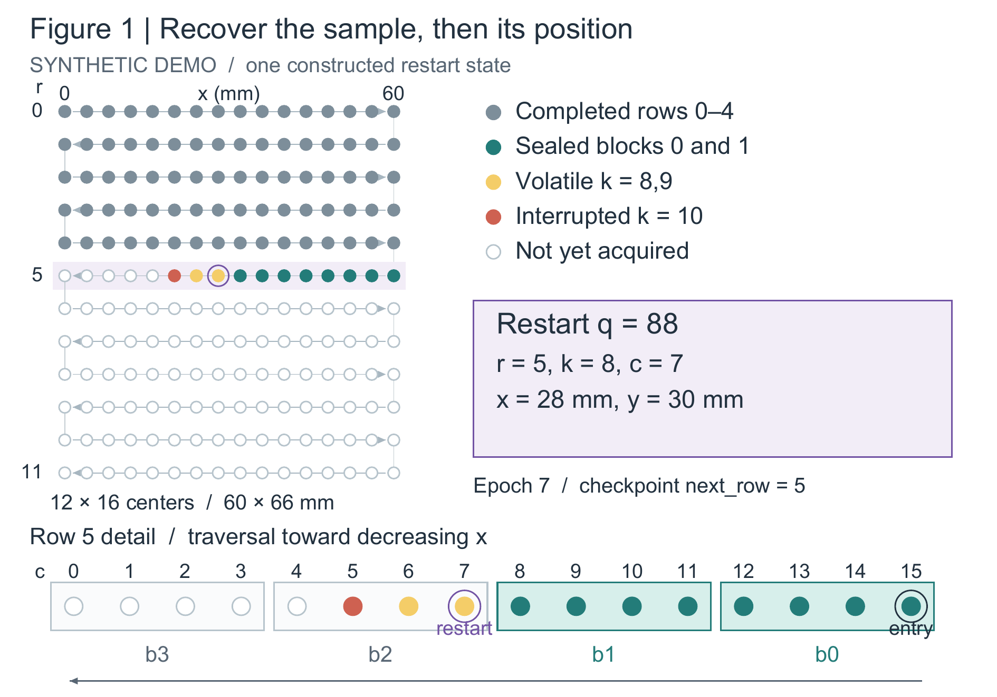
Figure 1. Logical progress and physical restart in a constructed BS state, independent of Table 1's cut times. The plane contains all 192 centers; the lower strip repeats row 5 for detail and adds no samples. Rows 0–4 are complete. At epoch 7 and checkpoint next_row = 5, blocks 0 and 1 are sealed, k = 8,9 are volatile, and k = 10 is interrupted. Restart q = 88 maps to c = 7, x = 28 mm, y = 30 mm; the entry reference is c = 15, x = 60 mm. Blocks follow right-to-left traversal, not increasing x.
Each startup first homes for 120 ms. A row-entry anchor then costs 30 ms, including travel from a known reference to the first missing position; after a cut, recovery lookup precedes this anchor. The same anchor duration applies regardless of distance. Each acquisition costs 10 ms including its local move. A cut terminates the current event and discards volatile data and remembered position. Powered time excludes outages; elapsed time additionally charges 40 ms per encountered cut. These fixed, serial costs are assumptions, not measured motion or storage latencies [S1, S3].
AR appends a self-validating 272-byte record after each acquisition, using a 16-byte metadata allowance and a 0.8 ms commit. A completed append advances a verified contiguous durable prefix by one. RC stages sixteen payloads and publishes a row checkpoint in a combined 4 ms event; an interrupted event publishes no row. The model thus gives RC an all-or-nothing logical outcome without asserting that a medium atomically writes 4096 bytes. Both policies already meet the model's logical output target in the supplied cases, so that property alone cannot distinguish BS.
BS buffers four successive 256-byte records, writes the 1024-byte payload, and publishes its seal in a combined 2 ms event. The 24-byte seal allowance covers epoch, row, block index, record count, and payload checksum information. After four sealed blocks, a separate 1 ms update advances the row checkpoint. RC and BS use two alternating 64-byte checkpoint slots. The reader chooses the valid generation with the largest counter; a torn newer slot leaves the older valid slot usable [S2, S4]. Payload durability before seal publication is essential to BS's meaning and is assumed, not demonstrated on storage hardware.
BS recovery starts from the checkpoint's next row and inspects blocks 0 through 3 in order. Acceptance requires a seal, the expected epoch, row and index, four records, 1024 payload bytes, and a matching CRC32. Validation stops at the first invalid or absent block: a valid later block cannot bridge a hole. If all four blocks survived but the checkpoint did not advance, recovery completes that checkpoint before entering the next row. Lookup after a cut costs 6 ms for BS, 4 ms for AR, and 1 ms for RC; initial startup has no lookup charge. As Figure 2 shows, the reader selects the next ordinal; the row anchor establishes the physical coordinate used to acquire it.
In Figure 1, rows 0–4 are complete and the next-row checkpoint remains 5. At epoch 7, blocks 0 and 1 retain k = 0...7, which correspond to columns 15...8. Samples k = 8,9 were acquired but remain volatile; k = 10 was interrupted at column 5. Recovery therefore selects q = 88, or r = 5, k = 8, c = 7, at (28,30) mm. The row-entry reference is (60,30) mm. Repeating the two lost samples is allowed. Establishing the coordinate from that reference must still precede acquisition; the durable prefix does not locate the carriage.
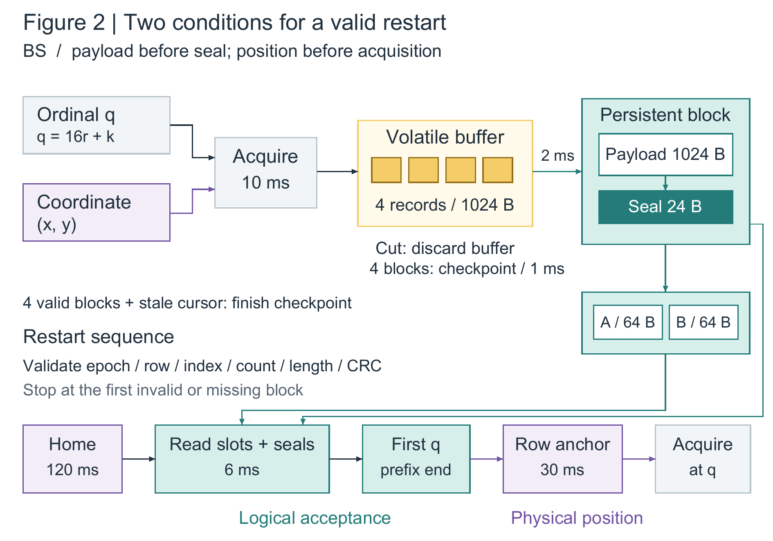
Figure 2. BS forward publication and restart dependencies. Four acquired records fill a volatile buffer; payload durability precedes seal publication in the combined 2 ms event. Four sealed blocks trigger a 1 ms update of one alternating checkpoint slot. On restart, homing precedes the reader, which uses slots and seals to accept only a contiguous prefix. The resulting first missing ordinal guides the 30 ms row anchor; acquisition follows position establishment. Cuts discard the volatile buffer. The diagram represents assumed serial behavior, not a measured device; metadata validity alone does not establish physical position.
Equation 1 accounts for each completed event at its configured duration d and each interrupted event at its elapsed duration tau. E_done and E_cut contain event instances, including homes, lookups, anchors, acquisitions, and commits. A cut exactly at an event's scheduled end wins before publication. The ledger retains this convention and partial durations rather than replacing all restart work by one constant penalty.
$$T_{power} = \sum_{e∈E_{done}}{d(e)} + \sum_{e∈E_{cut}}{τ(e)} (1)$$
Completed reacquisitions equal the number of completed acquisition events minus 192. A partially completed acquisition is excluded from that count but its consumed time remains in Equation 1. Operations do not overlap. Erase time, wear, caches, and communication delays are absent, and event costs are uncalibrated. Correctness here means one durable logical result per ordinal. It permits repeat acquisition without external side effects, a restriction that matters when interpreting both recovery and completion time.

3 Evidence across cuts and the coordinate control
Table 1 retains all twelve profiles and all three policies. Cuts use cumulative powered time, continuing across restarts and pausing during outages. Each policy receives the same absolute schedule, so unequal event durations cause a cut to strike different phases. T0 has no cut; T1 and T2 have two irregular cuts, T3 and T4 have six, and T5 has ten. T6–T11 are the complete regular two-cut probe set with spacings of 500, 600, 700, 800, 900, and 1000 ms [S3]. These diagnostic schedules are neither a sampled outage distribution nor a basis for population statistics.
Trace | Cuts | RC (ms) | AR (ms) | BS (ms)
T0 | 0 | 2448.0 | 2553.6 | 2508.0
T1 | 2 | 2821.0 | 2868.0 | 2851.0
T2 | 2 | 2813.0 | 2842.4 | 2833.0
T3 | 6 | 3825.0 | 3526.8 | 3619.0
T4 | 6 | 3781.0 | 3518.0 | 3595.0
T5 | 10 | 5449.0 | 4138.0 | 4194.0
T6 | 2 | 3061.0 | 2873.6 | 2875.0
T7 | 2 | 2873.0 | 2870.8 | 2834.0
T8 | 2 | 3073.0 | 2868.0 | 2877.0
T9 | 2 | 2885.0 | 2876.0 | 2836.0
T10 | 2 | 2697.0 | 2873.2 | 2879.0
T11 | 2 | 2897.0 | 2870.4 | 2838.0
Table 1. Deterministic powered completion times for all twelve constructed schedules. Every policy–trace case finishes with 192 durable logical records. Off intervals are excluded; elapsed time adds 40 ms per encountered cut. Reacquisition counts and partial-event accounting remain available in [S3]. Values are calculated outcomes, not trial means.
Without cuts, RC completes in 2448.0 ms, BS in 2508.0 ms, and AR in 2553.6 ms. BS therefore pays 60.0 ms relative to RC in the uncomplicated case. Its advantage is conditional: in T9, BS takes 2836.0 ms, 49.0 ms below RC's 2885.0 ms and 40.0 ms below AR's 2876.0 ms. In T10, however, RC takes 2697.0 ms while BS takes 2879.0 ms. The regular probes thus expose a timing reversal even though each contains two cuts. Counting interruptions does not predict the preferred granularity.
AR is the stronger fine-grained comparator in T5. It finishes in 4138.0 ms with zero completed reacquisitions; BS takes 4194.0 ms with eleven, and RC takes 5449.0 ms with 140. BS does not recover AR's timing advantage there. T1 further separates repeat work from total time: AR repeats one completed acquisition, BS two, and RC eight, yet RC finishes first at 2821.0 ms. The ledger, including publication costs and interrupted phases, is required to explain these comparisons. A repetition counter by itself is insufficient.
The supplied test record reports sixteen named checks passed, including 128 single-cut positions for each policy. All 384 sweep cases reach 192 durable records. Other checks cover coordinate uniqueness, odd-row reversal, analytic no-cut totals, seal rejection, prefix holes, and checkpoint selection [S4]. These checks exercise a finite implementation scope. The event simulator represents durability with prefix and row-checkpoint integers, while independent routines test metadata and CRCs on constructed byte arrays. Their combination is not a complete byte-level crash emulator or a proof for every cut and corruption pattern.
The coordinate control begins from Figure 1's row-5 state and injects a fixed +4 mm residual x displacement after reset. It covers only the eight remaining samples k = 8...15. With anchoring, physical columns match intended columns 7...0 and zero records are misassigned. Omitting the anchor yields physical columns 8...1 while logical labels remain 7...0: all eight assignments are wrong. This prescribed arithmetic failure is not an observed drift probability, and it says nothing about later rows. Payload checksums cannot detect an intact record acquired at the wrong location.

4 What the comparison supports
Completed-job persistent allowances are 49280 bytes for RC, 52224 for AR, and 50432 for BS. RC uses 192 × 256 payload bytes plus the 128-byte checkpoint pair; AR uses 192 × 272 bytes; BS uses 48 × 1048 bytes plus the same pair. These totals exclude alignment, allocators, and filesystems. Together with the payload-buffer figures, they describe distinct storage choices, but do not determine the configured write costs. Inferring those latency ratios from byte counts would add a causal explanation the materials do not support.
Recovery overhead is paid even when it recovers no useful progress. Homes, lookups, and anchors can themselves be interrupted; their partial durations are charged and required work repeats at the next startup. Neither lookup nor anchoring publishes a record. The finite sweep admits cuts during homing, although the twelve principal profiles do not cover every such sequence. Consequently, multiplying successful operations by their full costs would omit consumed work. Keeping the event ledger is necessary for faithful accounting, not an additional claim of reliability.
The coordinate control also limits the correctness definition. A changing object, destructive probe, or nonrepeatable external side effect could make reacquisition unacceptable even when the final ordinal set is complete. None is modeled here. Real deployment would additionally require a storage ordering guarantee for payload-before-seal publication, a physical positioning error model, and calibrated startup, motion, lookup, and write costs. The slot routines are metadata demonstrations, not a device driver or byte-exact serializer for the 64-byte allowance.
BS's concrete change is a persistence boundary inside RC's row, with ordered seal validation and completion of a stale row checkpoint. The inherited checkpoint mechanism remains necessary, and the extra reader conditions impose work even if no block survives. AR already provides finer progress and smaller payload buffering; RC can finish sooner when block publication brings no compensating benefit. Only one geometry, record size, and cost configuration were studied. Without a cost sweep or an outage model, the observed reversals support conditional choices rather than a general ranking or a recommended operating threshold.

5 Conclusion
Block seals recover within-row progress while retaining alternating row checkpoints, but their value depends on the cost and interruption configuration. Across the supplied synthetic traces, RC, AR, and BS each have cases that prevent a universal timing winner. Separately, the displacement control shows why a recovered ordinal must be paired with position establishment before acquisition. The package supports these mechanisms, calculated tradeoffs, and finite checks. Hardware timing, endurance, real outage behavior, exhaustive crash consistency, and originality relative to published systems remain untested.

Internal sources
[S1] specification.md and data/parameters.json. Constructed geometry, state semantics, timing assumptions, and scope. Synthetic DEMO sources created for this package.
[S2] implementation_log.md and model.py. Local construction record and executable model. No external project history is claimed.
[S3] data/traces.json, data/results.csv, and data/events.csv. Deterministic trace definitions and generated accounting results.
[S4] tests/test_results.json, tests/single_cut_sweep.csv, and data/anchor_control.csv. Local finite checks and prescribed coordinate fault injection. These are not experimental receipts from equipment.

