Restarting a Raster Job: Durable Granularity and Physical Re-anchoring in a Synthetic Model
Synthetic engineering DEMO. Geometry, event costs, interruption schedules, and coordinate faults are constructed. The evidence comprises a deterministic local model and finite checks; no physical apparatus or measured benchmark is represented.

Abstract
Restarting an interrupted raster job requires identifying both the surviving output and the physical position for the next acquisition. We examine these obligations in a synthetic, deterministic model of 192 sample centers. Three policies persist a complete row (RC), each record (AR), or four-record blocks with row checkpoints (BS). Their payload buffers are 4096, 256, and 1024 bytes, respectively. Across twelve constructed interruption schedules, all 36 cases finish with 192 durable logical records, but no policy is fastest throughout. RC takes 2448.0 ms without interruption; BS takes 2508.0 ms and AR 2553.6 ms. Under ten cuts, AR outperforms BS despite the latter's lower commit frequency. A separate prescribed displacement control misassigns eight of eight remaining row samples when anchoring is omitted. These results distinguish persistence granularity, event-phase effects, and coordinate recovery. Finite checks support the configured model, while hardware timing, storage ordering, real failure behavior, and external novelty remain unverified.

1 Introduction
An interrupted raster acquisition has two recovery questions: which results are durable, and where the next acquisition will occur. A valid checkpoint can answer the first while leaving the second unresolved. This distinction matters when volatile state includes both uncommitted samples and the remembered carriage coordinate. We use a constructed raster job to examine the interaction between storage granularity and restart work. Acquisition here is a discrete model event, not a measurement from an instrument; no physical carriage is evaluated [S1].
The comparison starts with row commit (RC), whose payload buffer holds sixteen 256-byte records. Append record (AR) instead persists each sample, reducing the payload buffer from 4096 to 256 bytes. Block seal (BS) persists four successive records at a time and requires 1024 payload bytes. BS retains the RC scaffold's alternating row checkpoints and adds seals within each row. This construction history identifies what was reused and added locally [S2]. It does not establish novelty relative to published restart systems.
AR is a necessary simple comparator: small, frequent commits can limit repeated acquisition without a block recovery protocol. RC tests the opposite tradeoff, accepting more volatile work to reduce commit frequency. BS lies between these granularities, but an intermediate buffer size does not imply intermediate completion time. Different event durations change which operation a common power cut interrupts. Consequently, neither the number of reacquisitions nor the number of cuts alone determines the ordering of policies.
The study provides an inspectable comparison for one configured instance, rather than a universally preferred restart policy. Its evidence consists of twelve complete trace profiles, event-level time accounting, finite model checks, and a separate coordinate failure control. We first define the logical and physical states and the persistence rules, then compare completion times and storage allowances. The resulting argument separates durable output recovery from physical re-anchoring and keeps the limits of both explicit.

2 Model and recovery protocol
The job visits 12 rows and 16 columns, with row r from 0 to 11 and traversal position k from 0 to 15. Physical column c equals k on even rows and 15 minus k on odd rows; the monotone logical ordinal is q = 16r + k. Sample centers lie at x = 4c mm and y = 6r mm, giving a 60 by 66 mm center-to-center extent. These dimensions describe sample locations, not a fixture's outer dimensions. Each ordinal produces a 256-byte synthetic payload [S1].
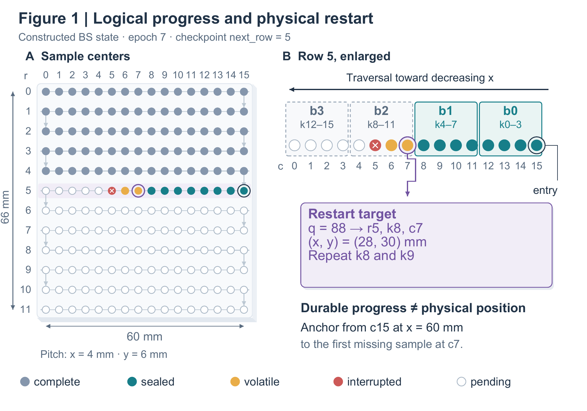
Figure 1. Logical progress and physical restart location in a constructed BS state. Rows 0–4 are complete; epoch 7 and checkpoint next_row = 5 identify the unfinished row. Blocks follow traversal order, so row 5 runs toward decreasing x. Its two sealed blocks survive, while two volatile acquisitions must be repeated. The restart target is q = 88 at (28, 30) mm. This state illustration is independent of the timed traces [S1, S2].
Every startup or restart performs 120 ms of homing. Each row entry then requires a 30 ms anchor event, including travel from a known row reference to the first missing sample. The duration is fixed independently of travel distance. Acquisition takes 10 ms per sample, including its local move. A cut terminates the current event and discards uncommitted volatile work. Recovery lookup after a cut costs 1 ms for RC, 4 ms for AR, and 6 ms for BS; the initial startup has no lookup charge [S1, S3].
AR publishes a self-validating record after its complete 0.8 ms append event and recovers the first missing ordinal from a verified contiguous record prefix. RC stages a full row and publishes its row checkpoint in a combined 4 ms event. If that event is interrupted, the row is unpublished. This all-or-nothing logical outcome does not imply that a medium atomically writes 4096 bytes. RC's two alternating 64-byte checkpoint slots carry generation, epoch, next row, and checksum information; the valid slot with the greatest generation wins.
BS first writes a four-record payload and then publishes its seal. The combined 2 ms event covers 1024 payload bytes and a 24-byte seal allowance, which represents epoch, row, block index, count, and payload CRC32. A row has four ordered block positions. After the fourth seal, a separate 1 ms update advances the inherited row checkpoint. A torn newer checkpoint leaves the older valid slot available. Payload-before-seal durability is assumed by this protocol; the package contains neither a storage driver nor a byte-exact serializer for the checkpoint slots [S2, S4].
After homing, the BS reader selects the valid checkpoint and inspects blocks 0 through 3 in its indicated row. Acceptance requires a published seal, matching epoch, row and index, four records, 1024 payload bytes, and a valid payload CRC. Recovery stops at the first absent or invalid block. An isolated later seal cannot bridge a gap. If all four blocks survive while the row cursor remains old, recovery completes the checkpoint before entering the next row. Figure 2 distinguishes this logical-prefix decision from the subsequent physical anchor operation.
Figure 1 makes that separation concrete. Rows 0–4 are complete. In row 5, blocks 0 and 1 retain k = 0–7, corresponding to columns 15–8. Positions k = 8 and 9 are volatile, and acquisition at k = 10, column 5, is interrupted. The first missing ordinal is therefore 88: row 5, k = 8, column 7, at x = 28 mm and y = 30 mm. Anchoring uses the row entry reference at column 15, x = 60 mm. Recovering the ordinal alone does not establish this physical location.
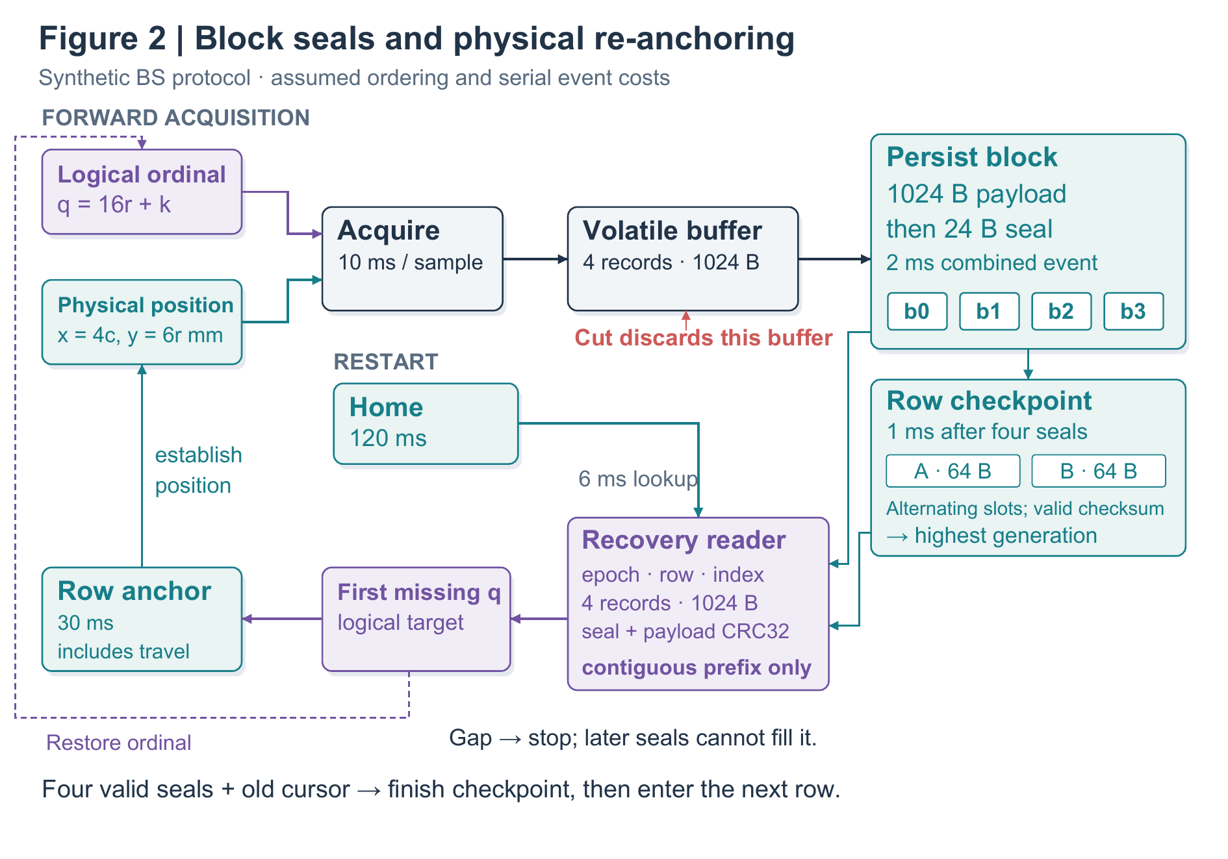
Figure 2. BS forward work and restart dependencies. Ordinal generation labels samples, while established physical position locates them. Persistent payloads precede seals; four sealed blocks permit a row checkpoint update. On restart, homing precedes the reader, whose accepted prefix supplies the first missing ordinal. Row anchoring then establishes position before acquisition resumes. Checksum validation has no direct path to trusted physical position. Durations and ordering are model assumptions [S1, S2].
Equation 1 counts each completed event at its configured duration d and each interrupted event at the elapsed duration tau before its cut. E_done and E_cut are sets of event instances, not operation types. At exact cut/event-end equality, the cut wins and publication does not occur. This convention applies to acquisitions, commits, homing, lookup, and anchoring; partial work remains in the time ledger even when it produces no durable output.
$$T_{power} = \sum_{e∈E_{done}}{d(e)} + \sum_{e∈E_{cut}}{τ(e)} (1)$$
Powered time excludes outages. The separate elapsed-time measure adds 40 ms per encountered cut. Completed reacquisitions equal completed acquisition events minus 192; interrupted acquisitions consume time but are excluded from this counter. All events execute serially. There is no erase, endurance, cache, communication, or overlap model. The event simulator represents durable progress by prefix and row-checkpoint integers, while separate routines test seal and slot validation on constructed bytes. Together these are inspectable abstractions, not a complete byte-level crash emulator.

3 Trace results and coordinate control
Table 1 retains all twelve constructed profiles [S3]. Cut times use cumulative powered milliseconds, pausing during outages but continuing across restarts. Within a profile, all three policies receive the same absolute schedule, so a cut can strike different event phases. T0 has no cuts. T1 uses 620 and 1730 ms; T2 uses 1110 and 2110 ms. T3 uses 390, 820, 1250, 1680, 2110, and 2540 ms; T4 uses 520, 760, 1000, 1240, 1480, and 1720 ms. T5 cuts every 300 ms from 300 through 3000 ms.
T6–T11 retain the complete regular two-cut probe set: cuts occur at s and 2s, with s = 500, 600, 700, 800, 900, and 1000 ms, respectively. These diagnostic schedules are not samples from an outage distribution. Their individual outcomes therefore support comparisons within the configured instance, without an implied population average or confidence interval.
Trace | Cuts | RC (ms) | AR (ms) | BS (ms)
T0 | 0 | 2448.0 | 2553.6 | 2508.0
T1 | 2 | 2821.0 | 2868.0 | 2851.0
T2 | 2 | 2813.0 | 2842.4 | 2833.0
T3 | 6 | 3825.0 | 3526.8 | 3619.0
T4 | 6 | 3781.0 | 3518.0 | 3595.0
T5 | 10 | 5449.0 | 4138.0 | 4194.0
T6 | 2 | 3061.0 | 2873.6 | 2875.0
T7 | 2 | 2873.0 | 2870.8 | 2834.0
T8 | 2 | 3073.0 | 2868.0 | 2877.0
T9 | 2 | 2885.0 | 2876.0 | 2836.0
T10 | 2 | 2697.0 | 2873.2 | 2879.0
T11 | 2 | 2897.0 | 2870.4 | 2838.0
Table 1. Powered completion times and cut counts for all twelve synthetic profiles. Every policy–trace case finishes with 192 durable logical records. The surrounding text specifies every cut schedule; data/results.csv also reports completed reacquisitions and elapsed time including outages. Values are deterministic calculations, not means of physical trials [S3].
Without cuts, RC finishes in 2448.0 ms, BS in 2508.0 ms, and AR in 2553.6 ms. BS therefore pays 60.0 ms over RC in this case. A different ordering appears in T9: BS takes 2836.0 ms, below AR's 2876.0 ms and RC's 2885.0 ms. Yet T10 favors RC at 2697.0 ms, while BS takes 2879.0 ms. Both profiles contain two cuts. Their reversal illustrates dependence on the configured schedule and event phase, rather than an advantage attributable solely to cut count.
The ten-cut T5 profile further preserves AR's role as a strong simple alternative. AR finishes in 4138.0 ms, BS in 4194.0 ms, and RC in 5449.0 ms, with zero, eleven, and 140 completed reacquisitions, respectively. BS limits repetition relative to RC but does not beat AR. Repetition is also insufficient as a timing proxy: in T1, AR repeats one completed record, BS two, and RC eight, yet RC finishes first at 2821.0 ms. Commit costs and interrupted partial events must remain in the comparison.
The recorded validation contains sixteen passing named checks [S4]. One is a finite sweep of 128 single-cut positions for each policy; all 384 cases reach 192 durable records. Other checks cover unique coordinates, odd-row reversal, analytic no-cut totals, invalid seals, a hole followed by a valid block, and checkpoint generation selection. In particular, the checks retain rejection cases and fallback from a torn newer slot. They support these exercised cases, rather than proving reliability for every failure time, corruption pattern, or hardware ordering behavior.
The separate coordinate control begins at the Figure 1 state and prescribes a +4 mm residual x displacement after reset. For the eight remaining row-5 samples, k = 8–15, anchoring yields actual columns 7–0 and zero incorrect assignments. Omitting anchoring yields actual columns 8–1 under unchanged logical labels, misassigning all eight samples. Rows 6 onward are outside this control. The result follows from injected coordinate arithmetic, not an observed mechanical failure rate. Payload integrity alone cannot detect intact bytes associated with the wrong location.

4 Resource tradeoffs and limits
Completed-job persistent allowances are 49,280 bytes for RC, 52,224 for AR, and 50,432 for BS. RC stores 192 payloads plus 128 checkpoint bytes; AR stores 192 records of 272 bytes; BS stores 48 blocks of 1048 bytes plus the checkpoint pair. These totals exclude alignment, allocation, and filesystems. The earlier payload-buffer figures also exclude metadata RAM, motion state, and stack space. Thus BS reduces RC's payload buffer by fourfold while adding persistence metadata, but the figures neither identify total implementation size nor explain the assumed latency ratios.
Restart work itself remains vulnerable to cuts. Interrupted home, lookup, or anchor events consume powered time and must be repeated as needed; lookup and anchoring publish no records. Multiplying only successful operation counts by their full durations would therefore undercount some traces. The ledger retains each partial event rather than replacing recovery with a single fixed penalty. The finite sweep includes admissible cuts during homing, but neither it nor the twelve main profiles exhausts possible sequences of interrupted recovery operations.
The correctness target is one durable logical result per ordinal, with repeatable acquisition and no external side effect. It does not require readings taken at different times to describe an unchanged physical object. Destructive probes, moving targets, or nonrepeatable actions would need a different target. Geometry, payload size, write costs, lookup costs, and anchor duration are each fixed here. There is no measured calibration or sensitivity sweep from which to infer behavior for another apparatus, medium, or outage process.
BS's local addition is a finer persistence boundary and its contiguous-prefix validation path, not a replacement for row checkpoints. The retained reader remains necessary even when no useful block survives, and a fully sealed row can still require checkpoint completion. Assessing deployment would require evidence for payload/seal ordering, calibrated storage and movement costs, and failure behavior beyond these finite examples. The present package supplies no endurance, power, or empirical error measurements. It also supplies no external literature comparison, so external originality remains an open question.

5 Conclusion
For this synthetic 192-position job, persistence granularity trades payload buffering and commit cost against repeated work. All supplied policy–trace cases complete their durable logical output, but RC, AR, and BS each win under different schedules. The coordinate control adds a separate requirement: establishing physical position before resumed acquisition. These conclusions are bounded by constructed schedules, assumed serial event costs, finite checks, and a prescribed displacement. They justify an inspectable model comparison, while leaving hardware performance, universal crash consistency, and external novelty unestablished.

Internal sources
[S1] specification.md and data/parameters.json. Constructed geometry, state semantics, timing assumptions, and scope. Synthetic DEMO sources created for this package.
[S2] implementation_log.md and model.py. Local construction record and executable model. No external project history is claimed.
[S3] data/traces.json, data/results.csv, and data/events.csv. Deterministic trace definitions and generated accounting results.
[S4] tests/test_results.json, tests/single_cut_sweep.csv, and data/anchor_control.csv. Local finite checks and prescribed coordinate fault injection. These are not experimental receipts from equipment.

