RoboND-Localization-Project

Report

Lutong Zhang

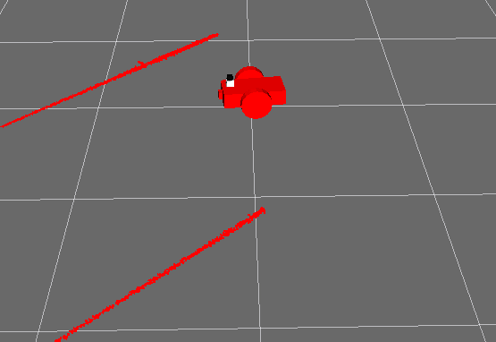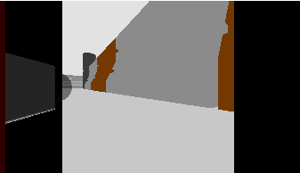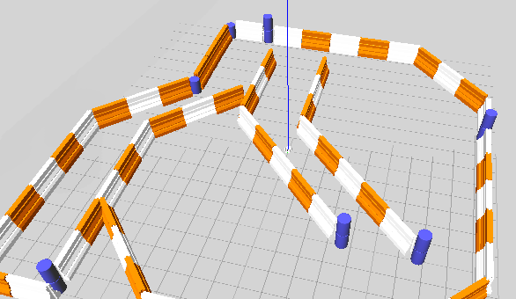

# 1. Abstract

# 2. Introduction

# 3. Background

# 4. Model Configuration

# 5. Results

# 6. Discussion

# 7. Future Work