Project 2 Backpropagation Learning(Basic)
Author: Lieyuan Zhou PantherID: 6177738

Comment on BP neural networks training process:
- If learning rate is too large, mean squared error is more likely to increase even diverge.
- If learning rate is too small, mean squared error decreasing speed is slow but converge finally. We could get optimal weight matrices.
- If learning rate is a proper value,gradient descent would rapidly decrease and we could get optimal weight matrices.
- If neural networks have too much layers or too much neurons(like 3 hidden layer and more than 200 neurons), accuracy on training set would be very high, but it loses generalization. So I add a lambda(generalization parameter) in our my function(Mean Squared Error) to fit the weight.
- If neural networks have few layers and few neurons(like 1 hidden layer, 30 neurons on project 2), accuracy on training set would be very low, we still can not predict our test set precisely.

Comment on “Fault Tolerance”:
Zeroes Rate Test1(HR) Test2(HR) Test3(HR)
0.0 1.0 0.96 0.96
0.2 0.84 0.76 0.60
0.4 0.76 0.68 0.68
Our 2-layer which has 30 neurons and well trained by a proper learning rate and regularization parameters neural networks model is very powerful! When the neurons of hidden-layer is much enough and our weight is separately scattered between input-layer and hidden-layer, hidden-layer and output-layer, 20% weights changed to zero just have a little influence on our hit-ratio. And the data of 40% is as our expect, just a little lower than data in 20% does.

Conclusion:
BP(backpropagation) of Neuron Networks is a very powerful algorithm in machine learning, just review the project 1 we did, Hebb and Pseudo-Inverse algorithm is much more simpler and concise than BP algorithm, but their performance is worse than BP. The disadvantage I find currently is BP is difficult to implement and computationally complex, what’s more, it often takes more time to train.

Training Process:
Feature 1 is the worst case when training the model
learning rate a=3
Number of epochs epochs=80 - infinity (diverge)
Stop criterion stopCri = 10^(-1)=1
Regularization lambda = 0.80
Hidden Layer Size hidden_layer_size=30

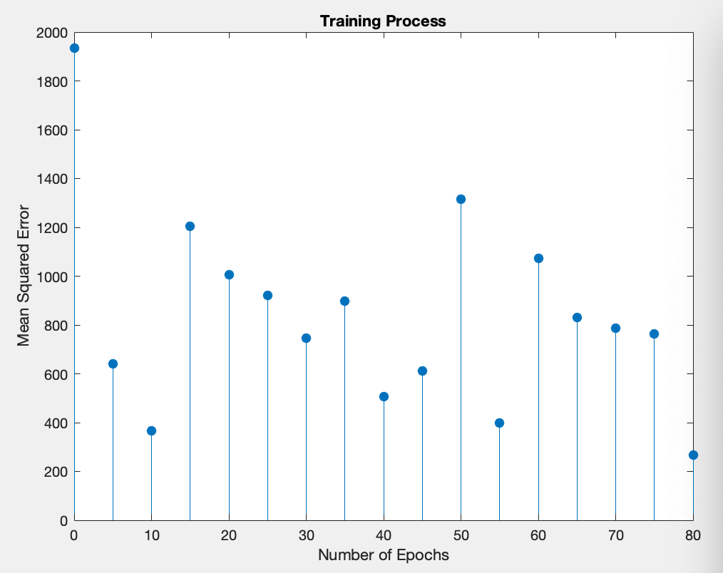
Feature 1

Feature 2 is the intermediate case when training the model
learning rate a=0.01
Number of epochs epochs=180 (converge)
Stop criterion stopCri = 10^(-1)=1
Regularization lambda = 0.80
Hidden Layer Size hidden_layer_size=30

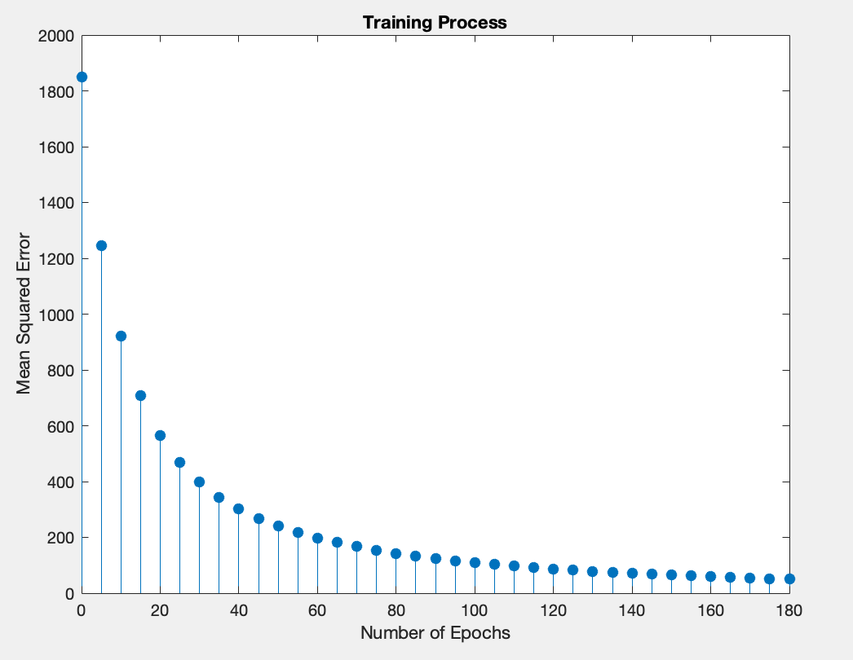
Feature 2

Feature 3 is the best case when training the model
learning rate a=0.1
Number of epochs epochs=68 (converge)
Stop criterion stopCri = 10^(-2)=0.1
Regularization lambda = 0.80
Hidden Layer Size hidden_layer_size=30

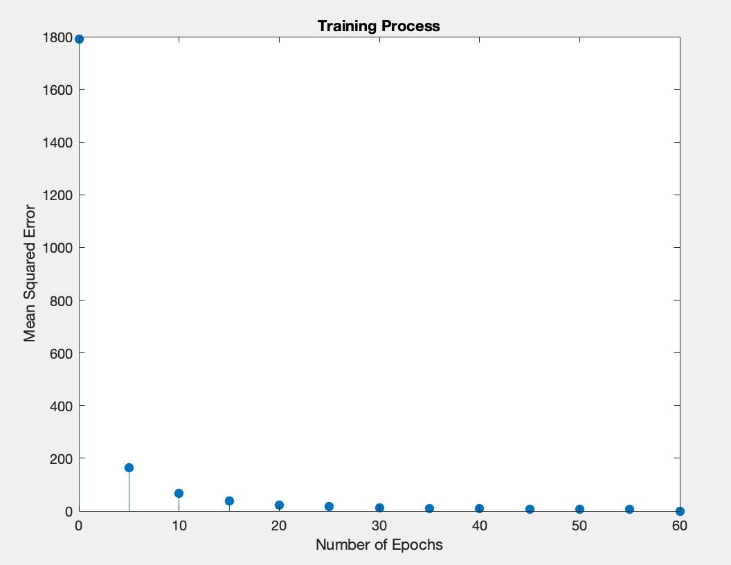
Feature 3

Feature 4 below is the final weights 1 colorful checkboard plot with regularization. Their variance is very small, in order to plot more clearly, every weight is modified by formula: weight * 100 + 256. But their values are showed originally.

Feature 5 below is the final weights 2 colorful checkboard plot with regularization. Their variance is very small, in order to plot more clearly, every weight is modified by formula: weight * 100 + 256. But their values are showed originally.

Test Part
PatternName Output WrongBits Hit/Miss
pt101 [ 1,-1,-1,-1,-1]' 0 Hit
pt102 [ 1,-1,-1,-1,-1]' 0 Hit
pt103 [ 1,-1,-1,-1,-1]' 0 Hit
pt104 [ 1,-1,-1,-1,-1]' 0 Hit
pt105 [ 1,-1,-1,-1,-1]' 0 Hit
pt106 [-1, 1,-1,-1,-1]' 0 Hit
pt107 [-1, 1,-1,-1,-1]' 0 Hit
pt108 [-1, 1,-1,-1,-1]' 0 Hit
pt109 [-1, 1,-1,-1,-1]' 0 Hit
pt110 [-1, 1,-1,-1,-1]' 0 Hit
pt111 [-1,-1, 1,-1,-1]' 0 Hit
pt112 [-1,-1, 1,-1,-1]' 0 Hit
pt113 [-1,-1, 1,-1,-1]' 0 Hit
pt114 [-1,-1, 1,-1,-1]' 0 Hit
pt115 [-1,-1, 1,-1,-1]' 0 Hit
pt116 [-1,-1,-1, 1,-1]' 0 Hit
pt117 [-1,-1,-1, 1,-1]' 0 Hit
pt118 [-1,-1,-1, 1,-1]' 0 Hit
pt119 [-1,-1,-1, 1,-1]' 0 Hit
pt120 [-1,-1,-1, 1,-1]' 0 Hit
pt121 [-1,-1,-1,-1, 1]' 0 Hit
pt122 [-1,-1,-1,-1, 1]' 0 Hit
pt123 [-1,-1,-1,-1, 1]' 0 Hit
pt124 [-1,-1,-1,-1, 1]' 0 Hit
pt125 [-1,-1,-1,-1, 1]' 0 Hit
Test1
Total:25
Miss:0
Hit Rate: 1.0

PatternName Output WrongBits Hit/Miss
pt201 [ 1,-1,-1,-1,-1]' 0 Hit
pt202 [ 1,-1,-1,-1,-1]' 0 Hit
pt203 [ 1,-1,-1,-1,-1]' 0 Hit
pt204 [ 1,-1,-1,-1,-1]' 0 Hit
pt205 [ 1,-1,-1,-1,-1]' 0 Hit
pt206 [-1, 1,-1,-1,-1]' 0 Hit
pt207 [-1, 1,-1,-1,-1]' 0 Hit
pt208 [-1, 1,-1,-1,-1]' 0 Hit
pt209 [-1, 1,-1,-1,-1]' 0 Hit
pt210 [-1, 1,-1,-1,-1]' 0 Hit
pt211 [-1,-1, 1,-1,-1]' 0 Hit
pt212 [-1,-1, 1,-1,-1]' 0 Hit
pt213 [-1,-1, 1,-1,-1]' 0 Hit
pt214 [-1,-1, 1,-1,-1]' 0 Hit
pt215 [-1,-1, 1,-1,-1]' 0 Hit
pt216 [-1,-1,-1, 1,-1]' 0 Hit
pt217 [-1,-1,-1, 1,-1]' 0 Hit
pt218 [-1,-1,-1, 1,-1]' 0 Hit
pt219 [-1,-1,-1, 1,-1]' 0 Hit
pt220 [-1,-1,-1, 1,-1]' 2 Miss
pt221 [-1,-1,-1,-1, 1]' 0 Hit
pt222 [-1,-1,-1,-1, 1]' 0 Hit
pt223 [-1,-1,-1,-1, 1]' 0 Hit
pt224 [-1,-1,-1,-1, 1]' 0 Hit
pt225 [-1,-1,-1,-1, 1]' 0 Hit
Test2
Total:25
Miss:1
Hit Rate: 24/25 = 0.96

PatternName Output WrongBits Hit/Miss
pt301 [ 1,-1,-1,-1,-1]' 0 Hit
pt302 [ 1,-1,-1,-1,-1]' 0 Hit
pt303 [ 1,-1,-1,-1,-1]' 0 Hit
pt304 [ 1,-1,-1,-1,-1]' 0 Hit
pt305 [ 1,-1,-1,-1,-1]' 0 Hit
pt306 [-1, 1,-1,-1,-1]' 0 Hit
pt307 [-1, 1,-1,-1,-1]' 0 Hit
pt308 [-1, 1,-1,-1,-1]' 0 Hit
pt309 [-1, 1,-1,-1,-1]' 0 Hit
pt310 [-1, 1,-1,-1,-1]' 0 Hit
pt311 [-1,-1, 1,-1,-1]' 0 Hit
pt312 [-1,-1, 1,-1,-1]' 0 Hit
pt313 [-1,-1, 1,-1,-1]' 0 Hit
pt314 [-1,-1, 1,-1,-1]' 0 Hit
pt315 [-1,-1, 1,-1,-1]' 0 Hit
pt316 [-1,-1,-1, 1,-1]' 0 Hit
pt317 [-1, 1,-1,-1,-1]' 2 Miss
pt318 [-1,-1,-1, 1,-1]' 0 Hit
pt319 [-1,-1,-1, 1,-1]' 0 Hit
pt320 [-1,-1,-1, 1,-1]' 0 Hit
pt321 [-1,-1,-1,-1, 1]' 0 Hit
pt322 [-1,-1,-1,-1, 1]' 0 Hit
pt323 [-1,-1,-1,-1, 1]' 0 Hit
pt324 [-1,-1,-1,-1, 1]' 0 Hit
pt325 [-1,-1,-1,-1, 1]' 0 Hit
Test3
Total:25
Miss:1
Hit Rate: 24/25 = 0.96

Fault Tolerance
All indexes below in nn_params(unrolled by Weight1 and Weight2) are changed to 0 (20%)
135 282 673 87 250 740 626 642 648 464 628 712 23 508 352 236 55 659 482 248 781 344 574 631 764 7 685 678 691 361 227 745 263 225 186 132 649 491 92 687 160 633 405 340 413 147 21 564 545 570 79 618 420 124 156 713 635 409 716 147 230 61 630 282 315 141 698 455 190 296 618 120 548 427 714 177 346 61 567 106 293 625 355 351 40 671 7 647 650 395 251 157 499 599 172 491 500 308 26 420 260 415 654 683 92 401 467 697 1 217 685 451 296 587 387 391 629 588 271 20 20 739 663 372 308 26 623 336 307 748 1 148 628 187 285 148 533 430 284 212 182 200 521 428 489 188 128 109 93 366 213 432 781 785 424 509 314
PatternName Output WrongBits Hit/Miss
pt101 [ 1,-1,-1,-1,-1]' 0 Hit
pt102 [ 1,-1,-1,-1,-1]' 0 Hit
pt103 [ 1, 1,-1,-1,-1]' 1 Miss
pt104 [ 1,-1,-1,-1,-1]' 0 Hit
pt105 [ 1, 1,-1,-1,-1]' 1 Hit
pt106 [-1, 1,-1,-1,-1]' 0 Hit
pt107 [-1, 1,-1,-1,-1]' 0 Hit
pt108 [-1, 1,-1,-1,-1]' 0 Hit
pt109 [-1, 1,-1,-1,-1]' 0 Hit
pt110 [-1, 1,-1,-1,-1]' 0 Hit
pt111 [-1,-1, 1,-1,-1]' 0 Hit
pt112 [-1,-1, 1,-1,-1]' 0 Hit
pt113 [-1,-1, 1,-1,-1]' 0 Hit
pt114 [-1,-1, 1,-1,-1]' 0 Hit
pt115 [-1,-1, 1,-1,-1]' 0 Hit
pt116 [-1,-1,-1, 1, 1]' 1 Miss
pt117 [-1,-1,-1, 1, 1]' 1 Hit
pt118 [-1,-1,-1, 1, 1]' 1 Hit
pt119 [-1,-1,-1, 1,-1]' 0 Hit
pt120 [-1,-1,-1, 1, 1]' 1 Miss
pt121 [-1,-1,-1,-1, 1]' 0 Hit
pt122 [-1,-1,-1, 1, 1]' 1 Miss
pt123 [-1,-1,-1,-1, 1]' 0 Hit
pt124 [-1,-1,-1,-1, 1]' 0 Hit
pt125 [-1,-1,-1,-1, 1]' 0 Hit
Fault Tolerance Test1
Total: 25
Miss: 4
Hit Rate: 21/25 = 0.84

pt201 [ 1,-1,-1,-1,-1]' 0 Hit
pt202 [ 1,-1,-1,-1,-1]' 0 Hit
pt203 [ 1, 1,-1,-1,-1]' 1 Miss
pt204 [ 1,-1,-1,-1, 1]' 1 Miss
pt205 [ 1, 1,-1,-1,-1]' 1 Miss
pt206 [-1, 1,-1,-1,-1]' 0 Hit
pt207 [-1, 1,-1,-1,-1]' 0 Hit
pt208 [-1, 1,-1,-1,-1]' 0 Hit
pt209 [-1, 1,-1, 1,-1]' 1 Hit
pt210 [-1, 1,-1,-1,-1]' 0 Hit
pt211 [-1,-1, 1,-1,-1]' 0 Hit
pt212 [-1,-1, 1,-1,-1]' 0 Hit
pt213 [-1,-1, 1,-1,-1]' 0 Hit
pt214 [ 1,-1, 1, 1,-1]' 2 Miss
pt215 [-1,-1, 1,-1,-1]' 0 Hit
pt216 [-1,-1,-1, 1, 1]' 1 Hit
pt217 [-1,-1,-1, 1, 1]' 1 Miss
pt218 [-1,-1,-1, 1,-1]' 0 Hit
pt219 [-1,-1,-1,-1,-1]' 1 Miss
pt220 [-1,-1,-1,-1, 1]' 0 Hit
pt221 [-1,-1,-1,-1, 1]' 0 Hit
pt222 [-1,-1,-1, 1, 1]' 1 Miss
pt223 [-1,-1,-1,-1, 1]' 0 Hit
pt224 [-1,-1,-1,-1, 1]' 0 Hit
pt225 [-1,-1,-1,-1, 1]' 0 Hit
Fault Tolerance Test2
Total: 25
Miss: 6
Hit Rate: 19/25 = 0.76

pt301 [ 1,-1,-1,-1,-1]' 0 Hit
pt302 [ 1,-1,-1,-1,-1]' 0 Hit
pt303 [ 1, 1,-1,-1,-1]' 1 Miss
pt304 [ 1,-1,-1,-1,-1]' 0 Hit
pt305 [ 1, 1,-1,-1,-1]' 2 Miss
pt306 [-1, 1,-1,-1,-1]' 0 Hit
pt307 [-1, 1,-1,-1,-1]' 0 Hit
pt308 [-1, 1,-1,-1,-1]' 0 Hit
pt309 [-1, 1,-1, 1,-1]' 1 Miss
pt310 [-1, 1,-1,-1,-1]' 0 Hit
pt311 [-1,-1, 1,-1,-1]' 0 Hit
pt312 [-1,-1, 1,-1,-1]' 0 Hit
pt313 [-1,-1, 1, 1,-1]' 1 Miss
pt314 [-1,-1, 1, 1,-1]' 1 Miss
pt315 [-1,-1, 1,-1,-1]' 0 Hit
pt316 [-1,-1,-1, 1, 1]' 1 Miss
pt317 [-1,-1,-1, 1, 1]' 1 Miss
pt318 [-1, 1,-1,-1,-1]' 2 Miss
pt319 [-1, 1,-1,-1,-1]' 2 Miss
pt320 [-1,-1,-1,-1, 1]' 2 Miss
pt321 [-1,-1,-1,-1, 1]' 0 Hit
pt322 [-1,-1,-1,-1, 1]' 0 Hit
pt323 [-1,-1,-1,-1, 1]' 0 Hit
pt324 [-1,-1,-1,-1, 1]' 0 Hit
pt325 [-1,-1,-1,-1, 1]' 0 Hit
Fault Tolerance Test3
Total: 25
Miss: 10
Hit Rate: 15/25 = 0.60

All indexes below in nn_params(unrolled by Weight1 and Weight2) are changed to 0 (40%)
416 467 448 474 206 533 531 240 183 116 53 680 781 317 382 386 184 381 722 8 293 782 291 475 183 23 210 562 354 589 186 732 639 469 776 675 114 461 672 598 371 719 651 451 196 234 559 781 19 458 654 308 191 664 562 676 295 417 639 66 526 352 738 452 105 57 754 129 431 775 81 277 665 455 328 593 365 235 644 367 169 563 481 261 529 371 608 172 32 107 497 727 262 334 483 780 731 550 713 774 273 659 349 597 529 491 719 83 664 263 196 609 227 180 637 548 527 2 578 731 12 201 781 298 518 725 255 641 740 88 760 623 653 319 663 382 403 377 710 153 731 4 411 4 188 629 740 127 178 106 470 451 176 539 729 48 530 639 171 91 723 167 148 654 643 53 221 474 238 678 483 764 241 753 89 714 737 5 239 110 291 33 167 484 324 724 703 524 327 590 155 4 561 463 585 543 517 730 497 9 617 380 74 241 390 491 344 69 623 700 175 411 564 536 2 595 636 380 387 245 624 719 26 726 259 86 243 372 497 229 251 58 515 567 141 382 103 69 681 192 210 418 481 12 481 520 575 148 594 755 600 463 421 454 81 277 592 710 543 338 31 164 561 633 437 663 370 521 501 495 339 497 621 479 653 640 19 208 64 196 81 217 359 252 235 480 747 741 1 705 140 354 612 450 576 755 421 652 736 574 762 625 709 181 17 101 701 301 64 21 143 89 612 544
PatternName Output WrongBits Hit/Miss
pt101 [ 1,-1,-1,-1,-1]' 0 Hit
pt102 [ 1,-1,-1,-1,-1]' 0 Hit
pt103 [ 1,-1,-1,-1,-1]' 0 Hit
pt104 [ 1,-1,-1,-1,-1]' 0 Hit
pt105 [ 1,-1,-1,-1, 1]' 0 Hit
pt106 [-1, 1,-1,-1,-1]' 0 Hit
pt107 [-1,-1,-1,-1,-1]' 1 Miss
pt108 [-1,-1,-1,-1,-1]' 1 Hit
pt109 [-1, 1,-1,-1,-1]' 0 Hit
pt110 [-1,-1,-1,-1,-1]' 1 Hit
pt111 [-1,-1, 1,-1,-1]' 0 Hit
pt112 [-1,-1, 1,-1,-1]' 0 Hit
pt113 [-1,-1, 1,-1,-1]' 0 Hit
pt114 [-1,-1, 1,-1,-1]' 0 Hit
pt115 [-1, 1, 1,-1,-1]' 1 Miss
pt116 [-1,-1,-1,-1,-1]' 1 Miss
pt117 [-1,-1,-1,-1, 1]' 1 Miss
pt118 [-1,-1,-1,-1,-1]' 1 Miss
pt119 [-1,-1,-1, 1,-1]' 0 Hit
pt120 [-1,-1,-1,-1,-1]' 1 Miss
pt121 [-1,-1,-1,-1, 1]' 0 Hit
pt122 [-1,-1,-1,-1, 1]' 0 Hit
pt123 [-1,-1,-1,-1, 1]' 0 Hit
pt124 [-1,-1,-1,-1, 1]' 0 Hit
pt125 [-1,-1,-1,-1, 1]' 0 Hit
Fault Tolerance Test1
Total: 25
Miss: 6
Hit Ratio: 19/25 = 0.76

pt201 [ 1,-1,-1,-1,-1]' 0 Hit
pt202 [ 1,-1,-1,-1,-1]' 0 Hit
pt203 [ 1,-1,-1,-1,-1]' 0 Hit
pt204 [ 1,-1,-1,-1, 1]' 1 Miss
pt205 [ 1,-1,-1,-1,-1]' 0 Hit
pt206 [-1, 1,-1,-1,-1]' 0 Hit
pt207 [-1, 1,-1,-1,-1]' 0 Hit
pt208 [-1,-1,-1,-1,-1]' 1 Hit
pt209 [-1, 1,-1,-1,-1]' 0 Hit
pt210 [-1,-1,-1,-1,-1]' 1 Miss
pt211 [-1,-1, 1,-1,-1]' 0 Hit
pt212 [-1,-1, 1,-1,-1]' 0 Hit
pt213 [-1,-1, 1,-1,-1]' 0 Hit
pt214 [-1,-1, 1,-1,-1]' 0 Hit
pt215 [-1, 1, 1,-1,-1]' 1 Miss
pt216 [-1,-1,-1,-1,-1]' 1 Miss
pt217 [-1,-1,-1,-1, 1]' 2 Miss
pt218 [-1,-1,-1,-1,-1]' 1 Miss
pt219 [-1,-1,-1,-1,-1]' 1 Miss
pt220 [-1,-1,-1,-1,-1]' 1 Miss
pt221 [-1,-1,-1,-1, 1]' 0 Hit
pt222 [-1,-1,-1,-1, 1]' 0 Hit
pt223 [-1,-1,-1,-1, 1]' 0 Hit
pt224 [-1,-1,-1,-1, 1]' 0 Hit
pt225 [-1,-1,-1,-1, 1]' 0 Hit
Fault Tolerance Test2
Total: 25
Miss: 8
Hit Ratio: 17/25 = 0.68

pt301 [ 1,-1,-1,-1,-1]' 0 Hit
pt302 [ 1,-1,-1,-1,-1]' 0 Hit
pt303 [ 1,-1,-1,-1,-1]' 0 Hit
pt304 [ 1,-1,-1,-1, 1]' 1 Miss
pt305 [ 1,-1,-1,-1, 1]' 1 Miss
pt306 [-1, 1,-1,-1,-1]' 0 Hit
pt307 [-1, 1,-1,-1,-1]' 0 Hit
pt308 [-1,-1,-1,-1,-1]' 1 Miss
pt309 [-1, 1,-1,-1,-1]' 0 Hit
pt310 [-1,-1,-1,-1,-1]' 1 Miss
pt311 [-1,-1, 1,-1,-1]' 0 Hit
pt312 [-1,-1, 1,-1,-1]' 0 Hit
pt313 [-1,-1, 1,-1,-1]' 0 Hit
pt314 [-1,-1, 1,-1,-1]' 0 Hit
pt315 [-1, 1, 1,-1,-1]' 1 Miss
pt316 [-1,-1,-1,-1,-1]' 1 Miss
pt317 [-1,-1,-1,-1, 1]' 2 Miss
pt318 [-1,-1,-1,-1,-1]' 1 Miss
pt319 [-1,-1,-1,-1,-1]' 1 Miss
pt320 [-1,-1, 1,-1,-1]' 2 Miss
pt321 [-1,-1,-1,-1, 1]' 0 Hit
pt322 [-1,-1,-1,-1, 1]' 0 Hit
pt323 [-1,-1,-1,-1, 1]' 0 Hit
pt324 [-1,-1,-1,-1, 1]' 0 Hit
pt325 [-1,-1,-1,-1, 1]' 0 Hit
Fault Tolerance Test3
Total: 25
Miss: 8
Hit Ratio: 17/25 = 0.68

Original Code

nnCostFunction.m
function [J,grad] = nnCostFunction(nn_params, ...
input_layer_size, ...
hidden_layer_size, ...
num_labels,...
X, y, lambda)
%NNCOSTFUNCTION Implements the neural network cost function for a two layer
%neural network which performs classification
% [J grad] = NNCOSTFUNCTON(nn_params, hidden_layer_size, num_labels, ...
% X, y, lambda) computes the cost and gradient of the neural network. The
% parameters for the neural network are "unrolled" into the vector
% nn_params and need to be converted back into the weight matrices.
%
% The returned parameter grad should be a "unrolled" vector of the
% partial derivatives of the neural network.
%
% Reshape nn_params back into the parameters Theta1 and Theta2, the weight matrices
% for our 2 layer neural network
% Weight1 30x21
Weight1 = reshape(nn_params(1:hidden_layer_size * (input_layer_size + 1)), ...
hidden_layer_size, (input_layer_size + 1));
% Weight2 5x31
Weight2 = reshape(nn_params((1 + (hidden_layer_size * (input_layer_size + 1))):end), ...
num_labels, (hidden_layer_size + 1));

% Setup some useful variables
m = size(X, 1);
J = 0;
Weight1_grad = zeros(size(Weight1));
Weight2_grad = zeros(size(Weight2));
% Feedforward the neural network and return the cost in the
% variable J.
% original X is 25x20, add one column 1 as bias to 25x21
X = [ones(m,1) X];
a2 = tansig(X * Weight1');
% original a2 is 25x30, add one colums 1 as bias to 25x31
a2 = [ones(size(a2,1),1) a2];
a3 = tansig(a2 * Weight2');
h = a3;

% Costfunction Without regularization
% inner sum is the sum of 5000 rows result is 1x10
% outer sum is the sum of 10 colums result is a scalar
J = (1/2*m) * sum(sum((h-y).^2));

% Implement the backpropagation algorithm to compute the gradients
% Theta1_grad and Theta2_grad
% Here X is including 1 column at begining
A1 = X;
Z2 = A1 * Weight1';
A2 = tansig(Z2);
A2 = [ones(size(A2,1),1), A2];
Z3 = A2 * Weight2';
A3 = tansig(Z3);
DELTA3 = A3 - y; % 25x5
DELTA2 = (DELTA3 * Weight2) .* [ones(size(Z2,1),1) dtansig(Z2)];% 25x30
DELTA2 = DELTA2(:,2:end); % 25 x 30 Removing delta2 for bias node
Weight1_grad = (1/m) * (DELTA2' * A1); % 30 x 21
Weight2_grad = (1/m) * (DELTA3' * A2); % 5 x 31
% Implement regularization with the cost function and gradients.
% Regularize grad
Weight1_grad_reg_term = (lambda/m) * [zeros(size(Weight1, 1), 1) Weight1(:,2:end)]; % 25 x 401
Weight2_grad_reg_term = (lambda/m) * [zeros(size(Weight2, 1), 1) Weight2(:,2:end)]; % 10 x 26
Weight1_grad = Weight1_grad + Weight1_grad_reg_term;
Weight2_grad = Weight2_grad + Weight2_grad_reg_term;
% Regularize J (Cost Function)
reg_term = (lambda/(2*m)) * (sum(sum(Weight1(:,2:end).^2)) + sum(sum(Weight2(:,2:end).^2))); %scalar
J = J + reg_term;
% -------------------------------------------------------------

% =========================================================================
% Unroll gradients
grad = [Weight1_grad(:) ; Weight2_grad(:)];
end

gradientDescent.m
function [weight, J_history] = gradientDescentMulti(X, y, weight, alpha, num_iters)
%GRADIENTDESCENTMULTI Performs gradient descent to learn weight
% weight = GRADIENTDESCENTMULTI(x, y, theta, alpha, num_iters) updates weight by
% taking num_iters gradient steps with learning rate alpha
% Initialize some useful values
m = length(y); % number of training examples
J_history = zeros(num_iters, 1);
for iter = 1:num_iters
% hypothesis
h = X * weight;
% X' * (h - y) = sum((h - y) .* X)'
weight = weight - alpha * (1 / m) * (X' * (h - y));
% ===========================================================
% Save the cost J in every iteration
J_history(iter) = computeCostMulti(X, y, weight);
end
end

dtansig.m
% Project 1
% Author: Lieyuan Zhou
% PatherID: 6177738
% Return derivative of tansig
function dt = dtansig(z)
dt = 1 - tansig(z).^2;
end

plotCheckerboard.m
function plotCheckerBoard(data)
% Plot Checkerboard
image(data * 100 + 128);
% Initialize a color map array of 256 colors.
colorMap = jet(256);
% Apply the colormap and show the colorbar
colormap(colorMap);
colorbar;
title("Weight Checkerboard")

[row,column] = size(data);
for i = 1:row
for j = 1:column
txt = num2str(data(i,j));
text(j,i,txt,'FontSize',11);
end
end
end

faultTolerance.m
% This function is used to experiment fault tolerance
% on trained BP neural networks
% nn_params: unrolled by Weight1 and Weight2
% PP :the original training matrix
% faultRate: required percentage of zeros in Weights
function faultTolerance(nn_params,PP,faultRate)
lengthV = length(nn_params);
faultNum = lengthV * faultRate;
index_change_history = zeros(1, faultNum);
for i=1:faultNum
index = randi([1,lengthV],1,1);
index_change_history(i) = index;
nn_params(index)= 0;
end
% print changed index
for ii = 1:size(index_change_history,1)
fprintf('%g\t',index_change_history(ii,:));
fprintf('\n');
end
finalWeight1 = reshape(nn_params(1:630),30,21);
finalWeight2 = reshape(nn_params(631:785),5,31);
finalTest(finalWeight1,finalWeight2,PP);

end

prj2.m (main execute file)
% Project 2
% Author: Lieyuan Zhou
% PatherID: 6177738

%% Initialization
clear ; close all; clc
load('PRJ2TRAIN.mat');

%% Setup the parameters that will be used for this project
input_layer_size = 20; % 4x5 Input Pixels
hidden_layer_size = 30; % 30 hidden units
num_labels = 5; % 5 labels {A,E,I,O,U}
lambda = 0.80; % Regularization parameter
alpha = 0.1; % Learning rate
maxIte = 200; % Max gradient descent times
stopIndex =200; % StopIndex When Gradient Descent
stopCri = 10^(-1); % Stopping criterion(difference)
% Standard epsilon
epsilon = sqrt(6)/sqrt(input_layer_size+ num_labels);
% Random initialization of weights (a.k.a sqrt(6)/sqrt(inputsize + outputsize))
Weight1 = rand(30,21)*2*epsilon-epsilon;
Weight2 = rand(5,31)*2*epsilon-epsilon;
input = PP';
target = TT';
globalGrad = 1;
nn_params = [Weight1(:) ; Weight2(:)];
J_history = zeros(maxIte, 1);
%% =========== Part 1 Training BP NeuralNetwork=============
for iter=1:maxIte
[J,grad] = nnCostFunction(nn_params, ...
input_layer_size, ...
hidden_layer_size, ...
num_labels, ...
input, target, lambda);
globalGrad = grad;
nn_params = nn_params - alpha * grad;

% Save the cost J in every iteration
J_history(iter) = J;
if iter > 1 ...
&& (abs(J_history(iter) - J_history(iter-1)) < stopCri)
stopIndex = iter;
fprintf('\nStop Iter Index: %d\n', iter);
break;
end
end
finalWeight1 = reshape(nn_params(1:630),30,21);
finalWeight2 = reshape(nn_params(631:785),5,31);
% plot(1:numel(J_history), J_history, '-b', 'LineWidth', 2);
% plot(1:5:stopIndex, J_history(1:5:stopIndex), '-b', 'LineWidth', 2);
figure
X = linspace(0,60,13);
Y = J_history(1:5:65);
stem(X,Y,'filled')
xlabel('Number of Epochs');
ylabel('Mean Squared Error');
title('Training Process')
%% =========== Part 1 Implement Predict=============
% finalWeight1 = reshape(nn_params(1:630),30,21);
% finalWeight2 = reshape(nn_params(631:785),5,31);
% pred = predict(finalWeight1, finalWeight2, input);
% fprintf('\nTraining Set Accuracy: %f\n', mean(double(pred == target)) * 100);
finalTest(finalWeight1,finalWeight2,PP);
% plotCheckerBoard(finalWeight1)
% plotCheckerBoard(finalWeight2)
faultTolerance(nn_params,PP,0.4);
% Round Matrix to Print
Weight1 = roundn(Weight1,-2);
Weight2 = roundn(Weight2,-2);
fid = fopen('Weight1.txt','wt');
for ii = 1:size(Weight1,1)
fprintf(fid,'%g\t',Weight1(ii,:));
fprintf(fid,'\n');
end
fclose(fid)
fid = fopen('Weight2.txt','wt');
for ii = 1:size(Weight2,1)
fprintf(fid,'%g\t',Weight2(ii,:));
fprintf(fid,'\n');
end
fclose(fid)
plotCheckerBoard(Weight2);

predict.m
% Using the best trained Weights to predict the test set
% Using hardlims considered bipolar 5-value
function p = predict(Weight1, Weight2, X)
% Set size
m = size(X, 1);
p = zeros(size(X, 1), 1);
h1 = tansig([ones(m, 1) X] * Weight1');
p = tansig([ones(m, 1) h1] * Weight2');
p = hardlims(p);
% =========================================================================
end

btans1e.m
% bptans1e - performs a full epoch of training for a 2-layer MLP
% Using basic Backpropagation
% IT ASSUMES TAN-SIGMOID activation function in all elements of the ntwk.
% Receives initial weights and biases, as well as the alpha value
% Receives all the training patterns in matrix PP and all targets in TT
% Each column of PP is a training pattern
% Each column of TT is a target vector
% Returns final weights and biases and average squared error for the epoch
%
% SYNTAX:
% [W1out, W2out, b1out, b2out, ave2] = bptans1e(W1,W2,b1,b2,alp,PP,TT);
%
function [W1out, W2out, b1out, b2out, ave2] = bptans1e(W1,W2,b1,b2,alp,PP,TT);
[rp, cp] = size(PP);
ave2 = 0;
for q = 1:cp;
[W1new, W2new, b1new, b2new, avge2] = bptans1pat(W1,W2,b1,b2,alp,PP(:,q),TT(:,q));
ave2 = ave2 + avge2; % Accumulate the average error squared per pattern
%Transfer weights and biases fornext pattern:
W1 = W1new;
W2 = W2new;
b1 = b1new;
b2 = b2new;
end
ave2 = ave2 / cp;
W1out = W1new;
W2out = W2new;
b1out = b1new;
b2out = b2new;
end

bptans1pat.m
% bptans1pat.m - Function to train a 2 layer MLP with basic BP
% IT ASSUMES THE USE OF (bipolar) tansig activation function in all neurons
% It receives TWO WEIGHT MATRICES (old weights) W1, W2
% and TWO BIAS VECTORS (old biases) b1, b2
% IT ALSO RECEIVES THE INPUT PATTERN, p (column vector) and
% The column vector of targets, t, and the adaptation rate alpha (alp)
% It returns TWO NEW WEIGHT MATRICES W1new, W2new,
% and TWO NEW BIAS VECTORS b1new, b2new,
% AND an average square error avge2 for the current pattern
%
% SYNTAX: [W1new, W2new, b1new, b2new, avge2] = bptans1pat(W1,W2,b1,b2,alp,p,t);
%
function [W1new, W2new, b1new, b2new, avge2] = bptans1pat(W1,W2,b1,b2,alp,p,t);
% PHASE I - Forward propagation, and calculation of avge2
% From input pattern to activation of first layer, a1
n1 = W1 * p + b1;
a1 = tansig(n1);
% From a1 to activation of layer 2 (which is the output)
n2 = W2 * a1 + b2;
a2 = tansig(n2);
numouts = length(t);
avge2 = ( (t - a2)' * (t-a2) ) / numouts;
% PHASE II - Backpropagation of sensitivities
% s2 is found directly using the error (t - a2)
s2 = (-2) * ( (fdtansig(n2,a2) ) * (t - a2) );
% Then s1 will be BACK PROPAGATED from s2:
s1 = ( fdtansig(n1,a1) ) * W2' * s2;
%PHASE III - UPDATE AL THE WEIGHTS AND BIASES
% Update the weights for layer 2
W2new = W2 - alp * (s2 *a1');
b2new = b2 - alp * s2;
% Update the weights for layer 1
W1new = W1 - alp * (s1 *p');
b1new = b1 - alp * s1;
end

fdtansig.m
% fdtansig - function for implementing BP of sensitivities
% This is mean to implement F dot m (n M) in page 11-26 of book
% It evaluates THE DERIVATIVE of tansig at the previously
% (forward propagation) net input values in col, vector n
% Returns result already as a diagonal matrix
%
% SYNTAX: FDMNM = fdtansig(n,a);
%
function FDMNM = fdtansig(n,a);
% da_dn = tansig('dn',n,a);
% FDMNM = diag(da_dn);
FDMNM = diag( tansig('dn',n,a) );
end

finalTest.m
% Indicate the "hits" and "misses" for each pattern in each of
% the three ( TEST1, TEST2, TEST3) test sets, as well as the "hit ratio"
function finalTest(finalWeight1,finalWeight2,PP)
fileID = fopen("tolerance1_test.txt",'w');
fprintf(fileID,'PatternName\tOutput\t\t\tWrongBits\t\tHit/Miss\t\n');
% Testing BackPropagation Neural Networks with set pt101-pt125 (Lowest noise set)
% Test1
pt101 = PP(:,1);
fprintf(fileID,'%s\t',"pt101");
fprintf(fileID,'\t[%2.1g,%2.1g,%2.1g,%2.1g,%2.1g]''\t',(predict(finalWeight1, finalWeight2, pt101')'));
fprintf(fileID,'\t%d\t',0);
fprintf(fileID,'\t%s\t',"Hit");

pt102 = togglp1(pt101,4,1);
fprintf(fileID,'\n%s\t',"pt102");
fprintf(fileID,'\t[%2.1g,%2.1g,%2.1g,%2.1g,%2.1g]''\t',(predict(finalWeight1, finalWeight2, pt102')'));
fprintf(fileID,'\t%d\t',0);
fprintf(fileID,'\t%s\t',"Hit");

pt103 = togglp1(pt101,5,3);
fprintf(fileID,'\n%s\t',"pt103");
fprintf(fileID,'\t[%2.1g,%2.1g,%2.1g,%2.1g,%2.1g]''\t',(predict(finalWeight1, finalWeight2, pt103')'));
fprintf(fileID,'\t%d\t',0);
fprintf(fileID,'\t%s\t',"Hit");

pt104 = togglp1(pt101,2,4);
fprintf(fileID,'\n%s\t',"pt104");
fprintf(fileID,'\t[%2.1g,%2.1g,%2.1g,%2.1g,%2.1g]''\t',(predict(finalWeight1, finalWeight2, pt104')'));
fprintf(fileID,'\t%d\t',0);
fprintf(fileID,'\t%s\t',"Hit");

pt105 = togglp1(pt101,1,2);
fprintf(fileID,'\n%s\t',"pt105");
fprintf(fileID,'\t[%2.1g,%2.1g,%2.1g,%2.1g,%2.1g]''\t',(predict(finalWeight1, finalWeight2, pt105')'));
fprintf(fileID,'\t%d\t',0);
fprintf(fileID,'\t%s\t',"Hit");

pt106 = PP(:,6);
fprintf(fileID,'\n%s\t',"pt106");
fprintf(fileID,'\t[%2.1g,%2.1g,%2.1g,%2.1g,%2.1g]''\t',(predict(finalWeight1, finalWeight2, pt106')'));
fprintf(fileID,'\t%d\t',0);
fprintf(fileID,'\t%s\t',"Hit");

pt107 = togglp1(pt106,4,1);
fprintf(fileID,'\n%s\t',"pt107");
fprintf(fileID,'\t[%2.1g,%2.1g,%2.1g,%2.1g,%2.1g]''\t',(predict(finalWeight1, finalWeight2, pt107')'));
fprintf(fileID,'\t%d\t',0);
fprintf(fileID,'\t%s\t',"Hit");

pt108 = togglp1(pt106,5,3);
fprintf(fileID,'\n%s\t',"pt108");
fprintf(fileID,'\t[%2.1g,%2.1g,%2.1g,%2.1g,%2.1g]''\t',(predict(finalWeight1, finalWeight2, pt108')'));
fprintf(fileID,'\t%d\t',0);
fprintf(fileID,'\t%s\t',"Hit");

pt109 = togglp1(pt106,2,4);
fprintf(fileID,'\n%s\t',"pt109");
fprintf(fileID,'\t[%2.1g,%2.1g,%2.1g,%2.1g,%2.1g]''\t',(predict(finalWeight1, finalWeight2, pt109')'));
fprintf(fileID,'\t%d\t',0);
fprintf(fileID,'\t%s\t',"Hit");

pt110 = togglp1(pt106,1,2);
fprintf(fileID,'\n%s\t',"pt110");
fprintf(fileID,'\t[%2.1g,%2.1g,%2.1g,%2.1g,%2.1g]''\t',(predict(finalWeight1, finalWeight2, pt110')'));
fprintf(fileID,'\t%d\t',0);
fprintf(fileID,'\t%s\t',"Hit");

pt111 = PP(:,11);
fprintf(fileID,'\n%s\t',"pt111");
fprintf(fileID,'\t[%2.1g,%2.1g,%2.1g,%2.1g,%2.1g]''\t',(predict(finalWeight1, finalWeight2, pt111')'));
fprintf(fileID,'\t%d\t',0);
fprintf(fileID,'\t%s\t',"Hit");

pt112 = togglp1(pt111,4,1);
fprintf(fileID,'\n%s\t',"pt112");
fprintf(fileID,'\t[%2.1g,%2.1g,%2.1g,%2.1g,%2.1g]''\t',(predict(finalWeight1, finalWeight2, pt112')'));
fprintf(fileID,'\t%d\t',0);
fprintf(fileID,'\t%s\t',"Hit");

pt113 = togglp1(pt111,5,3);
fprintf(fileID,'\n%s\t',"pt113");
fprintf(fileID,'\t[%2.1g,%2.1g,%2.1g,%2.1g,%2.1g]''\t',(predict(finalWeight1, finalWeight2, pt113')'));
fprintf(fileID,'\t%d\t',0);
fprintf(fileID,'\t%s\t',"Hit");

pt114 = togglp1(pt111,2,4);
fprintf(fileID,'\n%s\t',"pt114");
fprintf(fileID,'\t[%2.1g,%2.1g,%2.1g,%2.1g,%2.1g]''\t',(predict(finalWeight1, finalWeight2, pt114')'));
fprintf(fileID,'\t%d\t',0);
fprintf(fileID,'\t%s\t',"Hit");

pt115 = togglp1(pt111,1,2);
fprintf(fileID,'\n%s\t',"pt115");
fprintf(fileID,'\t[%2.1g,%2.1g,%2.1g,%2.1g,%2.1g]''\t',(predict(finalWeight1, finalWeight2, pt115')'));
fprintf(fileID,'\t%d\t',0);
fprintf(fileID,'\t%s\t',"Hit");

pt116 = PP(:,16);
fprintf(fileID,'\n%s\t',"pt116");
fprintf(fileID,'\t[%2.1g,%2.1g,%2.1g,%2.1g,%2.1g]''\t',(predict(finalWeight1, finalWeight2, pt116')'));
fprintf(fileID,'\t%d\t',0);
fprintf(fileID,'\t%s\t',"Hit");

pt117 = togglp1(pt116,4,1);
fprintf(fileID,'\n%s\t',"pt117");
fprintf(fileID,'\t[%2.1g,%2.1g,%2.1g,%2.1g,%2.1g]''\t',(predict(finalWeight1, finalWeight2, pt117')'));
fprintf(fileID,'\t%d\t',0);
fprintf(fileID,'\t%s\t',"Hit");

pt118 = togglp1(pt116,5,3);
fprintf(fileID,'\n%s\t',"pt118");
fprintf(fileID,'\t[%2.1g,%2.1g,%2.1g,%2.1g,%2.1g]''\t',(predict(finalWeight1, finalWeight2, pt118')'));
fprintf(fileID,'\t%d\t',0);
fprintf(fileID,'\t%s\t',"Hit");

pt119 = togglp1(pt116,2,4);
fprintf(fileID,'\n%s\t',"pt119");
fprintf(fileID,'\t[%2.1g,%2.1g,%2.1g,%2.1g,%2.1g]''\t',(predict(finalWeight1, finalWeight2, pt119')'));
fprintf(fileID,'\t%d\t',0);
fprintf(fileID,'\t%s\t',"Hit");

pt120 = togglp1(pt116,1,2);
fprintf(fileID,'\n%s\t',"pt120");
fprintf(fileID,'\t[%2.1g,%2.1g,%2.1g,%2.1g,%2.1g]''\t',(predict(finalWeight1, finalWeight2, pt120')'));
fprintf(fileID,'\t%d\t',0);
fprintf(fileID,'\t%s\t',"Hit");

pt121 = PP(:,21);
fprintf(fileID,'\n%s\t',"pt121");
fprintf(fileID,'\t[%2.1g,%2.1g,%2.1g,%2.1g,%2.1g]''\t',(predict(finalWeight1, finalWeight2, pt121')'));
fprintf(fileID,'\t%d\t',0);
fprintf(fileID,'\t%s\t',"Hit");

pt122 = togglp1(pt121,4,1);
fprintf(fileID,'\n%s\t',"pt122");
fprintf(fileID,'\t[%2.1g,%2.1g,%2.1g,%2.1g,%2.1g]''\t',(predict(finalWeight1, finalWeight2, pt122')'));
fprintf(fileID,'\t%d\t',0);
fprintf(fileID,'\t%s\t',"Hit");
pt123 = togglp1(pt121,5,3);
fprintf(fileID,'\n%s\t',"pt123");
fprintf(fileID,'\t[%2.1g,%2.1g,%2.1g,%2.1g,%2.1g]''\t',(predict(finalWeight1, finalWeight2, pt123')'));
fprintf(fileID,'\t%d\t',0);
fprintf(fileID,'\t%s\t',"Hit");
pt124 = togglp1(pt121,2,4);
fprintf(fileID,'\n%s\t',"pt124");
fprintf(fileID,'\t[%2.1g,%2.1g,%2.1g,%2.1g,%2.1g]''\t',(predict(finalWeight1, finalWeight2, pt124')'));
fprintf(fileID,'\t%d\t',0);
fprintf(fileID,'\t%s\t',"Hit");
pt125 = togglp1(pt121,1,2);
fprintf(fileID,'\n%s\t',"pt125");
fprintf(fileID,'\t[%2.1g,%2.1g,%2.1g,%2.1g,%2.1g]''\t',(predict(finalWeight1, finalWeight2, pt125')'));
fprintf(fileID,'\t%d\t',0);
fprintf(fileID,'\t%s\t',"Hit");

% Testing BP with set pt201-pt225 (Medium noise set)
% Test2
pt201 = PP(:,1);
fprintf(fileID,'\n%s\t',"pt201");
fprintf(fileID,'\t[%2.1g,%2.1g,%2.1g,%2.1g,%2.1g]''\t',(predict(finalWeight1, finalWeight2, pt201')'));
fprintf(fileID,'\t%d\t',0);
fprintf(fileID,'\t%s\t',"Hit");
pt202 = togglp1(pt102,3,2);
fprintf(fileID,'\n%s\t',"pt202");
fprintf(fileID,'\t[%2.1g,%2.1g,%2.1g,%2.1g,%2.1g]''\t',(predict(finalWeight1, finalWeight2, pt202')'));
fprintf(fileID,'\t%d\t',0);
fprintf(fileID,'\t%s\t',"Hit");
pt203 = togglp1(pt103,1,3);
fprintf(fileID,'\n%s\t',"pt203");
fprintf(fileID,'\t[%2.1g,%2.1g,%2.1g,%2.1g,%2.1g]''\t',(predict(finalWeight1, finalWeight2, pt203')'));
fprintf(fileID,'\t%d\t',0);
fprintf(fileID,'\t%s\t',"Hit");
pt204 = togglp1(pt104,3,3);
fprintf(fileID,'\n%s\t',"pt204");
fprintf(fileID,'\t[%2.1g,%2.1g,%2.1g,%2.1g,%2.1g]''\t',(predict(finalWeight1, finalWeight2, pt204')'));
fprintf(fileID,'\t%d\t',0);
fprintf(fileID,'\t%s\t',"Hit");
pt205 = togglp1(pt105,2,1);
fprintf(fileID,'\n%s\t',"pt205");
fprintf(fileID,'\t[%2.1g,%2.1g,%2.1g,%2.1g,%2.1g]''\t',(predict(finalWeight1, finalWeight2, pt205')'));
fprintf(fileID,'\t%d\t',0);
fprintf(fileID,'\t%s\t',"Hit");
pt206 = PP(:,6);
fprintf(fileID,'\n%s\t',"pt206");
fprintf(fileID,'\t[%2.1g,%2.1g,%2.1g,%2.1g,%2.1g]''\t',(predict(finalWeight1, finalWeight2, pt206')'));
fprintf(fileID,'\t%d\t',0);
fprintf(fileID,'\t%s\t',"Hit");
pt207 = togglp1(pt107,3,2);
fprintf(fileID,'\n%s\t',"pt207");
fprintf(fileID,'\t[%2.1g,%2.1g,%2.1g,%2.1g,%2.1g]''\t',(predict(finalWeight1, finalWeight2, pt207')'));
fprintf(fileID,'\t%d\t',0);
fprintf(fileID,'\t%s\t',"Hit");
pt208 = togglp1(pt108,1,3);
fprintf(fileID,'\n%s\t',"pt208");
fprintf(fileID,'\t[%2.1g,%2.1g,%2.1g,%2.1g,%2.1g]''\t',(predict(finalWeight1, finalWeight2, pt208')'));
fprintf(fileID,'\t%d\t',0);
fprintf(fileID,'\t%s\t',"Hit");
pt209 = togglp1(pt109,3,3);
fprintf(fileID,'\n%s\t',"pt209");
fprintf(fileID,'\t[%2.1g,%2.1g,%2.1g,%2.1g,%2.1g]''\t',(predict(finalWeight1, finalWeight2, pt209')'));
fprintf(fileID,'\t%d\t',0);
fprintf(fileID,'\t%s\t',"Hit");
pt210 = togglp1(pt110,2,1);
fprintf(fileID,'\n%s\t',"pt210");
fprintf(fileID,'\t[%2.1g,%2.1g,%2.1g,%2.1g,%2.1g]''\t',(predict(finalWeight1, finalWeight2, pt210')'));
fprintf(fileID,'\t%d\t',0);
fprintf(fileID,'\t%s\t',"Hit");
pt211 = PP(:,11);
fprintf(fileID,'\n%s\t',"pt211");
fprintf(fileID,'\t[%2.1g,%2.1g,%2.1g,%2.1g,%2.1g]''\t',(predict(finalWeight1, finalWeight2, pt211')'));
fprintf(fileID,'\t%d\t',0);
fprintf(fileID,'\t%s\t',"Hit");
pt212 = togglp1(pt112,3,2);
fprintf(fileID,'\n%s\t',"pt212");
fprintf(fileID,'\t[%2.1g,%2.1g,%2.1g,%2.1g,%2.1g]''\t',(predict(finalWeight1, finalWeight2, pt212')'));
fprintf(fileID,'\t%d\t',0);
fprintf(fileID,'\t%s\t',"Hit");
pt213 = togglp1(pt113,1,3);
fprintf(fileID,'\n%s\t',"pt213");
fprintf(fileID,'\t[%2.1g,%2.1g,%2.1g,%2.1g,%2.1g]''\t',(predict(finalWeight1, finalWeight2, pt213')'));
fprintf(fileID,'\t%d\t',0);
fprintf(fileID,'\t%s\t',"Hit");
pt214 = togglp1(pt114,3,3);
fprintf(fileID,'\n%s\t',"pt214");
fprintf(fileID,'\t[%2.1g,%2.1g,%2.1g,%2.1g,%2.1g]''\t',(predict(finalWeight1, finalWeight2, pt214')'));
fprintf(fileID,'\t%d\t',0);
fprintf(fileID,'\t%s\t',"Hit");
pt215 = togglp1(pt115,2,1);
fprintf(fileID,'\n%s\t',"pt215");
fprintf(fileID,'\t[%2.1g,%2.1g,%2.1g,%2.1g,%2.1g]''\t',(predict(finalWeight1, finalWeight2, pt215')'));
fprintf(fileID,'\t%d\t',0);
fprintf(fileID,'\t%s\t',"Hit");
pt216 = PP(:,16);
fprintf(fileID,'\n%s\t',"pt216");
fprintf(fileID,'\t[%2.1g,%2.1g,%2.1g,%2.1g,%2.1g]''\t',(predict(finalWeight1, finalWeight2, pt216')'));
fprintf(fileID,'\t%d\t',0);
fprintf(fileID,'\t%s\t',"Hit");
pt217 = togglp1(pt117,3,2);
fprintf(fileID,'\n%s\t',"pt217");
fprintf(fileID,'\t[%2.1g,%2.1g,%2.1g,%2.1g,%2.1g]''\t',(predict(finalWeight1, finalWeight2, pt217')'));
fprintf(fileID,'\t%d\t',0);
fprintf(fileID,'\t%s\t',"Hit");
pt218 = togglp1(pt118,1,3);
fprintf(fileID,'\n%s\t',"pt218");
fprintf(fileID,'\t[%2.1g,%2.1g,%2.1g,%2.1g,%2.1g]''\t',(predict(finalWeight1, finalWeight2, pt218')'));
fprintf(fileID,'\t%d\t',0);
fprintf(fileID,'\t%s\t',"Hit");
pt219 = togglp1(pt119,3,3);
fprintf(fileID,'\n%s\t',"pt219");
fprintf(fileID,'\t[%2.1g,%2.1g,%2.1g,%2.1g,%2.1g]''\t',(predict(finalWeight1, finalWeight2, pt219')'));
fprintf(fileID,'\t%d\t',0);
fprintf(fileID,'\t%s\t',"Hit");
pt220 = togglp1(pt120,2,1);
fprintf(fileID,'\n%s\t',"pt220");
fprintf(fileID,'\t[%2.1g,%2.1g,%2.1g,%2.1g,%2.1g]''\t',(predict(finalWeight1, finalWeight2, pt220')'));
fprintf(fileID,'\t%d\t',0);
fprintf(fileID,'\t%s\t',"Hit");
pt221 = PP(:,21);
fprintf(fileID,'\n%s\t',"pt221");
fprintf(fileID,'\t[%2.1g,%2.1g,%2.1g,%2.1g,%2.1g]''\t',(predict(finalWeight1, finalWeight2, pt221')'));
fprintf(fileID,'\t%d\t',0);
fprintf(fileID,'\t%s\t',"Hit");
pt222 = togglp1(pt122,3,2);
fprintf(fileID,'\n%s\t',"pt222");
fprintf(fileID,'\t[%2.1g,%2.1g,%2.1g,%2.1g,%2.1g]''\t',(predict(finalWeight1, finalWeight2, pt222')'));
fprintf(fileID,'\t%d\t',0);
fprintf(fileID,'\t%s\t',"Hit");
pt223 = togglp1(pt123,1,3);
fprintf(fileID,'\n%s\t',"pt223");
fprintf(fileID,'\t[%2.1g,%2.1g,%2.1g,%2.1g,%2.1g]''\t',(predict(finalWeight1, finalWeight2, pt223')'));
fprintf(fileID,'\t%d\t',0);
fprintf(fileID,'\t%s\t',"Hit");
pt224 = togglp1(pt124,3,3);
fprintf(fileID,'\n%s\t',"pt224");
fprintf(fileID,'\t[%2.1g,%2.1g,%2.1g,%2.1g,%2.1g]''\t',(predict(finalWeight1, finalWeight2, pt224')'));
fprintf(fileID,'\t%d\t',0);
fprintf(fileID,'\t%s\t',"Hit");
pt225 = togglp1(pt125,2,1);
fprintf(fileID,'\n%s\t',"pt225");
fprintf(fileID,'\t[%2.1g,%2.1g,%2.1g,%2.1g,%2.1g]''\t',(predict(finalWeight1, finalWeight2, pt225')'));
fprintf(fileID,'\t%d\t',0);
fprintf(fileID,'\t%s\t',"Hit");

% Testing BP with set pt301-pt325 (High noise set)
% Test3
pt301 = PP(:,1);
fprintf(fileID,'\n%s\t',"pt301");
fprintf(fileID,'\t[%2.1g,%2.1g,%2.1g,%2.1g,%2.1g]''\t',(predict(finalWeight1, finalWeight2, pt301')'));
fprintf(fileID,'\t%d\t',0);
fprintf(fileID,'\t%s\t',"Hit");
pt302 = togglp1(pt202,5,2);
fprintf(fileID,'\n%s\t',"pt302");
fprintf(fileID,'\t[%2.1g,%2.1g,%2.1g,%2.1g,%2.1g]''\t',(predict(finalWeight1, finalWeight2, pt302')'));
fprintf(fileID,'\t%d\t',0);
fprintf(fileID,'\t%s\t',"Hit");
pt303 = togglp1(pt203,3,3);
fprintf(fileID,'\n%s\t',"pt303");
fprintf(fileID,'\t[%2.1g,%2.1g,%2.1g,%2.1g,%2.1g]''\t',(predict(finalWeight1, finalWeight2, pt303')'));
fprintf(fileID,'\t%d\t',0);
fprintf(fileID,'\t%s\t',"Hit");
pt304 = togglp1(pt204,1,3);
fprintf(fileID,'\n%s\t',"pt304");
fprintf(fileID,'\t[%2.1g,%2.1g,%2.1g,%2.1g,%2.1g]''\t',(predict(finalWeight1, finalWeight2, pt304')'));
fprintf(fileID,'\t%d\t',0);
fprintf(fileID,'\t%s\t',"Hit");
pt305 = togglp1(pt205,5,1);
fprintf(fileID,'\n%s\t',"pt305");
fprintf(fileID,'\t[%2.1g,%2.1g,%2.1g,%2.1g,%2.1g]''\t',(predict(finalWeight1, finalWeight2, pt305')'));
fprintf(fileID,'\t%d\t',0);
fprintf(fileID,'\t%s\t',"Hit");
pt306 = PP(:,6);
fprintf(fileID,'\n%s\t',"pt306");
fprintf(fileID,'\t[%2.1g,%2.1g,%2.1g,%2.1g,%2.1g]''\t',(predict(finalWeight1, finalWeight2, pt306')'));
fprintf(fileID,'\t%d\t',0);
fprintf(fileID,'\t%s\t',"Hit");
pt307 = togglp1(pt207,5,2);
fprintf(fileID,'\n%s\t',"pt307");
fprintf(fileID,'\t[%2.1g,%2.1g,%2.1g,%2.1g,%2.1g]''\t',(predict(finalWeight1, finalWeight2, pt307')'));
fprintf(fileID,'\t%d\t',0);
fprintf(fileID,'\t%s\t',"Hit");
pt308 = togglp1(pt208,3,3);
fprintf(fileID,'\n%s\t',"pt308");
fprintf(fileID,'\t[%2.1g,%2.1g,%2.1g,%2.1g,%2.1g]''\t',(predict(finalWeight1, finalWeight2, pt308')'));
fprintf(fileID,'\t%d\t',0);
fprintf(fileID,'\t%s\t',"Hit");
pt309 = togglp1(pt209,1,3);
fprintf(fileID,'\n%s\t',"pt309");
fprintf(fileID,'\t[%2.1g,%2.1g,%2.1g,%2.1g,%2.1g]''\t',(predict(finalWeight1, finalWeight2, pt309')'));
fprintf(fileID,'\t%d\t',0);
fprintf(fileID,'\t%s\t',"Hit");
pt310 = togglp1(pt210,5,1);
fprintf(fileID,'\n%s\t',"pt310");
fprintf(fileID,'\t[%2.1g,%2.1g,%2.1g,%2.1g,%2.1g]''\t',(predict(finalWeight1, finalWeight2, pt310')'));
fprintf(fileID,'\t%d\t',0);
fprintf(fileID,'\t%s\t',"Hit");
pt311 = PP(:,11);
fprintf(fileID,'\n%s\t',"pt311");
fprintf(fileID,'\t[%2.1g,%2.1g,%2.1g,%2.1g,%2.1g]''\t',(predict(finalWeight1, finalWeight2, pt311')'));
fprintf(fileID,'\t%d\t',0);
fprintf(fileID,'\t%s\t',"Hit");
pt312 = togglp1(pt212,5,2);
fprintf(fileID,'\n%s\t',"pt312");
fprintf(fileID,'\t[%2.1g,%2.1g,%2.1g,%2.1g,%2.1g]''\t',(predict(finalWeight1, finalWeight2, pt312')'));
fprintf(fileID,'\t%d\t',0);
fprintf(fileID,'\t%s\t',"Hit");
pt313 = togglp1(pt213,3,3);
fprintf(fileID,'\n%s\t',"pt313");
fprintf(fileID,'\t[%2.1g,%2.1g,%2.1g,%2.1g,%2.1g]''\t',(predict(finalWeight1, finalWeight2, pt313')'));
fprintf(fileID,'\t%d\t',0);
fprintf(fileID,'\t%s\t',"Hit");
pt314 = togglp1(pt214,1,3);
fprintf(fileID,'\n%s\t',"pt314");
fprintf(fileID,'\t[%2.1g,%2.1g,%2.1g,%2.1g,%2.1g]''\t',(predict(finalWeight1, finalWeight2, pt314')'));
fprintf(fileID,'\t%d\t',0);
fprintf(fileID,'\t%s\t',"Hit");
pt315 = togglp1(pt215,5,1);
fprintf(fileID,'\n%s\t',"pt315");
fprintf(fileID,'\t[%2.1g,%2.1g,%2.1g,%2.1g,%2.1g]''\t',(predict(finalWeight1, finalWeight2, pt315')'));
fprintf(fileID,'\t%d\t',0);
fprintf(fileID,'\t%s\t',"Hit");
pt316 = PP(:,16);
fprintf(fileID,'\n%s\t',"pt316");
fprintf(fileID,'\t[%2.1g,%2.1g,%2.1g,%2.1g,%2.1g]''\t',(predict(finalWeight1, finalWeight2, pt316')'));
fprintf(fileID,'\t%d\t',0);
fprintf(fileID,'\t%s\t',"Hit");
pt317 = togglp1(pt217,5,2);
fprintf(fileID,'\n%s\t',"pt317");
fprintf(fileID,'\t[%2.1g,%2.1g,%2.1g,%2.1g,%2.1g]''\t',(predict(finalWeight1, finalWeight2, pt317')'));
fprintf(fileID,'\t%d\t',0);
fprintf(fileID,'\t%s\t',"Hit");
pt318 = togglp1(pt218,3,3);
fprintf(fileID,'\n%s\t',"pt318");
fprintf(fileID,'\t[%2.1g,%2.1g,%2.1g,%2.1g,%2.1g]''\t',(predict(finalWeight1, finalWeight2, pt318')'));
fprintf(fileID,'\t%d\t',0);
fprintf(fileID,'\t%s\t',"Hit");
pt319 = togglp1(pt219,1,3);
fprintf(fileID,'\n%s\t',"pt319");
fprintf(fileID,'\t[%2.1g,%2.1g,%2.1g,%2.1g,%2.1g]''\t',(predict(finalWeight1, finalWeight2, pt319')'));
fprintf(fileID,'\t%d\t',0);
fprintf(fileID,'\t%s\t',"Hit");
pt320 = togglp1(pt220,5,1);
fprintf(fileID,'\n%s\t',"pt320");
fprintf(fileID,'\t[%2.1g,%2.1g,%2.1g,%2.1g,%2.1g]''\t',(predict(finalWeight1, finalWeight2, pt320')'));
fprintf(fileID,'\t%d\t',0);
fprintf(fileID,'\t%s\t',"Hit");
pt321 = PP(:,21);
fprintf(fileID,'\n%s\t',"pt321");
fprintf(fileID,'\t[%2.1g,%2.1g,%2.1g,%2.1g,%2.1g]''\t',(predict(finalWeight1, finalWeight2, pt321')'));
fprintf(fileID,'\t%d\t',0);
fprintf(fileID,'\t%s\t',"Hit");
pt322 = togglp1(pt222,5,2);
fprintf(fileID,'\n%s\t',"pt322");
fprintf(fileID,'\t[%2.1g,%2.1g,%2.1g,%2.1g,%2.1g]''\t',(predict(finalWeight1, finalWeight2, pt322')'));
fprintf(fileID,'\t%d\t',0);
fprintf(fileID,'\t%s\t',"Hit");
pt323 = togglp1(pt223,3,3);
fprintf(fileID,'\n%s\t',"pt323");
fprintf(fileID,'\t[%2.1g,%2.1g,%2.1g,%2.1g,%2.1g]''\t',(predict(finalWeight1, finalWeight2, pt323')'));
fprintf(fileID,'\t%d\t',0);
fprintf(fileID,'\t%s\t',"Hit");
pt324 = togglp1(pt224,1,3);
fprintf(fileID,'\n%s\t',"pt324");
fprintf(fileID,'\t[%2.1g,%2.1g,%2.1g,%2.1g,%2.1g]''\t',(predict(finalWeight1, finalWeight2, pt324')'));
fprintf(fileID,'\t%d\t',0);
fprintf(fileID,'\t%s\t',"Hit");
pt325 = togglp1(pt225,5,1);
fprintf(fileID,'\n%s\t',"pt325");
fprintf(fileID,'\t[%2.1g,%2.1g,%2.1g,%2.1g,%2.1g]''\t',(predict(finalWeight1, finalWeight2, pt325')'));
fprintf(fileID,'\t%d\t',0);
fprintf(fileID,'\t%s\t',"Hit");
fclose(fileID);
end

togglp1.m
% togglp1 -- toggles a pixel in a 4-row x 5 column grid
% WHICH HAS ALREADY BEEN CONVERTED TO A COLUMN VECTOR colin
% BY COLUMN-SCANNING, LEFT-to-RIGHT, TOP-to-BOTTOM
% ASSUMES the original pixels are coded BIPOLAR -1 , +1
%
% Receives the "x" and "y" "coordinates of the pixel to toggle
%
% SYNTAX: colout = togglp1(colin,x,y);
%
function colout = togglp1(colin,x,y);
indx = ( (x -1) * 4 ) + y;
oldval = colin( indx , 1);
colout = colin;
colout(indx , 1) = oldval * (-1);

end

