玄铁RISC-V C906 UT验证计划
版本号： V1.0

目录
玄铁RISC-V C906 UT验证计划 版本号： V1.0 1
目录 2
1. Document information 3
1.1. Revision 3
2. Design Dependencies 3
3. UVC(Uvm Verification Component) used 3
4. TB Environment 3
5. Appendix 3
5.1. UVM based design verification of a RISC-V CPU core 3

Document information

Revision

Revision | Date | Description | Author
V1.0 | 2025/12/7 | Initial release. | zhlyue

Design Dependencies

Design Architecture
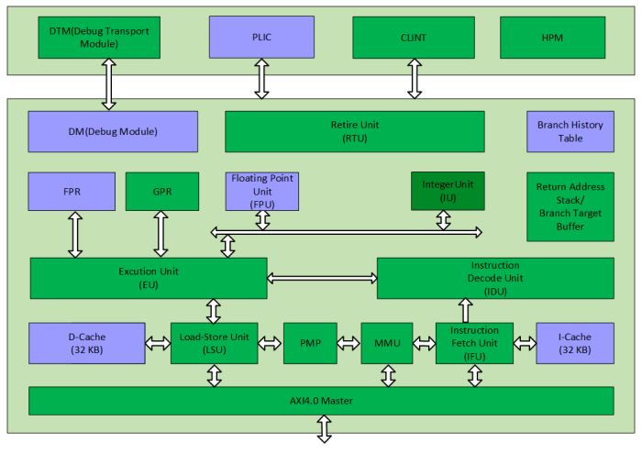
图表 1 C906 Micro Architecture

UVC(Uvm Verification Component) used

TB Environment

Appendix

UVM based design verification of a RISC-V CPU core
Ibex Core Verification environment
Test Plan — Ibex Documentation 0.1.dev50+g2fadd1afc documentation

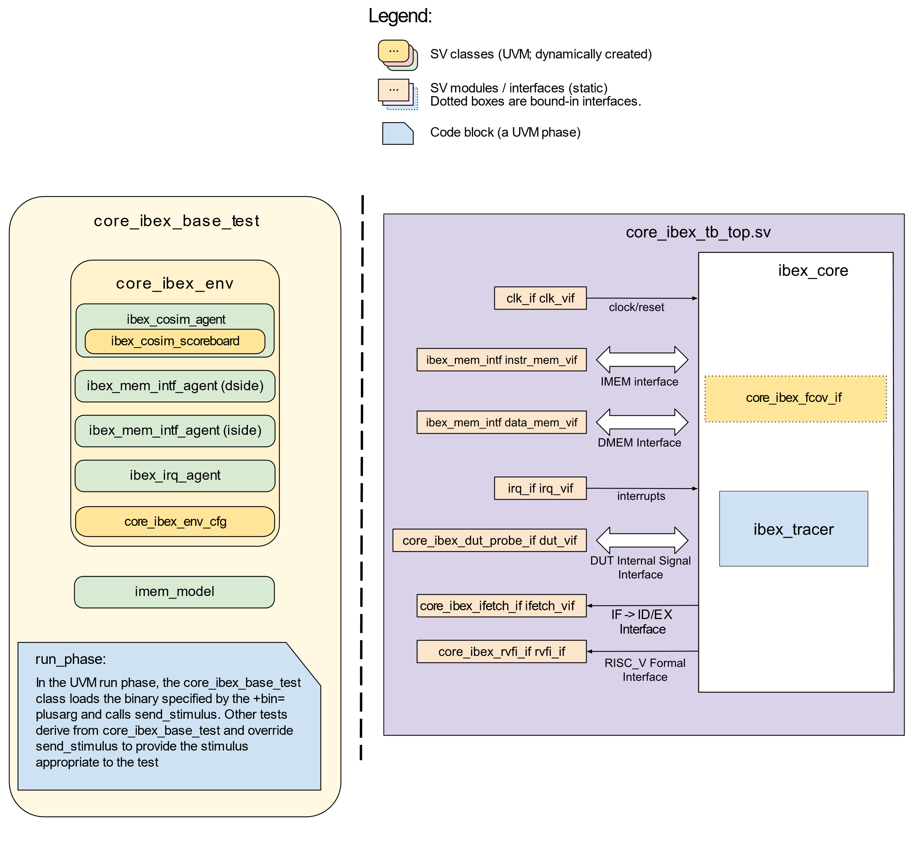
图表 2 Ibex Testbench architecture

