M-CORD是一个强大的平台，可以快速创新蜂窝网络，朝向5G。它具有一些5G特定的功能，例如RAN U面和C面的分离，可编程网络分割（ProgRAN）以及MME分解。 这些功能已经被证明。M-CORD是移动边缘云的CORD用例。 该体系结构允许服务提供商分解RAN和核心，并将其组件虚拟化为VNF或SDN应用程序。 此外，该体系结构能够对RAN进行编程控制，以及核心服务链。 基于M-CORD的边缘云也能够托管MEC服务。 至于其他CORD风格，VNF和SDN应用程序的服务管理由XOS协调。

The current release of M-CORD includes:

* An open source EPC, providing an SPGW control plane and an SPGW user plane (respectively represented in the system by two VMs deployed on the compute nodes). The current release of the EPC doesn’t yet provide MME, HSS and PCRF services.
* A closed source test suite, emulating UEs, eNodeBs, a minimal version of an MME with an integrated HSS, and an application server (used to emulate the upstream connectivity).

通过定制，系统可以使用真实的硬件基站，但是发布的版本只支持模拟流量的简单测试。  
 上，UE仿真器生成一些流量，流经EPC，流向模拟的应用服务器，然后再返回流量发生器。  
 角度来看系统，提供了三台虚拟机（其中一些实现了多种服务：

* **mysite_venb-X**: a test suite that emulates the RAN components (UEs, eNodeBs), an application server, and some of the EPC components (MME and HSS)
* **mysite_vspgwc-X**: a component of the EPC implementing the S-GW and the P-GW control plane functionalities
* **mysite_vspgwu-X**: a component of the EPC implementing the S-GW and the P-GW user plane functionalities

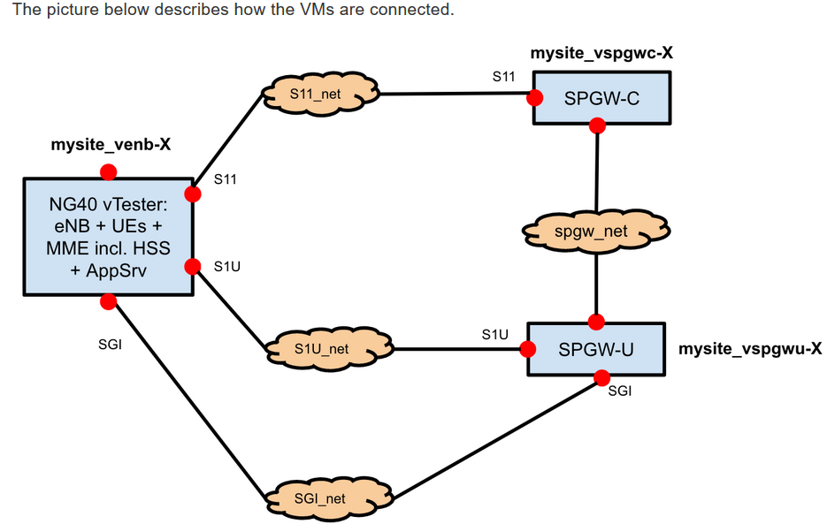

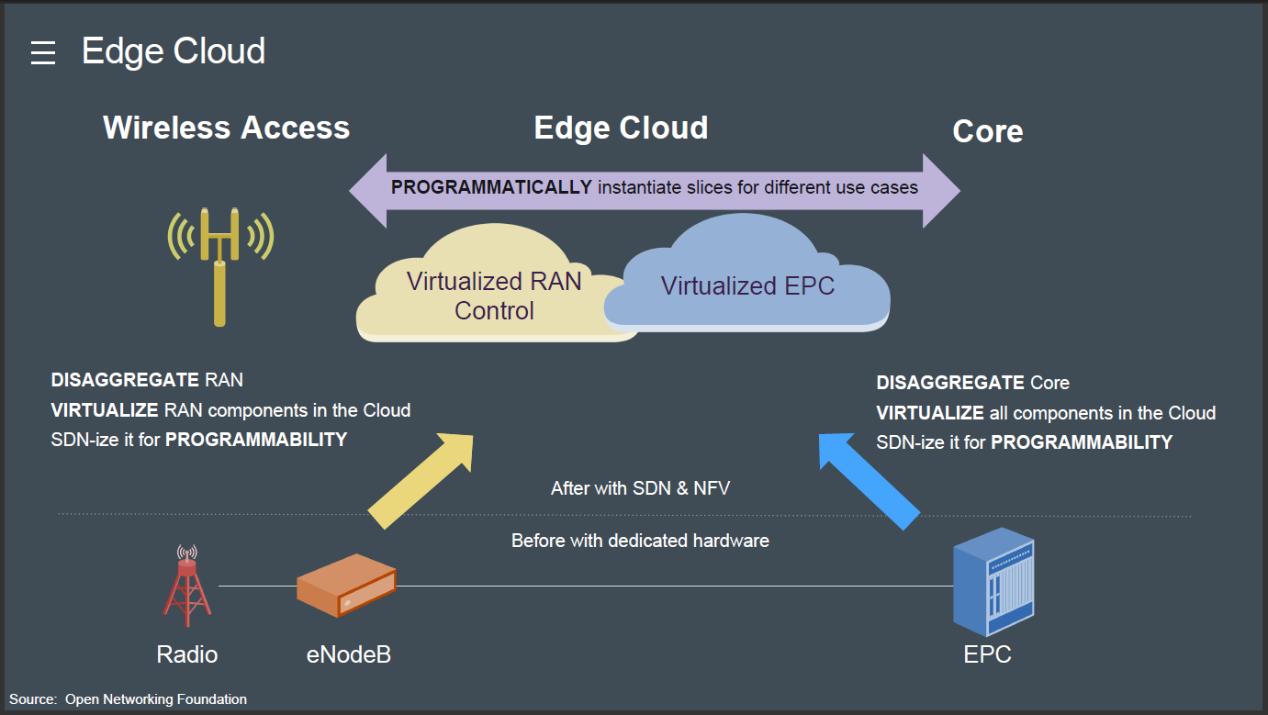

The EPC shipped with M-CORD is called “Next Generation Infrastructure Core” (NGIC). It’s provided as an open source reference implementation by Intel. In the current release it includes two services, implemented in separate VMs: the vSPGW-C and the vSPGW-U.

The vSPGW-C and the vSPGW-U are the Control User Plane Separated (CUPS) implementation of the conventional SAE-GW (S-GW and P-GW) which deals with converged voice and data services on Long Term Evolution (LTE) networks. The NGIC CUPS architecture is aligned with the 3GPP 5G direction. It has been developed using data plane development kit (DPDK) version optimized for Intel Architecture.

If you’re interested to know more and explore the EPC code, go to <https://gerrit.opencord.org/#/admin/projects/ngic>.

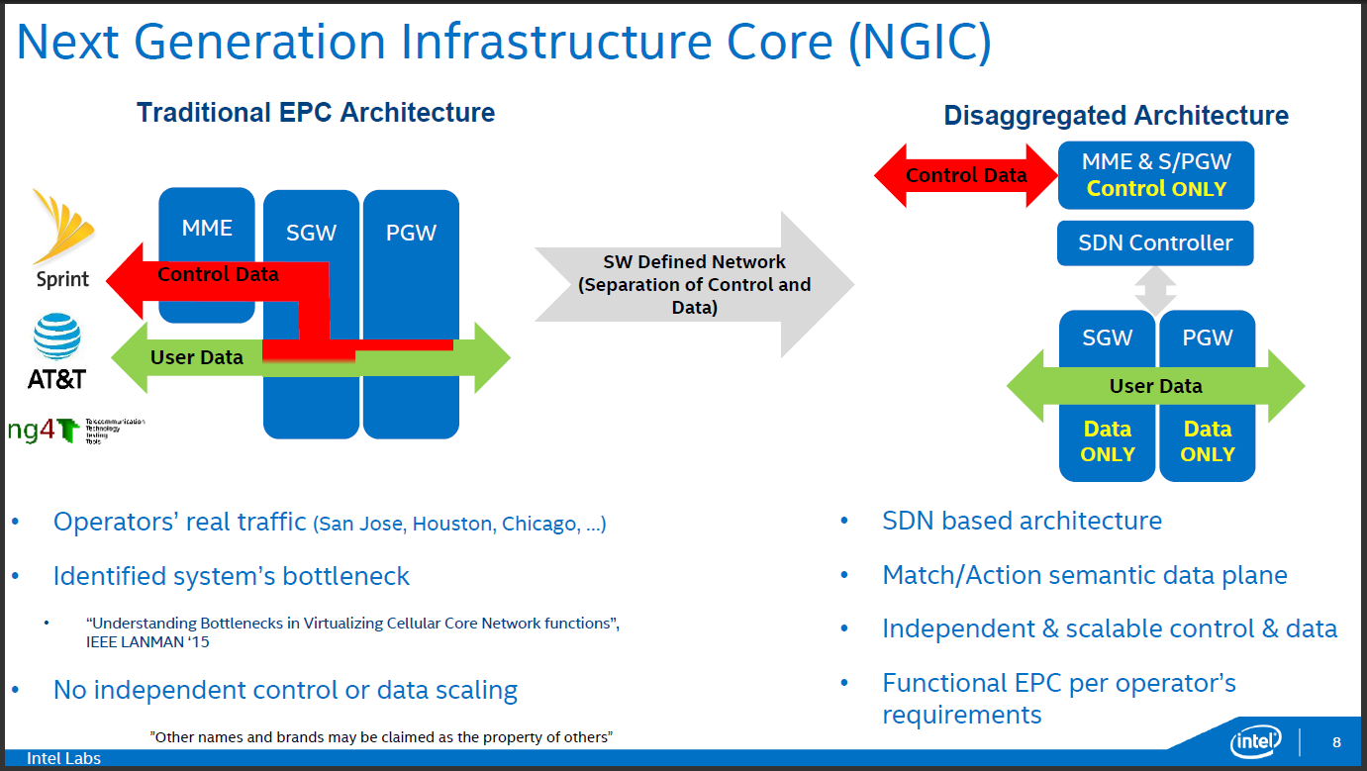

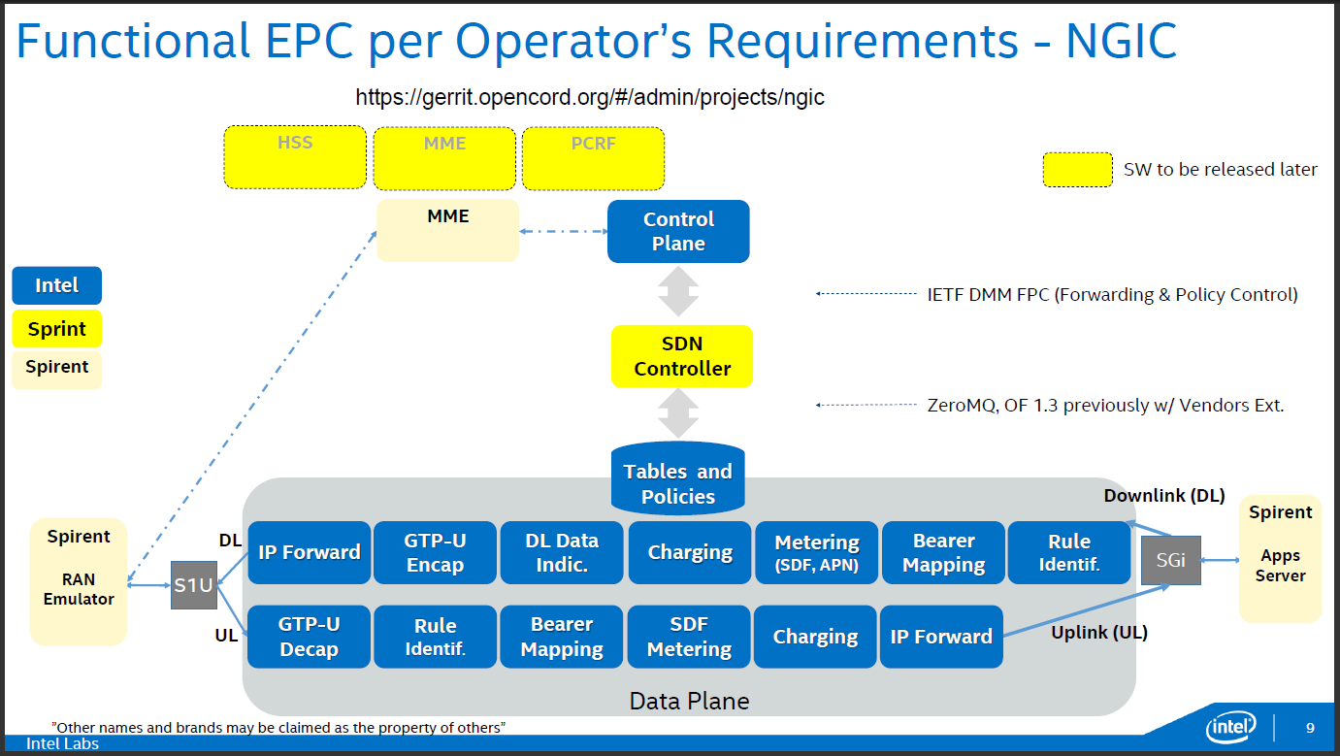

3.NGIC&M-CODE

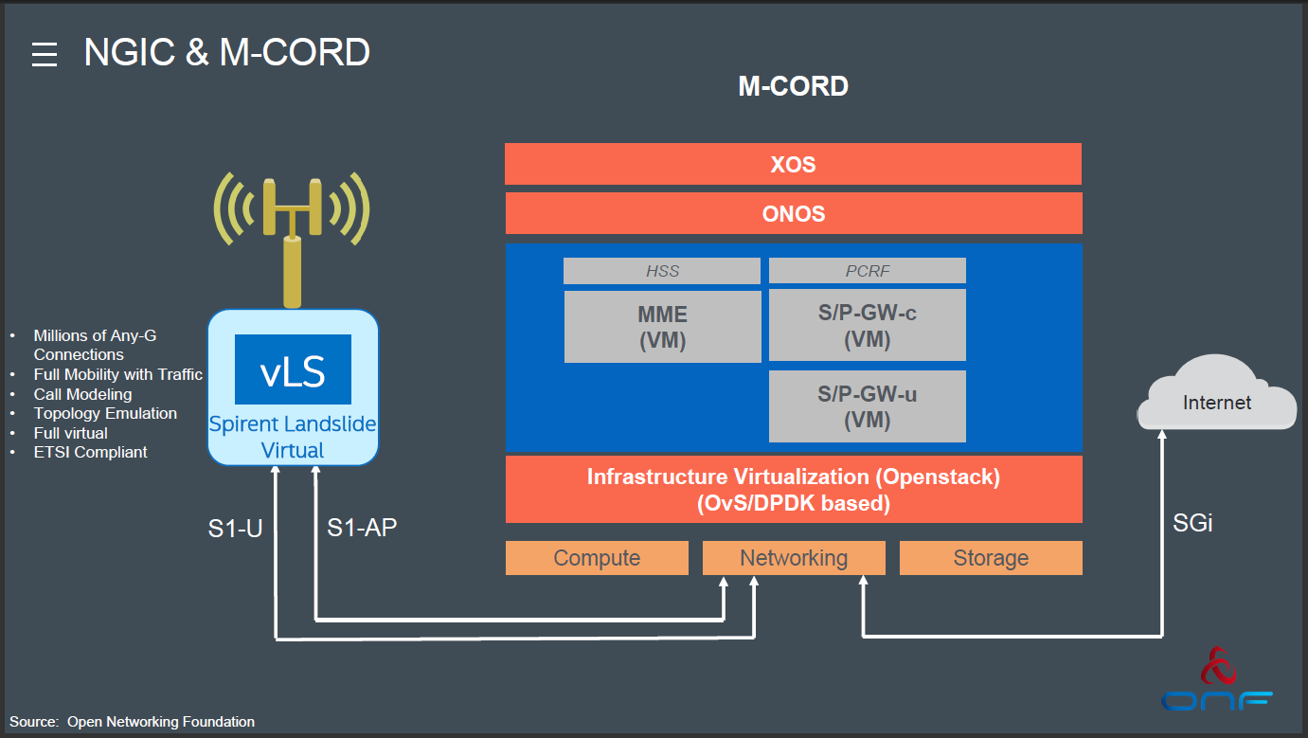

我们探讨了虚拟化蜂窝分组核心组件的问题。 使用简单的模型和实际的实验，我们发现了基于软件的LTE核心网架构的性能瓶颈。 我们量化了控制平面数据包处理在用户平面上引起的干扰。 尤其是，我们已经表明，33％的SGW忙于处理控制平面数据包，并且随着控制平面工作负载增加超过一定的阈值，用户平面容量受到影响。 我们确定了成本高昂的特定协议交互，并量化了这些消息集的性能瓶颈。 我们的研究结果使我们得出结论：简单地用虚拟等价物取代现有的EPC元件存在严重的性能瓶颈，需要仔细考虑虚拟EPC元件的设计。