This algorithm computes an approximate page rank vector of N pages to some convergence factor. It follows the formula given at http://www.mathworks.com/moler/exm/chapters/pagerank.pdf.

The application is written in Python, and uses only one Python library, Numpy.

In order to run this code, it is enough to import and install Numpy in Python. The input in given to the algorithm as an adjacency matrix, but the option to get the input as file is also provided as comment in the appropriate place.

***Input:***

This is the sample graph given for the assignment. The input of the algorithm is an adjacency matrix corresponding to the matrix below.

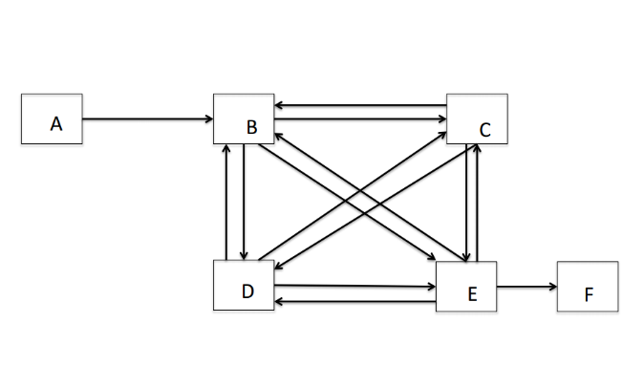

|  |  |  |  |  |  |  |
| --- | --- | --- | --- | --- | --- | --- |
|  | **A** | **B** | **C** | **D** | **E** | **F** |
| **A** | 0 | 1 | 0 | 0 | 0 | 0 |
| **B** | 0 | 0 | 1 | 1 | 1 | 0 |
| **C** | 0 | 1 | 0 | 1 | 1 | 0 |
| **D** | 0 | 1 | 1 | 0 | 1 | 0 |
| **E** | 0 | 1 | 1 | 1 | 0 | 1 |
| **F** | 0 | 0 | 0 | 0 | 0 | 0 |

***Output:***

The output of the algorithm is a sorted list of scores, corresponding to each page. The page with highest score has the highest importance according to page rank algorithm. The output generated by my code shows the transposed matrix, transition matrix, the final scores, and then sorts pages according to highest score. Here the index ‘0’ corresponds to page ‘A’, ‘1’ to page ‘B’ and so on. It should be noted that in this example, pages C and D had the exact same position in the network, so they have the same sore in page rank too.

Here is the generated output:

Transposed Matrix is:

[[ 0. 0. 0. 0. 0. 0.]

[ 1. 0. 1. 1. 1. 0.]

[ 0. 1. 0. 1. 1. 0.]

[ 0. 1. 1. 0. 1. 0.]

[ 0. 1. 1. 1. 0. 0.]

[ 0. 0. 0. 0. 1. 0.]]

Transition Matrix is:

[[ 0.025 0.025 0.025 0.025 0.025 0.16666667]

[ 0.875 0.025 0.30833333 0.30833333 0.2375 0.16666667]

[ 0.025 0.30833333 0.025 0.30833333 0.2375 0.16666667]

[ 0.025 0.30833333 0.30833333 0.025 0.2375 0.16666667]

[ 0.025 0.30833333 0.30833333 0.30833333 0.025 0.16666667]

[ 0.025 0.025 0.025 0.025 0.2375 0.16666667]]

unranked scores are:

[[ 0.03692527]

[ 0.23552039]

[ 0.21025556]

[ 0.21025556]

[ 0.22268062]

[ 0.08436262]]

Sorted Pages are:

[(0.23552038890948512, 1), (0.22268061543363932, 4), (0.21025555636182244, 2), (0.21025555636182244, 3), (0.084362615736554514, 5), (0.036925267196676208, 0)]

So, according to these results the ranking for pages will be:

R1🡪 B

R2🡪 E

R3🡪 C and D

R4🡪 F

R5🡪A