SAMPLE QUESTIONS:
Histology
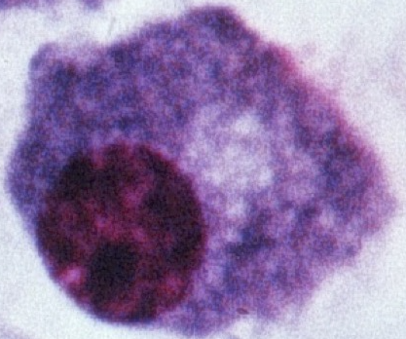
- Identify the cell shown
- B-lymphocyte
- Macrophage
- Plasma cell
- Megakaryocyte

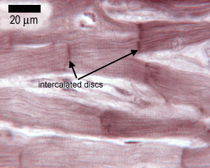
- What type of muscle cell is shown?
- Smooth
- Cardiac
- Skeletal

- If a glandular cell secretes by releasing part of its apical cytoplasm, its methoid of secretion is which of the following?
- Merocrine
- Eccrine
- Holocrine
- Apocrine
Physiology

- Which of the following types of ports does NOT permit movement AGAINST the concentration gradient of any of the ions being moved?
- uniporter
- symporter
- antiporter

- \Which of the following biophysical phenomena is used to distribute metabolites in the aqueous humor, within the anterior chamber of the eye?

a. diffusion
b. facilitated transport
c. active transport
d. convection

- If the blood has become acidic, which of the following would most rapidly improve the situation?

- Increased breathing rate
- Decreased breathing rate
- Increased elimination of H+ into urine
- Decrease elimination of H+ into urine

ANSWERS: 1)c, 2)b, 3)d, 4)a, 5)d, 6a

