**Web-based Pothole Tracking and Repair System**

Mamdouh Zayed

Colorado State University Global

CSC505: Principles of Software Development

Dr. Pubali Banerjee

May 13, 2024

**Web-based Pothole Tracking and Repair System**

**In the diagram, the steps are as follows:**

The citizen report pothole information and the information transits to a state of reported pothole information. The reported pothole information is then logged and State & transits state transits to a pothole logged state. In the next step the work order data is created the outcome of which is the Repair Crew specification sheet which contains data about the work crew. The damage file creation is done after that which also involves adding the costs and the state finally transits to the damage tile created state. In the final stage, the Damage file is up at updated to the website, and stale transits.

The sequence and a state diagram that follows the given work have been solved.

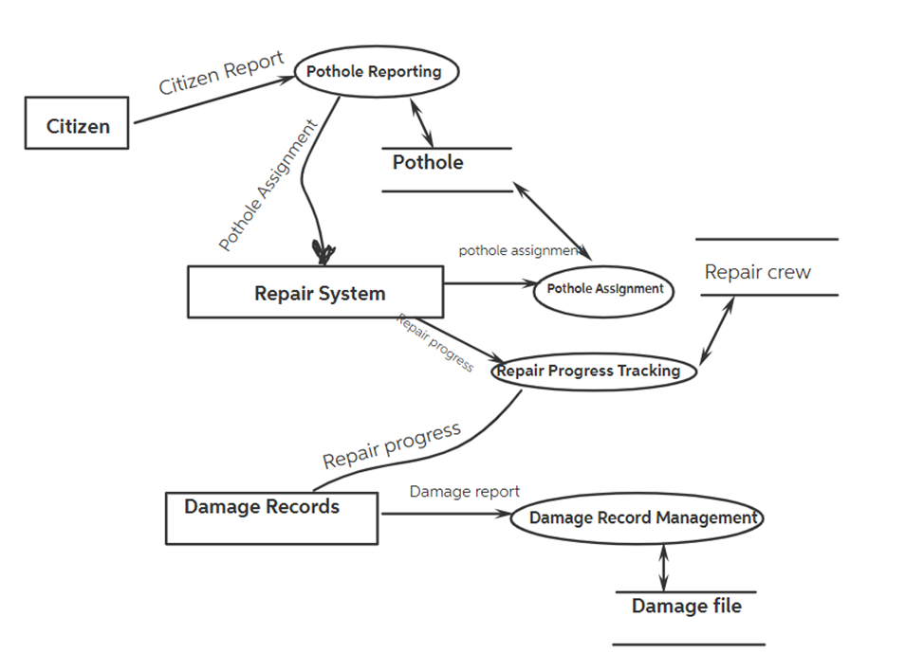

here is the use case diagram for the Pothole Tracking and Repair System (PHTRS):

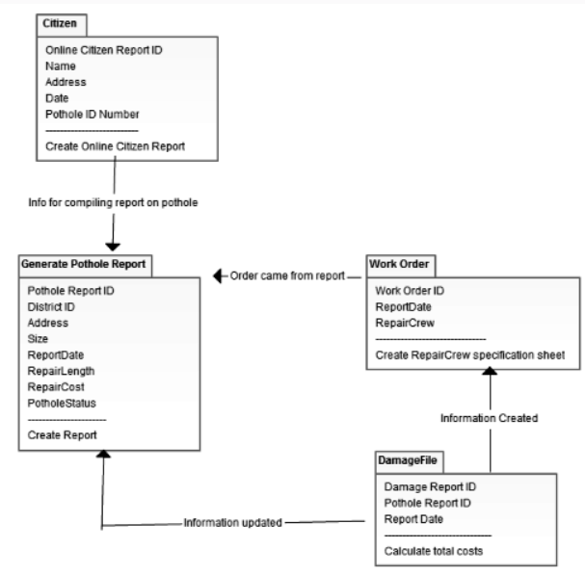

The screenshots of a successful execution of python program:

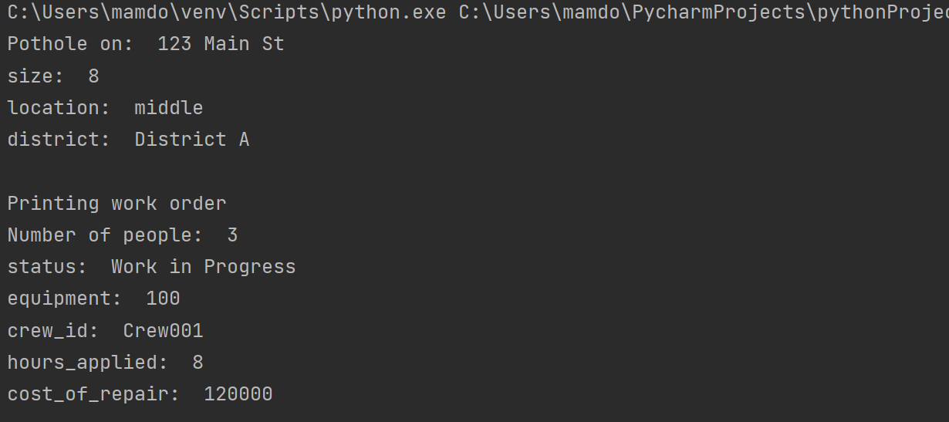

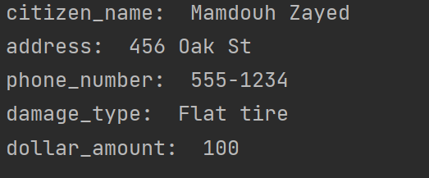

**References**

Pressman, R., & Maxim, B. (n.d.). Software Engineering. software-engineering-a-practitioners-approach-9nbsped-9781260548006-1259872971.

Robert J. Glushko, & Tim McGrath. (2005). Document Engineering: Analyzing and Designing Documents for Business Informatics and Web Services. The MIT Press.

Steve O’Leary, Kim Sheehan, & Sterling Lentz. (2011). Small Business Smarts: Building Buzz with Social Media. Praeger.

Technology, G. (2023, March 1). How a GIS Solution Creates a Pothole-Free City. Shibboleth authentication request. <https://eds-p-ebscohost-com.csuglobal.idm.oclc.org/eds/pdfviewer/pdfviewer?vid=1&sid=e6781ed2-895e-450f-bf35-b9d2231aa768%40redis>.