**Common Personality Traits**

Mamdouh Zayed

Colorado State University Global

CSC505: Principles of Software Development

Dr. Pubali Banerjee

May 7, 2024

**Common Personality Traits**

To depict three personality traits that appear to be common among excellent software developers, I can use a UML class diagram with three classes, each representing a personality trait. The traits I've chosen are:

Communication Skills

Problem-Solving Skills

Teamwork Skills

The positive attitude and communication skills aggregate, and the good technical skills are generalized to communication skills create a software developer.

It means a client with good technical experience, generalized communication skills and positive attitude creates a successful software developer.

Each class will have attributes representing the different levels of the trait, from beginner to expert. Here's the UML class diagram:

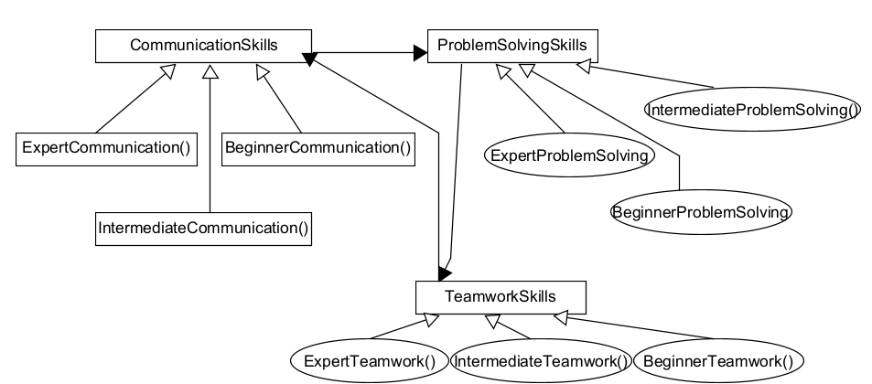

Here is Python script output:

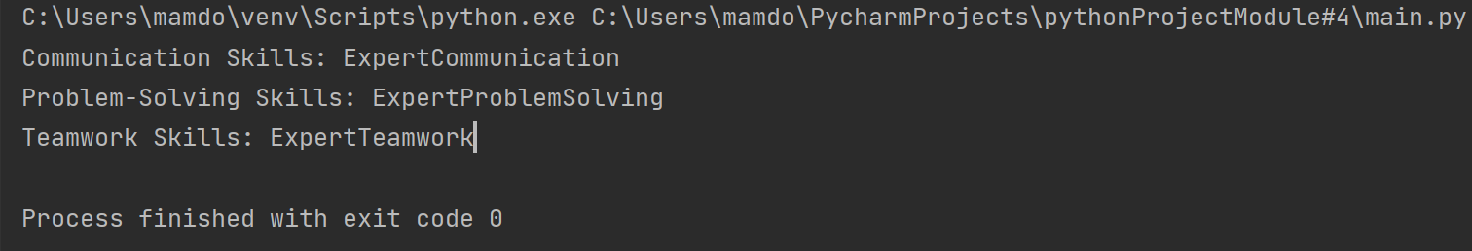

**References**

Pressman, R., & Maxim, B. (n.d.). Software Engineering. software-engineering-a-practitioners-approach-9nbsped-9781260548006-1259872971.

Miguel Angel Garcia, & Barry Harmsen. (2017). QlikView for Developers: Drive Value and Insight by Developing Business Critical Applications with QlikView 12. Packt Publishing.

Syngress. (2002). .NET Mobile Web Developers Guide. Syngress.