**Stepwise Refinement Approach**

Mamdouh Zayed

Colorado State University Global

CSC505: Principles of Software Development

Dr. Pubali Banerjee

May 20, 2024

**Stepwise Refinement Approach**

Let's choose the first program: Develop a check writer that, given a numeric dollar amount, will print the amount in words normally required on a check.

The first level of abstraction is the overall goal of the program. In this case, it is to convert a numeric dollar amount into words.

The second level of abstraction breaks down the overall goal into smaller tasks. For this program, these tasks could be:

1. Accept a numeric dollar amount as input.

2. Separate the dollar amount into whole dollars and cents.

3. Convert the whole dollar into words.

4. Convert the cents into words.

5. Combine the words for dollars and cents into a single string.

The third level of abstraction breaks down the tasks from level 2 into even smaller tasks. For example, the task of converting the whole dollars into words could be broken down into:

1. Convert each digit of the whole dollar into words.

2. Add "and" between the words for dollars and cents.

3. Add "dollars" at the end of the words for whole dollars.

**Also I choose transcendental equation:**

Find the derivative of the transcendental equation**:**

Y = 7x sin(x) + x^2e^x

By the rule, the derivative of 7xsin (x) + x^2e^x with respect to x is

d/dx[7xsin (x)] + d/dx[x^2e^x]

d/dx[7xsin (x)] + d/dx[x^2e^x]

y = 7xsin (x) + x^2e^x

Evaluate d/dx[7xsin (x)]

7(xcos(x) + sin(x)) + d/dx[x^2e^x]

Evaluate d/dx[x^1e^x]

7(xcos(x) + sin(x)) + x^2e^x + e^x(2(x)

Simplify: 7xcos (x)+ x^2e^x +2xe^x + 7sin(x)

Here is a Python algorithm that represents this stepwise refinement approach output:

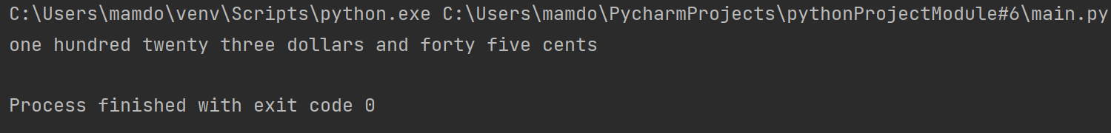

A diagram explains the stepwise refinement approach of converting a numeric dollar amount into words.

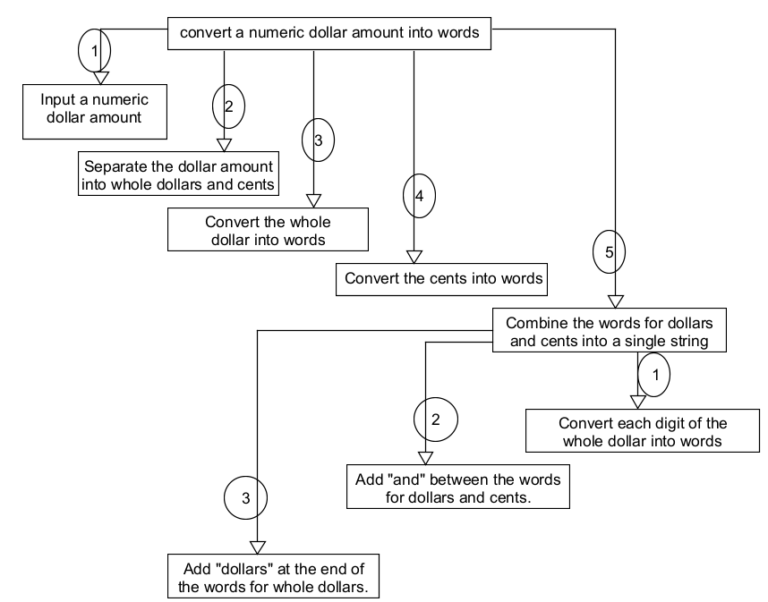

**References**

Pressman, R., & Maxim, B. (n.d.). Software Engineering. software-engineering-a-practitioners-approach-9nbsped-9781260548006-1259872971.

Sibley, E. H., & Reynolds, R. G. (1987, November). The partial metrics systems: Modeling the stepwise refinement process using partial metrics. Computing Practices. <https://eds-p-ebscohost-com.csuglobal.idm.oclc.org/eds/pdfviewer/pdfviewer?vid=1&sid=b5bc4020-2797-44c5-90c8-91110f072008%40redis>.

Sibley, E. H., & Reynolds, R. G. (1987, November). THE PARTIAL METRICS SYSTEMS: MODELING THE STEPWISE REFINEMENT PROCESS USING PARTIAL METRICS. Computing Practices. <https://eds-p-ebscohost-com.csuglobal.idm.oclc.org/eds/pdfviewer/pdfviewer?vid=1&sid=b5bc4020-2797-44c5-90c8-91110f072008%40redis>