Week 1 Applied Work: Mechanistic Framing for Polymer Degradation Pathways
Aryamann Zutshi
University of Kansas
EECS 692: Predicting Plastic Degradation Pathways with Machine Learning
Professor David Johnson
May 24, 2026

Introduction
The purpose of this Week 1 applied work was to establish the chemical foundation for the polymer degradation project. The project cannot begin with machine learning alone because the labels and descriptors must reflect real degradation mechanisms. Hydrolysis, photo-oxidation, and biodegradation can all lead to chain scission and loss of material performance, but they are driven by different chemical conditions.
The logic behind this framing comes from polymer degradation literature. Shah et al. (2008) describe biological degradation as a process involving microbial colonization, enzyme activity, and polymer accessibility. Wiles and Scott (2006) describe controlled environmental degradability in polyolefins as strongly dependent on oxidation and environmental exposure. Therefore, the central research question for Week 1 was: how should degradation pathways be separated so that later model features and targets remain chemically meaningful?
Research question. How should hydrolysis, photo-oxidation, and biodegradation be separated before polymer degradation is modeled with machine learning?
It was hypothesized that degradation pathway prediction would be more scientifically defensible if polymer chemistry, environmental exposure, and measured degradation outcomes were treated as separate model components rather than merged into one broad degradation label.

Methods and Materials
This week used a literature-guided conceptual analysis rather than a computational experiment. The materials were the course objective, project notes, and peer-reviewed literature on biological and abiotic plastic degradation. Each degradation pathway was examined for its initiating condition, chemical mechanism, measurable outcome, and likely model descriptor requirements.
The pathways were organized by causal role. Polymer-intrinsic variables described repeat-unit chemistry, functional groups, bond susceptibility, crystallinity, and morphology. Environmental variables described water activity, pH, ultraviolet exposure, oxygen, temperature, salinity, and microbial conditions. Outcome variables described carbonyl formation, molecular-weight loss, mass loss, embrittlement, and strength reduction.

Results
The result was a mechanism map that separated polymer degradation into chemically distinct pathways. Hydrolysis was identified as most relevant for polymers containing hydrolyzable linkages such as esters, anhydrides, carbonates, urethanes, and some amides. Photo-oxidation was identified as an exposure-driven pathway initiated by ultraviolet radiation and propagated through oxygen-dependent radical chemistry. Biodegradation was identified as a biologically mediated pathway that requires microbial access and, in many cases, prior physical or chemical weakening of the polymer surface.
This organization is summarized in Appendix Figure A1. The figure is used as a conceptual anchor for later weeks because it shows the flow from polymer structure to environmental exposure, chemical pathway, chain scission, and measurable degradation outcome.
Table 1
Week 1 Mechanistic Framing for Polymer Degradation Pathways
Pathway | Primary driver | Model implication
Hydrolysis | Water, pH, hydrolyzable bonds | Include functional groups, water activity, pH, and time.
Photo-oxidation | UV radiation and oxygen | Include UV dose, oxygen availability, carbonyl index, and surface exposure.
Biodegradation | Microbial and enzymatic activity | Include microbial context, biofilm indicators, and biodegradability class.

Discussion
The Week 1 hypothesis was supported at the conceptual level. The main claim is that polymer degradation should not be treated as a single undifferentiated label. The logic behind this claim is that different degradation pathways depend on different causal variables. Hydrolysis requires water access and susceptible linkages, photo-oxidation requires light and oxygen-mediated radical reactions, and biodegradation requires biological accessibility and microbial or enzymatic activity.
The claim is supported by Shah et al. (2008), who show that biological degradation depends on polymer chemistry and microbial mechanisms, and by Wiles and Scott (2006), who show that environmental oxidation is a central driver for polyolefin degradability. The limitation of this week is that the work produced a scientific framework rather than a dataset. The next step was to convert the mechanism map into a usable variable schema for data collection and modeling.

References
Shah, A. A., Hasan, F., Hameed, A., & Ahmed, S. (2008). Biological degradation of plastics: A comprehensive review. Biotechnology Advances, 26(3), 246-265. https://doi.org/10.1016/j.biotechadv.2007.12.005
Wiles, D. M., & Scott, G. (2006). Polyolefins with controlled environmental degradability. Polymer Degradation and Stability, 91(7), 1581-1592. https://doi.org/10.1016/j.polymdegradstab.2005.09.014

Appendix
Figure A1
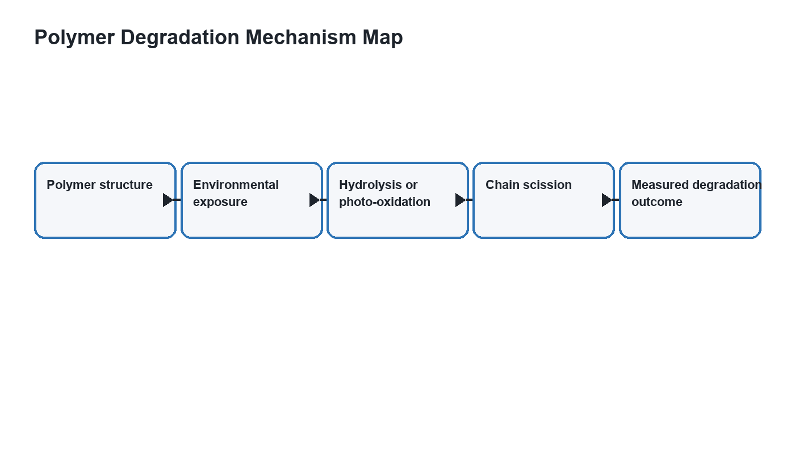
Figure A1. Mechanistic framing for polymer degradation pathways.

