Week 2 Applied Work: Environmental Variables for Polymer Degradation Modeling
Aryamann Zutshi
University of Kansas
EECS 692: Predicting Plastic Degradation Pathways with Machine Learning
Professor David Johnson
May 24, 2026

Introduction
The purpose of this Week 2 applied work was to identify the environmental, material, and outcome variables that should be represented in a machine-learning dataset for predicting polymer degradation. The practical problem was that degradation is not controlled by polymer identity alone. A polymer exposed to ultraviolet radiation, oxygen, moisture, salt water, or microbial films may follow different degradation pathways even when the underlying material is the same.
The scientific literature supports this framing. Andrady (2011, 2015) describes plastic degradation in the environment as a coupled process shaped by ultraviolet exposure, oxygen availability, temperature, material thickness, and environmental persistence. Gewert et al. (2015) similarly emphasize that plastics floating in marine environments can degrade through interacting photochemical, oxidative, hydrolytic, and physical pathways. Therefore, the central research question for this applied work was: which variables should be recorded so that a future model can distinguish chemically meaningful degradation mechanisms from general environmental labels?
It was hypothesized that a useful dataset schema would need to separate environmental exposure variables, polymer descriptors, and measured degradation outcomes. This hypothesis follows from the logic that exposure conditions act as drivers or modifiers, polymer chemistry determines susceptibility, and outcomes measure the consequences of degradation. If these categories are mixed together, the model may learn dataset-specific correlations rather than mechanism-based relationships.

Methods and Materials
This applied work used a literature-guided schema design method rather than a wet-laboratory procedure. The materials for the study were the Week 2 reading reports and peer-reviewed plastic degradation literature, especially Andrady (2011, 2015) and Gewert et al. (2015). These sources were used to identify environmental variables repeatedly described as important for polymer degradation.
The schema was constructed by separating variables into four functional categories. Environmental and exposure variables described the external conditions acting on the polymer. Polymer and material descriptors described the intrinsic properties of the plastic sample. Outcome variables described the measurable evidence of degradation. Metadata variables described how the measurement was collected and whether the data were suitable for comparison across studies.
The rationale for this organization was reproducibility. A future researcher should be able to examine a row of the dataset and understand what material was tested, what environment it experienced, what outcome was measured, and what source reported the measurement. This structure also helps preserve the distinction between independent variables, dependent variables, and contextual metadata.

Results
The result of the applied work was a structured variable schema for polymer degradation modeling. Table 1 summarizes the major variable groups, the variables assigned to each group, and the scientific rationale for including them.
Table 1
Week 2 polymer degradation dataset schema
Variable group | Variables included | Scientific rationale
Environmental exposure | UV intensity, UV wavelength distribution, exposure duration, temperature | These variables describe the energy and time available for photochemical initiation, radical formation, and temperature-dependent reaction kinetics.
Chemical medium | Relative humidity or water activity, oxygen availability, salinity, pH | These variables determine whether hydrolysis and oxidation can proceed and whether diffusion or chemical availability limits the observed degradation rate.
Biological surface conditions | Microbial load indicator, biofilm presence, biofilm thickness | These variables are included because biofilms can modify local hydration, oxygen transport, and acidity even when direct enzymatic cleavage is limited.
Mechanical context | Wave action class, abrasion index, stirring rate, sample thickness, surface-area-to-volume ratio | These variables separate chemical degradation from physical fragmentation after chain scission or embrittlement.
Polymer descriptors | Polymer identity, functional groups, additives, crystallinity, initial molecular weight | These variables encode the material properties that determine bond susceptibility, transport accessibility, and resistance to oxidation or hydrolysis.
Outcome variables | Molecular weight change, carbonyl index, mass loss, mechanical property change, fragmentation metric | These outputs distinguish chemical change from physical consequence so that the model does not collapse multiple degradation processes into a single vague label.
The schema also produced a conceptual map of how environmental inputs connect to measurable degradation outputs. That map is provided in Appendix Figure A1. The figure is placed in the appendix so that the Results section can focus on the factual schema while the visual summary remains available for reference.

Discussion
The schema supports the hypothesis that polymer degradation modeling requires separate representation of exposure conditions, material descriptors, and degradation outcomes. This conclusion follows from the source literature and from chemical logic. Ultraviolet radiation and oxygen are not merely labels for an outdoor environment; they are mechanistic inputs that influence radical initiation and oxidative propagation. Temperature and moisture affect reaction kinetics, diffusion, and hydrolysis potential. Salinity and biofilms can alter local surface chemistry and transport conditions rather than acting as simple direct causes of chain scission.
The main scientific claim from this applied work is that degradation rate cannot be modeled reliably if environmental variables are treated only as descriptive metadata. The logic behind this claim is that environmental factors participate in the causal chain that leads from exposure to chemical change. Andrady (2011, 2015) supports this point by describing how sunlight, oxygen, and environmental persistence influence plastic degradation. Gewert et al. (2015) further support it by showing that marine plastic degradation involves multiple interacting environmental pathways.
A limitation of this Week 2 work is that the schema had not yet been populated with quantitative degradation measurements. As a result, the output of the week was a reproducible data structure rather than a trained model or statistical result. Another limitation is that some proposed variables, such as microbial load or biofilm thickness, may not be consistently reported in published datasets. Future work should therefore prioritize sources that report controlled exposure conditions, time points, measurement methods, and uncertainty estimates.
The next step is to use this schema to guide data extraction. For each polymer-environment pair, the dataset should record the polymer identity, the relevant environmental exposure variables, the measurement method, and at least one time-dependent degradation outcome. This will make later modeling more scientifically defensible because the model inputs will reflect the chemical and environmental logic described in the literature.

References
Andrady, A. L. (2011). Microplastics in the marine environment. Marine Pollution Bulletin, 62(8), 1596-1605. https://doi.org/10.1016/j.marpolbul.2011.05.030
Andrady, A. L. (2015). Persistence of plastic litter in the oceans. In M. Bergmann, L. Gutow, & M. Klages (Eds.), Marine anthropogenic litter (pp. 57-72). Springer. https://doi.org/10.1007/978-3-319-16510-3_3
Gewert, B., Plassmann, M. M., & MacLeod, M. (2015). Pathways for degradation of plastic polymers floating in the marine environment. Environmental Science: Processes & Impacts, 17(9), 1513-1521. https://doi.org/10.1039/C5EM00207A

Appendix
Figure A1
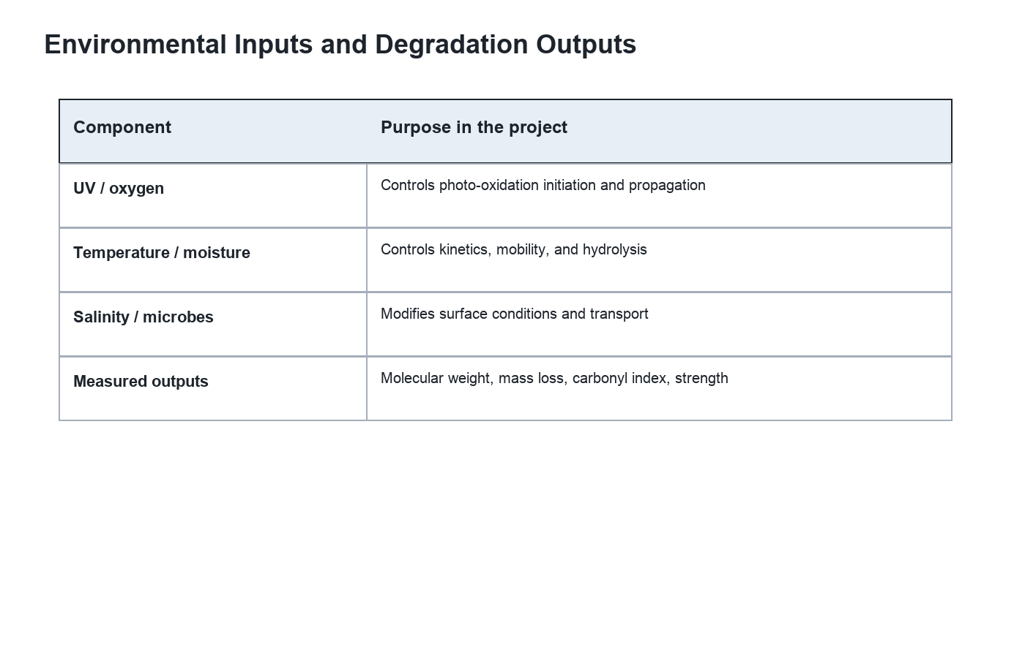
Figure A1. Environmental inputs and degradation outputs represented in the Week 2 schema.

