Week 3 Applied Work: Machine-Learning Framework for Polymer Degradation Prediction
Aryamann Zutshi
University of Kansas
EECS 692: Predicting Plastic Degradation Pathways with Machine Learning
Professor David Johnson
May 24, 2026

Introduction
The purpose of Week 3 was to define a machine-learning framework that connects polymer chemistry to degradation prediction. At this stage, the project needed a modeling strategy before training began. The main decision was whether to begin with engineered descriptors, graph representations, or both.
The literature supports beginning with chemically interpretable representations. Butler et al. (2018) describe machine learning for molecular and materials science as most reliable when representation, data quality, and domain knowledge are aligned. Chen et al. (2021) describe polymer informatics as dependent on careful polymer representation and curated data. Therefore, the research question was: which model representation should be used first so that predictions remain interpretable and scientifically defensible?
Research question. How should QSAR descriptors and graph-based representations be compared for polymer degradation modeling?
It was hypothesized that descriptor-based QSAR models would provide the most interpretable baseline, while graph-based representations could become valuable later if the dataset contains chemically resolved structures rather than only summary descriptors.

Methods and Materials
This week used a design-comparison method. QSAR modeling was evaluated as a baseline approach because the available data could be represented with numerical molecular descriptors. Graph-based learning was evaluated as a future extension because it can encode atoms, bonds, and local connectivity when appropriate molecular structures are available.
The proposed workflow separated polymer descriptors from environmental descriptors. Polymer descriptors included functional group counts, heteroatom density, molecular-weight proxies, polarity measures, and thermophysical indicators where available. Environmental descriptors included temperature, moisture, oxygen, ultraviolet exposure, salinity, and microbial indicators.

Results
The resulting workflow placed QSAR-style descriptor models first, followed by graph-based modeling only after the data representation becomes chemically detailed enough to justify it. This ordering prevents the project from using a complex model before the dataset can support the model assumptions.
Appendix Figure A1 summarizes this modeling pipeline. The flow begins with polymer descriptors and environmental descriptors, passes through a QSAR or graph-based model, produces pathway or severity predictions, and returns to chemical interpretation.
Table 1
Week 3 Machine-Learning Framework for Polymer Degradation Prediction
Model family | Strength | Risk
QSAR descriptors | Interpretable tabular baseline | May miss local bond context.
Graph learning | Can represent atomic connectivity | Requires chemically resolved graph inputs.
Hybrid approach | Combines descriptors and structure | Needs careful validation against overfitting.

Discussion
The Week 3 hypothesis was supported. QSAR descriptors are the appropriate first modeling layer because they are compatible with tabular data and easier to interpret chemically. Graph-based learning remains scientifically attractive, but the logic behind the claim is that graph neural networks require meaningful graph structure; if the dataset contains only 41 summary descriptors, a graph model could add complexity without adding true chemical information.
This interpretation follows Butler et al. (2018) and Chen et al. (2021), who both emphasize the importance of representation and data quality in molecular or polymer machine learning. The limitation is that no model was trained yet. The next step was to formalize the dataset schema so that later training and validation could proceed consistently.

References
Butler, K. T., Davies, D. W., Cartwright, H., Isayev, O., & Walsh, A. (2018). Machine learning for molecular and materials science. Nature, 559(7715), 547-555. https://doi.org/10.1038/s41586-018-0337-2
Chen, L., Pilania, G., Batra, R., Huan, T. D., Kim, C., Kuenneth, C., & Ramprasad, R. (2021). Polymer informatics: Current status and critical next steps. Materials Science and Engineering: R: Reports, 144, 100595. https://doi.org/10.1016/j.mser.2020.100595

Appendix
Figure A1
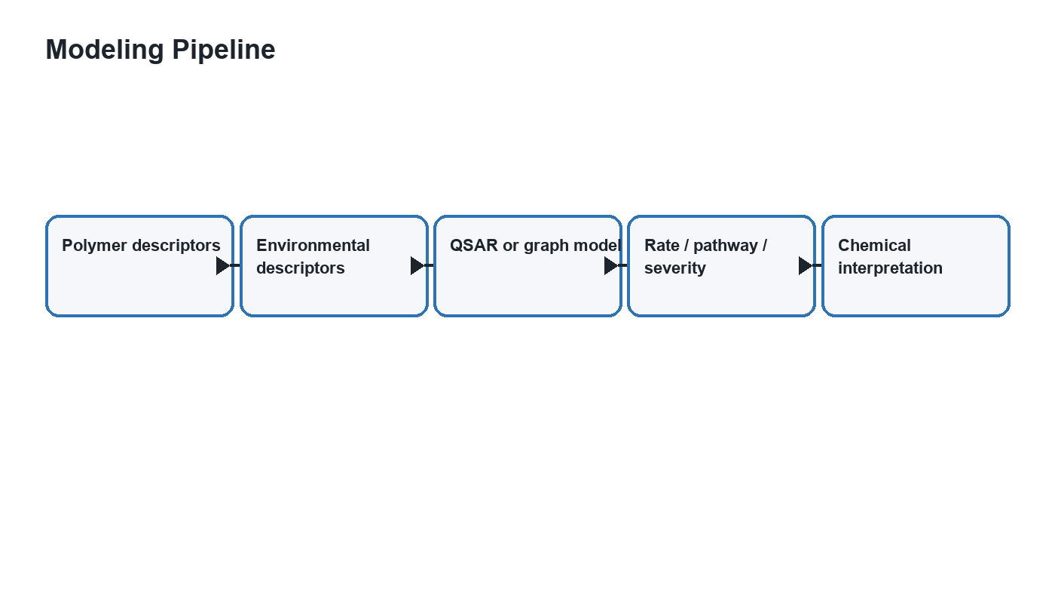
Figure A1. Modeling pipeline separating polymer chemistry, environment, and degradation outputs.

