Week 4 Applied Work: Dataset Schema for Polymer Degradation Modeling
Aryamann Zutshi
University of Kansas
EECS 692: Predicting Plastic Degradation Pathways with Machine Learning
Professor David Johnson
May 24, 2026

Introduction
The purpose of Week 4 was to convert the earlier conceptual model into a practical data structure. The project needed a schema capable of recording polymer identity, environmental exposure, experimental conditions, and degradation outcomes without losing source traceability.
This need follows directly from polymer informatics literature. Chen et al. (2021) argue that polymer machine learning depends on data curation and representation, while Lin et al. (2019) introduced BigSMILES to address the representational difficulty of polymers. Therefore, the Week 4 research question was: what schema would make degradation data reproducible enough for later modeling?
Research question. What row structure should be used to collect polymer degradation evidence from heterogeneous literature sources?
It was hypothesized that each dataset row should separate polymer identity, exposure conditions, time, outcome metric, and source metadata so that later models can distinguish chemical signal from reporting context.

Methods and Materials
The schema was designed by treating a dataset row as a record of one polymer under one exposure condition with one measured degradation outcome. The candidate fields were grouped into polymer identity, structural representation, exposure condition, time point, measurement method, outcome value, source citation, DOI, and extraction notes.
The design also separated raw values from standardized values. This was necessary because literature sources may report time, temperature, mass loss, molecular-weight change, or carbonyl index in inconsistent ways. Retaining the original values while adding standardized fields protects reproducibility.

Results
The resulting schema included five required components: polymer identity, exposure condition, time point, outcome metric, and source metadata. This structure created a reproducible bridge between literature extraction and later machine-learning analysis.
Appendix Figure A1 shows the proposed row structure. The figure is intentionally simple because the key Week 4 result was not a model score; it was the creation of a traceable dataset format.
Table 1
Week 4 Dataset Schema for Polymer Degradation Modeling
Schema component | Included information | Purpose
Polymer identity | Name, class, representation | Connects rows to chemical structure.
Exposure condition | Temperature, pH, UV, humidity, salinity | Defines environmental drivers.
Outcome metric | Mass loss, carbonyl index, molecular weight | Defines the dependent variable.
Source metadata | Citation, DOI, notes | Supports auditability.

Discussion
The Week 4 hypothesis was supported. A model-ready degradation dataset cannot be built from polymer names and labels alone. The logic is that degradation outcomes depend on time, exposure, measurement method, and source context. If those variables are omitted, the model may learn artifacts from inconsistent reporting rather than chemistry.
Chen et al. (2021) support this claim through their discussion of polymer informatics data needs, while Lin et al. (2019) supports the representational side by showing why polymers require specialized notation. The limitation is that the schema was still preliminary and did not yet include enough extracted rows for statistical analysis. The next step was to begin baseline classification on an available descriptor dataset.

References
Chen, L., Pilania, G., Batra, R., Huan, T. D., Kim, C., Kuenneth, C., & Ramprasad, R. (2021). Polymer informatics: Current status and critical next steps. Materials Science and Engineering: R: Reports, 144, 100595. https://doi.org/10.1016/j.mser.2020.100595
Lin, T.-S., Coley, C. W., Mochigase, H., Beech, H. K., Wang, W., Wang, Z., Woods, E., Craig, S. L., Johnson, J. A., Kalow, J. A., Jensen, K. F., & Olsen, B. D. (2019). BigSMILES: A structurally-based line notation for describing macromolecules. ACS Central Science, 5(9), 1523-1531. https://doi.org/10.1021/acscentsci.9b00476

Appendix
Figure A1
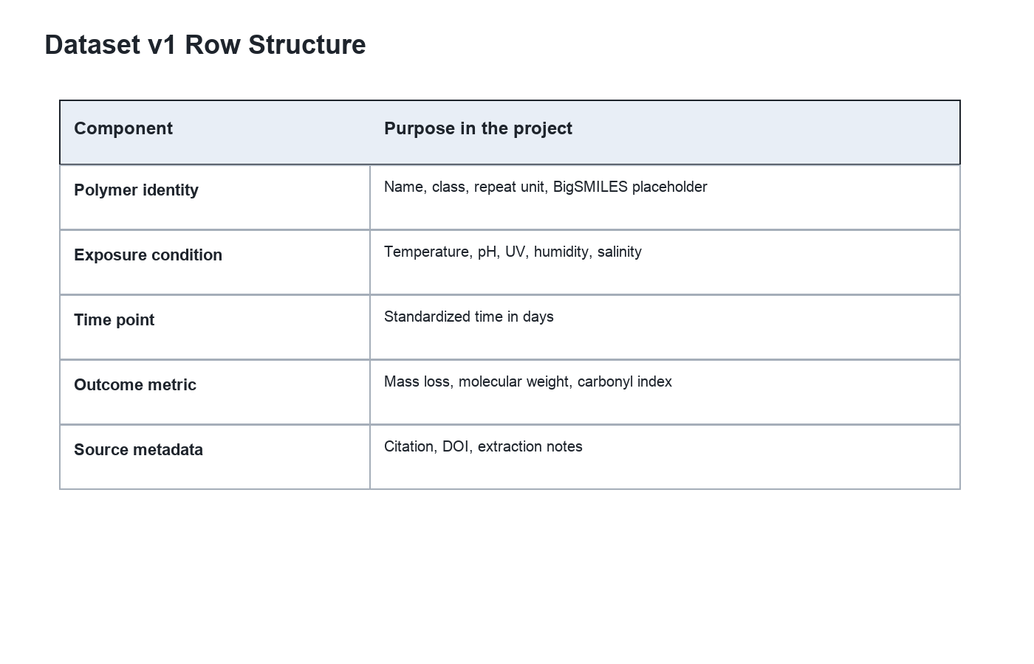
Figure A1. Dataset schema used to organize polymer, exposure, and outcome variables.

