Week 5 Applied Work: Baseline Classification of Ready Biodegradability
Aryamann Zutshi
University of Kansas
EECS 692: Predicting Plastic Degradation Pathways with Machine Learning
Professor David Johnson
May 24, 2026

Introduction
The purpose of Week 5 was to move from schema design to baseline classification. The task was to predict biodegradability class, ready biodegradable (RB) versus not readily biodegradable (NRB), from the available 41 molecular descriptors.
The modeling task follows the ready-biodegradability QSAR literature. Mansouri et al. (2013) developed QSAR models for ready biodegradability, showing that molecular descriptors can support classification. Breiman (2001) introduced Random Forest as a robust nonlinear ensemble method. Therefore, the Week 5 research question was whether simple baseline models could establish a defensible performance reference for later neural-network work.
Research question. How well do Logistic Regression and Random Forest predict biodegradability class from molecular descriptors?
It was hypothesized that Random Forest would outperform Logistic Regression because nonlinear descriptor interactions may be important for biodegradability classification.

Methods and Materials
The dataset contained 1,055 samples, with 699 NRB samples and 356 RB samples. This distribution is imbalanced, with approximately 66.3% NRB and 33.7% RB. The imbalance matters because a model can achieve high accuracy by favoring the majority class.
Two baseline classifiers were evaluated: Logistic Regression and Random Forest. Descriptors were used as model inputs, and the outcome was binary biodegradability class. Evaluation included accuracy, macro-F1, ROC-AUC, and confusion-matrix interpretation. A 50/50 train/test split and k-fold cross-validation were identified as necessary follow-up checks because the initial baseline should not be trusted from one split alone.

Results
Random Forest produced the strongest baseline performance, with accuracy of 0.8768, macro-F1 of 0.8529, and ROC-AUC of 0.9423. Logistic Regression achieved accuracy of 0.8626, macro-F1 of 0.8456, and ROC-AUC of 0.9136. These results indicate that nonlinear structure improved performance, although both models were useful baselines.
Appendix Figure A1 shows the class imbalance in the dataset, and Appendix Figure A2 summarizes the Week 5 baseline model performance.
Table 1
Week 5 Baseline Classification of Ready Biodegradability
Model | Accuracy | Macro-F1 | ROC-AUC
Logistic Regression | 0.8626 | 0.8456 | 0.9136
Random Forest | 0.8768 | 0.8529 | 0.9423

Discussion
The Week 5 hypothesis was supported because Random Forest outperformed Logistic Regression across the main metrics. The logic behind this result is that Random Forest can model nonlinear feature interactions and threshold behavior among molecular descriptors, while Logistic Regression assumes a more linear decision boundary.
The most important limitation is class imbalance. Because RB samples are the minority class, accuracy alone is not sufficient. Macro-F1, ROC-AUC, and confusion matrices are required to determine whether the model is detecting RB compounds rather than mostly learning the NRB majority. Future work should test class weighting, SMOTE applied only to the training split, 50/50 splitting, and k-fold cross-validation.

References
Breiman, L. (2001). Random forests. Machine Learning, 45(1), 5-32. https://doi.org/10.1023/A:1010933404324
Mansouri, K., Ringsted, T., Ballabio, D., Todeschini, R., & Consonni, V. (2013). Quantitative structure-activity relationship models for ready biodegradability of chemicals. Journal of Chemical Information and Modeling, 53(4), 867-878. https://doi.org/10.1021/ci4000213

Appendix
Figure A1
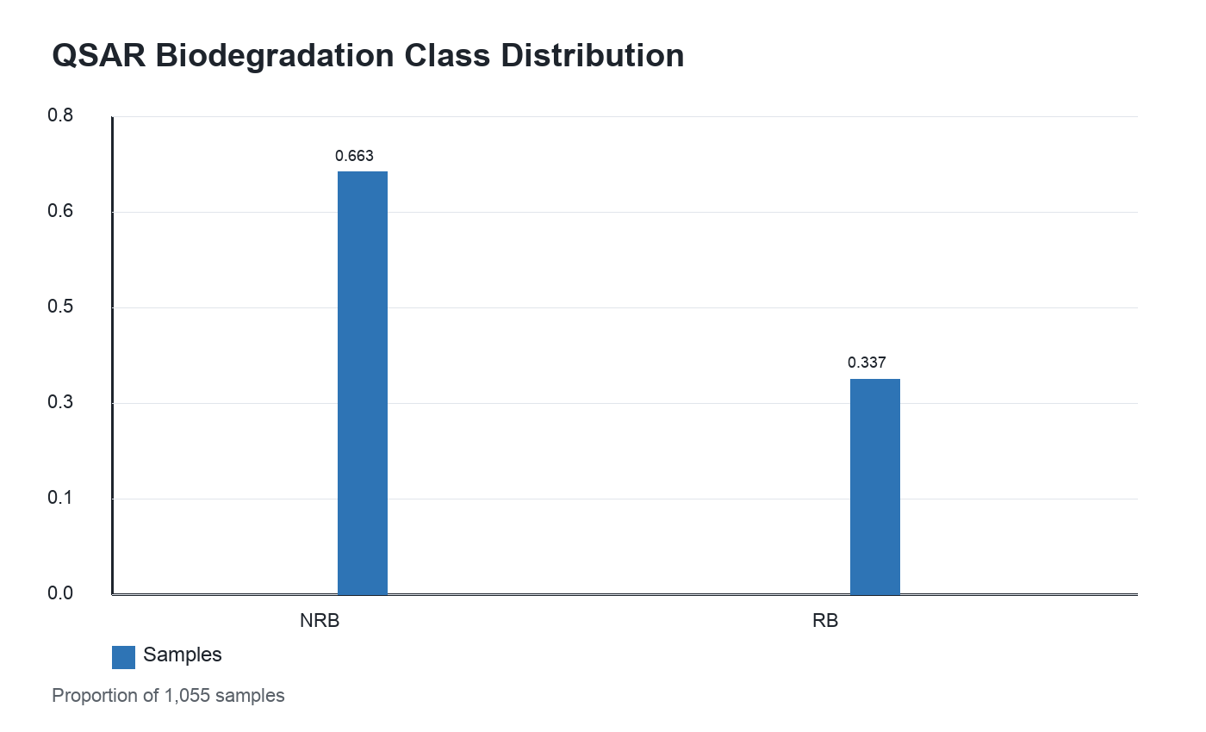
Figure A1. Class imbalance in the QSAR biodegradation dataset.

Figure A2
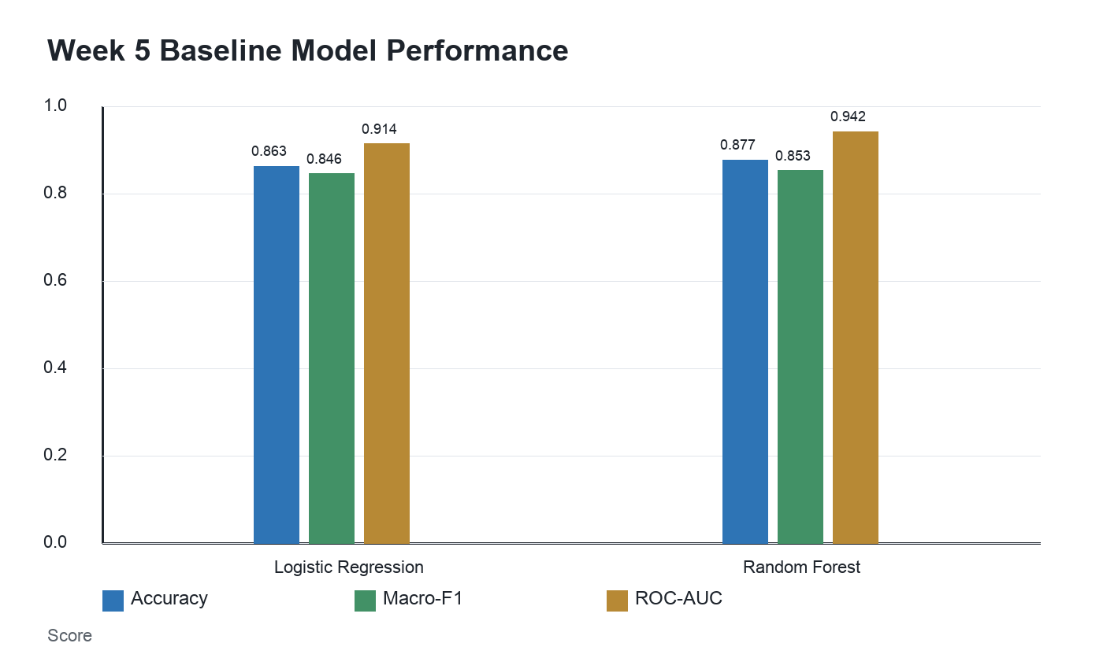
Figure A2. Baseline model performance for Week 5.

