Week 6 Applied Work: Feedforward Neural Network for Biodegradability Classification
Aryamann Zutshi
University of Kansas
EECS 692: Predicting Plastic Degradation Pathways with Machine Learning
Professor David Johnson
May 24, 2026

Introduction
The purpose of Week 6 was to implement a feedforward neural network (FNN) using the same descriptor-based biodegradability dataset evaluated in Week 5. The goal was not only to report accuracy but to compare the neural network against the earlier Logistic Regression and Random Forest baselines.
The neural-network experiment builds on standard deep-learning concepts described by Goodfellow et al. (2016) and on the same ready-biodegradability QSAR task described by Mansouri et al. (2013). The research question was whether a neural network could improve classification behavior while maintaining interpretable evaluation through confusion matrices and class-level analysis.
Research question. Can a feedforward neural network improve on the Week 5 baseline models for RB versus NRB classification?
It was hypothesized that an FNN could learn nonlinear descriptor interactions, but that performance would depend on tuning and class-imbalance handling.

Methods and Materials
The FNN used the 41 molecular descriptors as inputs and predicted the binary biodegradability class. The model was evaluated against the Week 5 baseline metrics, with particular attention to confusion-matrix behavior because the dataset was imbalanced.
The dataset still contained 699 NRB samples and 356 RB samples. In the held-out split represented by the confusion matrix, there were 140 NRB and 71 RB samples. This imbalance required class-level interpretation because minority-class errors could be hidden by overall accuracy.

Results
The FNN confusion matrix showed 125 correctly classified NRB samples, 15 NRB samples misclassified as RB, 49 correctly classified RB samples, and 22 RB samples misclassified as NRB. The FNN achieved accuracy of 0.8246 and ROC-AUC of 0.9025, which did not surpass the Random Forest baseline.
Appendix Figure A1 presents the FNN confusion matrix, and Appendix Figure A2 compares the neural-network performance with the Week 5 baselines.
Table 1
Week 6 Feedforward Neural Network for Biodegradability Classification
Model | Accuracy | ROC-AUC | Interpretation
Logistic Regression | 0.8626 | 0.9136 | Strong linear baseline.
Random Forest | 0.8768 | 0.9423 | Best Week 5 baseline.
FNN | 0.8246 | 0.9025 | Useful but undertuned for this dataset.

Discussion
The Week 6 hypothesis was only partially supported. The FNN learned useful patterns, but it did not outperform the Random Forest. The logic behind this result is that neural networks often require more extensive tuning, more data, and stronger regularization than classical models when working with small tabular descriptor datasets.
Class imbalance also affected interpretation. The RB class was smaller, and the confusion matrix showed that RB samples were still misclassified as NRB. This supports the need for class weighting, SMOTE on the training split only, threshold adjustment, and k-fold cross-validation. The main next step was to continue exploring neural-network structure while remaining skeptical of accuracy-only claims.

References
Goodfellow, I., Bengio, Y., & Courville, A. (2016). Deep learning. MIT Press.
Mansouri, K., Ringsted, T., Ballabio, D., Todeschini, R., & Consonni, V. (2013). Quantitative structure-activity relationship models for ready biodegradability of chemicals. Journal of Chemical Information and Modeling, 53(4), 867-878. https://doi.org/10.1021/ci4000213

Appendix
Figure A1
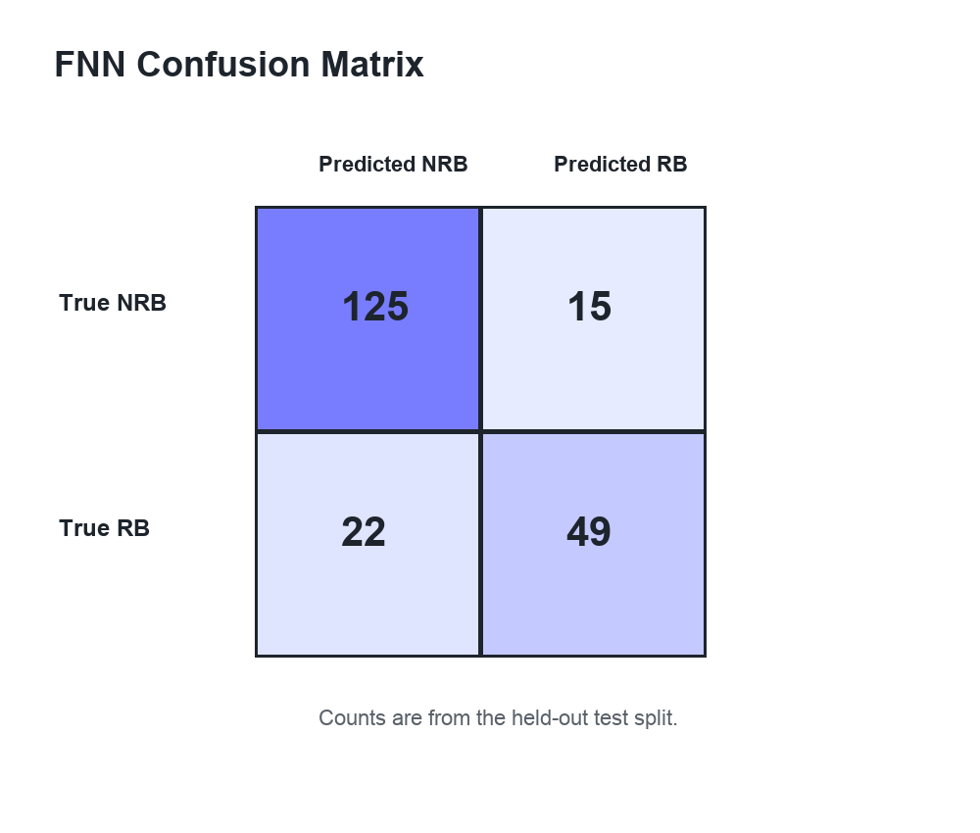
Figure A1. Week 6 FNN confusion matrix.

Figure A2
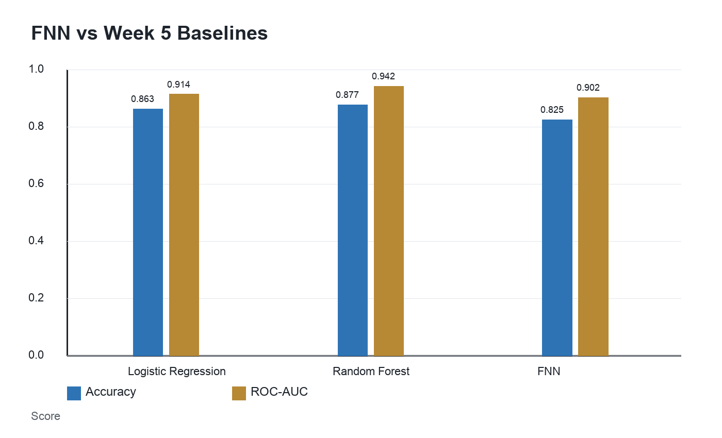
Figure A2. Week 6 neural network performance compared with Week 5 baselines.

