Week 7 Applied Work: Descriptor-Graph Prototype for Biodegradability Prediction
Aryamann Zutshi
University of Kansas
EECS 692: Predicting Plastic Degradation Pathways with Machine Learning
Professor David Johnson
May 24, 2026

Introduction
The purpose of Week 7 was to explore whether graph-inspired modeling could improve the biodegradability prediction task. This was a natural next step after QSAR baselines and the FNN because polymer degradation is ultimately controlled by chemical structure and local bonding environments.
The key distinction is that true graph neural networks require meaningful nodes, edges, and message passing. Wieder et al. (2020) describe molecular property prediction with graph neural networks as dependent on molecular graph structure. Therefore, the Week 7 research question was whether the available descriptor-based data could support a graph-style prototype without overclaiming it as a chemically complete GNN.
Research question. Does a descriptor-graph prototype improve biodegradability prediction compared with descriptor-only baselines?
It was hypothesized that graph-style structure could eventually help, but that a prototype built from descriptor vectors rather than true molecular graphs would underperform chemically grounded descriptor baselines.

Methods and Materials
A descriptor-graph prototype was evaluated using the available descriptor representation. The model was compared with earlier Logistic Regression, Random Forest, and FNN results. Evaluation focused on accuracy, ROC-AUC, and the confusion matrix.
Because the available dataset did not include atom-level graph structure, the graph prototype was treated as exploratory. This distinction is important for scientific honesty: a descriptor-derived graph is not equivalent to a polymer molecular graph.

Results
The descriptor-graph prototype underperformed the earlier baselines. Its confusion matrix showed 117 correctly classified NRB samples, 23 NRB samples misclassified as RB, 30 correctly classified RB samples, and 41 RB samples misclassified as NRB. Its accuracy was approximately 0.6967 and ROC-AUC was approximately 0.7689.
Appendix Figure A1 presents the descriptor-graph confusion matrix, and Appendix Figure A2 compares its performance with earlier baselines.
Table 1
Week 7 Descriptor-Graph Prototype for Biodegradability Prediction
Model | Approximate accuracy | Approximate ROC-AUC | Conclusion
Random Forest | 0.8768 | 0.9423 | Strongest earlier baseline.
FNN | 0.8246 | 0.9025 | Useful but not best.
Descriptor-graph prototype | 0.6967 | 0.7689 | Representation not sufficient.

Discussion
The Week 7 hypothesis was supported. The graph-style prototype did not outperform descriptor-only baselines because the input representation lacked chemically meaningful graph structure. The logic is straightforward: graph learning is powerful when nodes and edges represent atoms and bonds, but a graph imposed on summary descriptors may not carry the same mechanistic meaning.
This conclusion is backed by Wieder et al. (2020), who frame molecular graph neural networks around molecular structure. The limitation is that the result does not reject true graph neural networks for polymer degradation; it only shows that this dataset representation was not sufficient for a strong graph model. Future graph work would require curated repeat-unit or oligomer structures.

References
Wieder, O., Kohlbacher, S., Kuenemann, M., Garon, A., Ducrot, P., Seidel, T., & Langer, T. (2020). A compact review of molecular property prediction with graph neural networks. Drug Discovery Today: Technologies, 37, 1-8. https://doi.org/10.1016/j.ddtec.2020.11.009
Mansouri, K., Ringsted, T., Ballabio, D., Todeschini, R., & Consonni, V. (2013). Quantitative structure-activity relationship models for ready biodegradability of chemicals. Journal of Chemical Information and Modeling, 53(4), 867-878. https://doi.org/10.1021/ci4000213

Appendix
Figure A1
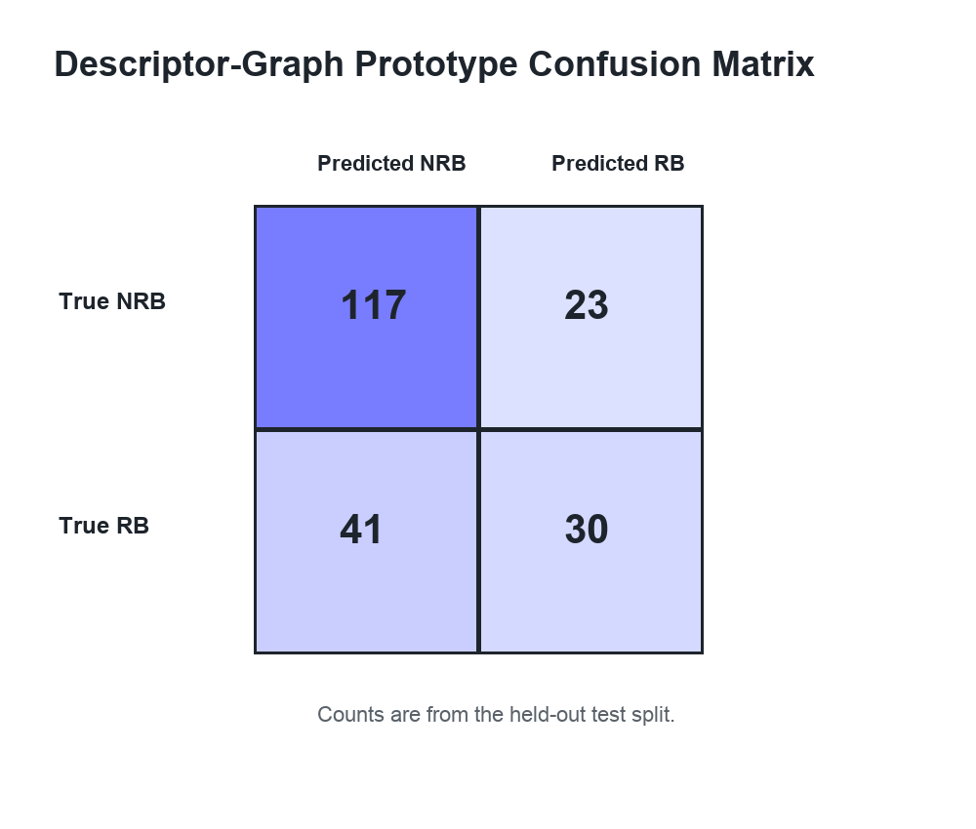
Figure A1. Week 7 descriptor-graph prototype confusion matrix.

Figure A2
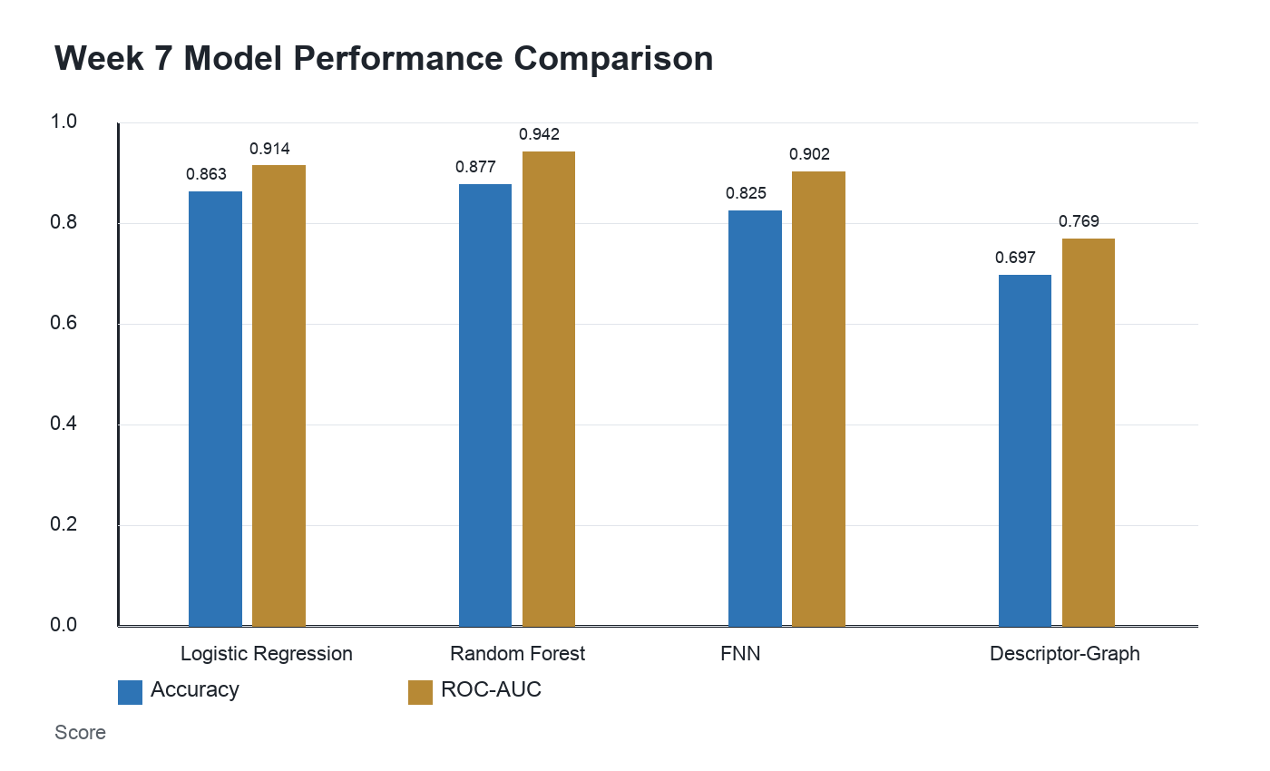
Figure A2. Week 7 model performance compared with earlier baselines.

