Week 8 Applied Work: Cross-Distribution Validation of Biodegradability Models
Aryamann Zutshi
University of Kansas
EECS 692: Predicting Plastic Degradation Pathways with Machine Learning
Professor David Johnson
May 24, 2026

Introduction
The purpose of Week 8 was to evaluate whether models trained on one data distribution remain reliable when tested under different distributional conditions. This question matters because polymer degradation data are often heterogeneous across sources, exposure environments, and measurement protocols.
The concern follows the broader materials-informatics warning that model performance depends heavily on data quality, representation, and domain coverage (Butler et al., 2018; Chen et al., 2021). Therefore, the Week 8 research question was whether the existing baselines could generalize beyond the standard train/test split.
Research question. How stable are the baseline models when evaluated under cross-distribution conditions?
It was hypothesized that model performance would drop under distribution shift, revealing that standard validation accuracy overstates real-world reliability.

Methods and Materials
The Week 8 analysis reused the baseline modeling logic and evaluated models under cross-distribution conditions. Logistic Regression and Random Forest were compared using mean accuracy after the data distribution changed.
The purpose of this design was not to optimize a new model. It was to test robustness. If a model performs well only in the original split but collapses under shifted conditions, its scientific usefulness is limited.

Results
Both models showed substantial performance drops under cross-distribution validation. Logistic Regression achieved mean accuracy of approximately 0.3727, while Random Forest achieved approximately 0.4210. Random Forest remained stronger, but neither model generalized well.
Appendix Figure A1 shows the Week 8 cross-distribution accuracy results.
Table 1
Week 8 Cross-Distribution Validation of Biodegradability Models
Model | Cross-distribution mean accuracy | Interpretation
Logistic Regression | 0.3727 | Poor transfer.
Random Forest | 0.4210 | Better but still unstable.

Discussion
The Week 8 hypothesis was supported. Performance dropped sharply under distribution shift, indicating that standard validation results were not enough to establish real-world reliability. The logic behind this claim is that descriptor models can learn patterns that are valid inside one dataset distribution but unstable when the chemical or experimental domain changes.
This finding connects to Butler et al. (2018) and Chen et al. (2021), who emphasize the importance of representative datasets in molecular and polymer machine learning. The limitation is that cross-distribution testing showed the failure but did not yet fix it. The next step was to address class imbalance and improve minority-class detection.

References
Butler, K. T., Davies, D. W., Cartwright, H., Isayev, O., & Walsh, A. (2018). Machine learning for molecular and materials science. Nature, 559(7715), 547-555. https://doi.org/10.1038/s41586-018-0337-2
Chen, L., Pilania, G., Batra, R., Huan, T. D., Kim, C., Kuenneth, C., & Ramprasad, R. (2021). Polymer informatics: Current status and critical next steps. Materials Science and Engineering: R: Reports, 144, 100595. https://doi.org/10.1016/j.mser.2020.100595

Appendix
Figure A1
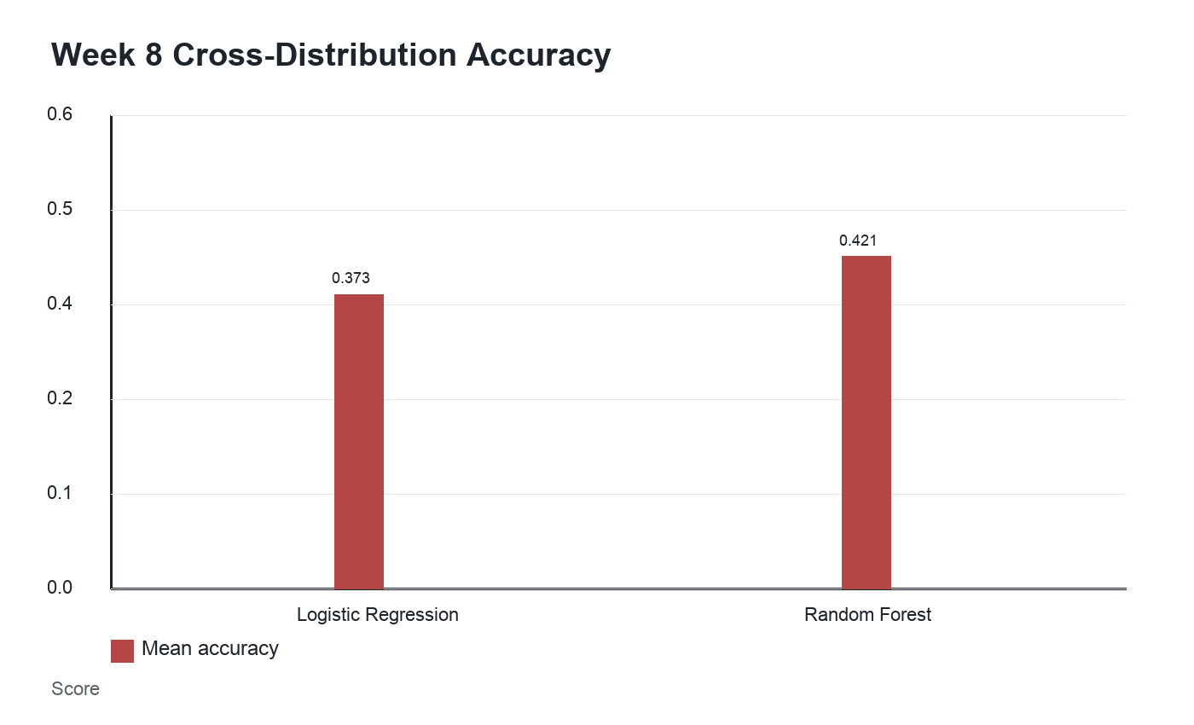
Figure A1. Reported cross-distribution accuracy drop during Week 8 validation.

